Google Contacts to MailEnable User Guide**

What It Does

* Imports Google Contacts (and possibly iOS contacts) to MailEnable mailboxes

Features

* Free! Open source platform
* Simple to use
* Retains nearly all contact information, including photos, notes, custom phone numbers, etc.

*Note! Copies all extra information into Notes field.*

* Creates groups
* Allows for custom phone number fields to be imported to defaults. *i.e. Can import cell into mobile.*
* Reformat phone numbers to standard format. *i.e. +1 517.555-1212 converts to (517) 555-1212*
* If no mobile phone number, can copy work, home, etc. into mobile field so that it displays number in main list.

Installation

* No installation. Just run GoogleContactsToMailEnable.exe

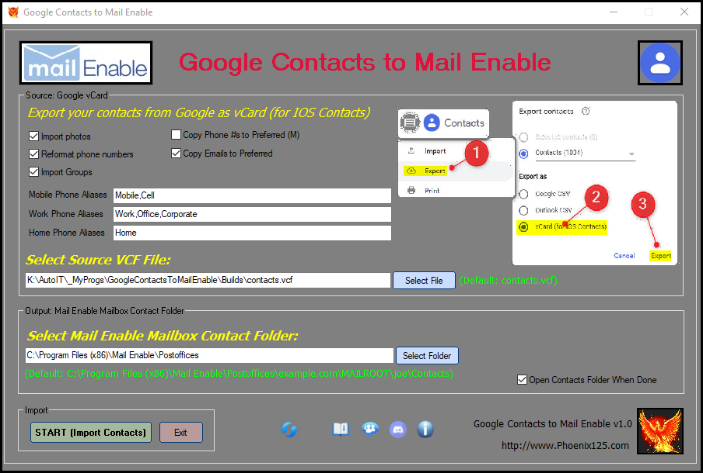

Instructions

* Export Google contacts from <https://contacts.google.com/>

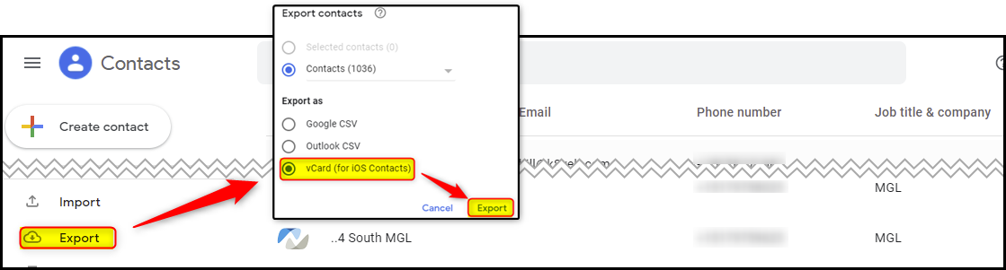

* Run GoogleContactsToMailEnable.exe
* Select the contacts.vcf file you just downloaded



* Select desired options *Tip! Hover mouse over any field for more information*

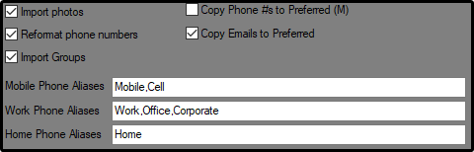

* Select output folder

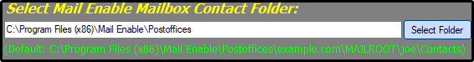

* Click START (Import Contacts) to start importing



*\* Note! The timer will occasionally stop during processing. This is normal.*

Options

* Import photos: import contact photos
* Reformat phone numbers: reformats most phone numbers. i.e. *+1 517.555-1212 converts to (517) 555-1212*
* Import groups: Creates group files and adds contacts to corresponding group
* Copy phone #s to Preferred (M): If contact does not have a mobile phone number, will copy personal, company, pager, fax # (prioritized in that order) into mobile field so that it displays number in main list. 
* Copy Emails to Preferred: If contact does not have a preferred email address, will copy personal or company email address to the Preferred Email field so that it displays number in main list.
* Phone Aliases: If no mobile/work/home phone #, imports custom labels into desired field. i.e. Custom label “cell” will import into Mobile field. Custom label “Office” & “Corporate” will import into Work field.