Discord: <http://discord.gg/EU7pzPs> Main website: <http://www.phoenix125.com/> Forum: <https://phoenix125.createaforum.com/index.php>

**UniFi Camera Image Archiver & Uploader**

Download: <http://www.phoenix125.com/share/atlas/AtlasServerUpdateUtility.zip>

Download: <http://www.phoenix125.com/share/unificameraimagearchiverftpuploader/UniFiCameraImageArchiverFTPUploader.zip>

GitHub (Open Source): <https://github.com/phoenix125/UniFiCameraImageArchiverFTPUploader>

Features

* Create archives of Ubiquiti UniFi cameras (or any camera with http snapshot).
* Upload images via FTP. Works with Wunderground.
* Resize images for upload and archive.
* Use third-party software to create time-lapse videos from archived images. I personally use [AviDemux](http://avidemux.sourceforge.net/).
* Works with 1-100 cameras.
* Each camera has independent settings:

○ Save Folder ○ Upload folder ○ Independent archive and FTP frequency

* Logs of archives and FTPs.

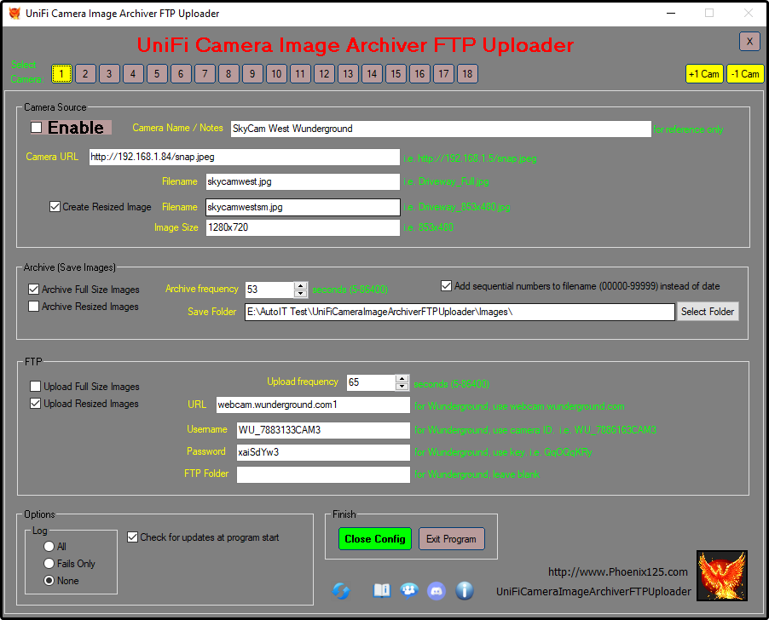

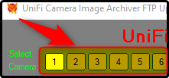Instructions

* Run UniFiCameraImageArchiverFTPUploader_vX.exe
* Config window will open. Set parameters.
* Click on Camera Number to change camera.
* Hove mouse over any option for details.
* To set Camera Snapshot URL, see instructions below. 

How to Enable SnapShot on UniFi cameras

* In a web browser, enter your camera’s IP address: *ie. 192.168.1.80*
* Log in. Username: ubnt Password: *(get from UniFi Protect – see below for instructions)*

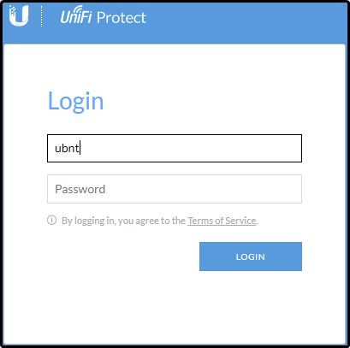

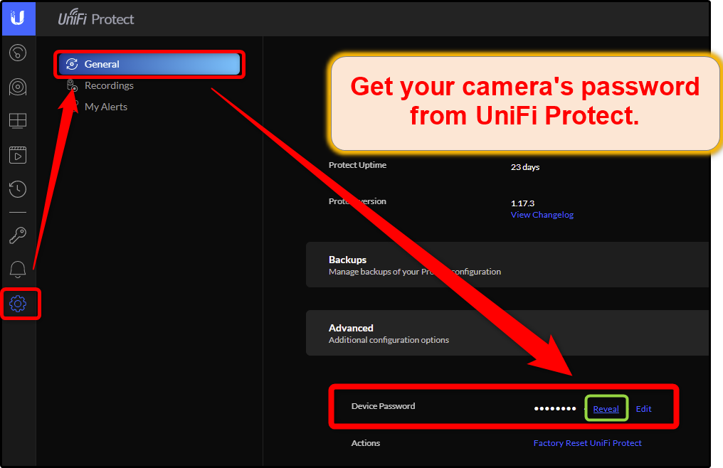

* Click “Enable Anonymous Snapshot” to enable it. A checkmark will appear.

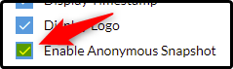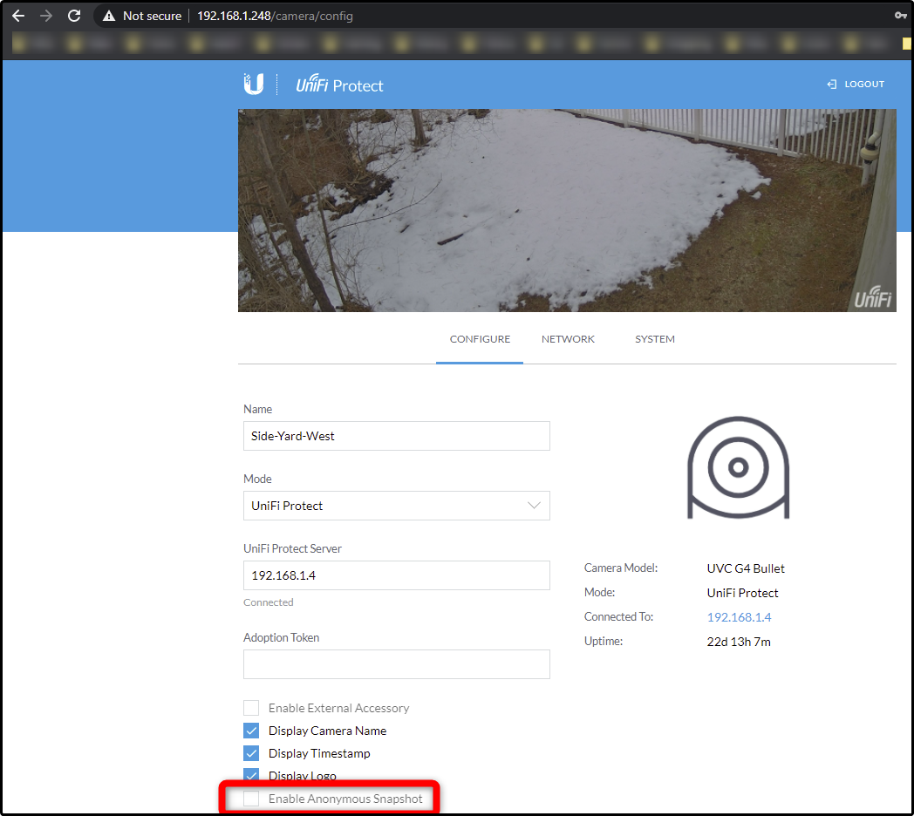

* Your UniFi camera will now create a snap.jpeg file in the URL’s root folder every second or so.

To access it, enter http://{IP}/snap.jpeg in any web browser.  *i.e. http://192.168.1.84/snap.jpeg*

**Revision History**

2021-03-06 v1.2 Config GUI!

- Added: Config GUI

- Added: Separate options for archiving and uploading full size and resized images

2021-02-28 v1.1

- Added: Separate save intervals for each camera

- Added: Optionally add sequential numbers at end of filename instead of date. Useful for some Image-To-Video programs

2020-12-13 v1.0 Initial Release