1、学生成绩查询系统
数据结构大致如下：
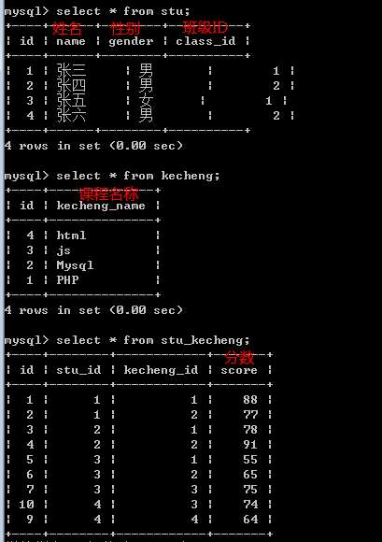
注意：以上数据并不意味着全部数据，自己可根据题目要求构建（插入）适当数量的数据。
要求：
- 查询选修了 MySQL 的学生姓名；
select stu.name as 选修mysql学生姓名 from stu,course,score where stu.stu_id = score.stu_id and course.kc_id = score.kc_id and course.kc_name = 'mysql';
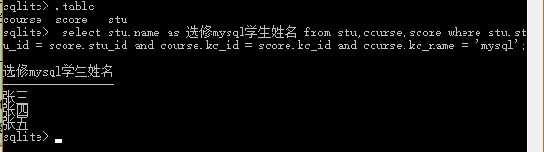
- 查询 张三 同学选修了的课程名字；
select course.kc_name as 张三选修的课程 from stu,course,score where stu.stu_id = score.stu_id and course.kc_id = score.kc_id and stu.name='张三';
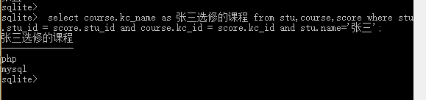
- 查询只选修了1门课程的学生学号和姓名；

select count(distinct kc_id) as 选修一门的课程id from score;
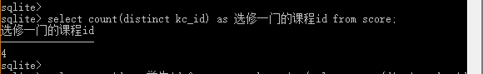
select stu_id as 学生id from score where kc_id in (select count(distinct kc_id) from score);
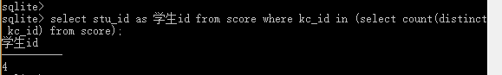
select stu_id as 学号,name as 学生姓名 from stu where stu_id in (select stu_id from score where kc_id in (select count(distinct kc_id) from score));
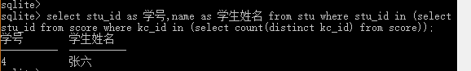
4)查询选修了至少3门课程的学生信息；
通过排序，order by asc 以及limit分页的方法取得数据学生id
select * from score order by stu_id asc limit 4,3;
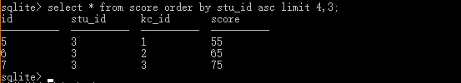
通过学生id，读取学生信息
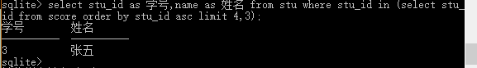

5)查询选修了所有课程的学生；
A、先查找选修过的学生和课程
select * from score,course,stu where score.stu_id = stu.stu_id and course.kc_id = score.kc_id;
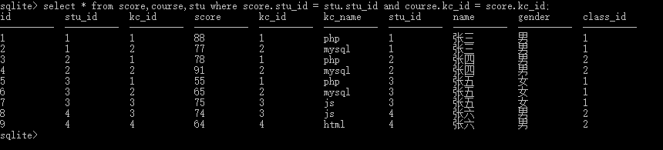
B、通过所选的课程id找到多对应的学生id，并去重复的distinct
课程id：
select kc_id from course where kc_id in (select course.kc_id from score,course,stu where score.stu_id = stu.stu_id and course.kc_id = score.kc_id);
学生id：
select distinct(stu_id) from score where kc_id in(select kc_id from course where kc_id in (select course.kc_id from score,course,stu where score.stu_id
= stu.stu_id and course.kc_id = score.kc_id));
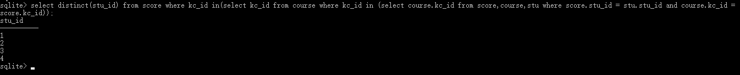
C、通过学生id找到姓名
select name as 学生姓名 from stu where stu_id in(select distinct(stu_id) from score where kc_id in(select kc_id from course where kc_id in (select course.kc_id from score,course,stu wh
ere score.stu_id = stu.stu_id and course.kc_id = score.kc_id)));

另外一种方法，先对课程id排序 在去重复，通过课程id获取学生id 再去名字
6)查询选修课程的学生人数；
select count(stu_id) as 选修课程人数 from score where kc_id in(select kc
_id from course where kc_id in (select course.kc_id from score,course,stu where
score.stu_id = stu.stu_id and course.kc_id = score.kc_id));
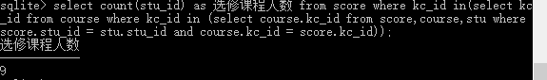

7)查询所学课程至少有一门跟 张三 所学课程相同的学生信息。
张三课程id
select course.kc_id from stu,course,score where stu.stu_id = score.stu_i
d and course.kc_id = score.kc_id and stu.name='张三';
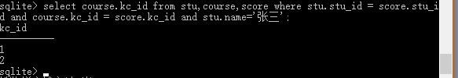
通过张三取的课程id 获取学生id
select stu_id from score where kc_id in (select course.kc_id from stu,course,score where stu.stu_id = score.stu_id and course.kc_id = score.kc_id and stu.name = '张三');
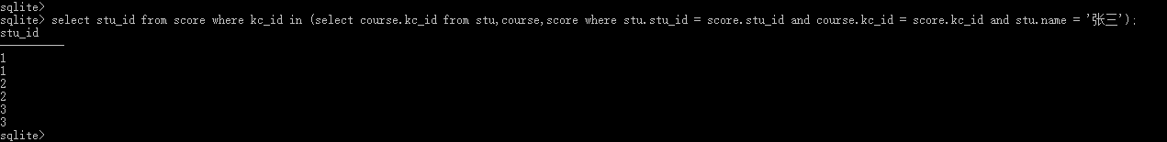
学生id获取学生信息
select stu_id as 学号,name as 姓名,gender as 性别, class_id as 班级 from stu where stu_id in (select distinct(stu_id) from score where kc_id in (select course.kc_id from stu,course,sco
re where stu.stu_id = score.stu_id and course.kc_id = score.kc_id and stu.name = '张三'));
8)查询两门及两门以上不及格同学的平均分
取不及格的学生id
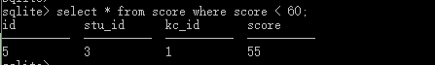
9)查询没有被选中的课程id 以及名称；
select kc_id,kc_name from course where not kc_id in (select course.kc_id from score,course,stu where score.stu_id = stu.stu_id and course.kc_id = score.kc_id);

学生表
create table stu(stu_id integer not null primary key autoincrement,name varchar(32),gender varchar(32) default '男',class_id int(8));
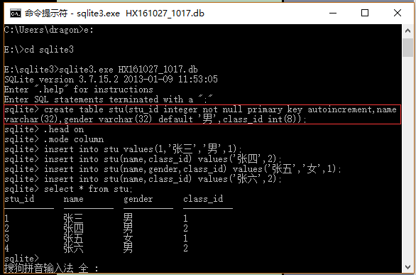

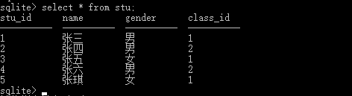
课程表
create table course(kc_id integer primary key autoincrement,kc_name varchar(32));
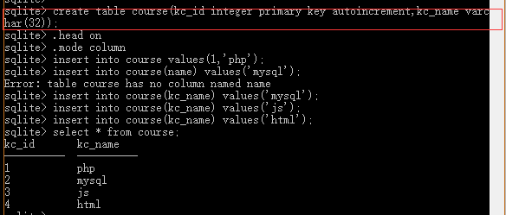
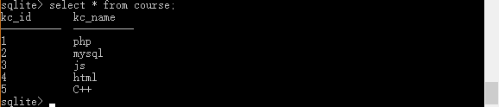
分数表
create table score(id integer primary key autoincrement,stu_id int(32),kc_id int(8),score int(32));
