Project Report: Product Sales Analysis

# Table of Contents

1. Problem Statement
2. Data Analysis using MySQL
3. Data Cleaning
4. Build Dashboard/Report using Power BI
5. Tools, Software, and Libraries
6. References

# 1. Problem Statement

The objective of this project is to analyze product sales data of the company to understand sales trends, product performance, customer behavior, and regional contributions. By leveraging structured data from customers, employees, offices, orders, payments, product lines, and products, the aim is to identify key business insights such as:  
- Most profitable products and product lines  
- Yearly and monthly sales performance  
- Customer distribution by geography  
- Employee contributions and office-wise sales  
- Profit margin analysis and anomalies in sales trends  
  
This analysis enables management to make data-driven decisions for improving profitability, optimizing inventory, and enhancing customer relationships.

# 2. Data Analysis using MySQL

The raw data was stored in a relational database consisting of multiple tables:  
- Customers – Contains customer details such as name, city, country, and contact.  
- Employees – Provides information about sales representatives.  
- Offices – Location and branch details.  
- Orders & OrderDetails – Information about customer orders and quantities purchased.  
- Payments – Records of customer transactions.  
- Products & ProductLines – Product catalog including descriptions and categories.  
  
SQL Queries performed included:  
- Joining orders, orderdetails, and products tables to calculate total sales.  
- Grouping by order_year to analyze yearly trends.  
- Aggregating by productLine and productName for performance comparison.  
- Linking customers with orders to evaluate customer distribution and sales contribution.  
- Identifying profit margins using sales vs. cost.

# 3. Data Cleaning

Before analysis, the dataset underwent cleaning and preprocessing to ensure accuracy:  
- Removed duplicate entries from customer and order tables.  
- Standardized date formats for sales and order dates.  
- Handled missing values in payments and employees tables.  
- Checked consistency of product names and descriptions.  
- Derived additional fields such as Order Year, Profit Margin %, and Total Sales by Region for deeper insights.

# 4. Build Dashboard/Report using Power BI

Using the cleaned dataset, an interactive Power BI dashboard was created with the following insights:  
- KPIs: Total Sales, Profit Margin %, Total Profit Margin, Most Ordered Product.  
- Time Series Analysis: Sales trends over years, months, and quarters with anomaly detection.  
- Geographical Analysis: Customer distribution by city and office location.  
- Product Analysis:  
 • Top 5 and bottom 5 products by sales.  
 • Sales distribution across product lines (Classic Cars, Vintage Cars, Motorcycles, etc.).  
- Customer & Employee Insights: Sales by sales representatives and customer contribution.  
- Trend Analysis: Highlighting peak sales periods and low-performing categories.  
  
The dashboard allows filtering by year, city, employee, and product line, making it highly dynamic for decision-making.

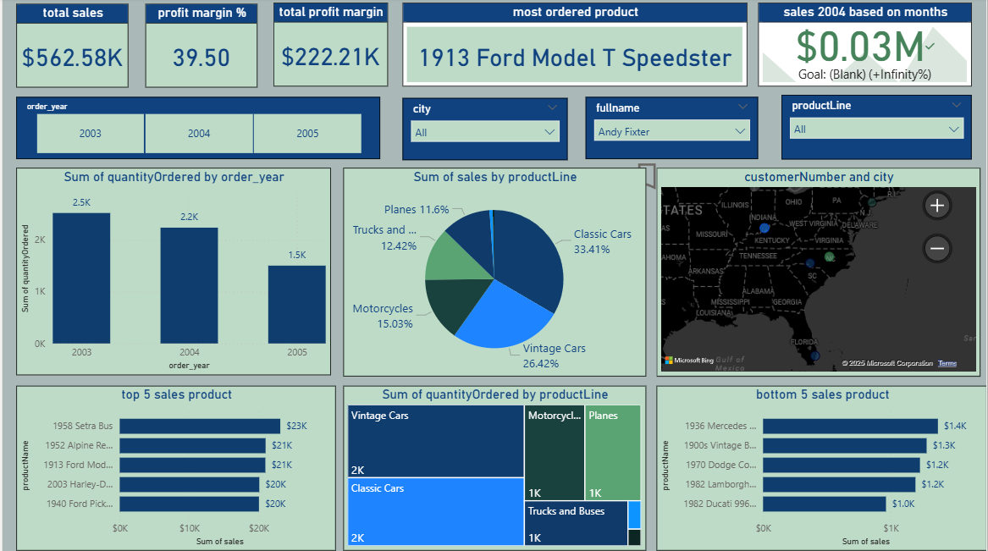

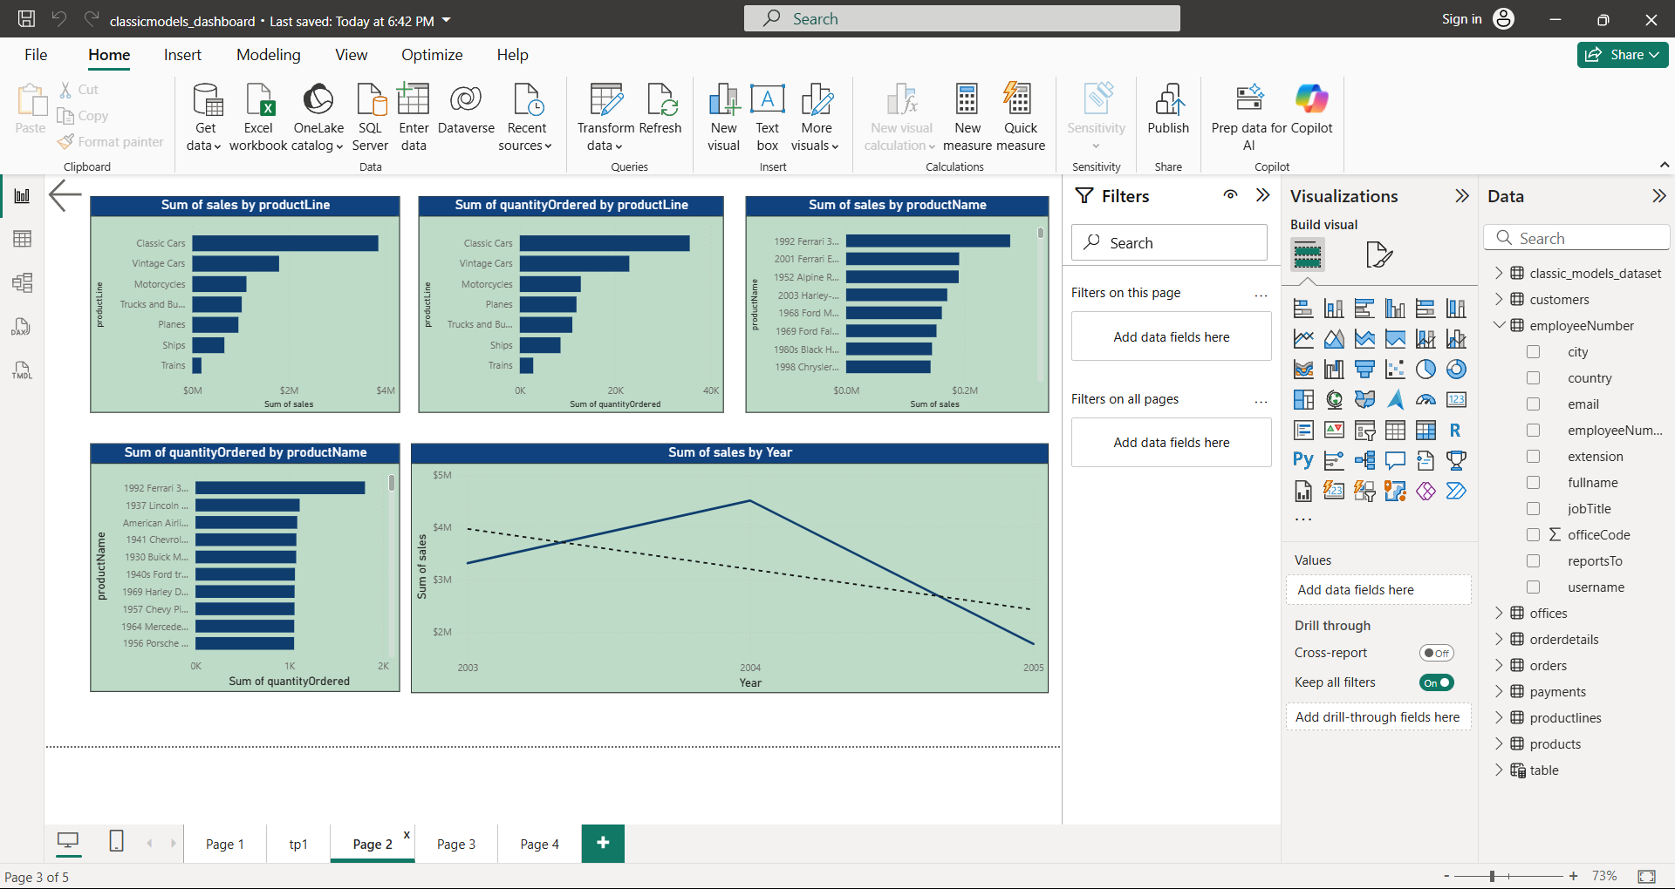

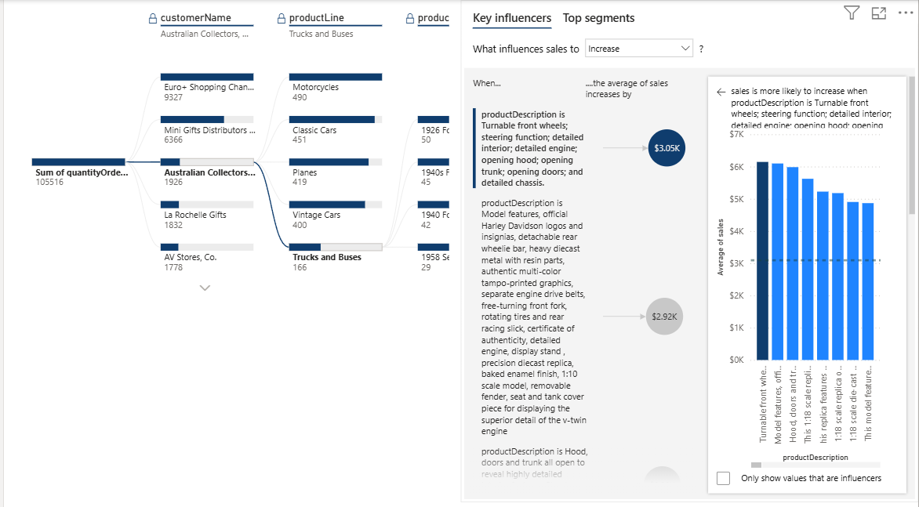

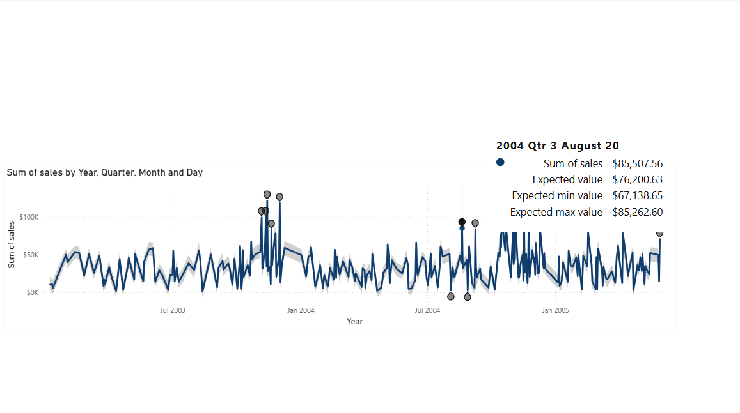

# 5. Tools, Software, and Libraries

- SQL (MySQL Workbench): Used for data extraction, joins, and transformations.  
- Power BI: Dashboard creation, data modeling, DAX calculations, and visualization.  
- Microsoft Excel: Preliminary cleaning and verification of datasets.  
- Libraries (if Python used for preprocessing): Pandas, NumPy, Matplotlib, Seaborn.

# 6. References

- Microsoft Power BI Documentation – https://learn.microsoft.com/power-bi  
- MySQL Documentation – https://dev.mysql.com/doc/  
- Kaggle/Classic Models Dataset (Sample Dataset used for BI Projects)