Benedict Cumberbatch  Data Analytics Professional |  |  |  | (555) 555-5555 |  | About Me  Tableau Certified Professional – Tableau  Alteryx Designer Core Certification – Alteryx  IT Specialist: Databases – Pearson  Big Data Analytics Certificate – University of Texas  Customer Analytics Certificate – University of Pennsylvania, Wharton School | Portfolio Contents  Dashboard Development 1  Data Storytelling 3  Training 4
 |  |  |  | person@yahoo.com | 
 |  |  |  | City, ST | 
 |  |  |  | Linkedin.com/in/myaddress | 
 |  |  |  | BS, Applied Mathematics | 
See more | Check out my LinkedIn profile: www.linkedin.com/in/myaddress

Dashboard Development
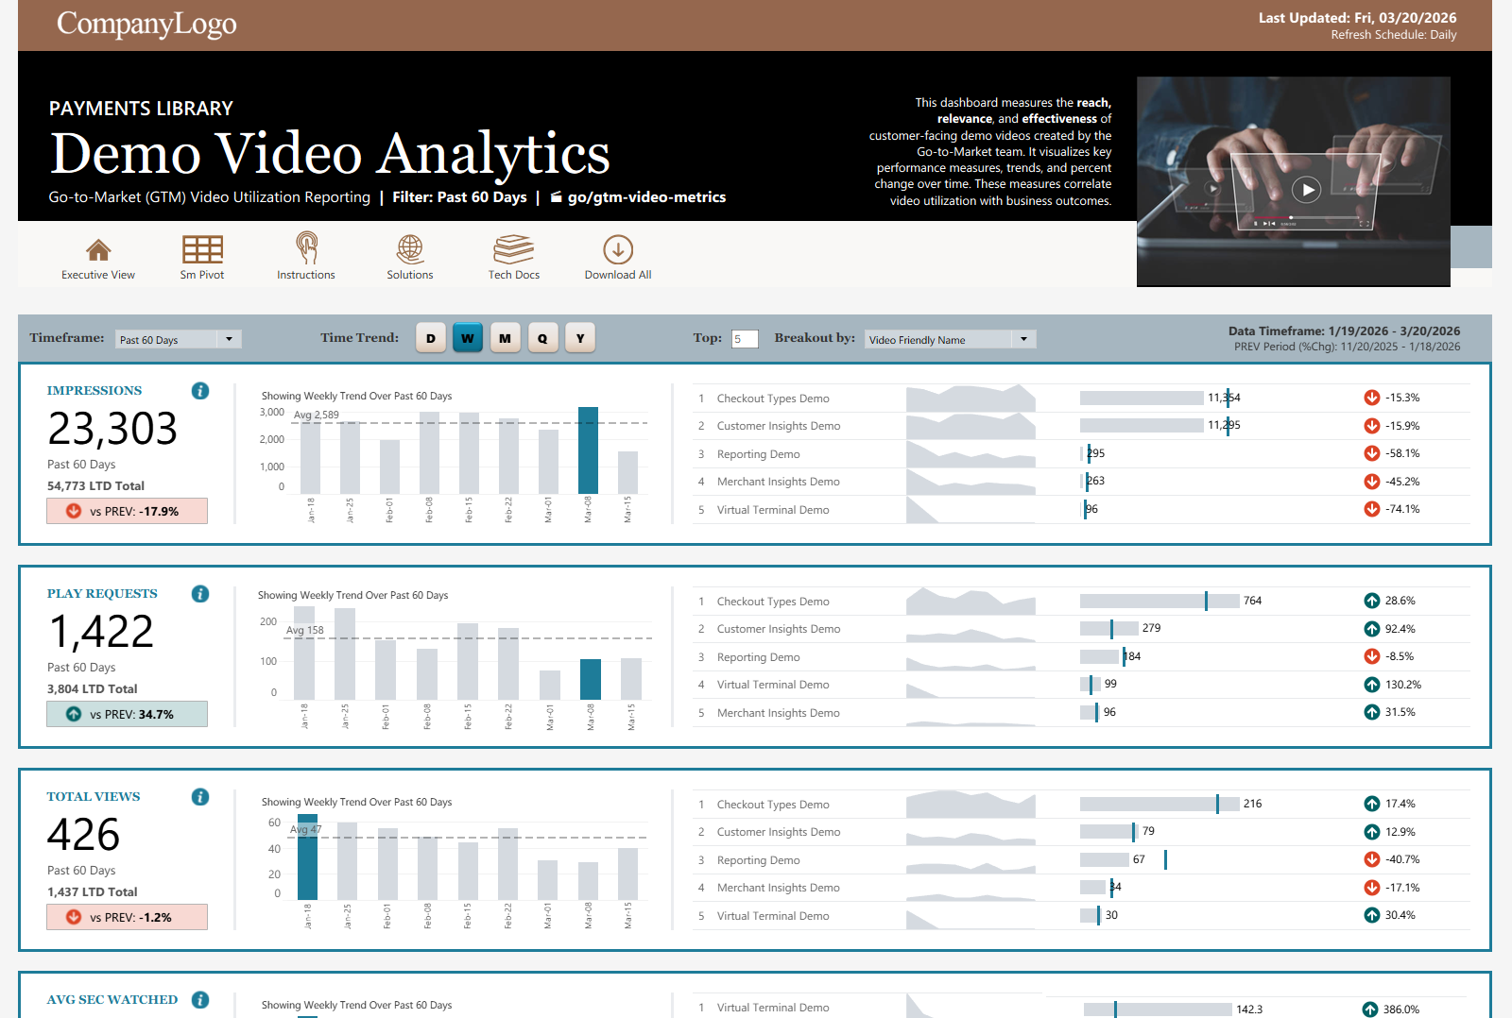 | 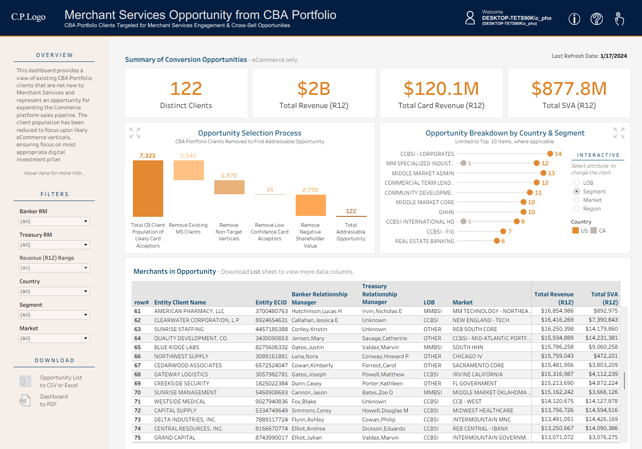 | 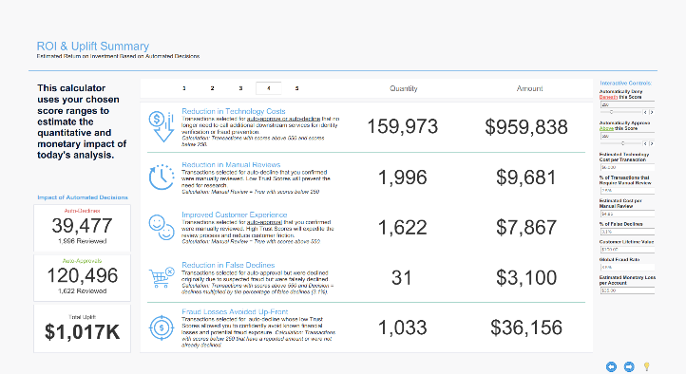
Asset Utilization Executive Dashboard Suite  As part of a modernization and server-migration effort, I designed operational and strategic dashboards to surface key performance metrics, consolidating end-user engagement signals from multiple hosting environments into a single view. These insights enabled content owners to understand reach, relevance, adoption, and usage; to refine asset creation strategies; and to better support product education in alignment with customer interest. This suite of asset-utilization dashboards gave executive leadership and asset owners a unified view of how go-to-market resources (demo videos, data-product library assets, and technical documentation) were being consumed across platforms.  PDF of Dashboards | Live Data Product  GTM-Asset-Utilization-Analytics_Dashboards_Internal_2026.pdf  Live data is synthetic and anonymized. | Cross-Sell Opportunity Waterfall Analysis  To identify pilot opportunities for a new payments platform within an existing global enterprise, I conducted a portfolio analysis across multiple lines of business (LOBs) to surface clients in target verticals with strong cross‑sell potential. The results were translated into a Tableau dashboard to visually explain the selection logic, to highlight the most promising opportunities, and to allow relationship managers to explore associated revenue and client details for better prioritization and research. This interactive view provided a structured, repeatable way to identify and evaluate cross‑sell candidates across the broader client ecosystem.  PDF of Dashboard | Live Data Product  Client-Opportunity-Waterfall_Dashboard_Internal_2023.pdf  All portfolio data is synthetic and anonymized. | Tableau Presentation Tool & Interactive Calculator  A B2B SaaS launch of a new ML-based risk scoring product stalled after prospects struggled to see value after proof-of-concept trials. Sales summaries lacked the analytical rigor needed to tie product output to monetary ROI uplift. I designed this Tableau data product as a pre-Sales framework to deliver a standardized, visual storyline for communicating product value – showcasing how Tableau can support both narrative delivery and real-time data exploration with live adjustments during discussions. This Tableau workbook served as both a presentation tool and interactive calculator, using animation and guided sequencing to keep audiences focused without overwhelming them with dense analysis.  PDF of Slides | Live Data Product  Email-Verification-SaaS-ROI_Tableau_External_2022.pdf  Email addresses are redacted.
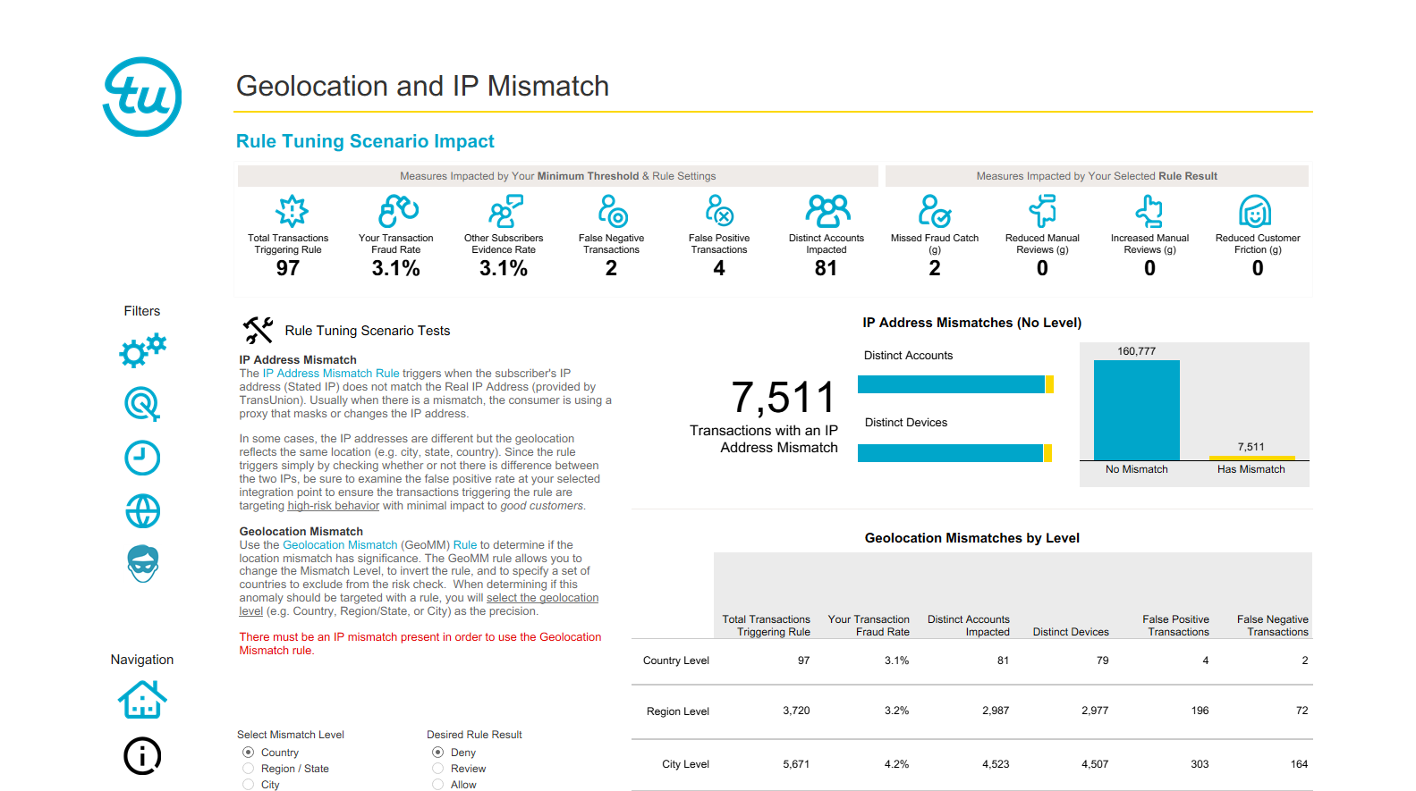 | 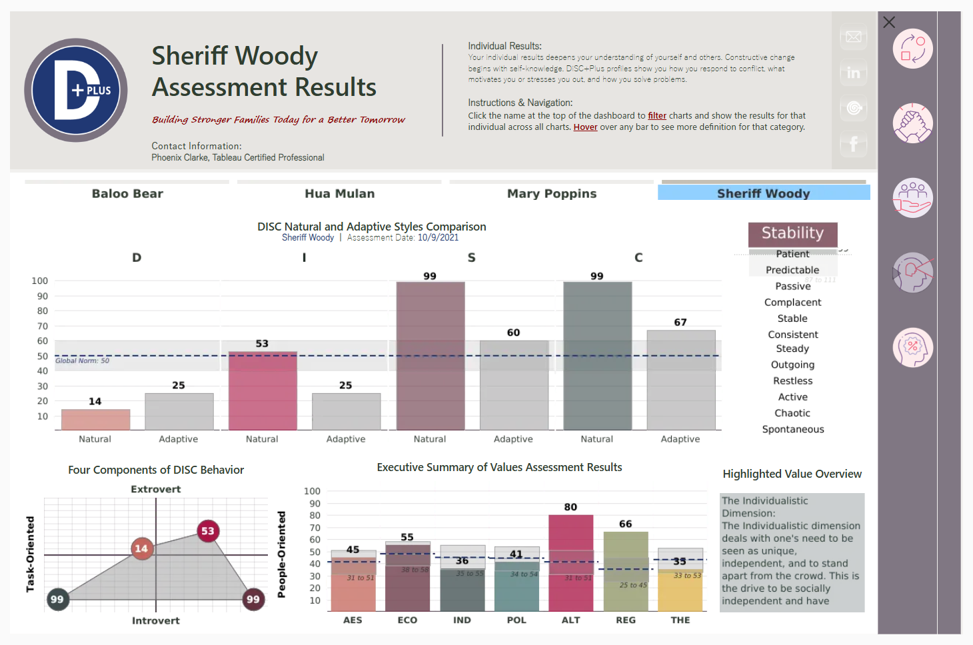 | 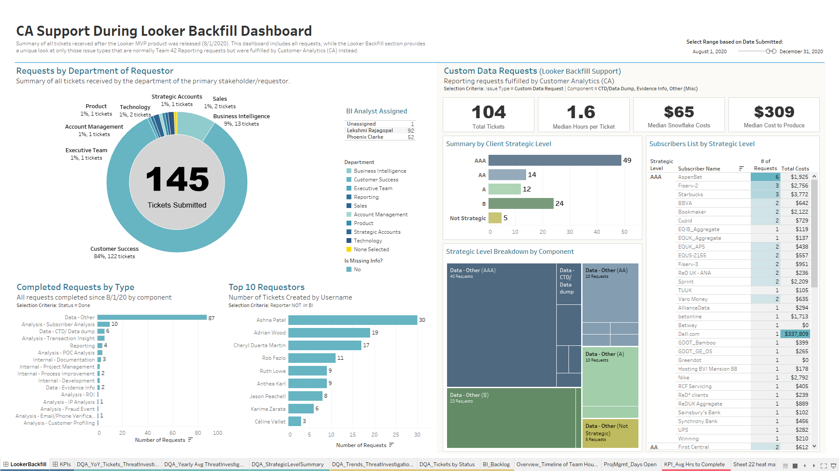
Scenario Simulations Sandbox Environment  Clients attempting to optimize 50+ business rules targeting risky online behaviors were challenged by the product’s high complexity and quickly-evolving fraud techniques. I proposed a self-serve, near-real-time sandbox environment for clients to run scenario simulations, adjust risk rules, and test channel-specific configuration changes before deploying them in production. Using a Tableau-based prototype to demonstrate each business rule’s configuration options and the measurable impact, this prototype showcased how a future web application could streamline experimentation, reduce implementation risk, and give clients greater control over optimizing their SaaS configurations. This proposed web application established revenue-generating opportunities when sold alongside the product.  PDF of Prototype  Web-Application-Prototype_Tableau_Internal_2022.pdf | Personality Profile Explanation Tool  An interactive Tableau tool designed to explore and explain the results of my family DiSC Plus personality Assessment, providing a structured way for each member to understand their natural and adaptive behaviors and motivators. The dashboard breaks personality insights into three levels – team dynamics, comparisons of individual values, and a detailed view of each person’s components and definitions – allowing users to navigate personality patterns in a clear, intuitive format. This personal project demonstrates how Tableau can be used to translate complex assessment data into an accessible, engaging, and meaningful visual experience for non-technical users.  PDF of Dashboards | Live Data Product  Interactive-DiSC-Test-Results_Dashboard_External_2021.pdf  All original names are anonymized. | Resource Capacity & Workload Dashboard  Leadership needed a transparent, data‑driven way to understand the workload, capacity, costs, and the impact of upcoming data science initiatives. I developed a personal Tableau workbook to organize my team’s projects, to aggregate time-based costs and effort, and to forecast future resource needs – providing a clear operational view of analytics projects that ultimately supported the business case for expanding the team. I extracted and transformed underlying data from multiple project‑management systems into a unified and streamlined data structure, enabling consistent KPI reporting at both strategic and operational levels.  PDF of Dashboard  Team-Capacity-Planning_Dashboard_Internal_2019.pdf  All employee and client names are redacted.

Data Storytelling
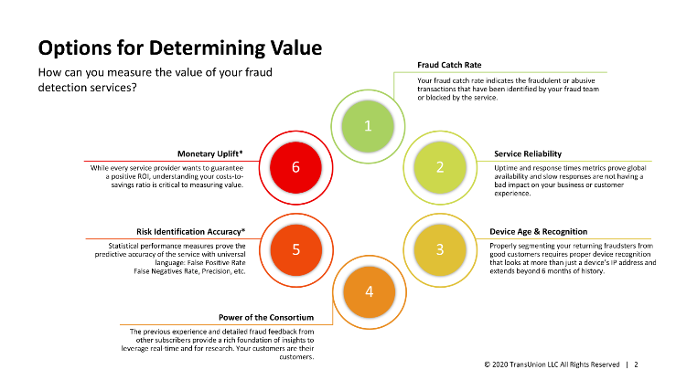 | 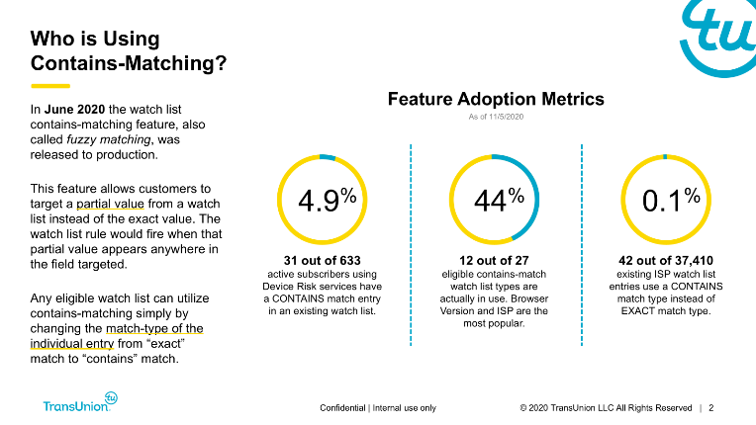 | 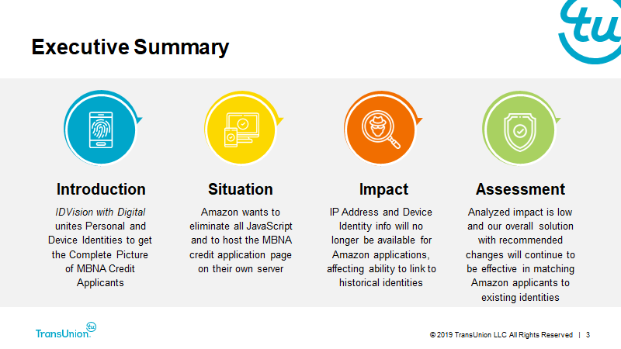
Fraud Product Value Framework  Client conversations about a device-intelligence fraud solution were overly focused on machine-learning performance metrics, which limited clients’ understanding of the product’s broader value. To expand the narrative, I delivered a repeatable framework that connected fraud-catch categories, service reliability, and response-times with clear, monetized uplift that is client-strategy-focused. This approach helped Sales, Customer Success, and Product teams articulate the full value of the SaaS suite in terms that resonated with business stakeholders, moving discussions beyond basic false-positive and accuracy rates.  PDF of Data Story  Client-Value-Prop-w-ROI_Presentation_Internal_2021.pdf | Feature Adoption & Implementation Best Practices  Client support teams needed clearer guidance on newly released product functionality to help customers optimize fraud‑detection rules. To support the rollout, I created a structured training program that explained how the feature works, its adoption metrics, the universe of clients most likely to benefit, and the best practices identified through data mining and clustering. This resulting presentation ensured client-facing teams could confidently support the new release and guide customers toward high-impact configurations that maximize the value of the new release.  PDF of Data Story  Product-Feature-BestPractices_Presentation_Internal_2020.pdf | Impact Analysis with Next Seps  A client’s integration engineer completed an initial impact analysis but needed support translating raw results into an executive-ready narrative. I reshaped the findings into a clear data story that highlighted the implications of proposed configuration changes and recommended next steps. The final presentation guided both the client and internal teams through recommended next steps for implementing a stronger solution. By reframing technical results into a business-focused storyline, stakeholders gained a clearer understanding of the path toward reduced risk.  PDF of Data Story  Change-Impact-Analysis_Presentation_External_2020.pdf

Training
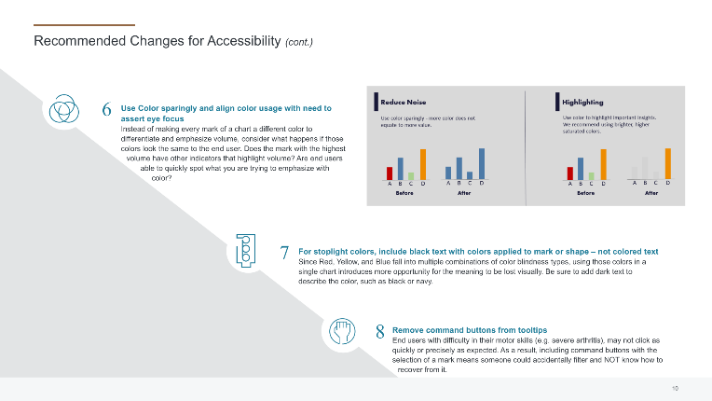 | 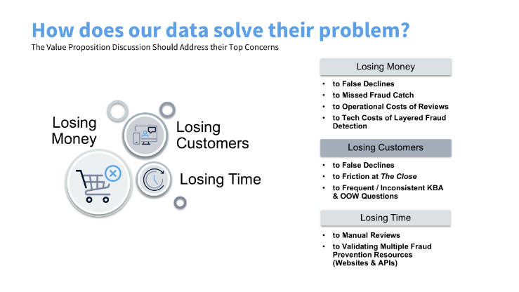
Accessibility & Inclusive Dashboard Design  Internal dashboard users were experiencing accessibility challenges across the team’s dashboard library. I interviewed users, consolidated feedback, and built a practical, team-wide accessibility training program to introduce color-blind-safe design practices. These recommendations evolved into a set of best-practice design principles that raised the UI/UX maturity of junior and mid-level analysts. By standardizing accessible design expectations, the team produced dashboards that were more intuitive, inclusive, and aligned with modern data-visualization standards.  PDF of Training  Accessibility-Tips-n-Tricks_Presentation_Internal_2024.pdf | Proof-of-Concept Value Communication Training  A B2B SaaS launch of a new ML-based risk scoring product suite stalled after prospects struggled to see value after proof-of-concept trials. Qualitative summaries lacked the analytical rigor needed to demonstrate the product’s value. To address this gap, I redefined the end-to-end POC process with required inputs, standardized fields, and a clear interpretive framework that transformed trial results into quantified and monetary uplift. These training materials equipped Sales and Customer Success to collect the right evidence and communicate product value with a standardized storyline in go-to-market conversations.  PDF of Training | Live Data Product  Product-ROI-Seller-Education_Presentation_Internal_2022.pdf

