Name: Mostafa Ayman Hegazy

Email: [m.hegazy@innopolis.university](mailto:m.hegazy@innopolis.university)

Dynamics of non-linear Robotics

Homework 3 Report

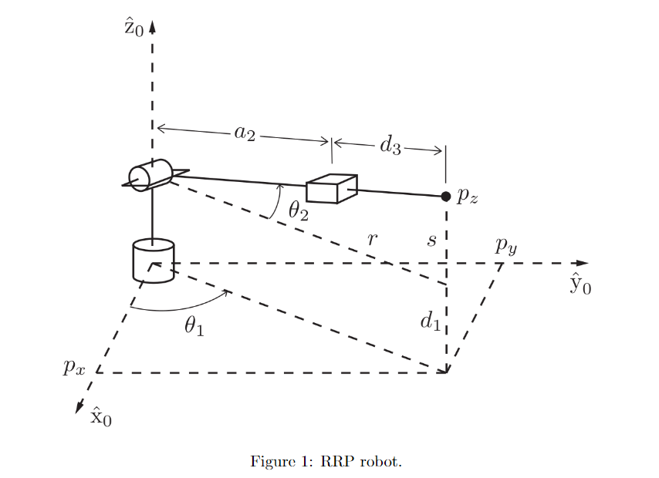

The Forward kinematic model:

$$H= R_{z}\left(q_{1}\right)*T_{z}\left(d_{1}\right)* R_{y}\left(q_{2}\right)* T_{x}\left(a_{2}\right)*T_{x}\left(d_{3}\right)$$

The inverse kinematics solution:

We have 4 solutions for the position of the robot since d3 can be both positive and negative so we have to take that in account.

The 1st solution:

$$s= d_{1}-z$$

$$r=\sqrt{x^{2}+y^{2}}$$

$$q_{1}=atan2\left( y, x \right)$$

$$q_{2}=atan2\left( s, r \right)$$

$$\left(a_{2}+d_{3}\right)\cos\left(q_{1}\right)=r$$

$$\left(a_{2}+d_{3}\right)\sin\left(q_{1}\right)=s$$

$$s^{2}+r^{2}=a_{2}+d_{3}$$

$${d_{3}=s}^{2}+r^{2}-a_{2}$$

The 2nd solution:

$$q_{12}=atan2\left( y, x \right)$$

$$q_{22}= q_{2 }+ π$$

$$d_{32}= -\left(d_{3}+2a_{2}\right)$$

The 3rd solution:

$$q_{13}=atan2\left( y, x \right)+π$$

$$q_{23}= {-q}_{2 }+ π$$

$$d_{33}= d_{3}$$

The 4th solution:

$$q_{14}=atan2\left( y, x \right)+π$$

$$q_{24}= {-q}_{2 }$$

$$d_{34}= -\left(d_{3}+2a_{2}\right)$$

The Jacobian

Numerical method:

Extract the rotation matrix from the Forward kinematics

$$H= R_{z}\left(q_{1}\right)*T_{z}\left(d_{1}\right)* R_{y}\left(q_{2}\right)* T_{x}\left(a_{2}\right)*T_{x}\left(d_{3}\right)$$

$$R=H\left(1:3,1:3\right)$$

Get the inverse of the rotation matrix

$$R^{-1}=[R^{-1} zeros\left(3,1\right);0 0 0 1]$$

$$J_{1r}=\dot{ R_{z}}\left(q_{1}\right)*T_{z}\left(d_{1}\right)* R_{y}\left(q_{2}\right)* T_{x}\left(a_{2}\right)*T_{x}\left(d_{3}\right)* R^{-1}$$

$$J_{1}=[ J_{1r}\left(1,4\right) J_{1r}\left(2,4\right) J_{1r}\left(3,4\right) J_{1r}\left(3,2\right) J_{1r}\left(1,3\right) J_{1r}\left(2,1\right)]$$

$$J_{2r}=R_{z}\left(q_{1}\right)*T_{z}\left(d_{1}\right)* \dot{R_{y}}\left(q_{2}\right)* T_{x}\left(a_{2}\right)*T_{x}\left(d_{3}\right)* R^{-1}$$

$$J_{2}=[ J_{2r}\left(1,4\right) J_{2r}\left(2,4\right) J_{2r}\left(3,4\right) J_{2r}\left(3,2\right) J_{2r}\left(1,3\right) J_{2r}\left(2,1\right)]$$

$$J_{3p}=R_{z}\left(q_{1}\right)*T_{z}\left(d_{1}\right)* R_{y}\left(q_{2}\right)* T_{x}\left(a_{2}\right)*\dot{T_{x}}\left(d_{3}\right)* R^{-1}$$

$$J_{3}=[ J_{3p}\left(1,4\right) J_{3p}\left(2,4\right) J_{3p}\left(3,4\right) J_{3p}\left(3,2\right) J_{3p}\left(1,3\right) J_{3p}\left(2,1\right)]$$

The full Jacobian matrix:

J = [$J_{1} J_{2} J_{3}]$

The Skew theory method:

$$T_{00}=eye\left(4\right)$$

$$T_{01}=R_{z}\left(q_{1}\right)*T_{z}\left(d_{1}\right)$$

$$T_{02}=R_{z}\left(q_{1}\right)*T_{z}\left(d_{1}\right)*R_{y}\left(q_{2}\right)$$

$$T_{03}=R_{z}\left(q_{1}\right)*T_{z}\left(d_{1}\right)*R_{y}\left(q_{2}\right)* T_{x}\left(a_{2}\right)*T_{x}\left(d_{3}\right)$$

$$O_{0}=T_{00}(1:3,4)$$

$$O_{1}=T_{01}(1:3,4)$$

$$O_{2}=T_{02}(1:3,4)$$

$$O_{3}=T_{03}(1:3,4)$$

$z_{0}=T_{00}(1:3,3)$/\* Corresponds to rotation around Z axis \*/

$z_{1}=T_{01}(1:3,2)$ $)$/\* Corresponds to rotation around Y axis \*/

$z_{2}=T_{02}(1:3,1)$ $)$/\* Corresponds to translation along X axis \*/

Full Jacobian

for revolute joint:

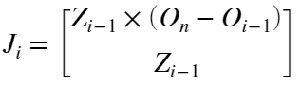

for prismatic joint:

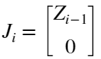

$$J_{1s}=[ z_{0}×\left( O_{3}-O_{0}\right); z_{0}]$$

$$J_{2s}=[ z_{1}×\left( O_{3}-O_{1}\right); z_{1}]$$

$$J_{3s}=[ z_{2};0;0; 0]$$

The full Jacobian matrix

J = [$J_{1s} J_{2s} J_{3s}]$