OF
CLINIC SOLUTIONS INC.

(the "Corporation")
Business Corporations Act, resolutions, as evidenced by

FINANCIAL STATEMENTS
1 . The financial statements of the Corporation, together with the prescribed disclosure of the aggregate remuneration of the directors and the aggregate remuneration of the officers and employees made up to the end of the last fiscal year of the Corporation and being current within six (6) months of the above-mentioned date (the "Financial Statements") be and are hereby approved.
- The approval of the Financial Statements be evidenced by the signature of one or more of the Directors on the Balance Sheet included in the Financial Statements.
- A copy of the Financial Statements be sent to each shareholder of the corporation, except to those shareholders who have informed the Corporation in writing that they do not want a copy of the financial statements.

RATIFICATION OF PAST ACTS
4. All acts, deeds, contracts, accounts, resolutions, proceedings, elections, appointments and payments by the directors and Officers of the Corporation for the last fiscal period be and the same are hereby approved, ratified and confirmed.

APPOINTMENT OF OFFICERS
5. The following individuals are hereby elected or appointed as Officers of the Corporation to hold the office referred to opposite his or her respective name for the ensuing year or until their successors are elected or appointed by the Directors of the Corporation:

Name Title
Tammy Wilde Scott Wilde

ANNUAL MEETING
6. In lieu of calling an annual meeting of the Shareholders of the Corporation, a resolution in writing shall deal with alt matters required by the Act to be dealt with at such meeting.
These Resolutions may be executed electronically or in any number of counterparts and may be delivered by electronic means. All counterparts together shall constitute
March, 2021
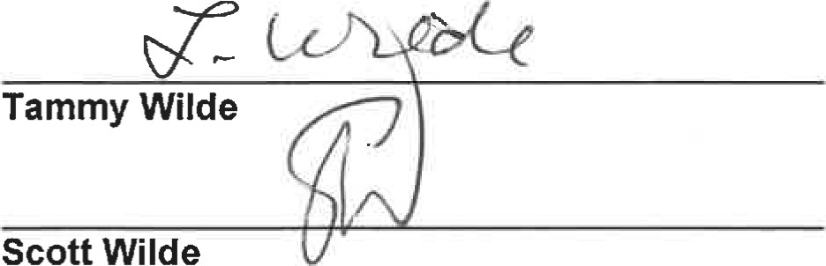
CLINIC SOLUTIONS INC.

(the "Corporation")
141(1) Business Corporations Act, Alberta of the Corporation hereby consent in writing to the following resolutions, as evidenced by the signatures below.
RESOLVED THAT:

APPROVAL OF FINANCIAL STATEMENTS
1 . The Financial Statements of the Corporation for the past fiscal year, as approved by the Directors be accepted.

DISPENSING WITH AUDITOR
2. Pursuant to Section 163(3) of the Act, the Corporation dispenses with the appointment of an Auditor, provided however that this resolution shall be valid only for the current fiscal year of the Corporation.

ELECTION OF DIRECTOR
3. The following persons be elected as Directors of the Corporation, to hold office until the next Annual Meeting of the Shareholders, or the signing of resolutions in lieu thereof, or until a successor has been duly elected or appointed:
Tammy Wilde
Scott Wilde
These Resolutions may be executed in any number of counterparts, and may be delivered by electronic means, and each such original or electronic copy when so executed and delivered shall be deemed to be an original and all of which taken together shall constitute one and the same instrument.
DATED effective the 31 ^{st} day of March, 2021
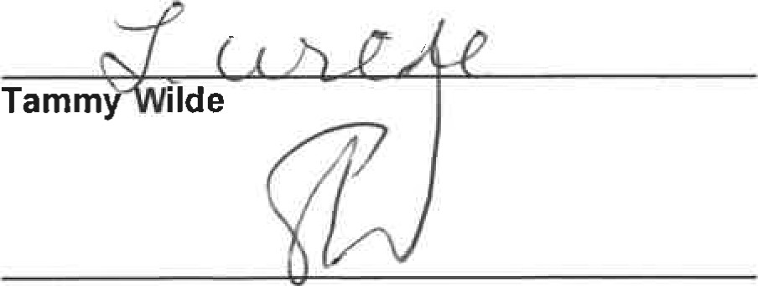
CLINIC SOLUTIONS INC.

(the "Corporation")
Business Corporations Act, resolutions, as evidenced by

FINANCIAL STATEMENTS
l . The financial statements of the Corporation, together with the prescribed disclosure of the aggregate remuneration of the directors and the aggregate remuneration of the officers and employees made up to the end of the last fiscal year of the Corporation and being current within six (6) months of the above-mentioned date (the "Financial Statements") be and are hereby approved.
- The approval of the Financial Statements be evidenced by the signature of one or more of the Directors on the Balance Sheet included in the Financial Statements.
- A copy of the Financial Statements be sent to each shareholder of the corporation, except to those shareholders who have informed the Corporation in writing that they do not want a copy of the financial statements.

RATIFICATION OF PAST ACTS
4. All acts, deeds, contracts, accounts, resolutions, proceedings, elections, appointments and payments by the directors and Officers of the Corporation for the last fiscal period be and the same are hereby approved, ratified and confirmed.

APPOINTMENT OF OFFICERS
5, The following individuals are hereby elected or appointed as Officers of the Corporation to hold the office referred to opposite his or her respective name for the ensuing year or until their successors are elected or appointed by the Directors of the Corporation:

Name Title
Tammy Wilde Scott Wilde

ANNUAL MEETING
6. In lieu of calling an annual meeting of the Shareholders of the Corporation, a resolution in writing shall deal with all matters required by the Act to be dealt with at such meeting.
These Resolutions may be executed electronically or in any number of counterparts and may be delivered by electronic means. All counterparts together shall constitute
March, 2020.
OF
CLINIC SOLUTIONS INC.

(the 'Corporation")
141 (1) Business Corporations Act, Alberta of the Corporation hereby consent in writing to the following resolutions, as evidenced by the signatures below.
RESOLVED THAT:

APPROVAL OF FINANCIAL STATEMENTS
1. The Financial Statements of the Corporation for the past fiscal year, as approved by the Directors be accepted.

DISPENSING WITH AUDITOR
2. Pursuant to Section 163(3) of the Act, the Corporation dispenses with the appointment of an Auditor, provided however that this resolution shall be valid only for the current fiscal year of the Corporation.

ELECTION OF DIRECTOR
3. The following persons be elected as Directors of the Corporation, to hold office until the next Annual Meeting of the Shareholders, or the signing of resolutions in lieu thereof, or until a successor has been duly elected or appointed:
Tammy Wilde
Scott Wilde
These Resolutions may be executed in any number of counterparts, and may be delivered by electronic means, and each such original or electronic copy when so executed and delivered shall be deemed to be an original and all of which taken together shall constitute one and the same instrument.
DATED effective the 31 ^{st} day of March, 2020.

Tammy
WILDELAND HOLDINGS INC.

(the "Corporation")
Business Corporations Act, resolutions, as evidenced by

FINANCIAL STATEMENTS
1, The financial statements of the Corporation, together with the prescribed disclosure of the aggregate remuneration of the directors and the aggregate remuneration of the officers and employees made up to the end of the last fiscal year of the Corporation and being current within six (6) months of the above-mentioned date (the "Financial Statements") be and are hereby approved.
- The approval of the Financial Statements be evidenced by the signature of one or more of the Directors on the Balance Sheet included in the Financial Statements.
- A copy of the Financial Statements be sent to each shareholder of the corporation, except to those shareholders who have informed the Corporation in writing that they do not want a copy of the financial statements.

RATIFICATION OF PAST ACTS
4. Ail acts, deeds, contracts, accounts, resolutions, proceedings, elections, appointments and payments by the directors and Oficers of the Corporation for the last fiscal period be and the same are hereby approved, ratified and confirmed.

APPOINTMENT OF OFFICERS
5. The following individuals are hereby elected or appointed as Officers of the Corporation to hold the office referred to opposite his or her respective name for the ensuing year or until their successors are elected or appointed by the Directors of the Corporation:

Name Title
Tammy Wilde Scott Wilde

ANNUAL MEETING
6. In lieu of calling an annual meeting of the Shareholders of the Corporation, a resolution in writing shall deal with all matters required by the Act to be dealt with at such meeting.
These Resolutions may be executed electronically or in any number of counterparts and may be delivered by electronic means. Al counterparts together shall constitute
October, 2019.
WILDELAND HOLDINGS INC.

(the "Corporation")
141 (1) Business Corporations Act, Alberta of the Corporation hereby consent in writing to the following resolutions, as evidenced by the signatures below.
RESOLVED THAT:

APPROVAL OF FINANCIAL STATEMENTS
1 . The Financial Statements of the Corporation for the past fiscal year, as approved by the Directors be accepted.

DISPENSING WITH AUDITOR
2. Pursuant to Section 163(3) of the Act, the Corporation dispenses with the appointment of an Auditor, provided however that this resolution shall be valid only for the current fiscal year of the Corporation.

ELECTION OF DIRECTOR
3. The following persons be elected as Directors of the Corporation, to hold office until the next Annual Meeting of the Shareholders, or the signing of resolutions in lieu thereof, or until a successor has been duty elected or appointed:
Tammy Wilde
Scott Wilde
These Resolutions may be executed in any number of counterparts, and may be delivered by electronic means, and each such original or electronic copy when so executed and delivered shall be deemed to be an original and all of which taken together shall constitute one and the same instrument.
DATED effective the 31 ^{st} day of October, 2019.

Tammy

MmUTES OF A MEETNG AMALGAMATORS OF CLINIc SOLUTIONS INC.

HELD AT #320, 11808 ST. ALBERT TRAIL, THE CITY OF EDMONTON, PROVINCE OF ALBERTA, ON THE 1ST DAY OF MARCH, 2017
PRESENT: TAMMY WILDE scorr WLDE
being all the Amalgamators of the Corporation.
All the Amalgamators being present, formal notice calling the meeting was dispensed with and the meeting was declared to be regularly constituted.
Upon motion duly made, seconded and unanimously carried, Tammy Wilde assumed the Chair and Scott Wilde acted as Secretary of the Meeting.
The Articles of Amalgamation filed with the Registrar of Companies incorporating the Corporation were submitted and read to the meeting and the said Articles of Amalgamation and the Certificate of Amalgamation were adopted as the Charter of the Corporation.
The Chairman presented to the meeting application for the issue of Shares from the Treasury of the Corporation, and upon motion duly made, seconded and unanimously carried, it was approved and ordered that the Treasury do issue Shares to the following, namely:
TAMMY WILDE 100 Class "A" Voting Shares

1 Class "B" Voting Share
scorr WILDE 99 Class "B" Voting Shares
The following Memorandum was then read and ordered to be inserted in these Minutes and form a part thereof.
"We, the Amalgamators to the Articles of Amalgamation of the above named Corporation hereby consent to this Meeting being held at the above time and place and do hereby waive notice of this meeting and publication thereof, and consent to the transaction of such business as may have come before it as testified by our signatures h reto."
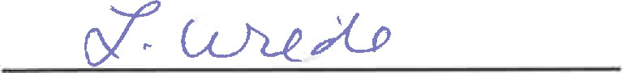 | scorr 11, E
TAMMY WLDE
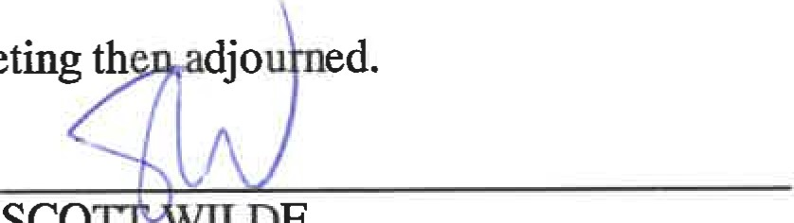
There being no further business, the Meeting th d.
scor
Il
DE
TAMMY WILDE
Chairman Secretary
CANADA IN MATTER AMALGAMATION OF GLENORA VETERINARY CLINIC LTD., VETCORE PROVINCE OF ALBERTA CORP. AND CLINIC SOLUTIONS INC.
TO WIT: AND IN THE MATIER OF Section 185 (2) of the Business Corporations Act, RSA 2000, Chapter B-9.

STATUTORY DECLARATION
1, scorr WILDE, of the City of St. Albert, in the Province of Alberta, DO HEREBY SOLEMNLY DECLARE THAT:
- I am a proposed Director of the Amalgamated Corporation, Clinic Solutions Inc., and have personal knowledge of the matters hereinafter deposed to and declared.
- I am a Director of Glenora Veterinary Clinic Ltd., Vetcore Corp. and Clinic Solutions Inc., the Amalgamating Corporations herein.
- I have reasonable grounds to believe that:
  - Glenora Veterinary Clinic Ltd., Vetcore Corp. and Clinic Solutions Inc. are and the Amalgamated Corporation will be able to pay its liabilities as they become due; and
  - the realizable value of the Amalgamated Corporation's assets will not be less than the aggregate of its liabilities and stated capital of all classes; and
  - no creditor will be prejudiced by the amalgamation.
AND 1 MAKE TMS SOLEMN DECLARATION conscientiously believing it to be true, and knowing that it is of the same force and effect as if made under oath.
scor | WII DE

DECLARED BEFORE ME at the City of
Edmonton, in the Province of Alberta, this day of February, 2017.
A Con •ssi ner for Oaths in and for the Province of Alberta

BRENDA M. SVEC
Commissioner for Oaths in and for Alberta
My Commission Expires: May 14, 2012
MINUTES OF A SPECIAL MEETING DIRECTORS OF CLNIC SOLUTIONS INC.

HELD ON THE 1ST DAY OF JANUARY, 2017
PRESENT: TAMMY WILDE scom WILDE
being all the Directors of the Corporation.
All the Directors being present, formal notice calling the meeting was dispensed with and the meeting was declared to be regularly constituted.
Upon motion duly made, seconded and unanimously carried, Tammy Wilde assumed the Chair and Scott Wilde acted as Secretary of the Meeting.
The Secretary then informed the Meeting that the Corporation's Chartered Professional Accountants had advised that assets totalling FOUR HUNDRED AND TMRTY THOUSAND ($430,000.00) DOLLARS had been distributed to the Shareholders of record to the Corporation effective as of the 1st day of January, 2017, and accordingly a dividend should be declared effecting same for the purposes of the corporate records.
On motion duly made, seconded and unanimously carried, it was resolved that:
"BE IT RESOLVED THAT a dividend of $2,128.2828 per Share on the outstanding Class "A" Shares and $2,171.7172 per Share on the outstanding Class "B" Shares of the Corporation be and the same are hereby declared effective as of the r^{t} day of January, 2017 to the Shareholders of record at the close of business on the 1st day of January, 2017 by way of a credit to the shareholders' loan account.
The following Memorandum was then read and ordered to be inserted in these Minutes and form a part thereof.
"We, the Directors of the above named Corporation hereby consent to this Meeting being held at the above time and place and do hereby waive notice of this meeting and publication thereof, and consent to the transaction of such business as may have come before it as testified by our signatures hereto."
TAMMY WILDE scon WILDE
There being no further business, the Meeting then adjourned.
TAMMY WILDE | SCOTT WILDE
Chairman | Secretary

- 2 -
CERTIFICATE
1, scorr WILDE, Secretary of CLINIC SOLUTIONS INC., do hereby certify the above to be a true copy of the Resolution passed on the 1st day of January, 2017.
DATED this day of October, 2017.

Secretary

DIVIDEND NOTICE
CLINIC SOLUTIONS INC., at a meeting held on the 1st day of January, 2017, declared a dividend of $2, 128.2828 per Share on the outstanding Class "A" Shares and $2,171.7172 per Share on the outstanding Class "B" Shares of the Corporation, payable effective as of the 1st day of
January, 2017, by way of a credit to the shareholders' loan account.
BY ORDER OF DIRECTORS:

scorr WILDE, Secretary

DATED at the City of Edmonton, in the Province of Alberta, this day of October,
2017.

