as signatures below.

FINANCIAL STATEMENTS
1 . The financial statements of the Corporation, together with the prescribed disclosure of the aggregate remuneration of the directors and the aggregate remuneration of the officers and employees made up to the end of the last fiscal year of the Corporation and being current within six (6) months of the above-mentioned date (the "Financial Statements") be and are hereby approved.
- The approval of the Financial Statements be evidenced by the signature of one or more of the Directors on the Balance Sheet included in the Financial Statements.
- A copy of the Financial Statements be sent to each shareholder of the corporation, except to those shareholders who have informed the Corporation in writing that they do not want a copy of the financial statements.

RATIFICATION OF PAST ACTS
4. All acts, deeds, contracts, accounts, resolutions, proceedings, elections, appointments and
payments by the directors and Officers of the Corporation for the last fiscal period be and the same are hereby approved, ratified, and confirmed.

APPOINTMENT OF OFFICERS
5. The following individuals are hereby elected or appointed as Officers of the Corporation to hold the office referred to opposite his or her respective name for the ensuing year or until their successors are elected or appointed by the Directors of the Corporation:
Name Title
Tammy Wilde Scott Wilde

ANNUAL MEETING
6. In lieu of calling an annual meeting of the Shareholders of the Corporation, a resolution in writing shall deal with all matters required by the Act to be dealt with at such meeting.
These Resolutions may be executed electronically or in any number of counterparts and may be delivered together
2024.

OF
(the "Corporation")
141 (1) Corporations Act, of the Corporation hereby consent in writing to the following resolutions, as evidenced by the signatures below.
RESOLVED THAT:

APPROVAL OF FINANCIAL STATEMENTS
1 . The Financial Statements of the Corporation for the past fiscal year, as approved by the Directors be accepted.

DISPENSING WITH AUDITOR
2. Pursuant to Section 163(3) of the Act, the Corporation dispenses with the appointment of an Auditor, provided however that this resolution shall be valid only for the current fiscal year of the Corporation.

ELECTION OF DIRECTOR
3. The following persons be elected as Directors of the Corporation, to hold office until the next Annual Meeting of the Shareholders, or the signing of resolutions in lieu thereof, or until a successor has been duly elected or appointed:
Tammy Wilde
Scott Wilde
These Resolutions may be executed in any number of counterparts, and may be delivered by electronic means, and each such original or electronic copy when so executed and delivered shall be deemed to be an original and all of which taken together shall constitute one and the same instrument.
DATED effective the 31 ^{st} day of March 2024

Tammy Wilde

OF
as the signatures below

FINANCIAL STATEMENTS
1 . The financial statements of the Corporation, together with the prescribed disclosure of the aggregate remuneration of the Directors and the aggregate remuneration of the Officers and employees made up to the end of the last fiscal year of the Corporation and being current within six (6) months of the above-mentioned date (the "Financial Statements") be and are hereby approved.
- The approval of the Financial Statements be evidenced by the signature of one or more of the Directors on the Balance Sheet included in the Financial Statements.
- A copy of the Financial Statements be sent to each shareholder of the corporation, except to those shareholders who have informed the Corporation in writing that they do not want a copy of the
Financial Statements.

RATIFICATION OF PAST ACTS
4. All acts, deeds, contracts, accounts, resolutions, proceedings, elections, appointments, and payments by the Directors and Officers of the Corporation for the last fiscal period be and the same are hereby approved, ratified, and confirmed.

APPOINTMENT OF OFFICERS
5. The following individuals are hereby elected or appointed as Officers of the Corporation to hold the office referred to opposite his or her respective name for the ensuing year or until their successors are elected or appointed by the Directors of the Corporation:
Name Title
Tammy Wilde
Scott Wilde

ANNUAL MEETING
6. In lieu of calling an annual meeting of the Shareholders of the Corporation, a resolution in writing shall deal with all matters required by the Act to be dealt with at such meeting.
These Resolutions may be executed electronically or in any number of counterparts and may be delivered together 202/3
(the "Corporation")
141 (1) Corporations Act, of the Corporation hereby consent in writing to the following resolutions, as evidenced by the signatures below.
RESOLVED THAT:

APPROVAL OF FINANCIAL STATEMENTS
I The Financial Statements of the Corporation for the past fiscal year, as approved by the Directors be accepted.

DISPENSING WITH AUDITOR
2. Pursuant to Section 163(3) of the Act, the Corporation dispenses with the appointment of an Auditor, provided however that this resolution shall be valid only for the current fiscal year of the Corporation.

ELECTION OF DIRECTOR
3. The following persons be elected as Directors of the Corporation, to hold office until the next Annual Meeting of the Shareholders, or the signing of resolutions in lieu thereof, or until a successor has been duly elected or appointed:
Tammy Wilde
Scott Wilde
These Resolutions may be executed in any number of counterparts, and may be delivered by electronic means, and each such original or electronic copy when so executed and delivered shall be deemed to be an original and all of which taken together shall constitute one and the same instrument.
DATED effective the 31 ^{st} day of March 202% ^{Z}/

Tammy Wilde

as signatures below.

FINANCIAL STATEMENTS
1 The financial statements of the Corporation, together with the prescribed disclosure of the aggregate remuneration of the directors and the aggregate remuneration of the officers and employees made up to the end of the last fiscal year of the Corporation and being current within six (6) months of the above-mentioned date (the "Financial Statements") be and are hereby approved.
- The approval of the Financial Statements be evidenced by the signature of one or more of the Directors on the Balance Sheet included in the Financial Statements.
- A copy of the Financial Statements be sent to each shareholder of the corporation, except to those shareholders who have informed the Corporation in writing that they do not want a copy of the financial statements.

RATIFICATION OF PAST ACTS
4. All acts, deeds, contracts, accounts, resolutions, proceedings, elections, appointments and payments by the directors and Officers of the Corporation for the last fiscal period be and the same are hereby approved, ratified and confirmed.

APPOINTMENT OF OFFICERS
5. The following individuals are hereby elected or appointed as Officers of the Corporation to hold the office referred to opposite his or her respective name for the ensuing year or until their successors are elected or appointed by the Directors of the Corporation:
Name Title
Tammy Wilde
Scott Wilde

ANNUAL MEETING
6. In lieu of calling an annual meeting of the Shareholders of the Corporation, a resolution in writing shall deal with all matters required by the Act to be dealt with at such meeting.
These Resolutions may be executed electronically or in any number of counterparts and may be delivered together
2022.
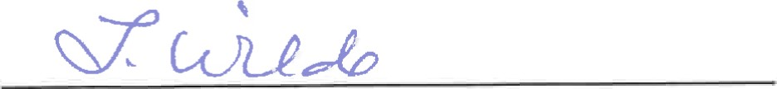
(the "Corporation")
141(1) Corporations Act, of the Corporation hereby consent in writing to the following resolutions, as evidenced by the signatures below.
RESOLVED THAT:

APPROVAL OF FINANCIAL STATEMENTS
1 . The Financial Statements of the Corporation for the past fiscal year, as approved by the Directors be accepted.

DISPENSING WITH AUDITOR
2. Pursuant to Section 163(3) of the Act, the Corporation dispenses with the appointment of an Auditor, provided however that this resolution shall be valid only for the current fiscal year of the Corporation.

ELECTION OF DIRECTOR
3. The following persons be elected as Directors of the Corporation, to hold office until the next Annual Meeting of the Shareholders, or the signing of resolutions in lieu thereof, or until a successor has been duly elected or appointed:
Tammy Wilde
Scott Wilde
These Resolutions may be executed in any number of counterparts, and may be delivered by electronic means, and each such original or electronic copy when so executed and delivered shall be deemed to be an original and all of which taken together shall constitute one and the same instrument.
DATED effective the 31 ^{st} day of March, 2022.

Tammy Wilde

MNUTES OF MEETNG cmuc SOLUTIONS
HELD THE 1 ^{ST} DAY OF
PRESENT: TÆ•ÆMYWLDE SCOTr WLDE
being all the Directors ofthe Corporation.
All the Directors being present, formal notice calling the meeting was dispensed with and the meeting was declared to be regularly constituted.
Upon moüon duly made, seconded and unanimously carried, Tammy Wilde assumed the Chair and Scott Wilde acted as Secretary of the Meeting.
The Secretary then informed the Meeting that the Corporation's Accountant had advised that pursuant to Section 89(1) ofthe Income Tax Act assets totalling SEXTY-NINE THOUSAND, ONE HUNDRED ($69,100.00) DOLLARS had been distributed to the Shareholders of record to the Corporation effective as of the 1st day of January, 2021, and accordingly an eligible dividend should be declared effecting same for the purposes of the corporate records.
On motion duly made, seconded and unanimously carried, it was resolved that:
'^{I}BE IT RESOLVED THAT an eligible dividend of $342.0101 per Share on the outstanding Class "A" Shares and $348.99 per Share on the outstanding Class "B" Shares of the Corporation be and the same are hereby declared effecfive as of the 1 ^{st} day of January, 2021 to the Shareholders of record at the close of business on the day of January, 2021 by way of a credit to the shareholders' loan account.
The following Memorandum was then read and ordered to be inserted in these Minutes and form a part thereof.

"We, the Directors of the above narned Corporation hereby consent to fliis Meeting being held at the above time and place and do hereby waive notice of this meeång and publication thereof, and consent to the transaction of such business as may have come before it as testified by our signatures hereto." 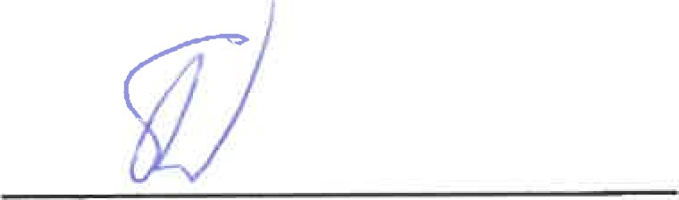
scon
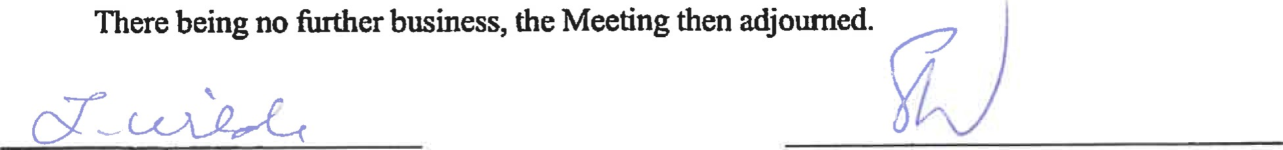
scorn

CERTIFICATE
1, scom WLDE, Secretary ofCLNIC SOLUTIONS mc., do hereby certify the above to be a frue copy of the passed on the 1 ^{st} day of January, 2021.
DATED this day of July, 2021. 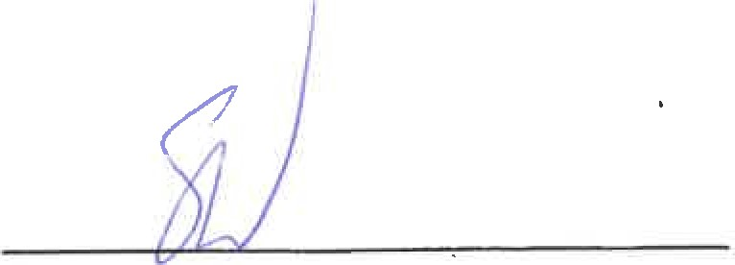
Secretary
DIVIDEND NOTICE
CLINIC SOLUTIONS mc., at a meeting held on the 1 ^{st} day of January, 2021, declared an eligible dividend of $342.0101 per Share on the outstanding Class "A" Shares and $348.99 per Share on the outstanding Class 'B" Shares of the Corporation, payable effective as of the 1 ^{st} day of
January, 2021, by way ofa credit to the shareholders' loan account.
BY ORDER OF THE DRECTORS: 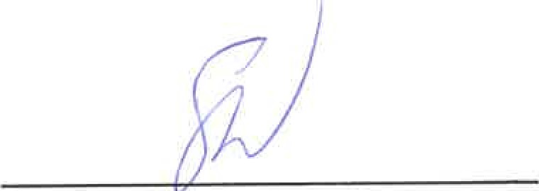
scorr WLDE, Secretary
of Province of Alberta, this day of July,
IvmUTES OF MEETNG
CLE€IC SOLUTIONS HELD THE 1 ^{ST} DAY OF
PRESENT: TANMYWLDE SCOTT WLDE
being all the Directors ofthe Corporation.
All the Directors being present, fonnal notice calling the meeting was dispensed with and the meeting was declared to be regularly constituted.
Upon moüon duly made, seconded and unanimously carried, Tammy Wilde assumed the Chair and Scott Wilde acted as Secretary of the Meeting.
The Secretary then informed the Meeting that the Corporation's Chartered Professional Accountants had advised that assets totalling ONE HUNDRED AND FORTY-FOUR THOUSAND, NNE HUNDRED ($144,900.00) DOLLARS had been distibuted to the Shareholders of record to the Corporation effective as of the 1 ^{5t} day of January, 2021, and accordingly an ineligible dividend should be declared effecting same for the purposes of the corporate records.
On motion duly made, seconded and unanimously carried, it was resolved that:
"BE IT RESOLVED THAT an ineligible dividend of $717.1818 per Share on the outstanding Class "A" Shares and $731 ,8182 per Share on the outstanding Class 'B" Shares of the Corporation be and the same are hereby declared effecfr€.^{r}e as of the 1 ^{st} day of January, 2021 to the Shareholders of record at the close of business on the day of January, 2021 by way of a credit to the shareholders' loan account.
The following Memorandum was then read and ordered to be inserted in these Minutes and form a part thereof.

"We, the Directors of the above named Corporation hereby consent to this Meeting being held at the above time and place and do hereby waive nofice of this meeting and publication thereof, and consent to the transaction of such business as may have come before it as tesffed by our signatures hereto." 
scom
adjoumed.
SCOTT

CERTIFICATE
1, scorr WLDE, Secretary of Clumc SOLUTIONS INC., do hereby certify the above to be a t•ue copy ofthe Resolution passed on the 1 ^{st} day of January, 2021.
DATED thisday ofJuly, 2021.
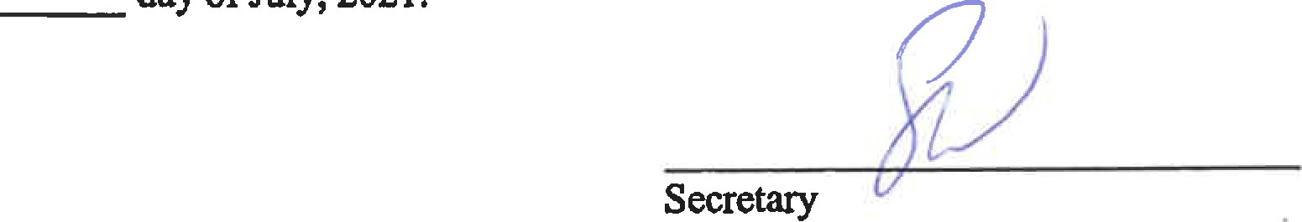

DIVDEND NOTICE
CLNIC SOLUTIONS mc., at a meeting held on the 1 ^{st} day of January, 2021, declared an ineligible dividend of $717.1818 per Share on the outstanding Class "A" Shares and $731.8182 per Share on the outstanding Class "B" Shares of the Corporation, payable effective as of the 1 ^{st} day of January, 2021, by way of a credit to the shareholders' loan account.
BY ORDER OF DRECTORS: 
scorr WLDE, Secretary
of Province of Alberta, thisday of July,
MNUTES OF MEETING cL11N1c SOLUTIONS
HELD THE 1 ^{ST} DAY OF
PRESENT: TAMMY WILDE SCOTT WLDE
being all the Directors of the Corporation.
All the Directors being present, formal notice calling the meeting was dispensed with and the meeting was declared to be regularly constituted.
Upon motion duly made, seconded and unanimously carried, Tammy Wilde assumed the Chair and Scott Wilde acted as Secretary of the Meeting.
The Secretary then informed the Meeting that the Corporation's Chartered Professional Accountants had advised that assets totalling ONE HUNDRED AND THIRTY-THREE THOUSAND, FIVE HUNDRED ($133,500.00) DOLLARS had been distributed to the Shareholders of record to the Corporation effective as of the 1 ^{st} day of January, 2022, and accordingly an ineligible dividend should be declared effecting same for the purposes of the corporate records.
On motion duly made, seconded and unanimously carried, it was resolved that:
"BE IT RESOLVED THAT an ineligible dividend of $1,335.00 per Share on the outstanding Class "B" Shares of the Corporation be and the same are hereby declared effective as of the 1 ^{st} day of January, 2022 to the Shareholders of record at the close of business on the 1 ^{st} day of January, 2022 by way of a credit to the shareholders' loan account.
The following Memorandum was then read and ordered to be inserted in these Minutes and form a part thereof.
"We, the Directors of the above named Corporation hereby consent to this Meeting being held at the above time and place and do hereby waive notice of this meeting and publication thereof, and consent to the transaction of such business as may have come before it as testified by our signatures hereto."
SCOTT
adjourned.
SCOTT

CERTIFICATE
1, SCOTT WILDE, Secretary of CLINIC SOLUTIONS INC., do hereby certify the above to be a true copy ofthe Resolution passed on the 1 ^{st} day of January, 2022.
DATED this day of August, 2022.

Secretary
DIVIDEND NOTICE
CLINIC SOLUTIONS INC., at a meeting held on the 1 ^{st} day of January, 2022, declared an ineligible dividend of $1,335.00 per Share on the outstanding Class "A" Shares of the Corporation, payable effective as of the 1 ^{st} day of January, 2022, by way of a credit to the shareholders' loan account.
BY ORDER OF THE DIRECTORS:

SCOTT WILDE, Secretary
of Province of Alberta, this day of August,

Ivm•wTEs OF MEETNG SHAREHOLDERS OF CLINIC SOLUTIONS INC.
HELD AT #320, 11808 ST. ALBERT TRAIL, m THE CITY
OF EDMONTON, THE PROVNCE OF ALBERTA,
ON THE 1ST DAY OF MARCH, 2017
PRESENT: TAMMY WILDE scorr WLDE
being all the Shareholders of the Corporation.
CONSTITUTION OF NEETING
All the Shareholders being present and having waived notice of the meeting and consented to the holding of the same, the meeting was declared to be regularly constituted.
With the unanimous consent of the meeting, Tammy Wilde assumed the Chair and Scott Wilde acted as Secretary of the Meeting.
AMALGAMATION WITH GLENORA VETERINARY CLINIC LTD. AND VETCORE CORP.
WHEREAS it is considered to be in the best interests of the Corporation for it to amalgamate with Glenora Veterinary Clinic Ltd. and Vetcore Corp. pursuant to Section 184 of the Alberta Business Corporations Act (the "Act").
Upon motion duly made, seconded and unanimously carried, IT WAS RESOLVED AS A SPECIAL RESOLUTION THAT:
- The amalgamation of the Corporation with Glenora Veterinary Clinic Ltd. and Vetcore Corp. in accordance with the terms of the Amalgamation Agreement dated as of the 1st day of March, 2017 between the Corporation, Glenora Veterinary Clinic Ltd. and Vetcore Corp., which was submitted to the Shareholders, be and the same is hereby approved.
- The Corporation be and is hereby authorized to enter into and adopt the said Amalgamation Agreement.
- Any director or offcer of the Corporation be and he is hereby authorized to do all things and execute all instruments and documents necessary or desirable to carry out and give effect to the foregoing.
WAIVER OF IRREGULARITIES
The following Memorandum was then read and ordered to be inserted in these Minutes and form a part thereof.
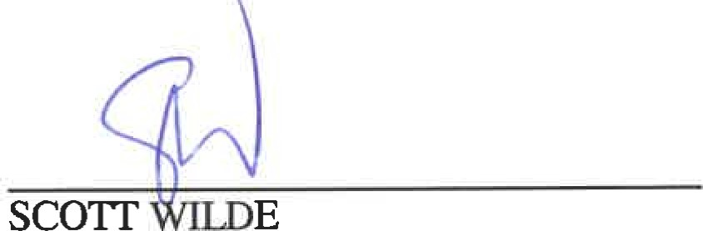
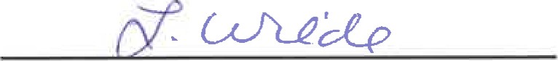
"We, the undersigned, being all the Shareholders of do hereby consent to this Meeting being held at the above time and place and do hereby waive notice of this meeting and consent to the transaction of such business as may have come before it as testified by our signatures hereto."
TAMMY WILDE
ADJOURI•OÆNT
then adjourne | .

There being no further business, the Meeting
TAMMY WILDE scorr WLDE
Chairman Secretary

WAIVER
The undersigned, being all of the Shareholders of the Corporation, pursuant to Section 135 of the Business Corporations Act, hereby waive notice of a meeting of the Shareholders to consider the proposed amalgamation of the Corporation with Glenora Veterinary Clinic Ltd. and Vetcore Corp. and do hereby consent to the transaction of the foregoing business by written Resolution pursuant to Section 141 of the Business Corporations Act. The undersigned acknowledge having reviewed a copy of the Amalgamation Agreement and that a dissenting shareholder is entitled to be paid the fair market value of his shares in accordance with Section 191 of the Act.
scorr | 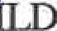
TAMMY WILDE
CecCcG

MmUTES OF A SPECIAL MEETING OF THE SHAREHOLDERS OF VETCORE CORP.
I-ELD AT #320, 11808 ST. ALBERT TRAIL, IN CITY
OF EDMONTON, m THE PROVNCE OF ALBERTA, ON THE 1ST DAY OF MARCH, 2017
PRESENT: SCOITWILDE, Proxy for Clinic Solutions Inc.
being all the Shareholders of the Corporation.
CONSTITUTION OF rvÆETING
All the Shareholders being present and having waived notice of the meeting and consented to the holding of the same, the meeting was declared to be regularly constituted.
With the unanimous consent of the meeting, Scott Wilde assumed the Chair and acted as Secretary of the Meeting.
AMALGAMATION WITH GLENORA VETERINARY CLINIC LTD. AND CLINIC SOLUTIONS INC.
WHEREAS it is considered to be in the best interests of the Corporation for it to amalgamate with Glenora Veterinary Clinic Ltd. and Clinic Solutions Inc. pursuant to Section 184 of the Alberta Business Corporations Act (the "Act").
Upon motion duly made, seconded and unanimously carried, IT WAS RESOLVED AS A SPECIAL RESOLUTION THAT:
- The amalgamation of the Corporation with Glenora Veterinary Clinic Ltd. and Clinic Solutions Inc. in accordance with the terms of the Amalgamation Agreement dated as of the
1st day of March, 2017 between the Corporation, Glenora Veterinary Clinic Ltd. and Clinic Solutions Inc., which was submitted to the Shareholders, be and the same is hereby approved.
- The Corporation be and is hereby authorized to enter into and adopt the said Amalgamation Agreement.
- Any director or offcer of the Corporation be and he is hereby authorized to do all things and execute all instruments and documents necessary or desirable to carry out and give effect to the foregoing.
- 2 -
WAIVER OF IRREGULARITIES
The following Memorandum was then read and ordered to be inserted in these Minutes and form a part thereof.
"The undersigned, being the sole Shareholder of do hereby consents to this Meeting being held at the above time and place and does hereby waive notice of this meeting and consents to the transaction of such business as may have come before it as st• ed by my signature hereto."
scorr WILDE, Proxy for Clinic Solutions Inc. ADJOURNNfENT
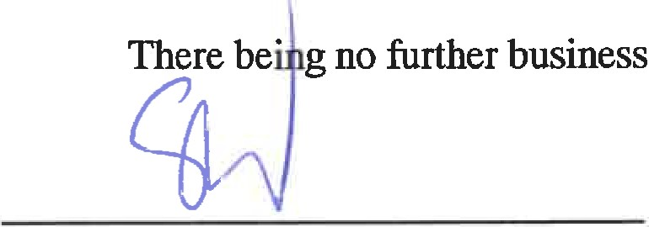
business,
the
Meeting
then
adjourned.
scorr WILDE Chairman and Secretary PROXY
The undersigned Shareholder of hereby appoints SCOTT WILDE, as the nominee of the undersigned, to attend and act for and on behalf of the undersigned at the meeting of the Shareholders of the said Corporation to be held on the 1st day of March, 2017 and at any adjournment thereof in the same manner, to the extent and with the same power as if the undersigned were personally present at the said meeting or such adjournment thereof.
DATED the day of February, 2017.
Per: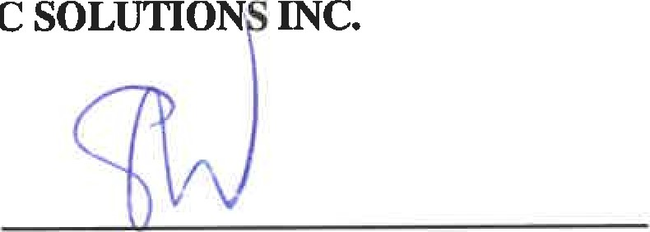
CLINIC
Per: 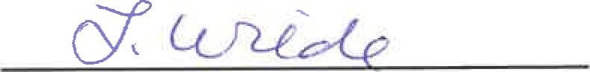

WAIVER
The undersigned, being all of the Shareholders of the Corporation, pursuant to Section 135 of the Business Corporations Act, hereby waive notice of a meeting of the Shareholders to consider the proposed amalgamation of the Corporation with Glenora Veterinary Clinic Ltd. and Clinic Solutions Inc. and do hereby consent to the transaction of the foregoing business by written Resolution pursuant to Section 141 of the Business Corporations Act. The undersigned acknowledge having reviewed a copy of the Amalgamation Agreement and that a dissenting shareholder is entitled to be paid the fair market value of his shares in accordance with Section 191 of the Act.
Per: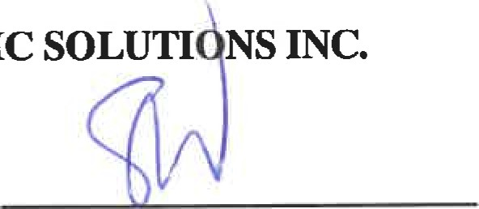
CLINIC
Per: 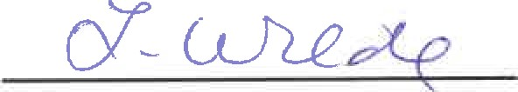
MNUTES OF A SPECIAL MEETING OF THE SHAREHOLDERS OF GLENORA VETERINARY CLINIC LTD.
HELD AT #320, 11808 ST. ALBERT TRAIL, THE CITY
OF EDMONTON, THE PROVINCE OF ALBERTA, ON THE 1ST DAY OF MARCH, 2017
PRESENT: SCOTT WILDE, Proxy for Clinic Solutions Inc.
being all the Shareholders of the Corporation.
CONSTITUTION OF IVÆETING
All the Shareholders being present and having waived notice of the meeting and consented to the holding of the same, the meeting was declared to be regularly constituted.
With the unanimous consent of the meeting, Scott Wilde assumed the Chair and acted as Secretary of the Meeting.
AMALGAMATION WITH VETCORE CORP. AND CLINIC SOLUTIONS INC.
WHEREAS it is considered to be in the best interests of the Corporation for it to amalgamate with Vetcore Corp. and Clinic Solutions Inc. pursuant to Section 184 of the Alberta Business Corporations Act (the "Act").
Upon motion duly made, seconded and unanimously carried, IT WAS RESOLVED AS A SPECIAL RESOLUTION THAT:
- The amalgamation of the Corporation with Vetcore Corp. and Clinic Solutions Inc. in accordance with the terms of the Amalgamation Agreement dated as of the 1st day of March, 2017 between the Corporation, Vetcore Corp. and Clinic Solutions Inc., which was submitted to the Shareholders, be and the same is hereby approved.
- The Corporation be and is hereby authorized to enter into and adopt the said Amalgamation Agreement.
- Any director or offcer of the Corporation be and he is hereby authorized to do all and execute all instruments and documents necessary or desirable to carry out and give effect to the foregoing.
2-
WAIVER OF IRREGULARITIES
The following Memorandum was then read and ordered to be inserted in these Minutes and form a part thereof.
"The undersigned, being the sole Shareholder of do hereby consents to this Meeting being held at the above time and place and does hereby waive notice of this meeting and consents to the transaction of such business as may have come before it as test led by my signature hereto."
scorr WILDE, Proxy for Clinic Solutions Inc.
ADJOURNMENT
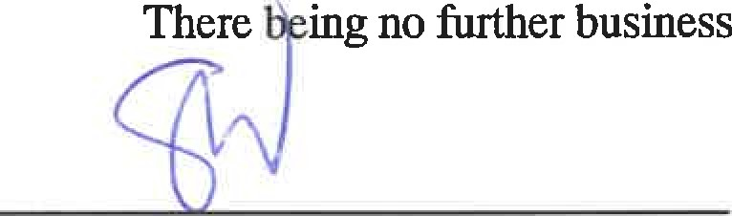ingno further business, the Meeting then adjourned.
scon WLDE Chairman and Secretary
- 3 -
PROXY
The undersigned Shareholder of hereby appoints SCOTT WILDE, as the nominee of the undersigned, to attend and act for and on behalf of the undersigned at the meeting of the Shareholders of the said Corporation to be held on the 1st day of March, 2017 and at any adjournment thereof in the same manner, to the extent and with the same power as if the undersigned were personally present at the said meeting or such adjournment thereof.
DATED the day of February, 2017.
Per: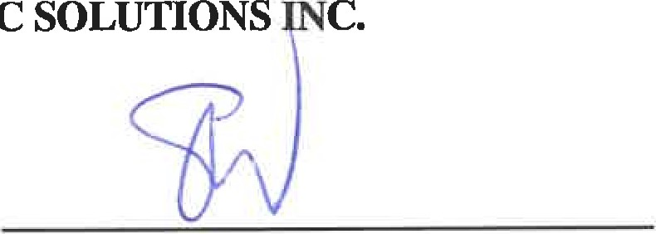
CLINIC
Per: 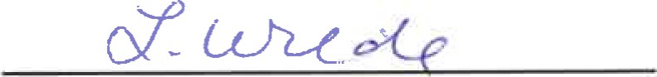

WAIVER
The undersiY1ed, being all of the Shareholders of the Corporation, pursuant to Section 135 of the Business Corporations Act, hereby waive notice of a meeting of the Shareholders to consider the proposed amalgamation of the Corporation with Vetcore Corp. and Clinic Solutions Inc. and do hereby consent to the transaction of the foregoing business by written Resolution pursuant to Section 141 of the Business Corporations Act. The undersigned acknowledge having reviewed a copy of the Amalgamation Agreement and that a dissenting shareholder is entitled to be paid the fair market value of his shares in accordance with Section 191 of the Act.
SOLUTION |  | INC.

CLINIC
Per:
Per: 

