CORPORATE ACCESS NUMBER: 209447101
Government of Alberta E
BUSINESS CORPORATIONS ACT
CERTIFICATE

OF
AMENDMENT
944710 ALBERTA LTD.
CHANGED ITS NAME TO CLINIC SOLUTIONS INC. ON 2014/07/16.

Name Change Alberta Corporation - Registration
Statement
Alberta Amendment Date: 2014/07/16
Service Request Number: 21777473

Corporate Access Number: 209447101
Legal Entity Name:  French Equivalent Name: | 944710 ALBERTA LTD.
Legal Entity Status : | Active
Alberta Corporation Type: | Named Alberta Corporation
New Legal Entity Name:  New French Equivalent Name: | CLINIC SOLUTIONS INC.
Nuans Number: | 112768173
Nuans Date: | 2014/07/09
French Nuans Number:
French Nuans Date:
Professional Endorsement Provided: Future Dating Required:
Annual Return
File Yea | Date File ^{d}
 | 2013/07/02
 | 2012/07/17
 | 

Attachment
Attachment Type | Microfilm Bar Coded Date Recorded
Other Rules or Provisions ELECTRONIC |  | 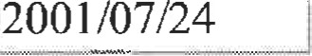
 | 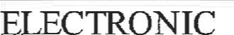 | 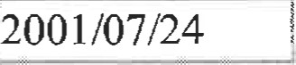
Display Certificates Page 1 of I
CORPORATE ACCESS NUMBER: 209447101

74&na
BUSINESS CORPORATIONS ACT
CERTIFICATE
OF
INCORPORATION
944710 ALBERTA LTD.
WAS INCORPORATED IN ALBERTA ON 2001/07/24

http://139.142.31.90/crprod/plsql/cr login.verify_password_submit 7/24/2001
BUSINESS CORPORATIONS ACT
FORM 1
(SECTION 6)

ALBERTA
REGISTRIES
ARTICLES OF INCORPORATION

- NAME OF CORPORATION:
944710 ALBERTA LTD.

- THE CLASSES, AND ANY MAXIMUM NUMBER OF SHARES THAT THE CORPORATION IS AUTHORIZED TO ISSUE:
See Schedule "A" attached hereto and forming part hereof.

- RESTRICTIONS ON SHARE TRANSFERS (IF ANY):
All transfers of Shares are subject to approval by the Board of Directors.

- NUMBER, OR MINIMUM AND MAXIMUM NUMBER, OF DIRECTORS THAT THE CORPORATION MAY HAVE:
Minimum One (1), Maximum Seven (7)

- IF THE CORPORATION IS RESTRICTED FROM CARRYING ON A CERTAIN BUSINESS, OR RESTRICTED TO CARRYING ON A CERTAIN BUSINESS, SPECIFY THE RESTRICTION:
None
6. OTHER RULES OR PROVISIONS (IF ANY):
See Schedule "B" attached hereto and forming part hereof.
7. DATE: July 24. 2001
INCORPORATORS NAMES: | ADDRESS (INCLUDING POSTAL CODE) | SIGNATURE
TAMMY WILDE | 5 Beaverbrook Crescent,  St. Albert, Alberta T8N 2L3 | 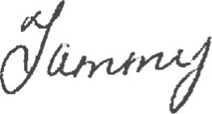
INCORPORATION DATE: July 24, 2001

Share Structure: Share Transfers Restrictions:
Num ber of Directors:
Min Number of Directors: Max Number of Directors:
Business Restricted To:
Business Restricted From:
Other Provisions:
Page 1 of I
Articles of Incorporation

For
944710 ALBERTA LTD.
SEE SCHEDULE "A^{l}' ATTACHED HERETO AND FORMING PART HEREOF.
ALL TRANSFERS OF SHARES ARE SUBJECT TO APPROVAL BY THE BOARD OF DIRECTORS
1
7
NONE
NONE
SEE SCHEDULE "B" ATTACHED HERETO AND FORMING PART HEREOF.
Registration Authorized By: IVAN B. BOMBAK SOLICITOR

http://13 9.142.31.90/crprod/plsql/cr_certif. 7/24/2001

SCHEDULE "A
ATTACHED TO AND FORMING PART OF
ARTICLES OF INCORPORATION

OF
944710 ALBERTA LTD.
The capital of the Corporation is divided into the classes set forth below, having the respective rights, privileges and preferences and being subject to the respective restrictions, conditions and limitations hereinafter set forth.
The said classes of the Corporation's capital are:
- An unlimited number of Class "A" Common Voting Shares without nominal or par value which may be issued and allotted by the directors of the Corporation from time to time for such consideration as may be fixed from time to time by such directors and otherwise having the rights, privileges, restrictions, conditions and limitations as are hereinafter provided.
- An unlimited number of Class "B" Common Voting Shares without nominal or par value which may be issued and allotted by the directors of the Corporation from time to time for such consideration as may be fixed from time to time by such directors and otherwise having the rights, privileges, restrictions, conditions and limitations as are hereinafter provided.
- An unlimited number of Class "C" Common Voting Shares without nominal or par value which may be issued and allotted by the directors of the Corporation from time to time for such consideration as may be fixed from time to time by such directors and otherwise having the rights, privileges, restrictions, conditions and limitations as are hereinafter provided.
- An unlimited number of Class "D" Common Voting Shares without nominal or par value which may be issued and allotted by the directors of the Corporation from time to time for such consideration as may be fixed from time to time by such directors and otherwise having the rights, privileges, restrictions, conditions and limitations as are hereinafter provided.
- An unlimited number of Class "E" Common Voting Shares without nominal or par value which may be issued and allotted by the directors of the
1 1
Corporation from time to time for such consideration as may be fixed from time to time by such directors and otherwise having the rights, privileges, restrictions, conditions and limitations as are hereinafter provided.
- An unlimited number of Class "F" Common Voting Shares without nominal or par value which may be issued and allotted by the directors of the Corporation from time to time for such consideration as may be fixed from time to time by such directors and otherwise having the rights, privileges, restrictions, conditions, and limitations as are hereinafter provided.
An unlimited number of Class "G" Common Non-Voting Shares without nominal or par value which may be issued and allotted by the directors of the Corporation from time to time for such consideration as may be fixed from time to time by such directors and otherwise having the rights, privileges, restrictions, conditions and limitations as are hereinafter provided.
- An unlimited number of Class "H" Common Non-Voting Shares without nominal or par value which may be issued and allotted by the directors of the Corporation from time to time for such consideration as may be fixed from time to time by such directors and otherwise having the rights, privileges, restrictions, conditions and limitations as are hereinafter provided.
- An unlimited number of Class "I" Common Non-Voting Shares without nominal or par value which may be issued and allotted by the directors of the Corporation from time to time for such consideration as may be fixed from time to time by such directors and otherwise having the rights, privileges, restrictions, conditions and limitations as are hereinafter provided.
- An unlimited number of Class "J" Common Non-Voting Shares without nominal or par value which may be issued and allotted by the directors of the Corporation from time to time for such consideration as may be fixed from time to time by such directors and otherwise having the rights, privileges, restrictions, conditions and limitations as are hereinafter provided.
- An unlimited number of Class "K" Common Non-Voting Shares without nominal or par value which may be issued and allotted by the directors of the Corporation from time to time for such consideration as may be fixed from time to time by such directors and otherwise having the rights, privileges, restrictions, conditions and limitations as are hereinafter provided.
(1) An unlimited number of Class "L" Common Non-Voting Shares without nominal or par value which may be issued and allotted by the directors of the Corporation from time to time for such consideration as may be fixed from time to time by such directors and otherwise having the rights, privileges, restrictions, conditions, and limitations as are hereinafter provided.
1 1
- An unlimited number of Class "M" Non-Cumulative Redeemable Preferred Voting Shares without nominal or par value and otherwise having the rights, privileges, preferences, restrictions, conditions and limitations as are hereinafter provided.
- An unlimited number of Class "N" Non-Cumulative Redeemable Preferred Voting Shares without nominal or par value and otherwise having the rights, privileges, preferences, restrictions, conditions and limitations as are hereinafter provided.
- An unlimited number of Class "O" Non-Cumulative Redeemable Preferred Voting Shares without nominal or par value and otherwise having the rights, privileges, preferences, restrictions, conditions and limitations as are hereinafter provided.
- An unlimited number of Class "P" Non-Cumulative Redeemable Preferred Voting Shares without nominal or par value and otherwise having the rights, privileges, preferences, restrictions, conditions and limitations as are hereinafter provided.
- An unlimited number of Class "Q" Non-Cumulative Redeemable Preferred Voting Shares without nominal or par value and otherwise having the rights, privileges, preferences, restrictions, conditions and limitations as are hereinafter provided.
- An unlimited number of Class "R" Non-Cumulative Redeemable Preferred Voting Shares without nominal or par value and otherwise having the rights, privileges, preferences, restrictions, conditions and limitations as are hereinafter provided.
- An unlimited number of Class "S" Non-Cumulative Redeemable Preferred Non-Voting Shares without nominal or par value and otherwise having the rights, privileges, preferences, restrictions, conditions and limitations as are hereinafter provided.
- An unlimited number of Class "T" Non-Cumulative Redeemable Preferred Non-Voting Shares without nominal or par value and otherwise having the rights, privileges, preferences, restrictions, conditions and limitations as are hereinafter provided.
- An unlimited number of Class "U" Non-Cumulative Redeemable Preferred Non-Voting Shares without nominal or par value and otherwise having the rights, privileges, preferences, restrictions, conditions and limitations as are hereinafter provided.
- An unlimited number of Class "V" Non-Cumulative Redeemable Preferred
Non-Voting Shares without nominal or par value and otherwise having the
11
rights, privileges, preferences, restrictions, conditions and limitations as are hereinafter provided.
- An unlimited number of Class "W" Non-Cumulative Redeemable Preferred Non-Voting Shares without nominal or par value and otherwise having the rights, privileges, preferences, restrictions, conditions and limitations as are hereinafter provided.
- An unlimited number of Class "X" Non-Cumulative Redeemable Preferred Non-Voting Shares without nominal or par value and otherwise having the rights, privileges, preferences, restrictions, conditions and limitations as are hereinafter provided.
The rights, privileges, preferences, restrictions, conditions and limitations attached or related to the aforesaid classes of the Corporation's capital are as follows.
- CLASS "A", CLASS CLASS "C" CLASS CLASS "E
CLASS "F" CLASS "G", CLASS "H" CLASS CLASS "J",
CLASS "K" and CLASS "L" COMMON SHARES
[herein collectively called the Common Shares]
1.01 DIVIDENDS
No dividend shall at any time be declared on any Common Shares if the result of the payment of the dividend once declared would be to impair the ability of the Corporation immediately thereafter to redeem all the Class "M", Class "N", Class "O", Class "P", Class "Q', Class "R", Class "S", Class "T", Class "U", Class "V", Class "W" and Class "X" non-cumulative redeemable Preferred Shares [herein collectively called the Preferred Shares] at their Redemption Price (as hereinafter defined).
Subject to the restrictions set out in the next preceding paragraph, the declaration and payment of dividends with regard to each class of shares shall be made at the discretion of the directors. No class of shares, whether common or preferred, shall be entitled to any preference on the declaration or payment of dividends over any other class of shares. The declaration or payrnent of dividends in respect of any class of shares, whether common or preferred, shall not necessitate, nor be a pre-condition to the declaration or payment of dividends in respect of any other class of shares.

1.02 RETURN OF CAPITAL

I I
Subject to the rights of the holders of Preferred Shares, in the event of a liquidation, dissolution, or winding-up of the Corporation, whether voluntarily or otherwise, or other distribution of the assets of the Corporation or repayment of capital to its shareholders for the purpose of winding-up its affairs, the holders of Common Shares will be entitled to participate equally in the distribution of the assets and property of the Corporation.
The proportionate interest to which each holder of Common Shares is entitled on such liquidation, dissolution, winding-up, distribution of assets of the Corporation or repayment of capital shall be determined by the total number of Common Shares held by such shareholder as it relates to the total number of outstanding Common Shares issued in the capital of the Corporation

1.03 VOTING RIGHTS
The registered holder of each Class "A", each Class "B", each Class "C" each Class "D", each Class "E", and each Class "F" Common Share shall each be entitled to receive notice of and attend all meetings of shareholders of the Corporation and shall be entitled to vote at any such meeting or to consent to a resolution in writing to be signed by all or any of the shareholders of the Corporation.
Each Class "A", each Class "B", each Class "C", each Class "D", each Class "E" and each Class "F" Common Share shall entitle the holder of such share to one vote. The Class "G", Class "H", Class "I", Class "J", Class "K" and Class "L" Common Shares shall not carry with them the right to vote.
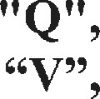
2. CLASS "M", CLASS CLASS CLASS "P", CLASS
CLASS "R", CLASS CLASS "T", CLASS "U", CLASS
CLASS "W" AND CLASS "X" NON-CUMULATIVE REDEEMABLE PREFERRED SHARES

2.01 SPECIAL PURPOSE
Pursuant to the Business Corporations Act, the Preferred Shares are hereby created for the purpose of being issued in exchange for either:
- property other than a Promissory Note or a promise to pay; or
- issued shares of the Corporation of a different class.

2.02 STATED CAPITAL ACCOUNT
1 1
In accordance with the provisions of subsection 26(3) of the Business Corporations Act, on the issuance of Preferred Shares in exchange for property or shares of another class, the directors of the Corporation may add to the stated capital account maintained for the respective classes of Preferred Shares the whole or any part of the amount of the consideration received by the Corporation in the exchange.

2.03 REDEMPTION AMOUNT
The price payable entirely in lawful money of Canada at which each class of Preferred Shares shall be redeemed [herein called the Redemption Amount for such class of Preferred Shares] shall be the amount of consideration received therefor as determined by the directors of the Corporation at the time of issuance of such Preferred Shares and adjusted by the directors at any time or times so as to ensure that the Redemption Amount of each class of Preferred Shares issued as partial or total consideration for the exchange of property or shares [herein called the Assets for such class of Preferred Shares] shall equal the difference between the fair market value of such property or shares as at the date of exchange by the Corporation and the aggregate value of non-share consideration, if any, issued by the Corporation as partial or total consideration therefor.
For greater certainty, such fair market value shall be determined by the directors of the Corporation upon such expert advice as they deem necessary. Should, however, any competent taxing authority at any time issue or propose to issue any assessment or assessments that impose or would impose any liability for tax on the basis that the fair market value of the Assets is other than the amount approved by the directors and if the directors or a competent Court or tribunal agree with such revaluation and all appeal rights have been exhausted or all times for appeal have expired without appeals having been taken, then the Redemption Amount of such Preferred Shares shall be adjusted nunc pro tunc pursuant to the provisions of this paragraph to reflect the agreed upon fair market value and all necessary adjustments, payments and repayments as may be required shall forthwith be made between the proper parties.

2.04 VOTING RIGHTS
The registered holder of each Class "M", each Class "N", each Class "O", each Class "P", each Class "Q" and each Class "R" Preferred Share shall be entitled to receive notice of and attend all meetings of shareholders of the Corporation and shall be entitled to vote at any such meeting or to consent to a resolution in writing to be signed by all or any of the shareholders of the Corporation.
Each Class "M", each Class "N", each Class "O", each Class "P", each Class "Q" and each Class "R" Preferred Share shall entitle the holder of such share to one vote. The Class
Class "T", Class "U", Class "V", Class "W" and Class "X" Preferred Shares shall not carry with them the right to vote.
1 1

2.05 DIVIDEND RIGHTS
When and if declared by the directors of the Corporation in their discretion, the holders of any class or classes of Preferred Shares in any calendar year shall be entitled to receive out of the net profits or surplus of the Corporation properly applicable to the payment of dividends, a non-cumulative dividend at such rate as the directors may from time to time determine (which shall not exceed 15% per annum) on the respective Redemption Amount or Amounts thereof.
The declaration and payment of dividends on the Preferred Shares shall be made at the discretion of the directors of the Corporation. No class of shares, whether common or preferred, shall be entitled to any preference on the declaration or payment of dividends over any other class of shares, whether common or preferred. The declaration or payment of dividends in respect of any class of shares, whether common or preferred, shall not necessitate, nor be a pre-condition to the declaration or payment of dividends in respect of any other class of shares.
Provided however, no dividends shall at any time be declared on any shares, whether common or preferred, if the result of the payment of the dividend once declared would be to impair the ability of the Corporation immediately thereafter to redeem all of the Preferred Shares at their Redemption Price (as hereinafter defined).

2.06 RETURN OF CAPITAL
Upon the liquidation, dissolution or winding-up of the Corporation, whether voluntary or otherwise, or other distribution of the assets of the Corporation or repayment of capital to its shareholders for the purpose of winding-up its affairs, the holders of the Preferred Shares shall be entitled to receive for each such share in priority to the holders of Common Shares, the Redemption Amount per share together with all declared but unpaid dividends thereon [herein called the Redemption Price for such share]. After the payment to the holders of the Preferred Shares of the Redemption Price for each such share as aforesaid, the holders of the Preferred Shares shall have no right or claim to any of the remaining assets of the Corporation.

2.07 PARITY RELATIONSHIP
If upon distribution of the assets of the Corporation upon any liquidation, dissolution or winding-up, whether voluntary or otherwise, or other distribution of the assets of the Corporation or repayrnent of capital to the shareholders of the Corporation for the purpose of winding-up its affairs, the assets of the Corporation shall be insufficient to permit payment in full to the holders of Preferred Shares, the assets of the Corporation shall be distributed pro-rata amongst such shareholders and in this event the proportionate interest
Page 7 of 11
to which each holder of Preferred Shares shall be entitled on such liquidation, dissolution, winding-up, distribution of assets of the Corporation or repayment of capital shall be determined by the aggregate of the Redemption Prices of the Preferred Shares held by such shareholder, as it relates to the total aggregate of the Redemption Prices of all Preferred Shares.

2.08 RETRACTION PRIVILEGE
- Each holder of Preferred Shares shall be entitled to require the Corporation to redeem or purchase all or any part of the Preferred Shares held by him, by delivering to the Corporation at its Registered Office or at such other place as the directors of the Corporation may from time to time designate:
the Certificate or Certificates representing such Preferred Shares, properly endorsed in blank for transfer or accompanied by an appropriate form of transfer properly executed in blank;
  - a written notice [herein called the Retraction Notice] signed by the holder of such Preferred Shares or by his duly authorized Attorney, requiring the Comoration to redeem or purchase the said Preferred Shares, and setting forth an address to which payment of the Redemption Price or Purchase Price for each share to be redeemed or purchased is to be mailed; and
  - such proof of execution, and if necessary, proof of authority, as may be satisfactory to the directors of the Corporation.
- A Retraction Notice shall be deemed to have been given only when actually received at the Registered Office of the Corporation, or at such other place as the directors of the Corporation may from time to time designate. Once given, a Retraction Notice shall be irrevocable unless the Board of Directors shall by ordinary resolution otherwise allow.
- The Redemption Price or the Purchase Price for each Preferred Share which is surrendered for redemption or sale shall be the Redemption Amount, as defined hereinabove, together with any declared but unpaid dividends on such surrendered Preferred Shares.
- Payment of the Redemption Price or of the Purchase Price shall be made by or on behalf of the Corporation to the holders of record of such Preferred Shares surrendered no later than 14 days (or such other period of time as may be set at the time of issuance of such Preferred Shares) following the date upon which the Retraction Notice is given. Such payment may be made by delivering or by fonvarding by mail, postage prepaid, to each holder of the Preferred Shares so surrendered at the address indicated in the Retraction Notice given by such holder, and payment shall be deemed to have been made to such holder as
1 1
soon as the envelope containing same has been mailed. Upon payment being so made, the Preferred Shares surrendered shall be deemed to have been redeemed or purchased, and the holders thereof shall cease to have any rights In respect of such Preferred Shares so surrendered.
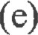In the event that the redemption or purchase of all those outstanding Preferred Shares in respect of which the Corporation has received Retraction Notices at any given time would cause the Corporation to be in contravention of the provisions of the Business Corporations Act, the Corporation shall at that time redeem or purchase, on a pro-rata basis, disregarding fractions, only such number of Preferred Shares as can be redeemed or purchased without causing such contravention; and the Corporation shall redeem or purchase the balance of the outstanding Preferred Shares in respect of which the Corporation has received Retraction Notices on a pro-rata basis, disregarding fractions, at such time or times as such redemption or purchase can be made without causing the Corporation to be in contravention of the provisions of the Business Corporations Act.
In this event, the proportionate amount of the funds that are available for redemption or purchase of the Preferred Shares to which each holder of Preferred Shares is entitled on such redemption or purchase shall be determined by the total Redemption Price and Purchase Price owed to such shareholder pursuant to the Retraction Notice(s) submitted to the Corporation by him as it relates to the total amount owed by way of Redemption Price or Purchase Price to all holders of Preferred Shares of the Corporation from whom the Corporation holds outstanding Retraction Notices. PROVIDED HOWEVER, the Corporation shall not redeem or purchase fractions of shares and the Corporation shall pay to each holder of shares from whom it has received Retraction Notices only such part of the proportionate amount of funds available for the redemption or purchase of his shares as will allow for redemption or purchase of whole shares.

2.09 REDEMPTION
The Corporation may, upon giving notice as hereinafter provided in Section 2.10, redeem or purchase the whole or any number of the Preferred Shares held by one or more shareholders on payment of the Redemption Price, as defined hereinabove, for each Preferred Share to be redeemed or purchased.

2.10 MANNER OF REDEMPTION OR PURCHASE
- The Corporation shall, at least 30 days (or such other period of time as may be set at the time of issuance of the Preferred Shares in question) before the date specified for redemption or purchase, or such lesser period of time as may be unanimously agreed upon by the holders of all Preferred Shares then being
1 1
redeemed or purchased, mail to each person, who at the date of mailing, is the registered holder of the Preferred Shares to be redeemed or purchased, a notice in writing [herein called the Redemption Notice] of the intention of the Corporation to redeem or purchase such Preferred Shares. Such Redemption Notice shall be mailed to each such shareholder at his address as it appears on the books of the Corporation, or in the event the address of any such shareholder not so appearing, the last known address of such shareholder; provided, however, that an accidental failure or omission to give such Redemption Notice to one or more of such shareholders shall not affect the validity of such redemption or purchase as to the other holders.
- Such Redemption Notice shall set out the Redemption Price for such shares, whether the shares are being redeemed pursuant to Section 34 of the Business Corporations Act, or whether the shares are being purchased pursuant to Section 32 of the Business Corporation Act, and the date on which redemption or purchase is to take place, and, if less than all of the Preferred Shares held by the person to whom it is addressed are to be redeemed or purchased, the number and Class designation of such shares so to be redeemed or purchased.
- On or after the date so specified for redemption or purchase, the Corporation shall pay or cause to be paid to or to the order of the registered holders of the Preferred Shares to be redeemed or purchased, the Redemption Price thereof on presentation and surrender at the head office of the Corporation, or any other place designated in such Redemption Notice, of the certificates for the Preferred Shares called for redemption or purchase and the certificates for such shares shall thereupon be cancelled and the shares represented thereby be deemed to be redeemed or purchased. If only part of the shares represented by any certificate are redeemed or purchased, a new certificate for the balance shall be issued at the expense of the Corporation.
- From and after the date specified in any such Redemption Notice, the Preferred Shares called for redemption or purchase shall cease to be entitled to dividends, and the holders thereof shall not be entitled to exercise any of their rights, privileges or preferences in respect thereof unless payment of the Redemption Price shall not be made upon the presentation of certificates in accordance with the foregoing provisions, in which case the rights of the holders shall remain unaffected.
- The Corporation shall have the right at any time after mailing of the Redemption Notice to deposit to a special account in any chartered bank or any trust company in Canada named in such Redemption Notice, the Redemption Price of the shares so called for redemption or purchase, or the Redemption Price of such number of such shares represented by certificates which have not at the date of such deposit been surrendered by the holders thereof in connection with such redemption or purchase. The deposit shall be made in such a manner that it will be paid without interest to or to the order of the respective holders of such Preferred Shares called for redemption or purchase
11
upon presentation and surrender to such bank or trust company of the share certificate or certificates representing the same, and upon such deposit being made or upon the date specified for the redemption or purchase in such Redemption Notice, whichever is the later, the Preferred Shares in respect of which such deposit shall have been made, shall be and be deemed to be redeemed or purchased and the rights of the holder thereof after such deposit or such redemption or purchase date, as the case may be, shall be limited to receiving without interest their proportionate share of the total Redemption Price so deposited against presentation and surrender of the said certificates held by them respectively, and any interest allowed on any such deposit shall belong to the Corporation.

2.11 DIRECTORS' DISCRETION
If only part of the outstanding Preferred Shares are to be redeemed or purchased at the option of the Corporation at any given time, the directors may, subject to any contrary rights, privileges, preferences, restrictions, conditions or limitations set at the time of issuance of any Preferred Shares, in their absolute discretion, determine the Preferred Shares so to be redeemed or purchased and such redemption or purchase need not be prorata to the holding of any shareholder or on any other fixed basis.
The redemption or purchase of Preferred Shares, shall be made at the absolute discretion of the directors of the Corporation. The redemption or purchase of any shares shall not necessitate, nor shall it be a pre-condition to the redemption or purchase of any other shares.

3. ALTERATIONS TO CAPITAL
The capital of the Corporation may be increased, divided, converted, consolidated and dealt with from time to time. Any shares of the original capital when dealt with in accordance with the law then prevailing or new capital may be issued having attached thereto any preferred, special, qualified or deferred rights, privileges, preferences, restrictions, conditions or limitations including any preference or priority in the payment of dividends, distribution of assets, voting or otherwise, over any other shares, whether common or preferred, and whether issued or not, and the regulations of the Corporation may be varied as far as necessary to give effect thereto.
I l

SCHEDULE "B

ATTACHED TO AND FORMING PART OF
FORM 1
ARTICLES OF INCORPORATION
OF
944710 ALBERTA LTD.
1. THE NUMBER OF SHAREHOLDERS OF THE CORPORATION, EXCLUSIVE OF:
- PERSONS WHO ARE IN ITS EMPLOYMENT OR THAT OF AN AFFILIATE,
- PERSONS WHO, HAVING BEEN FORMERLY IN ITS EMPLOYMENT OR THAT
OF AN AFFILIATE, WERE, WHILE IN THAT EMPLOYMENT, SHAREHOLDERS

OF THE CORPORATION AND HAVE CONTINUED TO BE SHAREHOLDERS OF
THE CORPORATION AFTER TERMINATION OF THAT EMPLOYMENT,
IS LIMITED TO NOT MORE THAN 50 PERSONS, 2 OR MORE PERSONS WHO ARE THE JOINT
REGISTERED OWNERS OF 1 OR MORE SHARES BEING COUNTED AS 1 SHAREHOLDER.
2. ANY INVITATION TO THE PUBLIC TO SUBSCRIBE FOR THE SECURITIES OF THE
CORPORATION IS PROHIBITED.
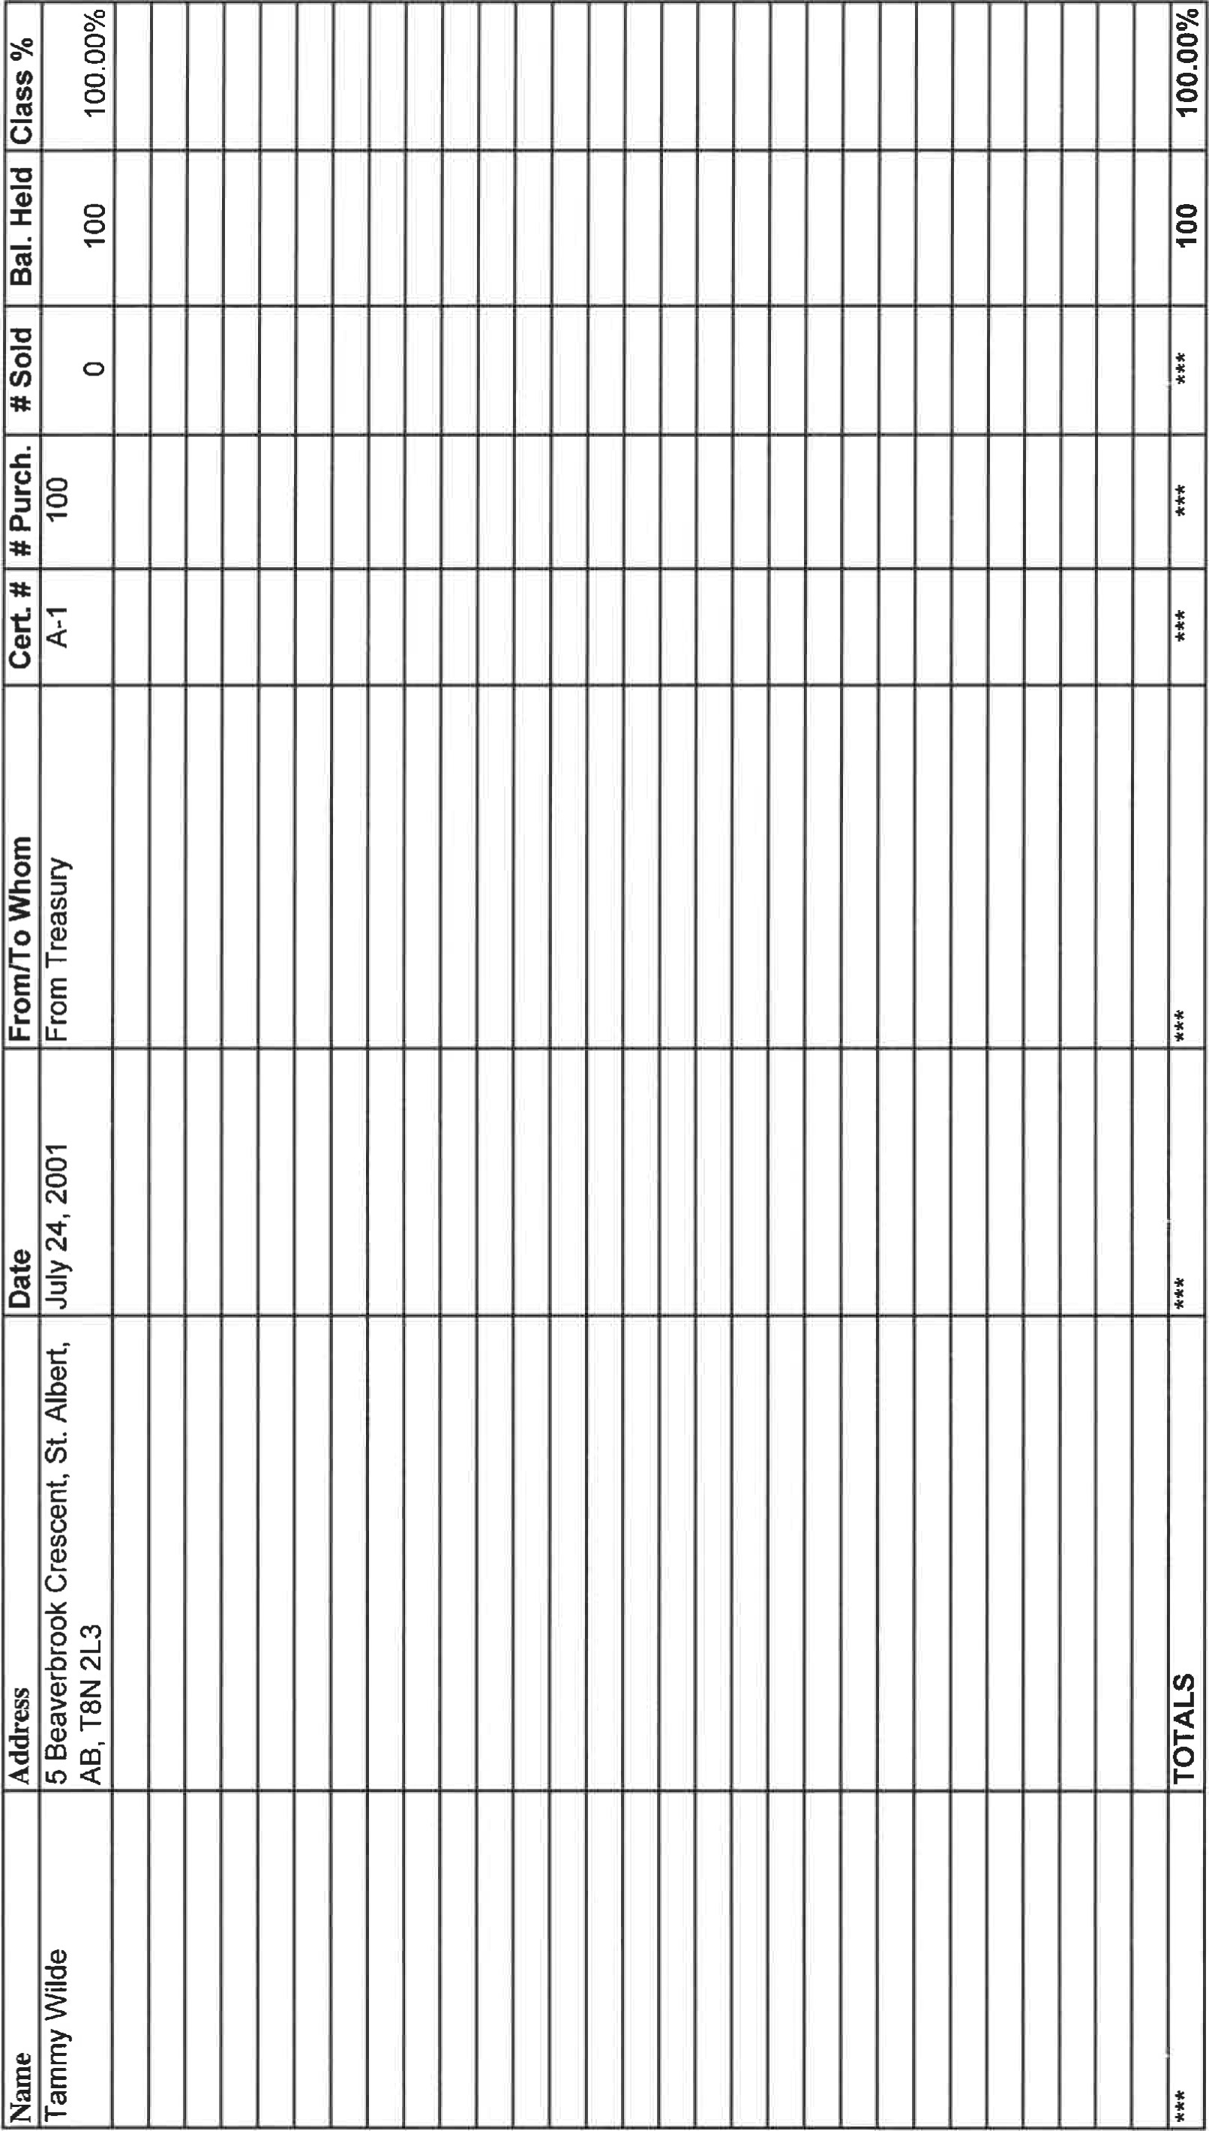:
^{İ}
(D
o
 |  |  |  |  |  |  |  |  |  |  |  | ı | ı | ı | ı | ı | ııııııııııı;
 |  |  |  |  |  |  |  |  |  |  |  | ı | ı | ı | ı | ııııııııııııı
 | .ızııııııııııııııııııııııııı
(9
o

;u |  |  | ı | ı | ı | ı | ı | ı | ı | ııııııııııı |  |  |  |  |  |  |  |  |  |  | ı | ı | ı | ı
âEl |  |  | ı | ı | ı | ı | ı | ı | ı | ı | ııııııııııı |  |  |  |  |  |  |  |  |  |  | ı | ı | ı | ı | ı | ı | ı | ı;
 |  |  |  |  |  |  |  |  |  | ı | ı | ı | ııııııııııı |  |  |  |  |  |  |  |  |  |  | ı | ı | ı |  |  | ıı
 | 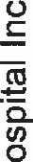

 | 28 | 00L
 | paunbov
 | ℃eと su ト | 0
I-UO%M0辷 |  | WOに
・ON
」 su ト
・ONゼeo
e20 |  | 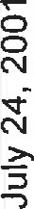
のコ代NGト'8V'peqlV'あ-をeos①」0 00」q」①>e①89
:SSOJPPV

のの」el-Iの61-1一一0>UOLUWOO のの2一0 :sæeqsちsselO


epl!M
・0トコVト 田8コV0に寸寸6 区田90田コの化田0コ0工山 くエの

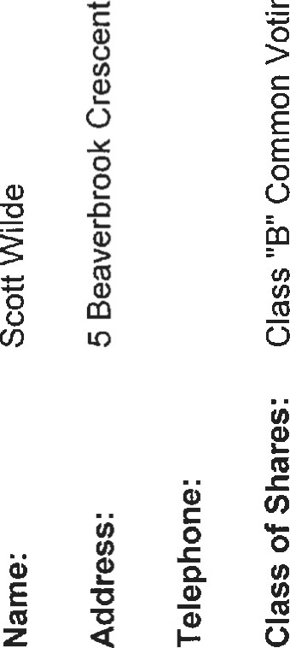 | : ı : ı:ıı ı ı ııııııııııııı    ıııııııııııııııı  ııııı ıııııııııı ı ı ı ı ı ı  l! ı ı ı ı ı ı ııııı ı ı ı ı ı ı ı ı ı

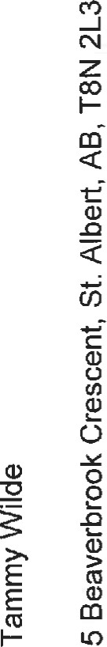 |  | ril II II II ııı II III

