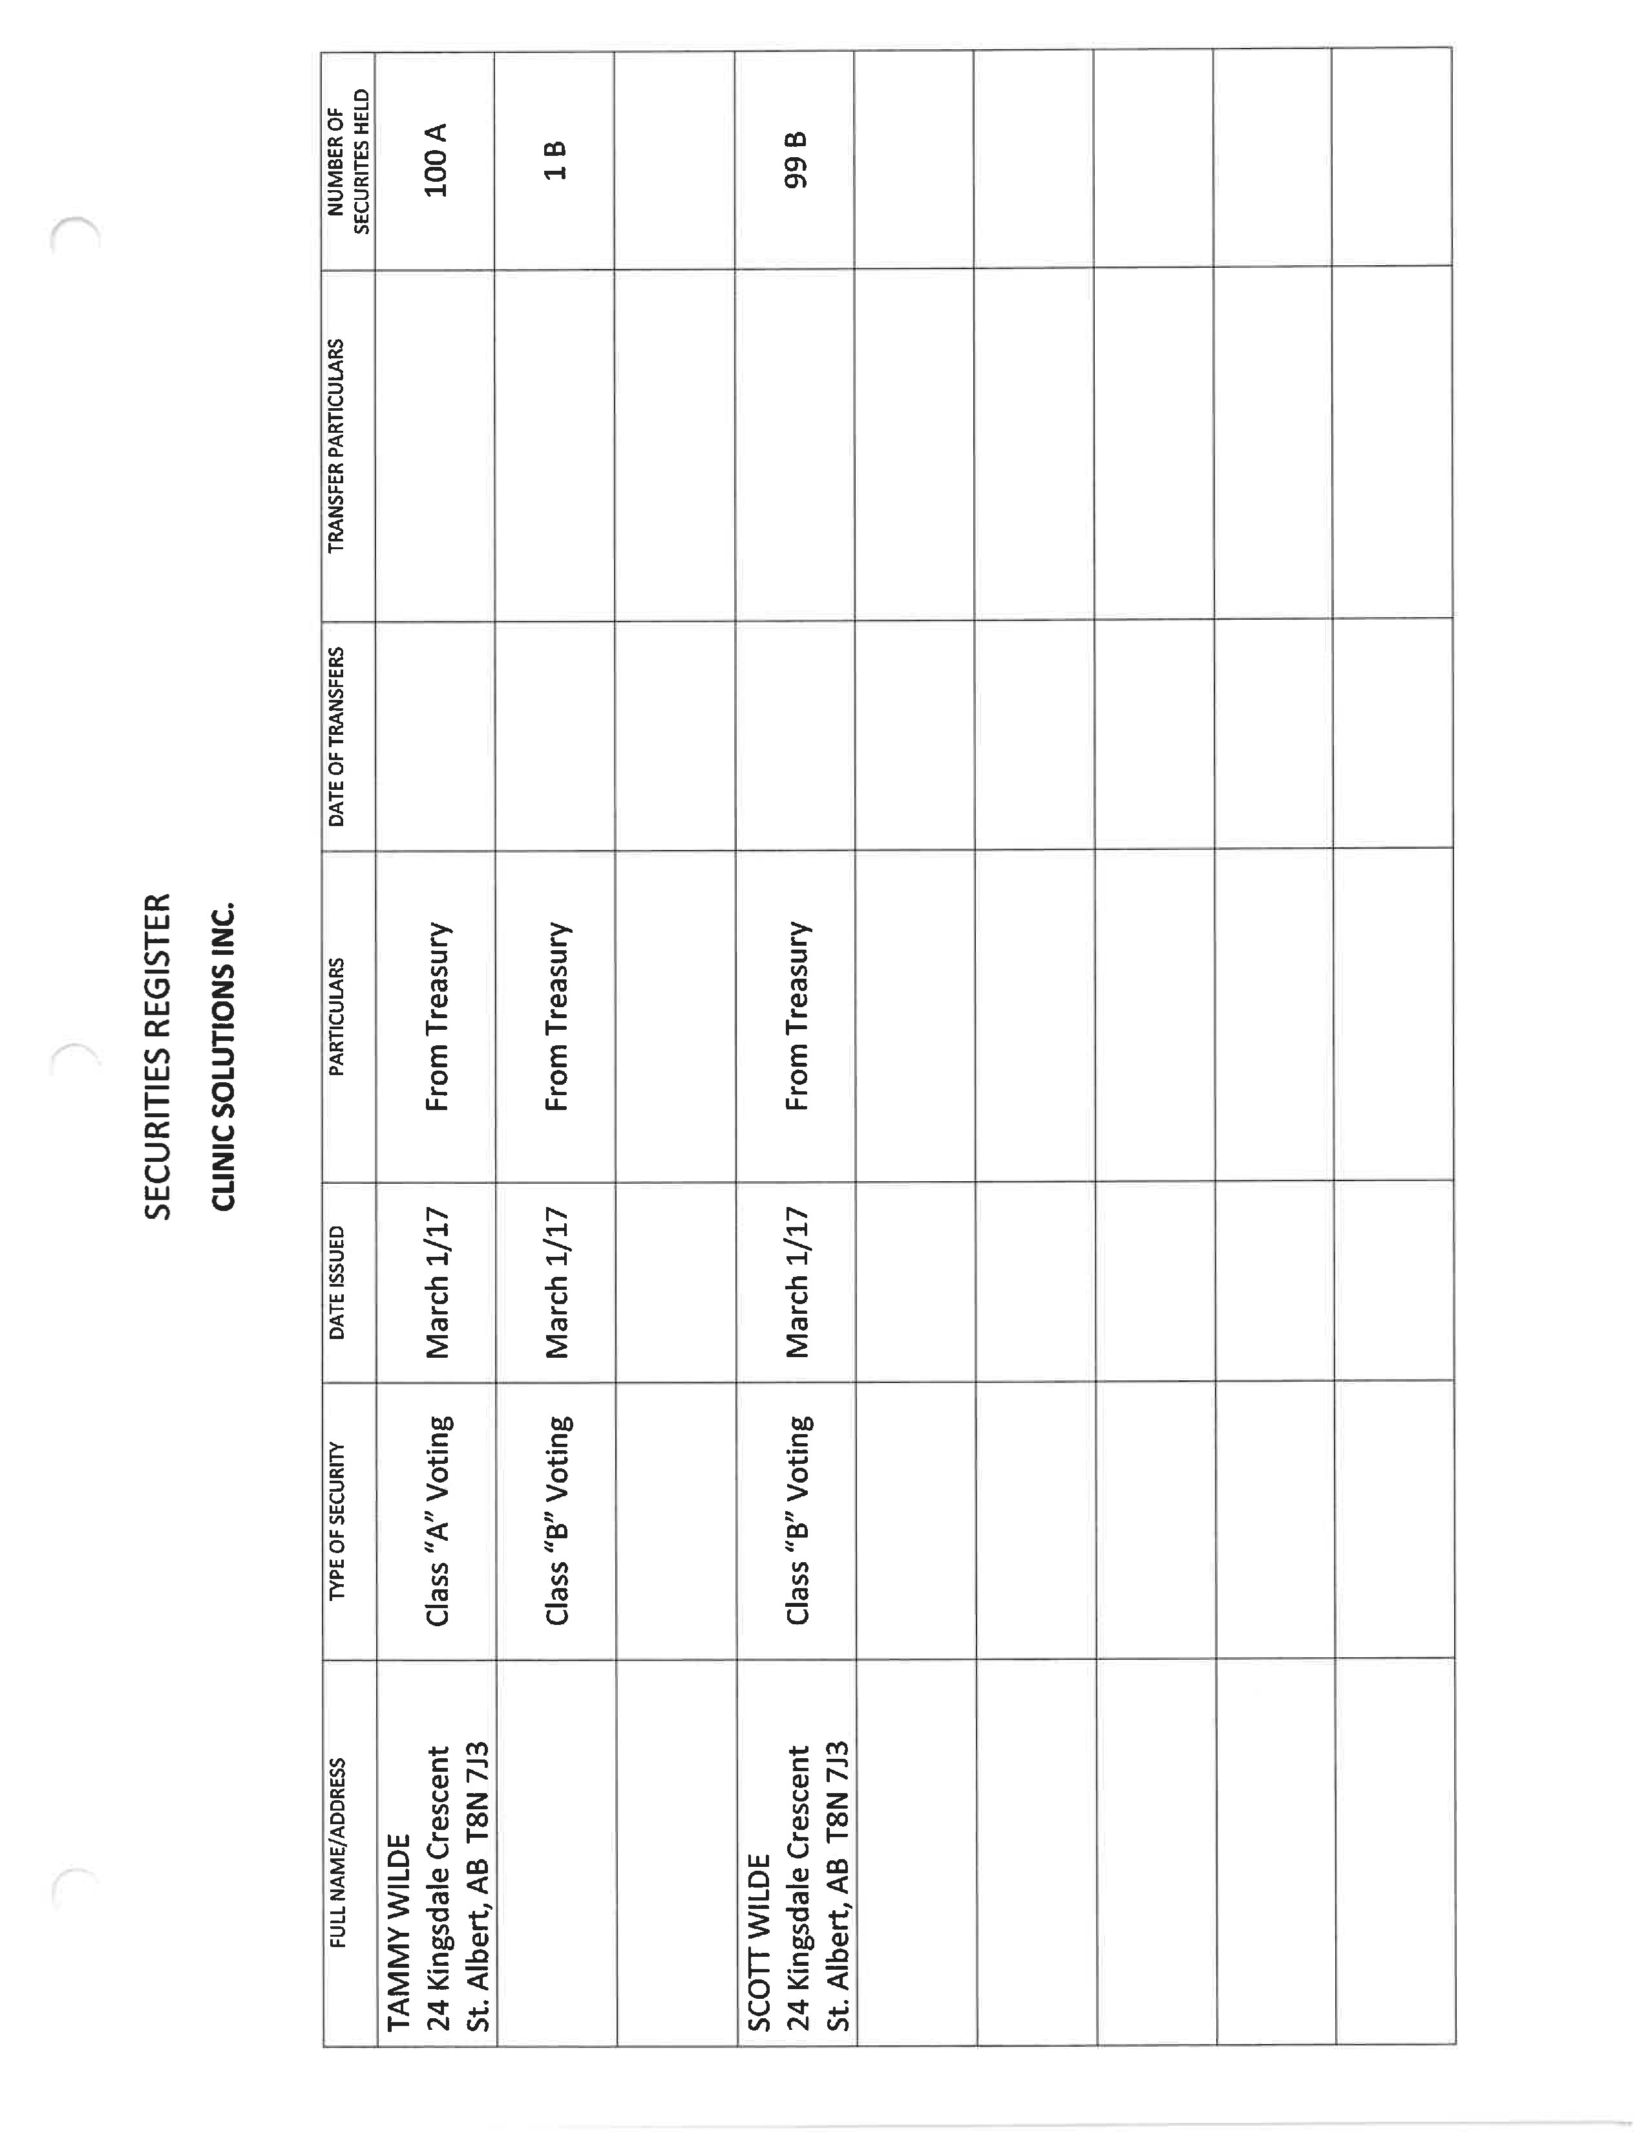

 |  |  | NAME: |  |  |  | TAMMY WILDE
 |  |  | ADDRESS: |  |  |  | 24 Kingsdale Crescent  St. Albert, AB T8N 7J3
 |  |  | CLASS: |  |  |  | A Common Voting
DATE | CERTIFICATE  ISSUED |  |  | CERTIFICATE  CANCELLED |  | TO OR FROM WHOM |  |  | STATED  CAPITAL | SOLD  SHARES | BOUGHT  SHARES | BALANCE
March 1, 2017 |  |  |  |  |  | From Treasury |  |  |  |  | 100 | 100
 |  | NAME: |  |  | TAMMY WILDE
 |  | ADDRESS: |  |  | 24 Kingsdale Crescent  St. Albert, AB T8N 7J3
CLASS:B Common Voting
DATE | CERTIFICATE  ISSUED |  | CERTIFICATE  CANCELLED |  | TO OR FROM WHOM |  | STATED  CAPITAL | SOLD  SHARES | BOUGHT  SHARES | BALANCE
March 1, 2017 |  |  |  |  | From Treasury |  |  |  | 1 | 1
 |  | NAME: |  | SCOTT WILDE
 |  | ADDRESS: |  | 24 Kingsdale Crescent  St. Albert, AB T8N 7J3
CLASS:B Common Voting
DATE | CERTIFICATE  ISSUED | CERTIFICATE  CANCELLED | TO OR FROM WHOM | STATED  CAPITAL | SOLD  SHARES | BOUGHT  SHARES | BALANCE
March 1, 2017 |  |  | From Treasury |  |  | 99 | 99

