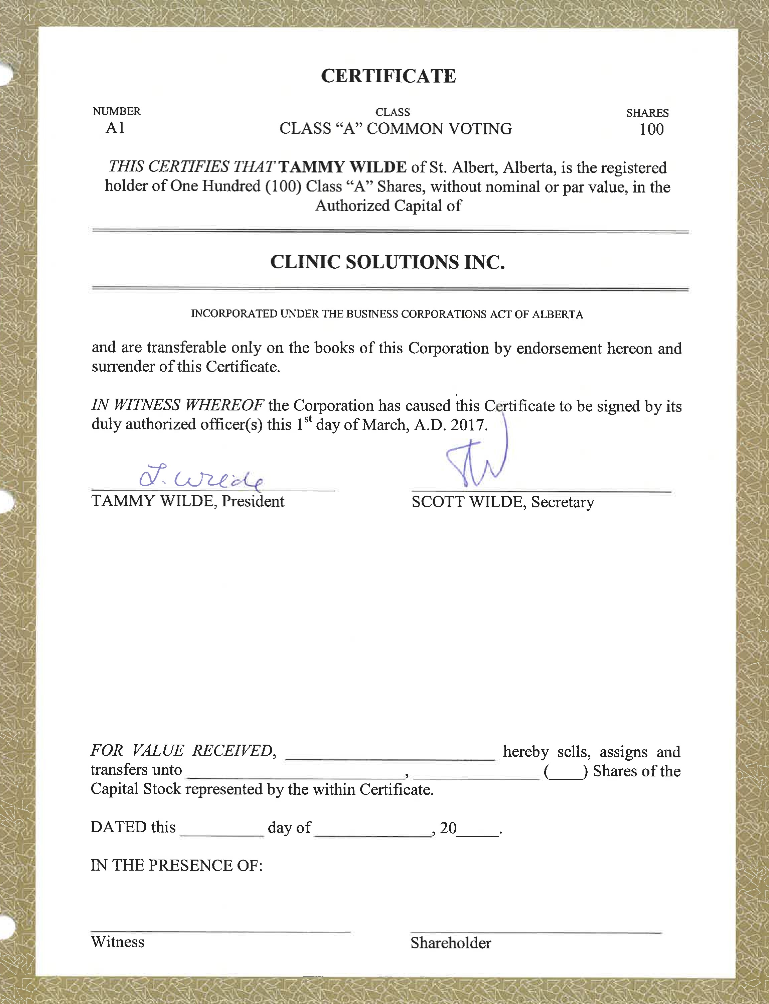
"B"
THIS CERTIFIES THAT TAMMY WILDE of St. Albert, Alberta, is the registered holder of One (1) Class "B" Shares, without nominal or par value, in the Authorized Capital of

CLINIC SOLUTIONS INC.

INCORPORATED UNDER THE BUSNESS CORPORATIONS ACT OF ALBERTA
and are transferable only on the books of this Corporation by endorsement hereon and surrender of this Certificate.






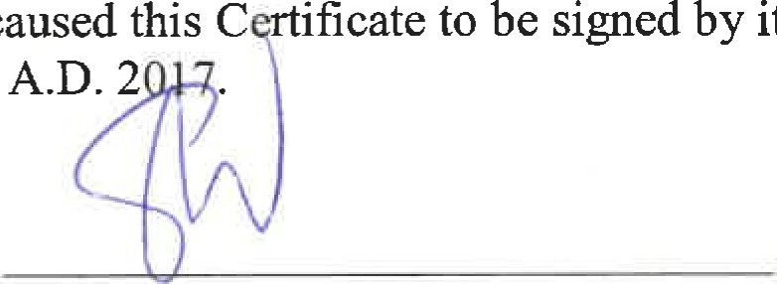
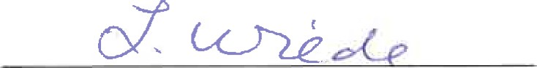
IN WITNESS WHEREOF the Corporation has caused this C ificate to be duly authorized officer(s) this 1 ^{st} day of March, A.D. 2
its
TAMMY WILDE, President SCOTT WILDE, Secretary
FOR VALUE RECEIVED, hereby sells, assigns and transfers unto Shares of the Capital Stock represented by the within Certificate.
DATED this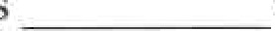day of 20
THIS CERTIFIES THAT SCOTT WILDE of St. Albert, Alberta, is the registered holder of Ninety Nine (99) Class "B" Shares, without nominal or par value, in the Authorized Capital of

CLINIC SOLUTIONS INC.

INCORPORATED UNDER THE BUSINESS CORPORATIONS ACT OF ALBERTA
and are transferable only on the books of this Corporation by endorsement hereon and surrender of this Certificate.
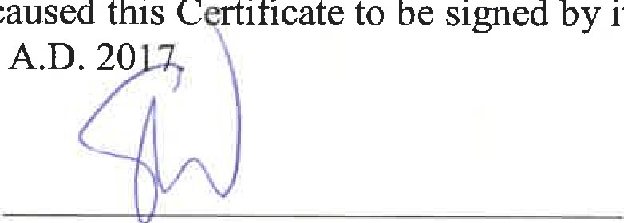
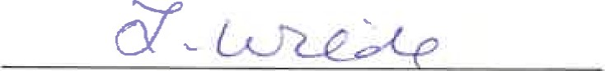
IN WITNESS WHEREOF the Corporation has caused this C ificate to duly authorized officer(s) this I ^{sl} day of March, A.D. 20
its




TAMMY WILDE, President SCOTT WILDE, Secretary
FOR VALUE RECEIVED,hereby sells, assigns and transfers unto(—) Shares of the Capital Stock represented by the within Certificate.
DATED this day of

