Executive Summary

Clinic Solutions is a Canadian corporation based in St. Albert, Alberta. The present owners are Dr. Tammy Wilde and her husband, Scott Wilde.
Clinic Solutions has been actively searching veterinary clinics to purchase in the Greater Edmonton region. They own Tudor Glen Veterinary Hospital in St. Albert which was purchased in August 2001 and then Lynnwood Veterinary Hospital in 2011. The most recent purchase being Family Pet Care Clinic in 2014.
Clinic Solutions has recently been contacted by Dr. Gayle McDonald from the Glenora Cat Clinic in Edmonton, Alberta with regards to a potential sale of her clinic. The Glenora Cat Clinic is located at 12230 – 107 Avenue in Edmonton. Clinic Solutions Inc seeks to borrow $400,000 to purchase 100% of the shares of the Glenora Cat Clinic from ATB. The corporation would request this loan be amortized over 7 years with an interest rate of %. Using a conservative profit percentage of 15% and based on projected realistic sales, the chart below shows a repayment schedule that uses less than 44% of the net income to service this loan.

Yearend | Projected Sales | 80% of Net Income from Operations (15%) | Approximate Funds Needed to Service Loan | % of Net Income Allocated to Service Loan
2016 | $802,620.00 | $96,314.40 | $44,199.60 | 46%
2017 | $842,750.00 | $101,130.00 | $44,199.60 | 44%
2018 | $884,890.00 | $106,186.80 | $44,199.60 | 42%
TOTALS | $2,530,260.00 | $303,631.20 | $132,598.80 | 44%
 | Note: Less than 44% of Net Income is needed to service loan

As a contingency plan, any short-falls from Glenora Cat Clinic due to either decreased sales or less than expected profits will be covered by Clinic Solutions Inc. Profits have been consistently in the $400,000 range.
Presently, there is an accepted offer from Dr. McDonald for $275,000 for a share transaction. The balance of $125,000 will be used for operating funds. Dr. McDonald has supplied a “List of Assets” that detail the current assets of the corporation, which are to be included in the purchase, to value $ .
Given the continuous growth that the Glenora Cat Clinic has enjoyed while experiencing what North American media describes as “a recession”, it appears that looking after cats is a “must” to cat lovers and as such is recession proof.
Nearly 13 years ago, Clinic Solutions borrowed $70,000 from the Scotia bank in St. Albert. The money was used to purchase Tudor Glen Veterinary Hospital. At the time the clinic was a single veterinarian practice that focused on holistic medicine. It had estimated sales of approximately $200,000 per year. The clinic was approximately 2,070 square feet and was in desperate need of renovations. The clinic purchase included only a phone and fax system, the outside signage and a reception desk. No equipment, product or client list was included in the sale.
Dr. Wilde started with one full-time Animal Health Technologist and one part time Receptionist. Today, Tudor Glen Veterinary Hospital has expanded to nearly 7,000 square feet taking up 80% of the strip mall it is in. The practice now has 5 Veterinarians servicing nearly 6,000 clients. The practice employs 10 Animal Health Technologists, 10 Tech Assistants, 3 Receptionists, a full time Operations Director, a full time Treatment Room/Operations Manager, an Administrative Assistant and an Executive Assistant.
The hospital has been completely renovated, expanding to add a much needed new exam room, and has the most modern equipment available. This equipment includes a digital x-ray, a full in house Laboratory, Ultrasound Machine and Pulse Signal Therapy machine. There are only three clinics in Canada that have Pulse Signal Therapy technology.
Dr. Wilde and her husband feel that the purchase of the Glenora Cat Clinic has similarities to their original purchase of Tudor Glen in terms of what they saw in potential. One exception is that the Glenora Cat Clinic does come with trained and experienced staff, is fully equipped with all the necessary equipment, completed lease hold and a client list that will supply clients immediately with the first day of ownership. These are all aspects that were missing with the purchase of Tudor Glen Veterinary Hospital.
Clinic Solutions saw the potential in both Tudor Glen Veterinary Hospital and Lynnwood Veterinary Hospital. We see the same potential in the Glenora Cat Clinic. Dr. Wilde and Scott Wilde have proven they are capable of providing outstanding veterinarian medicine to their clients. This is shown in the volume of repeat clients returning to the clinic since it opened. They have also proven year after year that they are capable of managing both the day to day operations as well as growing multiple businesses into being very efficient and profitable hospitals. In 2012, they moved all their personal and corporate banking to ATB, which has proven to be a sound business decision. They would like to expand their relationship with ATB in this financial endeavor.

The Company Overview

Clinic Solutions Inc., formerly incorporated as 944710 Alberta Ltd., is a Canadian company operating in St. Albert, Alberta and was incorporated in 2001. There have been no ownership changes since that date. Tammy and Scott Wilde own 100% of the voting share of the company. No non-voting shares have been issued at this time
Currently, the major goal of Clinic Solutions Inc. is to purchase the Glenora Cat Clinic and incorporate their proven management system. Clinic Solutions management system balances customer service (cat care) with “Management by Statistics”. This combination has served the bottom line extremely well.

Gross Sales By Hospital
 | 2011-12 | 2012-13 | 2013-14
Lynnwood Veterinary Hospital | $840,851 | $893,051 | $798,600
Tudor Glen Veterinary Hospital | $2,938,106 | $3,042,478 | $3,570,760
Total Gross Sales | $3,778,957 | $3,951,529 | $4,369,360
Total Income From Operations | $495.519 | $388,908 | $368,770

Products/Services:
The Glenora Cat Clinic will continue to provide veterinary procedures, services and surgeries to clients throughout the City of Edmonton, as well as Northern Alberta. In addition, clients may purchase cat food and various sundry items for their cats.

The Benefits to the Hospital’s Products and Services to Its Client:
Clients of the Glenora Cat Clinic will see these benefits of Clinic Solutions acquiring this clinic:
- The infusion of a proven management system that focuses on exceeding customer expectations.
- The added resources of additional experienced Veterinarians with up to date medical knowledge and updated equipment that will be shared through the corporation.
- The Glenora Cat Clinic’s trusted Veterinarian, Dr. Gayle McDonald, will now have more availability to dedicate to their clients cats well being. Dr. McDonald’s new role will allow her to concentrate on being a “Vet” and not worry about running the business.
- The opportunity to “do right by their cats” at a well known, professional veterinarian hospital.
- A safe, clean ABVMA (Alberta Veterinary Medical Association) inspected veterinarian hospital that adds to overall peace of mind when cats need anything from vaccines to surgery.
- Reasonable, competitive pricing that allows them to look after their cats thoroughly and consistently.

Benefits to the Hospital:
- The opportunity to expand and duplicate proven systems for creating profits and proven statistic gathering and analysis to predict trends and future opportunities.
- The ability to share resources. Not only in product and equipment but more importantly, staff. This share in labor will reduce the staffing cost for Clinic Solutions by almost 25.5% without any loss to production. On the other side, the Glenora Cat Clinic will get a much needed managing system that will increase its production. If history repeats itself, Tudor Glen’s production rose 39% the first year this management system was implemented.
Benefits to the Current Glenora Cat Clinic Staff:
- Since no staff changes are planned, current staff will not only have job security, but the added potential of profit sharing. Staff will be managed and rewarded through statistical production.
- Advanced Continuing Education programs will be introduced and implemented with the existing staff. Sharing continuing education resources between all hospitals will be a win-win for both management and staff. Reducing the costs per staff member for managing this program will ultimately allow for an even higher level of continuing education to be offered to all staff of the corporation. It is a proven statistic that increased staff knowledge leads to a higher level of client compliance, which leads to a larger profit margin.
- A larger staff pool in the entire organization will increase the available resources to all staff. This will include accessible access to experienced staff and also allow for more flexibility in scheduling.

Future Products/Services:

While the ABVMA (Alberta Veterinary Medical Association) has instituted rules relative to the specific products and services that veterinarian clinics and hospitals may provide/sell, plans for added revenue sources in the future include:
- Expanded food options and variety for clients
- Full companion cat retail outlet
- Expanded hours of service
- Increased range of professional services

Investment Considerations

Size and Growth Rate of the Industry:
The veterinary industry in the Greater Edmonton area has grown consistently over the last several years. The AVMA has reported yearly growth to be in the 5% range. The growth within the industry in both short term and long term will, as has been the case for years, present itself more in the form of additional business with existing clients than in the form of new clients. People are spending more on their existing cats and acquiring new cats. In the last four years clients of Tudor Glen Veterinary Hospital have increased their average transaction from $119.94 to $139.48. A trend we believe is a result of both our staff ability to increase our client knowledge base and our aggressive yet professional marketing. This increase of nearly 16.5% in spending is forecasted to be the same at Glenora Cat Clinic over the next three years.

Valuable Relationships with Suppliers:
Clinic Solutions has built strong relationships with suppliers over the years. This strong relationship sees benefits in both profitability and service. Profitability is seen in the large rebate cheques received by suppliers such as Hill’s Pet Food and WDDC ($53,680.40 and $40,862.76 respectively). On the service side, suppliers like WDDC and Pfizer have supplied our Veterinary Hospital’s with outstanding customer service, not just to the hospitals but to the clients as well. It is the belief that this positive relationship that Clinic Solutions has built with its suppliers will be immediately transferred to the Glenora Cat Clinic. It is assumed that the Glenora Cat Clinic will profit in much the same manner as Tudor Glen and Lynnwood have from these established relationships.
Strong and Scalable Business Model:
Clinic Solutions has spent much time, money and effort in developing a veterinary hospital that is driven by statistics. This education has helped to create the foundation for a successful business model which lends itself positive duplication.
The Glenora Cat Clinic and Clinic Solutions competitive advantages during the next three years will include:
- Both enjoy reputations as excellent providers of veterinary medicine. The Glenora Cat Clinic above average client satisfaction survey and Tudor Glen Veterinary Hospital being awarded “Best Veterinary Practice” for eight years and a recent St. Albert Chamber Award of Distinction for Small Business, illustrates this fact.
- Clinic Solutions has built a successful management team at Tudor Glen and Lynnwood that will be used to manage the new hospital. The Management team will integrate the Management by Statistics system. They will also manage Human Resources, control inventory, manage finances and implement the marketing plan. Management costs for managing the Glenora Cat Clinic will be shared between Clinic Solutions other clinics and the Glenora Cat Clinic. This cost sharing will no doubt add profit to the business’ bottom line.
Profitability:
Clinic Solutions has built the foundation for continued profitability each year, all of which will be integrated into the Glenora Cat Clinic. The key missing ingredient to continuing to create profit in the future is financing.

Controlled Costs:
Clinic Solutions financial statements clearly exhibit that their hospitals are able to operate at a very productive and profitable level!
Plans to increase profitability include:
- The commitment to hands-on staff education through the proven continuing education program designed and used at Tudor Glen and Lynnwood.
- Integrate the marketing model used at Tudor Glen and Lynnwood at a reduced cost due to the repetitive nature of the marketing plan.
- Introducing the proven “profit share” system for the current staff at the Glenora Cat Clinic. This system, when introduced was believed to be one of the most major factors in Tudor Glen becoming one of the most efficient and profitable hospitals in the country.
- Dr. McDonald’s commitment to continuing to provide outstanding veterinary services with the reduction of time spent managing the hospital will increase productivity and profitability of this already high producing Veterinarian.
- Clinic Solutions, which relies heavily on Dr Tammy Wilde, involvement not only at a management level but also as a support with Veterinarians working side by side with the staff at the Glenora Cat Clinic will allow transfer of knowledge at a greater increased rate. Dr Wilde’s success to date is not limited to medical abilities but equally to how she is able to communicate with her clients. The ability to communicate with clients is a skill that can be read in a book but the real transfer of knowledge occurs when staff sees first hand Dr. Wilde’s approach that she uses with her clients and their cats.

Economic Cycles:
Clinic Solutions is neither dependent nor reliant on the overall economic activity in the country. The veterinary industry is not, by nature and by industry statistics, cyclical.

Management and Operations
Management Objectives:
Clinic Solutions Inc. recognizes that its role during the first year of operations will serve the following purposes:
- To use our veterinary management teams experience to serve the Glenora Cat Clinic clients and more specifically, their cats. This allows for “hands on knowledge” of the clients and their wants and needs together with considerable cost savings relative to not having to hire additional management staff.
- To take advantage of the veterinary, marketing and business experience of Clinic Solutions to employ Management by Statistics, the very essence of Clinic Solutions Inc. successes for the last several years.
- To use our people skills to deal directly with clients and staff to generate a consistency that both clients and staff benefit from.

Facilities:

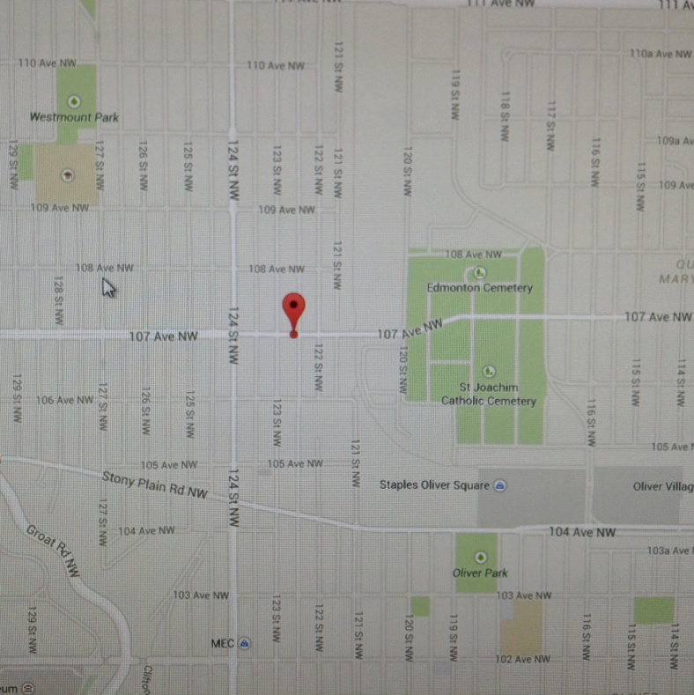

The Glenora Cat Clinic is located at 12230 – 107 Avenue in Edmonton, Alberta. It was established in 1994 and has been owned by Dr. McDonald since 2007. It is in the middle of a high traffic residential strip mall. The 2,100 square foot clinic has recently been renovated. The clinic is comprised of a waiting room/retail area, 3 exam rooms, a surgery suite, treatment room and lab area. The clinic is currently open six days a week. The practice easily supports 1.5 full time Veterinarians and support staff.
The lease is in its third year of a six year lease. The lease is transferable and is a condition of the purchase. The current lease is for $ a square foot plus occupancy costs.

Equipment:
The Glenora Cat Clinic by nature of its business does not need extensive equipment in order to function.
Present equipment includes:
- Cat kennels – allows for safe handling of in clinic cats
- Washer and Dryer – cleaning of linen for bedding
- Surgical packs – instruments for surgeries
- Avimark computer system and computers
- Veterinary library and resources
- Weight scales – diagnostic tool
- Intravenous pumps – used in cat care treatment
- Microscope – diagnostic tool
- X-ray machine
- Idexx laboratory equipment – same as Tudor Glen
- Centrifuge and stat spin – laboratory accessories
- Autoclave – sterilize surgical tools
- Dental machine – used in patient care treatment
- Digital Dental x-ray
- Food shelves – product display
- Surgery table and surgical lights – surgical accessories
- Head lamp system – surgical accessories
Equipment involved in hospital purchase totals approximately $

Inventory Control:
Clinic Solutions has shown that it has been consistently committed to an efficient operation of their hospitals. Our plan is to implement these efficiencies at the Glenora Cat Clinic. Inventory control will be set up and maintained by our corporate Inventory Control Manager. Immediate improvements are scheduled to be implemented to monitor and maintain a rotating inventory worth approximately $20,500. Management by Statistics will also focus on inventory profit. Weekly profit numbers will be monitored and used to plan future growth trends and potentials.

Industry Analysis:
Clinic Solutions Inc. owns Tudor Glen Veterinary Hospital, Lynnwood Veterinary Hospital and Family Pet Care. All required municipal and provincial licenses and permits, as well as proof of good standing as members of the Alberta Veterinary Medical Association are displayed at the hospitals.
The Alberta Veterinary Medical Association oversees the industry. According to the ABVMA:
To practice Veterinary Medicine in Alberta all persons must:
- Be a graduate of a four year, accredited university program in veterinary medicine.
- Successfully complete the North American Veterinary Licensing Exam (NAVLE), administered by the National Examining Board (NEB).
- Attend a minimum number of scientific education sessions each year.
- Renew their registration to practice annually

- Practice only through a registered inspected veterinary facility
- Be accountable to the public through an enforceable disciplinary procedure.
Size and growth rate of the industry:
The veterinary industry has been in existence since long before the Alberta Veterinary Medical Association was established. The following verbiage is from the ABVMA website:
The Alberta Veterinary Medical Association (ABVMA) is the professional regulatory organization governing the practice of veterinary medicine in Alberta under the authority of the Veterinary Profession Act. As a self governing profession, the ABVMA is required to perform its regulatory and professional functions in accordance with the law and in a manner responsible to the public of Alberta through the Government on Alberta Employment and Immigration.
The ABVMA has been in existence since 1906, when the newly created province passed the “Act Respecting Veterinary Surgeons”. There were 43 Veterinarians on the ABVMA Roster that year. As of October 2013, there were 1,385 Active General Veterinarians and 1,338 Animal Health Technologists registered. There are over 424 certified veterinary clinics throughout Alberta. The ABVMA is responsible for ensuring that all veterinarians in the province are qualified to practice veterinary medicine.

The positive business characteristics of the veterinary industry include:
- As the family cats importance within the family increases, so does the need for proper and human-like care for these “family members”
- Veterinarians are no longer seen as farm doctors who wear rubber boots to their calls. Instead they are seen as a medical professional with equal if not higher knowledge of medical issues.
- Veterinarian clinics have also evolved from the barn style clinic to fully equipped hospitals with the most modern technologies – digital x-ray, laser scalpels and complete in-house laboratories.
Maturity of the Industry:
The veterinary industry has been thriving for centuries. The industry ranks very close to the bottom of various sources of statistics reporting on corporate/clinic/hospital bankruptcies in Canada and the United States. The industry – even in the midst of a recession – has been afforded added stability by two key factors:
- The North American population is aging and cats serve as loyal companions, especially for seniors whose “yuppie children” do not have the time needed to devote to enhancing relationships with parents and
- Cats and their overall health care are seen by most cat owners as necessities and cost seldom play a major role in decisions about veterinary services for them.
The industry has matured, survived good and bad economic times and proven its value (especially when veterinarians are owners and operators) as a solid, safe and prudent investment.
Trends in the Industry:
The more than 10 million baby boomers in Canada and the more than 8 million seniors want safe, easy options for their cats. Society is aging and mature adults who are past their child rearing years are buying/adopting cats. These cats are not considered by most of their owners to be “animals” but rather as “members of the family”. Many studies have

proven beyond any doubt that when love enters into the equation, decisions on spending are made emotionally and seldom have financial caps.
Barriers to Entry:
Perhaps, the primary barriers of veterinary ownership are;
- The lack of existing clientele/reputation in the area of the clinic/hospital,
- Challenges in hiring and retaining capable and experienced personnel
- Plenty of veterinary experience, but little to no experience operating a clinic/hospital profitably.
Clinic Solutions is entering into this share transaction with creative and proven ammunition for each of these barriers.
- Clinic Solutions will be inheriting approximately 2,000 client files of the Glenora Cat Clinic.
- We have invested tens of thousands of dollars into a comprehensive and innovative recruiting and retention program that has served and will continue to serve as an “option creating insurance policy” relative to attracting, hiring and retaining capable staff. As well, we have educated and extensively trained all staff members not only on patient care, but also on identifying weekly and acting proactively on specific tasks that are designed to help to glean added profits. Weekly “Profit Sharing” meetings with all staff, focuses on what have been working at the hospitals. Individually, each staff member creates his or her own weekly written task list called “Battle Plan” that enhances his or her overall production.

- Financial statements over the last 10 years prove that operating a profitable hospital is within their capabilities.
Industry Opportunities:
Opportunities, in the Canadian veterinary industry, are seldom seen as events and trends. Indeed, the prevalent, most solid opportunity for Clinic Solutions is to fully integrate the successful and proven business model “Management by Statistics” approach that has generated consistent profits and has helped to foster planned growth at Tudor Glen and Lynnwood for several years.
Fallback plans accompany this learning process. One of the conditions to Clinic Solutions purchasing the Glenora Cat Clinic is that Dr. McDonald will stay on as “Chief Veterinarian”. Her contracted services will not only have her supply veterinarian service but will also have her act as a liaison between her existing clientele/staff and the management team of Clinic Solutions Inc. She has stated many times that the veterinarian profession in general needs to take a more proactive approach to the managing of hospitals. As a hospital group, they will be slowly and wholly educated in this vital area over a twelve-month period.

Marketing Outline and Sales Strategy

Overview:
The marketing strategy of Clinic Solutions is to continue to enhance relationships with clients as well as all stakeholders. These stakeholders include; Hill’s Pet Food, Pfizer, Novartis, WDDC and Boehringer, just to name a few.
Current advertising includes a weekly St. Albert newspaper article that features an “Ask the Expert” column. A large permanent billboard ad at Servus Place, where over 1 million people visit a year. A professionally designed and maintained web page. Weekly boulevard signage and dog treat giveaways to Starbucks customers who own cats are simple forms that increase the hospital exposure. Client information nights and trade shows are larger productions that have provided existing Tudor Glen and Lynnwood clientele and new cat owners the opportunity to meet our veterinary health team and get to know them on a more personal level. This expanded relationship has served both hospitals well in regards to future client compliance with doctor’s recommendation and our existing clients referring us to their friends.
The marketing plan and process for the Glenora Cat Clinic will essentially be the same. For over the last 10 years we have closely monitored what marketing strategies have produced the highest returns and this information has helped develop our current marketing plan. Costs that are typically paid for by only Glenora Cat Clinic will now be shared between all our our hospitals. The current marketing plan of Clinic Solutions Inc. is managed by our Communications Director. The proposed budget for the Glenora Cat Clinic will be 1% or $8,000. This increase in cost will be achieved by using already created products currently used by Tudor Glen and Lynnwood (websites, client info books, newsletters). The portfolio of the Communication Director will be expanded to include the Glenora Cat Clinic with “zero” additional management cost to the corporation. This efficient use of current management staff will yield additional profit to all hospitals.
Company Image/Message:
The hospitals logo, marketing materials, promotions and sales approach are all coordinated so as to present a clear and consistent message to its clients and potential clients. This is the Tudor Glen Veterinary Hospital and Lynnwood Veterinary Hospital logos. The hospital logo integrates with its slogan: Vets Love Pets or in this case with the Glenora Cat Clinic….Vets Love Cats!!

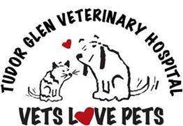 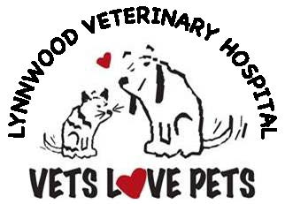 GCC logo

This integration leads to a variety of consitent messages throughout our communications with the existing target clients and stakeholders. The above concept and design will easily be transferred and introduced to the Glenora Cat Clinic soon after posession date.

Sales Strategies:
Hand on experience during the past years have uncovered the following needs and wants of the hospital clients:
- They want a veterinary clinic in which their cats will be more than just processed. Indeed, they want to be able to leave their cats at the hospital knowing that those who tend to them are people who LOVE CATS.
- They want an easy and thorough understanding of the procedures that their cats receive
- They want to be made an integral part of the decision making relative to these procedures
- They want to experience the confidence that accompanies dealing with a professional and well established hospital
- They deal with the hospital based – partially – on the assumption that the vets who look after their cats are educated and completely aware of the latest medical breakthroughs and techniques. Such assurances will be communicated to hospital clients.
Time invested in trade show talking to cat owners proved what we already believed to be true – cat owners want to be engaged and talk about their cats.

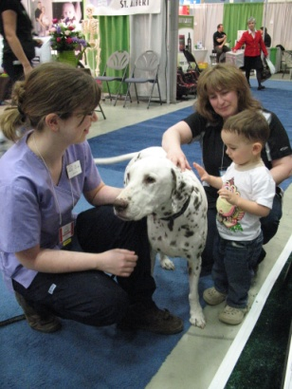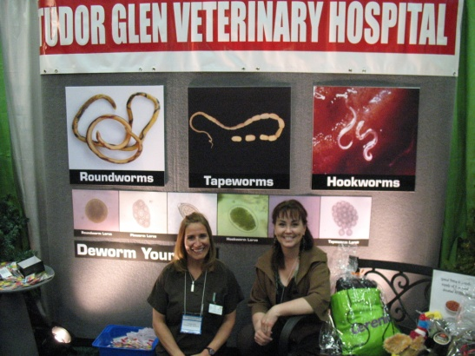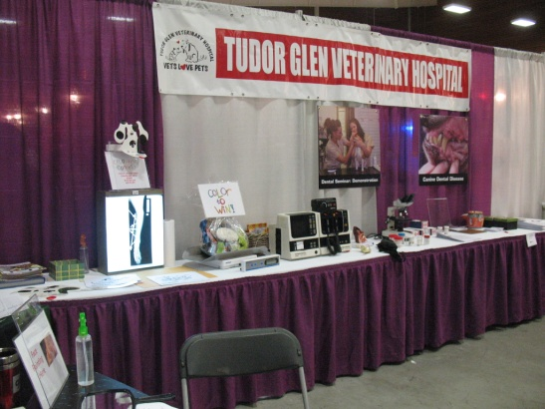
The established Management team’s current sales and marketing efforts have proven to meet and exceed the above needs of the clients. These sales and marketing techniques will be incorporated into the Glenora Cat Clinic marketing plan and will again meet all the needs of the above. Plans to consistently enhance both external and internal customer service and a steadfast commitment to continuously monitor both will serve as the foundation for credible marketing campaigns.
Marketing Vehicles:
The Glenora Cat Clinic’s marketing plan will follow the existing and successful plan of our other hospitals. The plan will continue to use “traditional” vehicles such as boulevard signs and treat give always at local Starbuck’s. As well the implementation of a monthly newsletter given out to every client with their invoice. In addition to these simple vehicles to market the clinic, larger scale plans include the following:

Local research has shown that many cat owners find veterinary clinics/hospitals through Yelp and/or Google advertising, word of mouth and websites. Tudor Glen and Lynnwood Veterinary Hospitals have developed very successful websites and Face book pages.
www.tudorglenvetclinic.ca and www.lynnwoodvetclinic.ca
http://www.tudorglenvethospital.ca and http://lynnwoodvethospital.ca
Currently, existing clients and potential clients are able to access a library of pet information. Through the web sites they are also able to ask questions and request appointments. Hundreds of pet/cat products are also available through the websites. The Glenora Cat Clinic will essentially be duplicated, the contact information will be added and the appearance of a professionally designed and managed site will be implemented. The cost for this will be a fraction of the cost since the design and information is already done and created.
Email addresses will be acquired and group informative emails will be sent to clients. These emails will also be promoting services and products and will keep the Glenora Cat Clinic brand and logo on the minds of clients.

Client Loyalty:
Clinic Solutions believes that in today’s marketplace, the most successful veterinary clinics/hospitals are those that provide excellent customer service and support to their clients. Clinic Solutions and the existing management team are fully committed to continuing to revere customer satisfaction at the Glenora Cat Clinic. Indeed we fully recognize that such customer service enhances the opportunity to separate the hospital from the competitors by servicing its clients better than any other clinic/hospital in the Greater Edmonton area. The Management team and specifically, the Operations Director, plans to communicate directly with as many hospital clients as possible during the first year of operation, confirming their satisfaction with the Glenora Cat Clinic level of client care.
Sales Forecast:
Based on the Glenora Cat Clinic’s past year’s production and the added level of management capabilities the sales forecast are as follows:

Yearend | Product Sales | Product % | Professional Services | Total Sales
2015 (9mths) | $165,410.00 | 28% | $425,340.00 | $590,750.00
2016 | $272,890.80 | 34% | $529,729.20 | $802,620.00
2017 | $320,245.00 | 38% | $522,505.00 | $842,750.00
2018 | $345,107.10 | 39% | $539,782.90 | $884,890.00
*Assumed transition of Product Sales over 2 yrs

The Target Market

Overview:
Veterinary services and the related products and services that clinic/hospitals offer are clearly seen as universal in nature. The industry does not have boundaries and it does not discriminate among clientele. It is needed and used by consumers in all economic classes, age groups and demographics. It has evolved from a “country vet industry” in the early part of the current century to a professional, regulated part of the health care industry.
Market Analysis:
Tudor Glen Veterinary Hospital, Lynnwood Veterinary Hospital and the Glenora Cat Clinic participate in the rapidly growing veterinary industry, which has grown consistently over the last three decades.
Customer Service:
Externally: Tudor Glen Veterinary and Lynnwood Hospitals have developed an envied reputation as a first class provider of excellence in patient care and customer service,
“Thank you to all of you who made his last minutes here as relaxing as possible and I will never forget your caring on what was a very busy day at the clinic and you made time to help us. You are the most compassionate veterinary staff I have ever known and I’ll never forget your kindness”

“We would like to thank you for your services and looking after our dogs all these years. Your expertise, kindness and empathy have not gone unnoticed”

“We would like to sincerely thank you and your wonderful staff for the ongoing love and care that you give all of our kitties at the Hervey Foundation. I can never find the words to express how much your support is appreciated”

“We appreciate all that you do. You’ve shown nothing but kindness and care, not only to Zoe, but to us. You ease our worries and concerns. Tudor Glen Vet Hospital is truly the best”

“It is nice to have a clinic like yours that is caring and competent (plus in emergencies!)…admire you so much!”

Internally: Tudor Glen Veterinary Hospital is unique in its unyielding loyalty to “Management by Statistics”. This is clearly not the norm in the industry. However, such loyalty has produced an initial growth of 39% the year it was implemented, followed by 28% and 12% over the next two years.
Barriers to Entry – The Competition:
Since 97 other clinics/hospitals have been operating while the statistics above were generated, Clinic Solutions does not see the competition as a barrier to entry. The hospital does, however, make consistent efforts to both watch and analyze competitor’s activities and to glean a consistent education from a valuable source…its loyal clients. – ADD IN CAT NICHE NATHAN TO COMPLETE

Positioning

Competitive Environment:
Although direct veterinary competitors exist, the current loyal clientele of the Glenora Cat Clinic together with the extensive good will that has been earned over the years clearly will give Clinic Solutions a competitive advantage as we begin this new endeavor. ADD IN CAT NICHE - NS
Company Strengths:
A track record of community involvement and envied recognition as an award winning hospital.
Tudor Glen Veterinary Hospital achievements:
- 1997 – Western College of Veterinary Medicine – Outstanding Achievement to Dr. Tammy Wilde
- 2006 and 2008 – Most Interactive Exhibitors Award– St. Albert Chamber of Commerce Lifestyle Expo
- 2009 and 2012 – Best Booth – St. Albert Chamber of Commerce Lifestyle Expo
- 2006 to 2013 – Best of St. Albert - Favorite Veterinarian/Best Practice
- 2006 and 2008 - nominated Outstanding Customer Service of Distinction –from St. Albert Chamber of Commerce
- 2010 - Winner Outstanding Customer Service of Distinction –from St. Albert Chamber of Commerce
- 2012 – Winner Marketing Award of Distinction – from St. Albert Chamber of Commerce
- 2011 and 2013 – nominated Small Business Award of Distinction – from St. Albert Chamber of Commerce
- 2014 – Winner Small Business Award of Distinction – from St. Albert Chamber of Commerce
Lynnwood Veterinary Hospital achievements:
- 2013 - voted “Favorite Vet Hospital” in Edmonton by Vue Weekly Magazine
A track record of diligence with all levels of government and the regulators of the veterinary industry. A new relationship with Alberta Treasury Branch that has been continuously growing and consistently nurtured by Clinic Solutions and that has been corner stoned by solid fiscal performance.

Definition of Strategic Position:
The potential to increase financial success of Clinic Solutions Inc. at this time is reliant on the corporation obtaining reasonable financial backing. The ability to purchase and operate the Glenora Cat Clinic partially depends on financing.

The Property

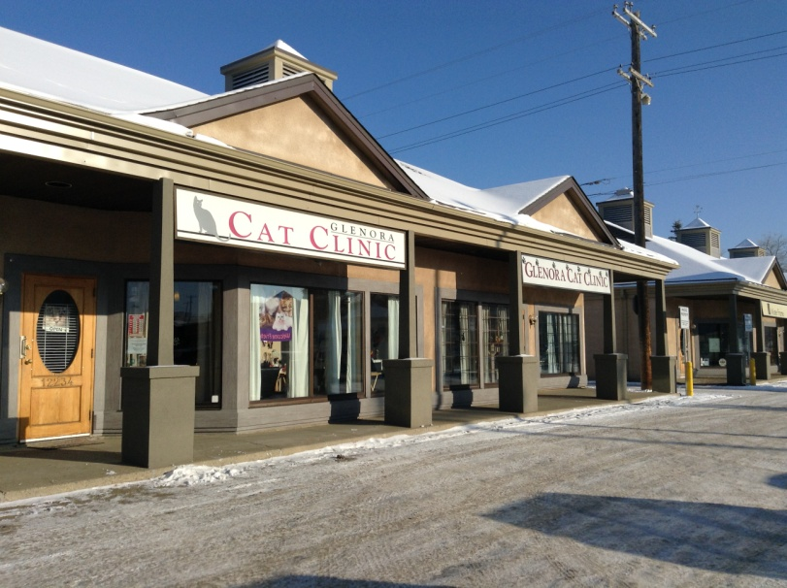 Front Elevation of Clinic

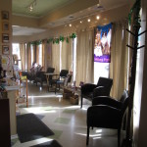 Waiting area West side #1
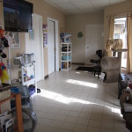 Waiting area West side #2
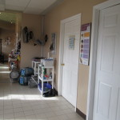 Waiting area East side
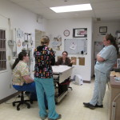 Treatment Room 1
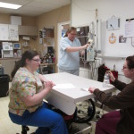 Treatment Room 2
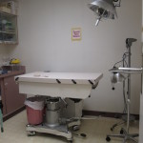 Surgery
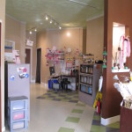 Reception
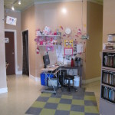 Reception 2
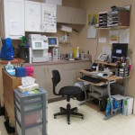 Lab
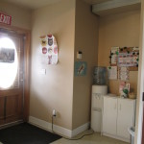 Front Door information
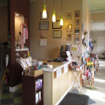 Front desk
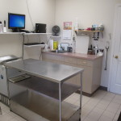 Exam Room 1 from waiting room
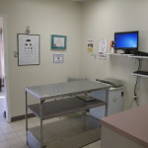 Exam Room 1 from Treatment Room
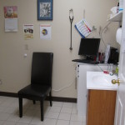 Exam Room 2
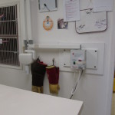 Dental - Xray

