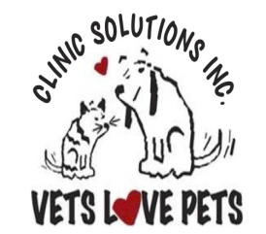 | Clinic Solutions Inc  CLINIC ACTION TRAINING |  | CAT NUMBER
 |  |  | Effective Date
 |  |  | Revision Date | N/A
 |  |  | Revision No. | Version 1
 |  |  | Page No. | 1 of 2
 | Created By | SW | Approval

BENEFITS OF THIS CAT

1. Improved Efficiency & Organization - Streamlines patient intake and rooming while ensuring all necessary information is recorded promptly.

2. Better Patient Care & Accuracy - Minimizes errors and ensures all patient details, treatments, and vaccinations are documented in the PVL for seamless care.

3. Increased Accountability & Clarity - Provides a clear, centralized system for tracking patient visits, reducing miscommunication and confusion.

4. Enhanced Client & Team Experience - Reduces wait times, improves workflow visibility, and creates a smoother, less stressful experience for both clients and the team.

PROCESS

• Check-In Process: As reception brings intake sheets to the pharmacy area, ensure clients and patients are taken to the appropriate room simultaneously.
• Filing Intake Sheets: Place intake sheets in the designated folder.
• Whiteboard Update: On the way back to reception, write the patient's name on the whiteboard outside the room.
• Initiate PVL: Start a PVL record.
• Vaccination Requirements: Add any necessary vaccination details to the PVL.
• Prepare Certificates: Print certificates for signing.

DEFINITION

Instake sheet
PVL (Patient Visit List)
Workflow visibility

Additional Information

REVISIONS

This is the original version

REFERENCE

Attached is the in take sheet – template and example on how to fill it out

