Transcendence Masternode Guide

Controller-Cold-Setup
This is the recommendedmethod to setup your Transcendence Masternodes. The wallet containing the coins does not have to be exposed and can run on your local computer. It does not have to run all the time and you are not vulnerable to someone hacking your VPS because all he can do when he hacked your VPS is stop your MNs but not steal your coins!

Desktop Wallet Setup
In the first steps the desktop wallet will be setup. This is the wallet you can run on your local PC. When the masternodes are connected this wallet can be closed and the PC does not have to run in order for the masternodes to generate rewards.

We will create an address, private key and transaction for each masternodeMN the following) and show the necessary steps for configuration.

- Open Console: Tools → Debug Console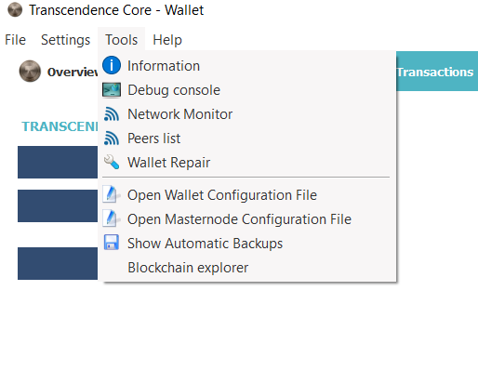

- Type “getaccountaddress<MN1” and press Enter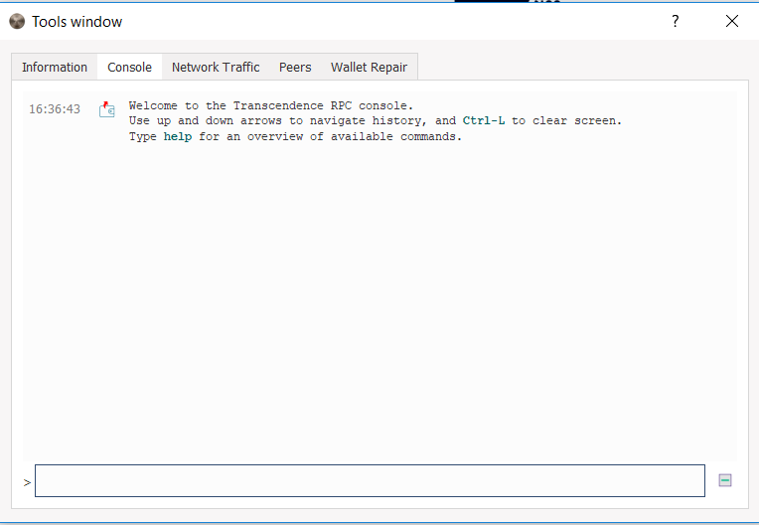
Repeat this step for the amount ofMasternodes you want to setup as shown. Make sure you count up (MN1, MN2, MN3 etc.)
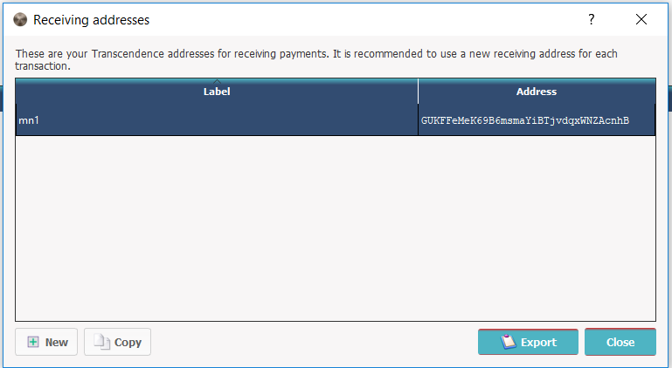These are the addresses that will be associated with the MNs. You can view all you created addresses under File → Receiving Addresses

- Send exactly 1000 coins to each MN address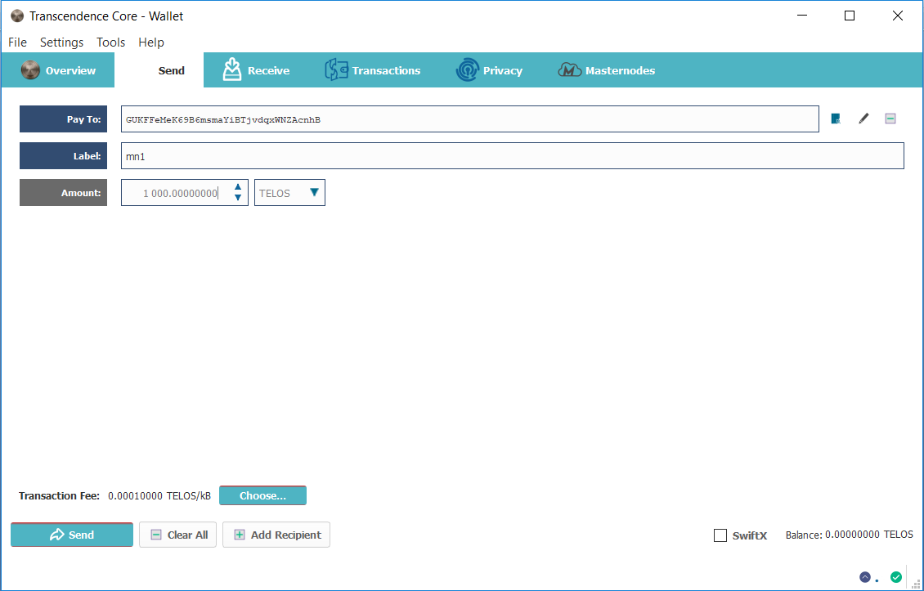
Click on “add recipient” to add lines so you can send to all nodes in one transaction.

- Setup MNs in config: Tools → Open Masternode Configuration File

Your text editor will open with the configuration file.
alias IP:portmasternodeprivkeytxhashoutputindex
We will now add a Line for each MN with the following Format:
  - Begin by entering and alias IP:port
    - Alias: the name of the MN receiving address (we named them MN1, MN2,…)
    - IP: The static IP of your server
    - port: A port the MN will connect to. For Transcendence, it’s 3133 for masternode #1. If you are installing more than one masternode, use 3132 for masternode #2, 3131 for masternode #3, 3130 for masternode #4, and so forth – in descending order.

  - Next we get the “masternodeprivkey “
    - 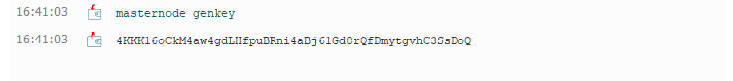Open debug console again, type “masternodegenkey” and press enter
    - Repeat the line for each MN you want to setup
    - Copy the output keys to the config
The private keys are used for voting and identify you as the real owner so don’t share them.
  - Next we will add txhash andoutputindex
    - 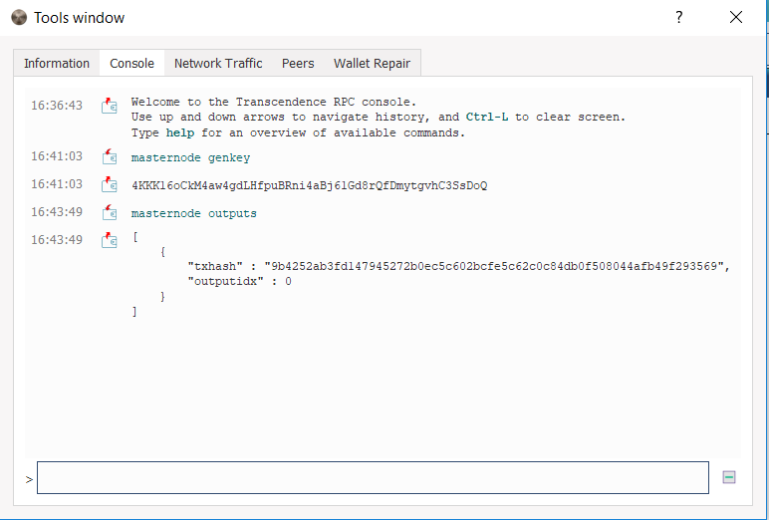Go to the debug console again, type “masternode outputs” and press enter
    - If you send the coins in one transaction the “txhash” will be the same. If you add a masternode later, another tuple will be added. So every masternode has a unique pair of txhash and outputindex
    - Copy the information to the config file (Make sure you don’t forget the outputindex!)
This is what your config should finally look like.
- Save the file and restart the wallet.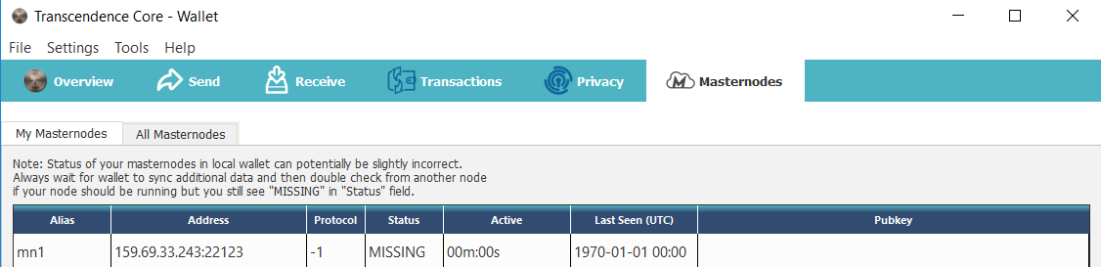
Verify now thatyour MN are shown in the Masternodes tab.

Getting a VPS
For the cold wallets you first need a linux VPS. You can get very cheap ones for 5$ here: https://www.vultr.com/?ref=7285424. These can run around 5 TELOSmasternode instances though it might be a good idea to split your MNs across some different Servers. The more isolation you have the less likely you are hit big by a server outage.
After registration you get to the Dashboard. You have to do the first payment with something else then Bitcoin. After the first payment you can pay the servers in BTC.

- Deploy the server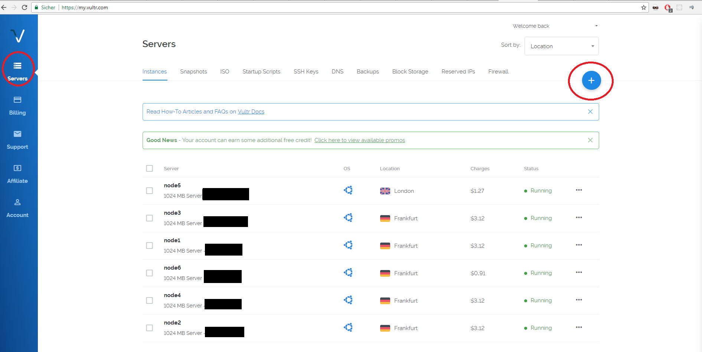Hit the plus top right to add new instances
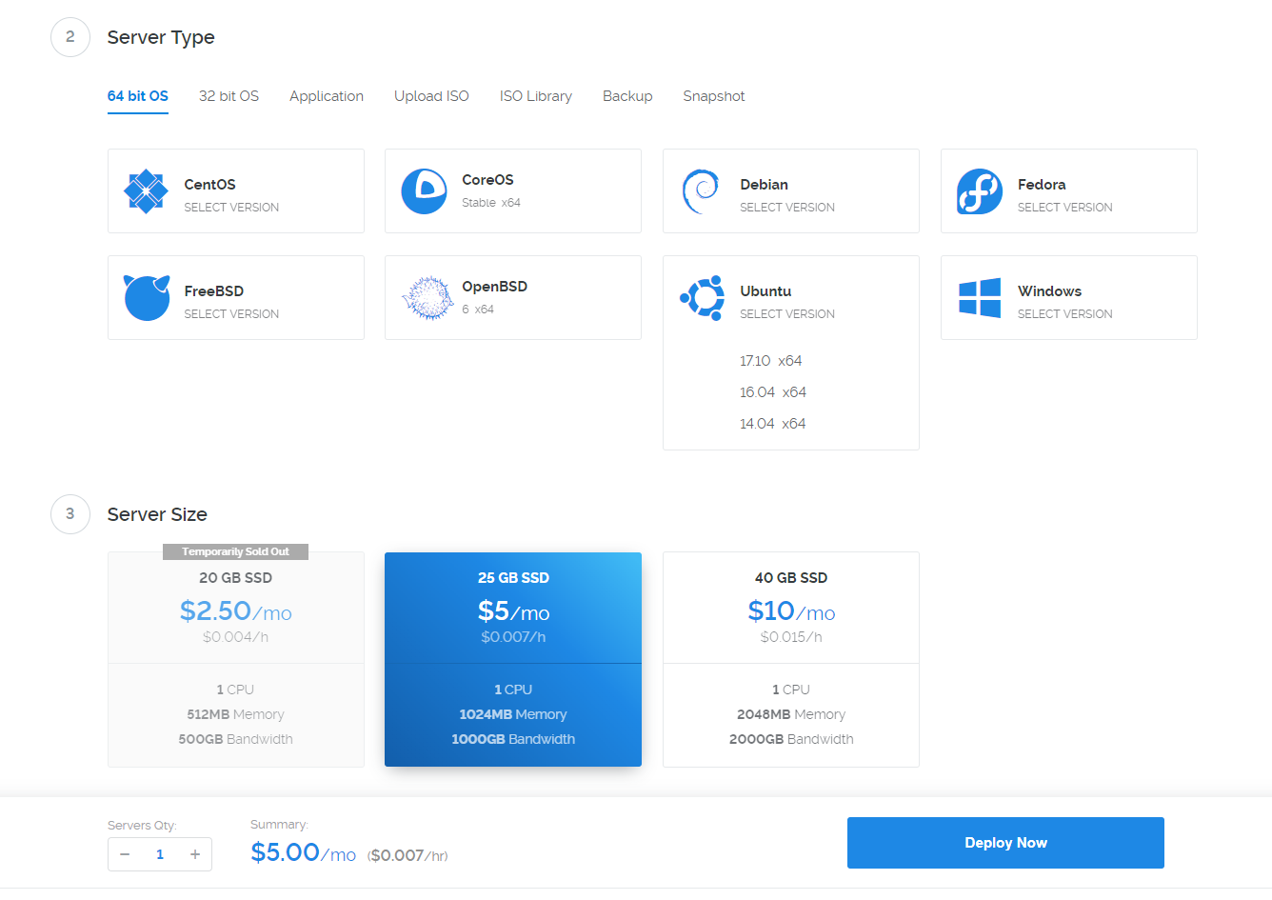
- Choose a region near you. It does not really matter.

  - As “Server Type” choose Ubuntu and klick 16.04 (Important don’t take 17.10!)
  - As Server Size choose the 5$ instance with 1GB Ram. If available you can choose the 2.50$ one if you only want to run one or two nodes on it.
  - Scroll down and give the node a name.
  - After that click “Deploy now” in the overview you should see this:
- Connect to the Server.
  - You will need some SSH tool connect. I use “Royal-TS” to manage several connections at once. It’s a bit harder getting used too but has real value.
  - To connect with “putty” a basic tool refer to this guide
  - You can find username (root) and password when you click on the newly created instance. The installation has to finish before!
  - Note: pasting your clipboard is “right click”

Automatic server installation and setup.
- Download and execute the scriptbelow on VPS, one line at a time. Press Enter after every line.
Wget https://raw.githubusercontent.com/phoenixkonsole/transcendence/master/setup.sh
chmod 755 setup.sh
./setup.sh

This process is interactive and takes several minutes.
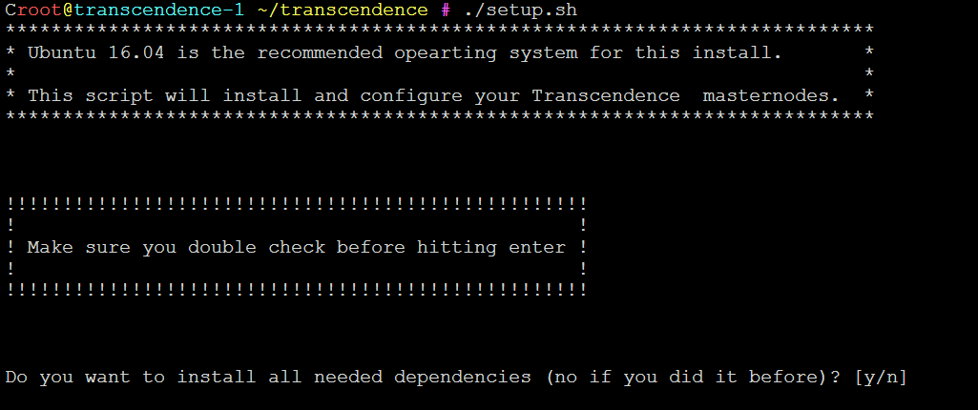
Enter y and press enter when you first setup the server. All dependencies and needed programs will be installed (takes some minutes)
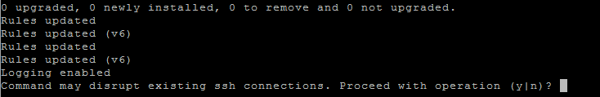
Enter y and press enter.
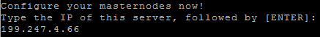
Enter the the servers IP address (199.247.4.66 in my case)
Enter the number of masternodes you want to run on the server (2 in my case)

Subsequently, you will be asked to enter:

    - Alias: mn1 (or as per the alias in your config file)
    - Port: 3133 (or as per the port number in your config file, corresponding to the alias)
    - MasternodePrivkey (as per the masternodeprivkey in your config file, corresponding to the alias)
    - RPC Port: same as port + 0. (Eg, if Port is 3133, RPC Port is 31330. If Port is 3132, RPC is 31320 and so forth)

If you are installing multiple MNs on the same server, you will need to repeat the above steps 1 - 4.

Once completed, you will see these:

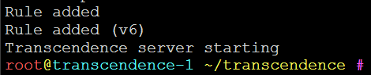
Enter the asked information. The alias is to give each node a unique name and control it. Enter port and masternode key which you configured before in the desktop wallet. Also unique free rpc port is needed. You can take any. The input process repeats for every node you want to configure (2 times in my case)
If you made an error when typing the interactive stuff: ctrl+c and restart the script

- Controlling the masternode
- The script from the last step already started all wallets on VPS
- Type “source .bashrc” in console
- Each MN has now its own control script under ~/bin (named with alias you typed before)
- To see if everything works type “cottoncoin-cli_mn1.shmnsync status”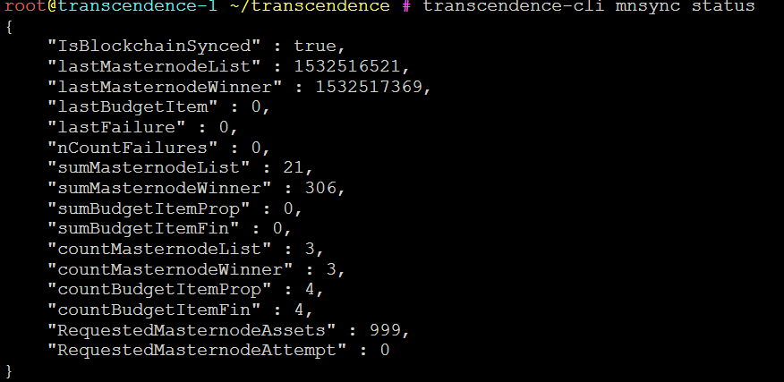
Every node has a script “cottoncoin-cli_ALIAS.sh”, “cottoncoind_ALIAS.sh”. Always use these scripts and not the daemon directly.
- If sync is finished go to your desktop wallet and start MNs in the masternode tab (unlock wallet before).

- You can close your Desktop wallet after a while.

Adding more nodes to existing VPS

To add more TELOS MNs to an existing server setup with the setup.sh script before

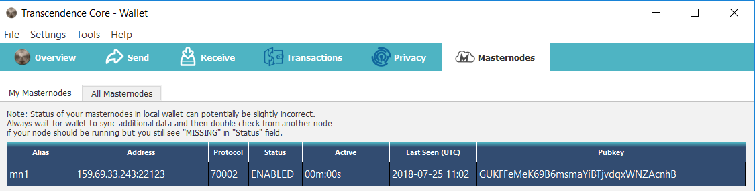

just restart the script below, one line at a time. Press Enter after each line.

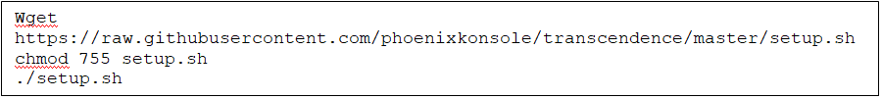

As you have already installed the script earlier on, simply type “n” when asked if you want to install the dependencies.

After that just follow the steps from before in the interactive script.

