1. 当服务已经开启之后，需要前往 设置>>无线局域网，然后点击当前所连接Wi-Fi后面蓝色蓝色圆圈的i图标。

When the service has been started, you need to go to “Settings->WLAN” and click the icon of the blue circle behind the current Wi-Fi connection.

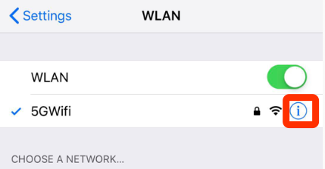

1. 进入之后拷贝IPV4地址栏中的IP地址，长按就会出现拷贝选项，或者可以在客户端内复制IP地址。

Copy the IP address in the IPV4 address, long press will appear the copy option, or you can copy the IP address in the client.

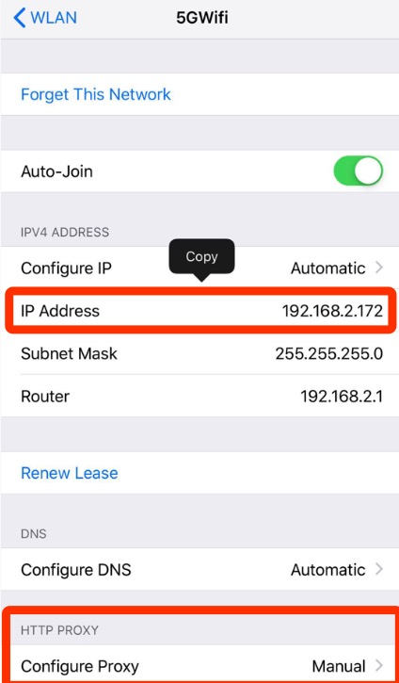

1. 点击HTTP代理一栏，选择手动，将刚才拷贝的IP地址复制到服务器一栏，端口号填写8001，点击右上方保存。

Click on the HTTP proxy column, select manual, copy the IP address just copied to the server column, fill in the port number 8001, click the upper right to save.

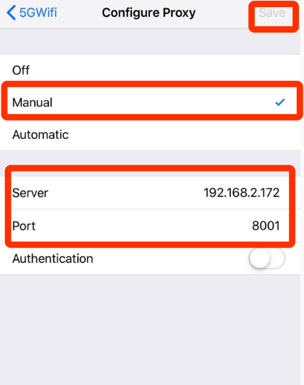

1. 这样配置就完成了，就可以查看设备所访问的网络请求信息，在同一个局域网内的其他设备也可以连接，IP地址使用你刚才使用的地址，端口号同样是8001，这样就可以查看其他设备的网络请求信息。

With this configuration completed, you can view the network request information accessed by the device, and other devices in the same LAN can also be connected. The IP address uses the address you just used, and the port number is 8001, so you can view the network request information of other devices.

1. 同时可以在电脑上查看具体的数据，访问的地址是[http://*.*.*.*:8002](http://*.*.*.*:8002)，这里的*.*.*.*就是您刚才所设置的IP，只要是属于同一个局域网内都可以访问。

At the same time, you can view datas on the computer. The address of access is http:/*. *. *. *: 8002, where *. *. *. * is the IP you just set, as long as it belongs to the same LAN.

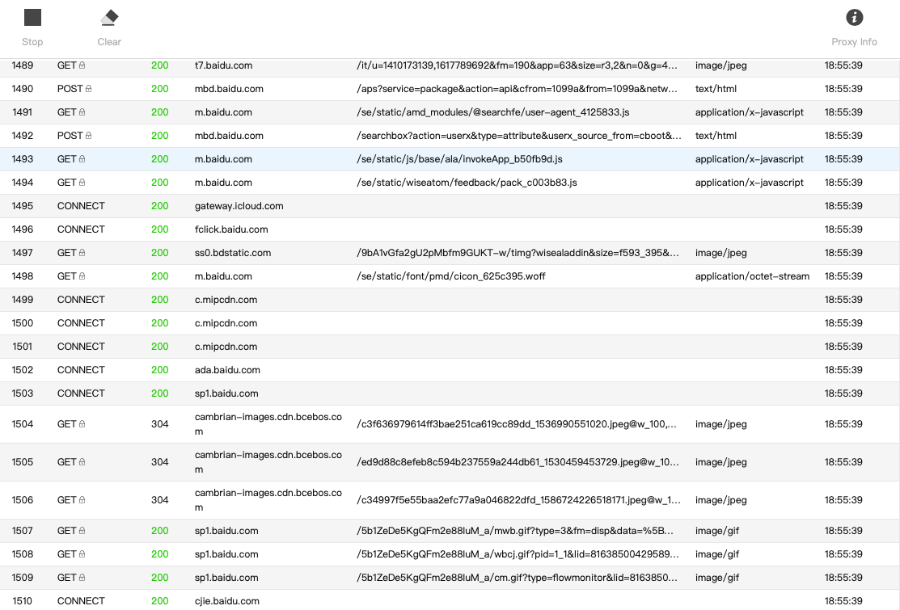

1. 提示：当关闭应用程序后记得关闭HTTP代理,否则的话会无法正常访问网络。

Tip: When shutting down the application, remember to shut down the HTTP proxy, otherwise you will not be able to access the network properly.

1. 关闭的方式同样是前往 设置>>无线局域网，然后点击当前所连接Wi-Fi后面蓝色蓝色圆圈的i图标，点击HTTP代理一栏，选择关闭，之后点击右上方的存储按钮。

The same way to close is to go to Settings > WLAN, click on the icon I of the blue circle behind the Wi-Fi currently connected, click on the HTTP proxy column, select Close, and then click save button on the upper right.

