Name : NITIN KUMAR
Roll No. : EP14B018
Graph show that the congestion windows size increases exponentially till the time ACK is received and remains less than threshold. Congestion windows increases linearly when it is above threshold.
Threshold is assigned to new values whenever ACK is not received ot timeout occurs.
Format or name of below plots : “Filename Ki Km Kn Kf Ps”
“out9 1 1.5 0.5 0.1 0.99”
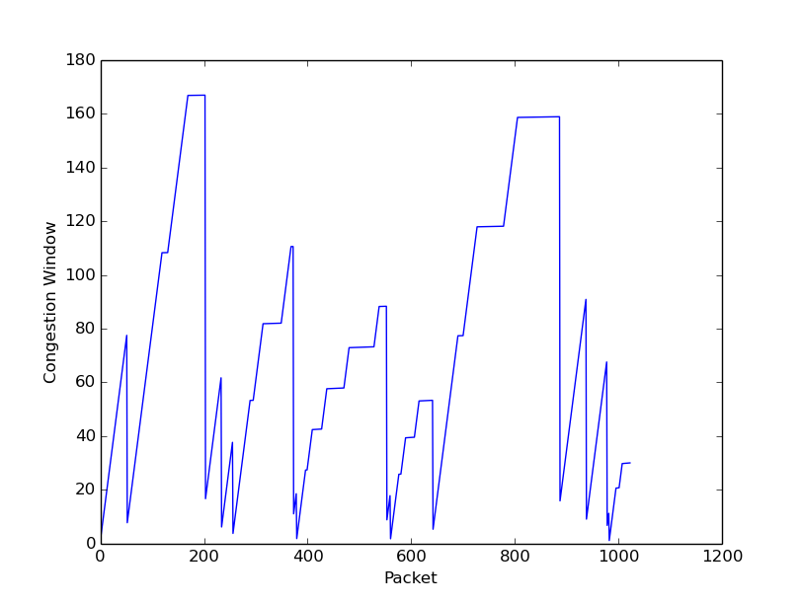

out13 1 1.5 1 0.1 0.99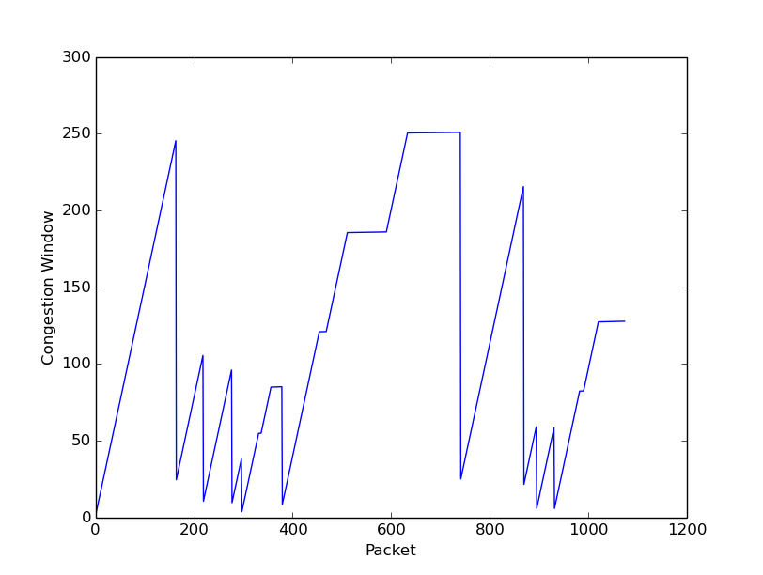

out16 1 1.5 1 0.3 0.9999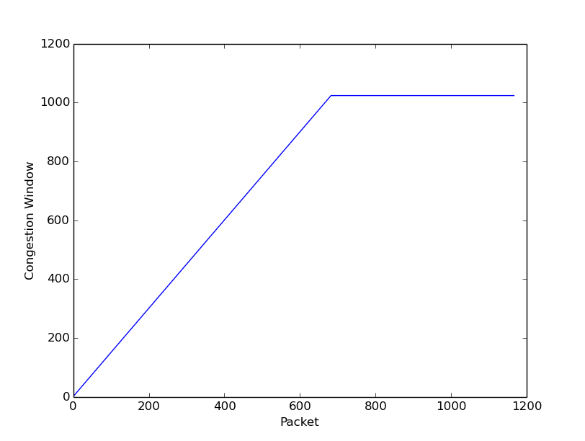out19 4 1 0.5 0.3 0.99