密级状态：绝密( ) 机密( ) 内部资料( ) 公开( √ ）

NPU Arch && Reg

文件状态：  ［√］草稿  ［ ］正式发布  ［ ］正在修改 | 文件编号：
文件状态：  ［√］草稿  ［ ］正式发布  ［ ］正在修改 | 当前版本： | V1.0
文件状态：  ［√］草稿  ［ ］正式发布  ［ ］正在修改 | 作 者： | 沈城
文件状态：  ［√］草稿  ［ ］正式发布  ［ ］正在修改 | 完成日期： | 2015年10月08日
文件状态：  ［√］草稿  ［ ］正式发布  ［ ］正在修改 | 审 核： | XXX
文件状态：  ［√］草稿  ［ ］正式发布  ［ ］正在修改 | 审核日期： | 年-月-日

历史版本
版本号 | 作者 | 修改日期 | 修改说明
0.1 | Phonix Shen | 2015-10-08 | 初始版本
0.2 | Phonix Shen | 2015-11-12 | 增加所有寄存器，并且编号
0.3 | Phonix Shen | 2015-11-14 | 增加比较模糊寄存器描述
1.0 | Phonix Shen | 2015-12-4 | 增加一些问题，补充寄存器描述

Open issue
序号 | 问题 | 结果 | 状态 | 责任人 | 备注
1 | 整体架构 |  | Done | 沈城
2 | 模块功能 |  | Done | 沈城
3 | Q&&A |  | Done | 沈城

目录
一、 整体架构 5
1. NPU在系统中的结构 5
2. NPU内部结构 5
3. NPU slow patch flow 6
4. Fast Path flow 7
二、 模块功能 9
（1） HIF模块 9
（2） GPI模块 11
（3） Classfier的验证 15
（4） TMU的验证 30
（5） BMU 模块 36
（6） WSP Global 模块 39
三、 Q & A 41

整体架构

NPU在系统中的结构
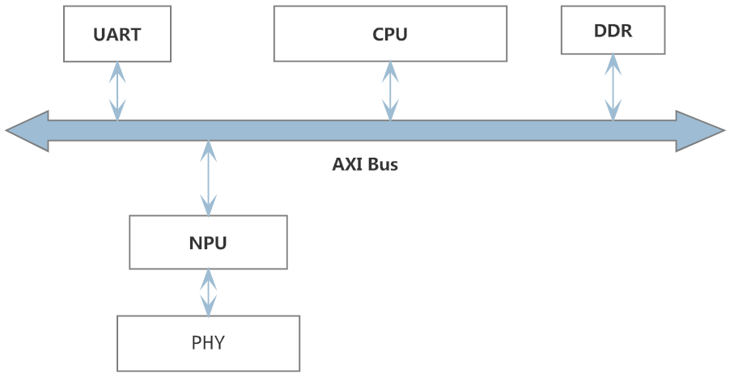

NPU内部结构
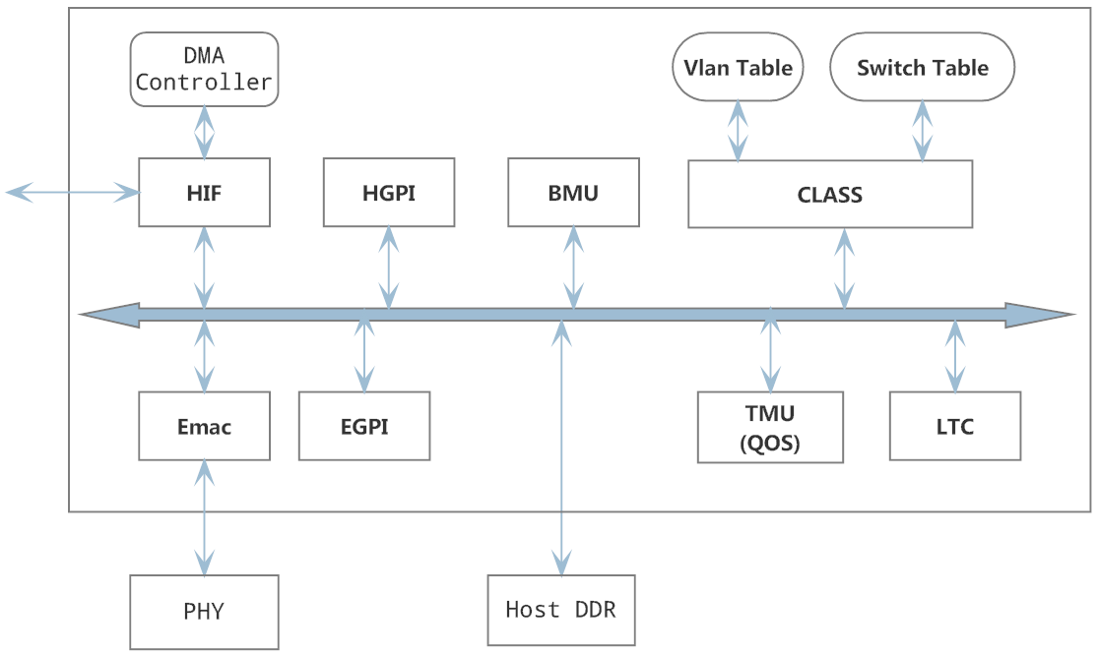

NPU slow patch flow
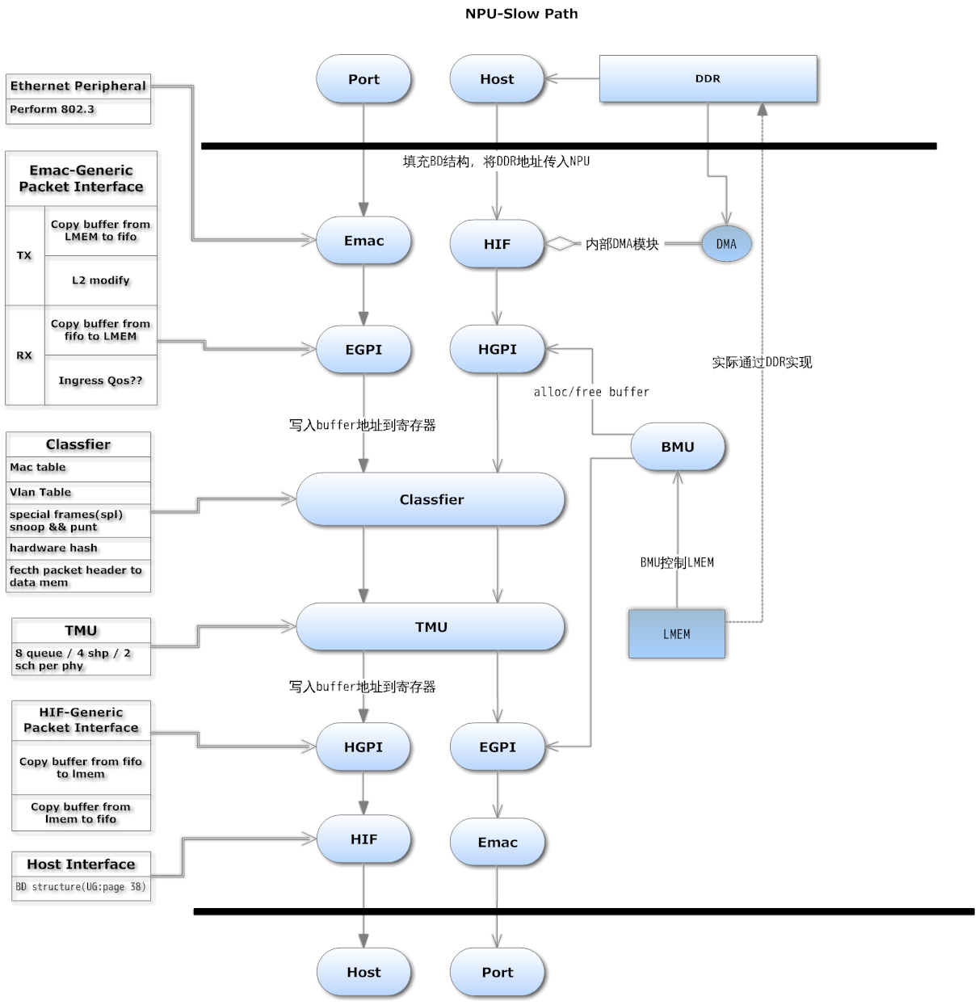

Fast Path flow
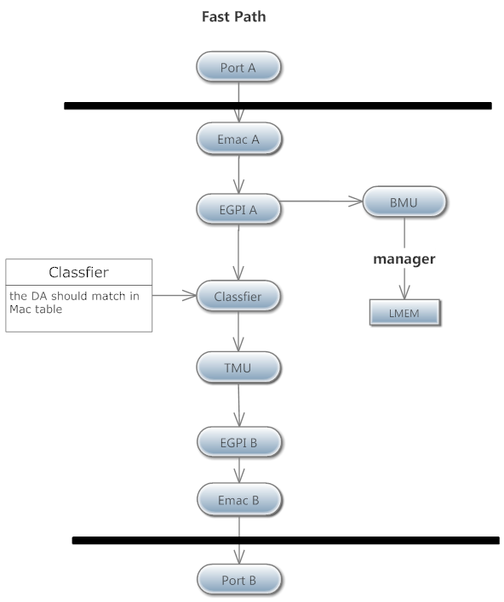
简介：
BMU模块：负责Alloc 和 Free buffer，管理LMEM。
Classfier 模块：进行Switch，读取packet header内容，将packet进行classify and modify,然后传递到TMU
TMU模块：负责实现QoS流程，将packet按照放入优先级队列后然后发送到指定port
GPI模块：通过BMU获取buffer，将TMU传递的指针指向的数据copy到内部fifo。
通过BMU获取buffer，将内部fifo数据copy到LMEM,传递指针到classfier
TX:
HIF模块：负责将HOST 端buffer通过DMA复制到内部fifo中.fifo连接到GPI.
EMAC模块：负责将fifo中的数据packet传输出去
RX:
HIF模块：负责将fifo中的buffer 通过DMA传输到Host。
EMAC模块：负责将packet传递到内部fifo

模块功能

HIF模块
通过DMA获取DDR中的packet数据，copy到内部的fifo中，trigger GPI读取数据。
HOST将BD ring 的首地址写入寄存器，通过更新BD的结构，trigger HIF不停的进行DMA数据读取，写入
硬件接受的数据包开头需要包含RX HEADER，TX HEADER，储存一些硬件使用的信息。
本模块包含TX/RX中断，在进行完DMA读取，写入操作之后，会触发中断。
寄存器描述：
- HIF_VERSION
模块基础信息
- HIF_TX_CTRL
Enable TX DMA功能，trigger DMA读取操作。
- HIF_TX_CURR_BD_ADDR
- HIF_TX_ALLOC
Number of cycles that HIF TX block would wait
before retrying for checking for destination buffer
allocation
- HIF_TX_BDP_ADDR
HOST写入TX BD地址到此寄存器
- HIF_TX_STATUS
- HIF_RX_CTRL
Enable RX DMA功能，trigger DMA读取操作。
- HIF_RX_BDP_ADDR
HOST写入RX BD地址到此寄存器
- HIF_RX_STATUS
- HIF_INT_SRC
中断源标志
- HIF_INT_EN
中断开关
- HIF_POLL_CTRL
Number of cycles that HIFR/TX BDP block would wait
before re-fetchecing the Descritpor control word if the
previous descriptor fetched was disabled
Link with HIF_RX/TX_ CTRL
- HIF_RX_CURR_BD_ADDR
- HIF_RX_ALLOC
Number of cycles that HIF RX block would wait
before retrying for checking for destination buffer
allocation
- HIF_TX_DMA_STATUS
- HIF_RX_DMA_STATUS
- HIF_INT_COAL
Used for coalescing of HIF interrupts and generate of interrupt after counter clock cycle expiry.
可以用来对中断进行一定的聚合,在大量中断出现是可以有效减少中断，相delay也会相对较小
- HIF_RX_DMA_STATUS
- HIF_MISC
- HIF_TX_PKT_CNT
- HIF_RX_PKT_CNT

GPI模块
所有数据存储在LMEM中。（实际LMEM为DDR，软件可以当作LMEM）
GPI作为传输模块，在TX端负责将数据从HIF/EMAC传输到classfier
在RX端在从TMU将数据传输到HIF/EMAC.
TX可以根据包头内容实现L2 Action ，对包的内容做一些改变
RX端有Flow control 设计，防止over run。
寄存器描述：
- GPI_VERSION
- GPI_CTRL
- GPI_RX_CONFIG
- GPI_HDR_SIZE
LMEM Buffer HDR size.
- GPI_BUF_SIZE
设定buffer size，必须与BMU设置一致
- GPI_LMEM_ALLOC_ADDR
- GPI_LMEM_FREE_ADDR
对应BMU_ALLOC_CTRL BMU_FREE_CTRL寄存器，申请 释放bmu buffer
- GPI_CLASS_ADDR
写入数据到classfier地址
- GPI_DRX_FIFO
- GPI_TRX_FIFO
- GPI_INQ_PKTPTR
将此寄存器地址写入到TMU 的寄存器中，GPI会trigger TMU往此寄存器写入传输数据指针
- GPI_TMLF_TX
Transmit starts if tx_fifo_count > Threshould or end of frame is happened.
Transmit MAC Low Level FIFO Interface block.=>TMLF
- GPI_DTX_ASEQ
- GPI_FIFO_DEBUG
包含fifo count && packet count
- GPI_TX_PAUSE_TIME
- GPI_LMEM_SEC_BUF_DATA_OFFSET
If the packet is stored in more than one buffer, from second buffer onwards the buffer header size is 16 (i.e. x10) for each buffer, to store the next pointer and other info.
- GPI_FIFO_STATUS
表示TX underrun status
- GPI_CSR_TOE_CHKSUM_EN
A-seq module gpi_dtx_aseq calculates ip/tcp/udp checks and updated the packet,crc recalc
- GPI_CSR_OVERRUN_DROPCNT
Overrun drop counter.
- GPI_TX_DBUG_REG1
- GPI_TX_DBUG_REG2
- GPI_TX_DBUG_REG3
- GPI_TX_DBUG_REG4
- GPI_TX_DBUG_REG5
- GPI_TX_DBUG_REG6
- GPI_RX_DBUG_REG1
- GPI_RX_DBUG_REG2
- GPI_BMU1_PHY_LOW_WATERMARK
These are used to enable emac flow control. If BMU1 phy (respective PHY ) buffer count is more than the HIGH_WATERMARK, emac flow control is enabled so that pause frames are generated by EMAC.
If current buffer count is less than the LOW_WATERMARK level, the resume frame(pause zero) is send request is given to EMAC. This is to resume transmit from the other end.
BMU1 PHY counters referes to BMU_MAS[0to7]_BUF_CNT. THis indicates, number of buffers used by respective phy's
- GPI_BMU1_PHY_HIGH_WATERMARK
- GPI_FW_CONTROL
- GPI_FW_CONTROL1
INV function is deprecated. Please ignore.
- GPI_RXF_FIFO_LOW_WATERMARK
used for the flow control based on RX FIFO count in GPI block
- GPI_RXF_FIFO_HIGH_WATERMARK
- GPI_USE_CLASS_INQ_AFULL
If classified inq almost full, stop writing
- GPI_PORT_SHP0_CTRL
- GPI_PORT_SHP0_WGHT
- GPI_PORT_SHP0_STATUS
- GPI_PORT_SHP1_CTRL
bit 0 : Shaper enable
bit [4:1] : Shaper Clock Div value.
- GPI_PORT_SHP0_WGHT
- GPI_PORT_SHP1_STATUS
- GPI_PORT_SHP_CONFIG
Bit[0-7]
Bit 0 0 ➔ Shaper0 is bps, 1 ➔ Shaper0 is pps.
Bit 1 0 ➔ Shaper1 is bps, 1 ➔ Shaper1 is pps,
Bits [3:2] 00 ➔ Shaper0 is for port level data rate,
01 ➔ Shaper0 is for BCAST Packets,
10 ➔ Shaper0 is for MCAST Packets.
Bits [5:4] 00 ➔ Shaper1 is for port level data rate,
01 ➔ Shaper1 is for BCAST Packets,
10 ➔ Shaper1 is for MCAST Packets.
- GPI_CSR_SHP_DROPCNT
- GPI_PORT_SHP0_MIN_CREDIT
- GPI_PORT_SHP1_MIN_CREDIT
NPU未使用：
GPI_DDR_FREE_ADDR
GPI_DDR_ALLOC_ADDR
GPI_DDR_DATA_OFFSET
GPI_LMEM_DATA_OFFSET
GPI_DDR_SEC_BUF_DATA_OFFSET
GPI_EMAC_1588_TIMESTAMP_EN
GPI_BMU2_PHY_LOW_WATERMARK
GPI_BMU2_PHY_HIGH_WATERMARK

Classfier的验证
负责分类以及辅助L3 modify功能。我们采用无PE结构，host需要处理 learning &&ageing 功能
需要实现报文的快速路径分发，特殊报文识别和传递。
对于mac/vlan table的hash，查找操作。
管理了对各个端口属性的设置，用于处理VLAN协议等。
- CLASS_VERSION
- CLASS_TX_CTRL
- CLASS_INQ_PKTPTR
GPI写入数据的寄存器地址
- CLASS_HDR_SIZE
Offset to data in buffer
- CLASS_SNOOP_SPL_ETYPE_REG01
配置snoop ether type类型
- CLASS_SNOOP_SPL_ETYPE_REG23
- CLASS_SNOOP_CONTROL
UG wrong: bit 6 is for spl mcast addr1 enable
UG wrong: bit 7 is for spl mcast addr 2 enable
- CLASS_TM_INQ_ADDR
TMU输入寄存器地址
- CLASS_PHY1_RX_PKTS
- CLASS_PHY1_L3_FAIL_PKTS
- CLASS_PHY1_V4_PKTS
- CLASS_PHY1_V6_PKTS
- CLASS_PHY1_CHKSUM_ERR_PKTS
- CLASS_PHY1_TTL_ERR_PKTS
- CLASS_PHY2_RX_PKTS
- CLASS_PHY2_L3_FAIL_PKTS
- CLASS_PHY2_V4_PKTS
- CLASS_PHY2_V6_PKTS
- CLASS_PHY2_CHKSUM_ERR_PKTS
- CLASS_PHY2_TTL_ERR_PKTS
- CLASS_PHY3_RX_PKTS
- CLASS_PHY3_L3_FAIL_PKTS
- CLASS_PHY3_V4_PKTS
- CLASS_PHY3_V6_PKTS
- CLASS_PHY3_CHKSUM_ERR_PKTS
- CLASS_PHY3_TTL_ERR_PKTS
- CLASS_PHY1_ICMP_PKTS
- CLASS_PHY1_IGMP_PKTS
- CLASS_PHY1_TCP_PKTS
- CLASS_PHY1_UDP_PKTS
- CLASS_PHY2_ICMP_PKTS
- CLASS_PHY2_IGMP_PKTS
- CLASS_PHY2_TCP_PKTS
- CLASS_PHY2_UDP_PKTS
- CLASS_PHY3_ICMP_PKTS
- CLASS_PHY3_IGMP_PKTS
- CLASS_PHY3_TCP_PKTS
- CLASS_PHY3_UDP_PKTS
- CLASS_PHY4_ICMP_PKTS
- CLASS_PHY4_IGMP_PKTS
- CLASS_PHY4_TCP_PKTS
- CLASS_PHY4_UDP_PKTS
- CLASS_PHY4_RX_PKTS
- CLASS_PHY4_L3_FAIL_PKTS
- CLASS_PHY4_V4_PKTS
- CLASS_PHY4_V6_PKTS
- CLASS_PHY4_CHKSUM_ERR_PKTS
- CLASS_PHY4_TTL_ERR_PKTS
- CLASS_GLOBAL_MGMT_REG
- CLASS_AFULL_THRES
Class full wartermark
- CLASS_SMEM_OFFSET
- CLASS_LMEM_BUF_SIZE
- CLASS_VLAN_ID
设定default vid
- CLASS_BMU1_BUF_FREE:
- CLASS_USE_TMU_INQ
Class will not write pointers to TMU, if tmu inq full condition is occurred.
- CLASS_VLAN_ID1
- CLASS_BUS_ACCESS_BASE_ADDR
- CLASS_TPID0_TPID1
- CLASS_TPID2
- CLASS_L4_CHKSUM
TCP/UDP/IP checksum drop is enables to check for respective checksum errors in packets and drop the frames.
If also consists of short packet threshold, if frames size is below threshold it is dropped.
- CLASS_STATE
- CLASS_QB_BUF_AVAIL
- CLASS_RO_BUF_AVAIL
- CLASS_DOS_CONTRL1
- CLASS_DOS_CONTRL2
- CLASS_DOS_TCP_FLAGCHK_COMB_VALUE1
- CLASS_DOS_ICMPV4_MAX_PKTLEN:
- CLASS_ING_AFULL_THRES(should be CLASS_INQ_AFULL_THRES)
- CLASS_DMEM_BRS_OFFSET
- CLASS_PHY5_RX_PKTS
- CLASS_PHY5_TX_PKTS
- CLASS_PHY5_L3_FAIL_PKTS
- CLASS_PHY5_V4_PKTS
- CLASS_PHY5_V6_PKTS
- CLASS_PHY5_CHKSUM_ERR_PKTS
- CLASS_PHY5_TTL_ERR_PKTS
- CLASS_PHY5_ICMP_PKTS
- CLASS_PHY5_IGMP_PKTS
- CLASS_PHY5_TCP_PKTS
- CLASS_PHY5_UDP_PKTS
- CLASS_PHY6_RX_PKTS
- CLASS_PHY6_TX_PKTS
- CLASS_PHY6_L3_FAIL_PKTS
- CLASS_PHY6_V4_PKTS
- CLASS_PHY6_V6_PKTS
- CLASS_PHY6_CHKSUM_ERR_PKTS
- CLASS_PHY6_TTL_ERR_PKTS
- CLASS_PHY6_ICMP_PKTS
- CLASS_PHY6_IGMP_PKTS
- CLASS_PHY6_TCP_PKTS(UG 描述有误)
- CLASS_PHY6_UDP_PKTS（UG描述有误）
- CLASS_SNOOP_SPL_MCAST_ADDR1_LSB
SPL means special frames, if the address matches with these configured registers, those are punt to host.
- CLASS_SNOOP_SPL_MCAST_ADDR1_MSB
- CLASS_SNOOP_SPL_MCAST_ADDR2_LSB
- CLASS_SNOOP_SPL_MCAST_ADDR2_MSB
- CLASS_SNOOP_SPL_MCAST_MASK1_LSB
- CLASS_SNOOP_SPL_MCAST_MASK1_MSB
- CLASS_SNOOP_SPL_MCAST_MASK2_LSB
- CLASS_SNOOP_SPL_MCAST_MASK2_MSB\
SPL means special frames, if the address matches with these configured registers, those are punt to host.
- CLASS_LMEM_DATA_OFFSET
- CLASS_DAMACHASH_HOST_CMD_REG

These are MAC/VLAN table access registers
- CLASS_DAMACHASH_HOST_MAC_ADDR1_REG
- CLASS_DAMACHASH_HOST_MAC_ADDR2_REG
- CLASS_DAMACHASH_HOST_MAC_ADDR3_REG
- CLASS_DAMACHASH_HOST_MAC_ADDR4_REG
- CLASS_DAMACHASH_HOST_MAC_ADDR5_REG
- CLASS_DAMACHASH_HOST_ENTRY_REG
- CLASS_DAMACHASH_HOST_STATUS_REG
- CLASS_DAMACHASH_HOST_DIRECT
- CLASS_DAMACHASH_PE_CMD_REG
- CLASS_DAMACHASH_PE_MAC_ADDR1_REG
- CLASS_DAMACHASH_PE_MAC_ADDR2_REG
- CLASS_DAMACHASH_PE_MAC_ADDR3_REG
- CLASS_DAMACHASH_PE_MAC_ADDR4_REG
- CLASS_DAMACHASH_PE_MAC_ADDR5_REG
- CLASS_DAMACHASH_PE_ENTRY_REG
- CLASS_DAMACHASH_PE_STATUS_REG
- CLASS_DAMACHASH_PE_DIRECT
- CLASS_DAMACHASH_FREELIST_ENTRIES:
- CLASS_DAMACHASH_FREELIST_HEAD_PTR
- CLASS_DAMACHASH_FREELIST_TAIL_PTR
- CLASS_DAVLANHASH_HOST_CMD_REG
- CLASS_ DAVLANHASH _HOST_MAC_ADDR1_REG
- CLASS_ DAVLANHASH _HOST_MAC_ADDR2_REG
- CLASS_ DAVLANHASH _HOST_MAC_ADDR3_REG
- CLASS_ DAVLANHASH _HOST_MAC_ADDR4_REG
- CLASS_ DAVLANHASH _HOST_MAC_ADDR5_REG
- CLASS_ DAVLANHASH _HOST_ENTRY_REG
- CLASS_ DAVLANHASH _HOST_STATUS_REG
- CLASS_ DAVLANHASH _HOST_DIRECT
- CLASS_ DAVLANHASH _PE_CMD_REG
- CLASS_ DAVLANHASH _PE_MAC_ADDR1_REG
- CLASS_ DAVLANHASH _PE_MAC_ADDR2_REG
- CLASS_ DAVLANHASH _PE_MAC_ADDR3_REG
- CLASS_ DAVLANHASH _PE_MAC_ADDR4_REG
- CLASS_ DAVLANHASH _PE_MAC_ADDR5_REG
- CLASS_ DAVLANHASH _PE_ENTRY_REG
- CLASS_ DAVLANHASH _PE_STATUS_REG
- CLASS_ DAVLANHASH _PE_DIRECT
- CLASS_ DAVLANHASH _FREELIST_ENTRIES:
- CLASS_ DAVLANHASH _FREELIST_HEAD_PTR
- CLASS_ DAVLANHASH _FREELIST_TAIL_PTR
- CLASS_PORT0_STRUC1

vid prefix used to | with the vid of frame, then do the mac search

Fallback_bd_id is a default vid

Untag from Btable – It is used at Egress port, when enabled and based on vlan entry settings, vid value delete vlan tag
- CLASS_PORT0_STRUC2
- CLASS_PORT1_STRUC1
- CLASS_PORT1_STRUC2
- CLASS_PORT2_STRUC1
- CLASS_PORT2_STRUC2
- CLASS_PORT3_STRUC1
- CLASS_PORT3_STRUC2
- CLASS_PORT4_STRUC1
- CLASS_PORT4_STRUC2
- CLASS_PORT5_STRUC1
- CLASS_PORT5_STRUC2
- CLASS_GLOBAL_CFG

L2 Special punt enable && default bd entry when no match

必须在初始化时正确设定，否则会出现因为没有bd entry导致无法转发
- CLASS_GLOBAL_CUTTHRU_REG

It is used when Cut through bit is set in MAC/VLAN table action field and Action defined as ACT_FORWARD.

Replce the tpid with default value
- CLASS_LPHY_PPHY_BITMAP
- CLASS_DEF_PTPID

When vlan id ==0 && ptpid matched ，frame is a ptag frame
- CLASS_PARSE_INCOMPLETE_ACTION
- CLASS_PUNT_COS
- CLASS_DOS_ICMPV6_MAX_PKTLEN
- CLASS_DEBUG_BUS01
- CLASS_DEBUG_BUS23
- CLASS_DEBUG_BUS45
- CLASS_DEBUG_BUS67
- CLASS_DEBUG_BUS89
- CLASS_DEBUG_BUS1011
- CLASS_NPU_CTRL

ACT_COS_DISCARD is not supported
- CLASS_UNMANAGED_PORTMAP
- CLASS_PORT0_STRUC3
- CLASS_PORT1_STRUC3
- CLASS_PORT2_STRUC3
- CLASS_PORT3_STRUC3
- CLASS_PORT4_STRUC3
- CLASS_PORT5_STRUC3
NPU not supported：
CLASS_PORT_TCP_CHKSUM_OFFLOAD
CLASS_QOS_PORT01_TC_SEL
CLASS_QOS_PORT23_TC_SEL
CLASS_QOS_PORT45_TC_SEL
CLASS_QOS_PORT67_TC_SEL
CLASS_QOS_GLOBAL_DSCP2TC_MAP0-6
CLASS_QOS_PORT0-7_PCP2TC_MAP
CLASS_QOS_PORT_PID2TC_MAP
CLASS_QOS_PORT0-7_TC2COS_MAP
CLASS_PE_STATUS
CLASS_ROUTE_HASH_ENTRY_SIZE
CLASS_ROUTE_TABLE_BASE
CLASS_ROUTE_MULTI_REG

CLASS_HIF_PARSE

CLASS_PE_INT_SRC

CLASS_PE_INT_ENABLE

CLASS_PHY5_INTF_FAIL_PKTS

CLASS_PHY5_INTF_MATCH_PKTS

CLASS_PHY5_LP_FAIL_PKTS

CLASS_PHY6_LP_FAIL_PKTS

CLASS_PHY6_INTF_FAIL_PKTS

CLASS_PHY6_INTF_MATCH_PKTS

CLASS_PHY7_*

CLASS_PHY8_*

CLASS_PHY1_TX_PKTS

CLASS_PHY1_LP_FAIL_PKTS

CLASS_PHY1_INTF_FAIL_PKTS

CLASS_PHY1_INTF_MATCH_PKTS

CLASS_PHY2_TX_PKTS

CLASS_PHY2_LP_FAIL_PKTS

CLASS_PHY2_INTF_FAIL_PKTS

CLASS_PHY2_INTF_MATCH_PKTS

CLASS_PHY3_TX_PKTS

CLASS_PHY3_LP_FAIL_PKTS

CLASS_PHY3_INTF_FAIL_PKTS

CLASS_PHY3_INTF_MATCH_PKTS

CLASS_PHY4_TX_PKTS

CLASS_PHY4_LP_FAIL_PKTS

CLASS_PHY4_INTF_FAIL_PKTS

CLASS_PHY4_INTF_MATCH_PKTS

CLASS_BCAST_PORTMAP

CLASS_PKT_CHAIN_CNTRL

CLASS_CACHE_HOST_CMD_REG

CLASS_CACHE_HOST_REG1

CLASS_CACHE_HOST_REG2

CLASS_CACHE_HOST_REG3

CLASS_CACHE_HOST_REG4

CLASS_CACHE_HOST_STATUS_REG

CLASS_CACHE_FW_CMD_REG

CLASS_CACHE_FW_REG1

CLASS_CACHE_FW_REG2

CLASS_CACHE_FW_REG3

CLASS_CACHE_FW_REG4

CLASS_CACHE_FW_STATUS_REG

CLASS_PORT6_STRUC1

CLASS_PORT6_STRUC2

CLASS_PORT7_STRUC1

CLASS_PORT7_STRUC2

CLASS_GLOBAL_REGISTER

CLASS_MEM_ACCESS_ADDR

CLASS_MEM_ACCESS_WDATA

CLASS_MEM_ACCESS_RDATA

CLASS_BUS_ACCESS_ADDR

CLASS_BUS_ACCESS_WDATA

CLASS_BUS_ACCESS_RDATA

CLASS_TCP_OFFLOAD_PKTLEN_THRESH

TMU的验证

支持8个queue，4个sharper，2个scheduler，每个scheduler可以最多链接8个queue

负责从classfier接受数据，输出到GPI模块。

负责处理802.1p，QOS协议，同时控制吞吐量。

对于每个端口的输出数据的流量进行控制。
- TMU_VERSION
- TMU_INQ_WATERMARK
Set the threshold which above shows inq full
- TMU_PHY_INQ_PKTPTR
由classfier写入packet && length信息，和info这两个寄存器需要一起写
- TMU_PHY_INQ_PKTINFO,
- TMU_PHY_INQ_STAT,
- TMU_CTRL,
- TMU_TEQ_CTRL,
- TMU_BMU_INQ_ADDR
BMU free addr，used to free buffer when inq is full
- TMU_LMEM_BUF_SIZE,
- TMU_LMEM_DATA_OFFSET,
- TMU_PHY0_INQ_ADDR
Egress port address，和GPI模块对接起来
- TMU_PHY1_INQ_ADDR,
- TMU_PHY2_INQ_ADDR,
- TMU_PHY3_INQ_ADDR,
- TMU_PHY4_INQ_ADDR,
- TMU_PHY5_INQ_ADDR,
- TMU_PHY0_TDQ_IIFG_CFG,
- TMU_PHY1_TDQ_IIFG_CFG,
- TMU_PHY2_TDQ_IIFG_CFG,
- TMU_PHY3_TDQ_IIFG_CFG,
- TMU_PHY4_TDQ_IIFG_CFG,
- TMU_PHY5_TDQ_IIFG_CFG,
- TMU_PHY0_TDQ_CTRL,
- TMU_PHY1_TDQ_CTRL,
- TMU_PHY2_TDQ_CTRL,
- TMU_PHY3_TDQ_CTRL,
- TMU_CNTX_ACCESS_CTRL,
- TMU_CNTX_ADDR,
- TMU_CNTX_DATA,
- TMU_CNTX_CMD,
- TMU_DBG_BUS_TOP,
- TMU_DBG_BUS_PP0,
- TMU_DBG_BUS_PP1,
- TMU_DBG_BUS_PP2,
- TMU_DBG_BUS_PP3,
- TMU_DBG_BUS_PP4,
- TMU_DBG_BUS_PP5,
- PHY0_TMU_SCH0_CTRL,
- PHY0_TMU_SCH0_Q0_WGHT,
- PHY0_TMU_SCH0_Q1_WGHT,
- PHY0_TMU_SCH0_Q2_WGHT,
- PHY0_TMU_SCH0_Q3_WGHT,
- PHY0_TMU_SCH0_Q4_WGHT,
- PHY0_TMU_SCH0_Q5_WGHT,
- PHY0_TMU_SCH0_Q6_WGHT,
- PHY0_TMU_SCH0_Q7_WGHT,
- PHY0_TMU_SCH0_Q_ALLOC0,
- PHY0_TMU_SCH0_Q_ALLOC1,
- PHY0_TMU_SCH0_BIT_RATE,
- PHY0_TMU_SCH0_POS,
- PHY0_TMU_SCH1_Q0_WGHT,
- PHY0_TMU_SCH1_Q1_WGHT,
- PHY0_TMU_SCH1_Q2_WGHT,
- PHY0_TMU_SCH1_Q3_WGHT,
- PHY0_TMU_SCH1_Q4_WGHT,
- PHY0_TMU_SCH1_Q5_WGHT,
- PHY0_TMU_SCH1_Q6_WGHT,
- PHY0_TMU_SCH1_Q7_WGHT,
- PHY0_TMU_SCH1_Q_ALLOC0,
- PHY0_TMU_SCH1_Q_ALLOC1,
- PHY0_TMU_SCH1_BIT_RATE,
- PHY0_TMU_SHP0_CTRL,
- PHY0_TMU_SHP0_WGHT,
- PHY0_TMU_SHP0_MAX_CREDIT,
- PHY0_TMU_SHP0_CTRL2,
- PHY0_TMU_SHP0_MAX_CREDIT,
- PHY0_TMU_SHP0_STATUS,
- PHY0_TMU_SHP1_CTRL,
- PHY0_TMU_SHP1_WGHT,
- PHY0_TMU_SHP1_MAX_CREDIT,
- PHY0_TMU_SHP1_CTRL2,
- PHY0_TMU_SHP1_MAX_CREDIT,
- PHY0_TMU_SHP1_STATUS,
- PHY0_TMU_SHP2_CTRL,
- PHY0_TMU_SHP2_WGHT,
- PHY0_TMU_SHP2_MAX_CREDIT,
- PHY0_TMU_SHP2_CTRL2,
- PHY0_TMU_SHP2_MAX_CREDIT,
- PHY0_TMU_SHP2_STATUS,
- PHY0_TMU_SHP3_CTRL,
- PHY0_TMU_SHP3_WGHT,
- PHY0_TMU_SHP3_MAX_CREDIT,
- PHY0_TMU_SHP3_CTRL2,
- PHY0_TMU_SHP3_MAX_CREDIT,
- PHY0_TMU_SHP3_STATUS
//UG error
- TMU_PHY_QUEUE_SEL
- TMU_CURQ_PTR:
- TMU_CURQ_PKT_CNT
- TMU_CURQ_DROP_CNT:
- TMU_CURQ_TRANS_CNT
- TMU_CURQ_QSTAT
- TMU_HW_PROB_CFG_TBL0
- TMU_HW_PROB_CFG_TBL1
- TMU_CURQ_DEBUG
// end UG error
Not Support By NPU
TMU_AFULL_THRES
TMU_BMU_BUF_SIZE
TMU_MAX_BUF_CNT
TMU_DDR_DATA_OFFSET
TMU_LMEM_BASE_ADDR
TMU_PHY6_INQ_ADDR
TMU_PHY7_INQ_ADDR
TMU_PHY6_TDQ_IIFG_CFG
TMU_PHY7_TDQ_IIFG_CFG
TMU_PHY4_TDQ_CTRL
TMU_PHY5_TDQ_CTRL
TMU_PHY6_TDQ_CTRL
TMU_PHY7_TDQ_CTRL
TMU_DBG_BUS_PP6
TMU_DBG_BUS_PP7
TMU_METER_CFG0
TMU_METER_CFG1
TMU_METER_CMD
TMU_METER_ADDR
TMU_SCH_SHP_RANGE
SCH&&SHP regs for each PHY, not a actually reg

BMU 模块
控制所有的buffer alloc 和 free，有多个中断用来表示buffer管理的异常状态。
- BMU_VERSION,
- BMU_CTRL,
- BMU_UCAST_CONFIG,
- BMU_UCAST_BASEADDR,
- BMU_BUF_SIZE,
- BMU_BUF_CNT,
- BMU_THRES,
- BMU_LOW_WATERMARK
global buffer count number is means the num in BMU_BUF_CNT
pause/resume action will happen for all flow control enabled ports
These are used to enable emac flow control. If BMU1 global current buffer count is more than the HIGH_WATERMARK, emac flow control is enabled so that pause frames are generated by EMAC.
If current buffer count is less than the LOW_WATERMARK level, the resume frame(pause zero) is send request is given to EMAC. This is to resume transmit from the other end.
pause action will happen for all flow control enabled ports

- BMU_HIGH_WATERMARK,
- BMU_MCAST_CNT,
- BMU_REM_BUF_CNT,
- BMU_INT_SRC,
- BMU_INT_ENABLE,
- BMU_ALLOC_CTRL,
- BMU_FREE_CTRL,
- BMU_MCAST_ALLOC_CTRL,
The BMU_MCAST_ALLOC_CTRL register is used to inform BMU, the LMEM buffer and its count. Bit [3:0] refers to the count.
- BMU_FREE_ERROR_ADDR,
- BMU_CURR_BUF_CNT,
- BMU_MAS0_BUF_CNT,
- BMU_MAS1_BUF_CNT,
- BMU_MAS2_BUF_CNT,
- BMU_MAS3_BUF_CNT,
- BMU_MAS4_BUF_CNT,
- BMU_MAS5_BUF_CNT,
- BMU_MAS6_BUF_CNT,
- BMU_MAS7_BUF_CNT,
- BMU_MAS8_BUF_CNT,
- BMU_MAS9_BUF_CNT,
- BMU_MAS10_BUF_CNT,
- BMU_MAS11_BUF_CNT,
- BMU_MAS12_BUF_CNT,
- BMU_MAS13_BUF_CNT,
- BMU_MAS14_BUF_CNT,
- BMU_MAS15_BUF_CNT,
- BMU_DEBUG_BUS
DONE:
NPU未使用：
BMU_INT_MEM_ACCESS

WSP Global 模块
- WSP_VERSION
- WSP_CLASS_PE_CNT,
- WSP_LMEM_SIZE,
- WSP_TMU_EMAC_PORT_COUNT,
- WSP_EGPIS_PHY_NO,
- WSP_HIF_SUPPORT_PHY_NO,
- WSP_CLASS_HW_SUPPORT,
- WSP_SYS_GENERIC_CONTROL, //0x7
- WSP_SYS_GENERIC_STATUS,
Use to reset system
- WSP_SYS_GEN_CON0,
User define use
- WSP_SYS_GEN_CON1,
User define use
- WSP_SYS_GEN_CON2,
- WSP_SYS_GEN_CON3,
- WSP_SYS_GEN_CON4,
- WSP_DBUG_BUS,
- WSP_CLK_FRQ,
=========================================================
待定：
EMAC的验证
Please refer GEM GXL userguide for the detail description of registers. 此份文档暂未提供
Emac提供数据与EGPI进行交互，并且控制phy寄存器
Spec所属功能如下
Support for Ethernet-II and 802.3 packets
Full Duplex Operation in 10/100/1000 Mbps and 10 Gbps
Half Duplex Operation in 10/100 Mbps
Flow Control with Pause Packets and Resume Packets.
Half duplex flow control by forcing collisions on incoming frames.
Enough buffering for re-transmission. Programmable FIFO sizes from 64 bytes to 512 bytes in
transmit and receive directions to sustain high throughput and latencies.
Complete RMON Statistics for MIB
Supports packet sizes from 64 bytes up to 10K bytes for jumbo frames, Jumbo frame support
again depends on the application and the fifo depths used. NPU supports max packet size of
2K bytes.
VLAN Packet Identification and tagging.
Programmable embedded IEEE 1588 TSU (time stamp unit)
Support for 1588 precision clock synchronization protocol
Automatic 1588 timestamp insertion and capture for PTP frames
Optional Address Recognition Circuit for efficient bridging. 32 specific address registers for
filtering.
Optional padding for short packets
Ten-bit interface (TBI) to the PMA layer.
Integrated Physical Coding Sub-layer (PCS) with auto-negotiation
Support for SGMII
Flexible I/O Interface with MII, RMII, GMII, RGMII, xGMII interfaces

- Q & A
HIF
问：与旧的的spec相比，终端去掉了timeout等错误中断
IMG：新的架构较为简单，不需要错误处理
GPI：
Ingress Qos 功能
开发中

问：the file describs LMEM buffer says the buffer header size is 0x30 But in the UG : the reg GPI_LMEM_SEC_BUF_DATA_OFFSET && used in EGPI LMEM Second buffer data offset register it says the offset of the second buffer && subsequent buffer is 0x10 not 0x30 and in the LMEM file, Int Transmit LMEM structure, it not shows the port info where the packtet goes to could you help to clarify this?
答： The LMEM buffer file explains the first buffer header info of each packet in LMEM.
If the packet is stored in more than one buffer, from second buffer onwards the buffer header size is 16 (i.e. x10) for each buffer, to store the next pointer and other info.
In transmit LMEM buffer, we will not have the port info where the packet should go, port info goes as seperate information from classifier to TMU and TMU write the pointer of TX LMEM buffer to respective phy GPI block for transmit.

问what is the mean of field_valids in Vlan Table Field Valids and how to use it ?
答：This is number of fields used for search,
Vlan Table : 1 Field (Value 0x100)
MAC Table : 2 Field (Value 0x300
flag csr_rx_bdp_poll_cntr_en of hif register HIF_RX_CTRL
[IMG]is not is use, means we are using STROBE not POLL.
In general there are no issues with POLL but we have not used it in the recent past.
Poll mode is polling
Strobe mode need host trigger
问：Our cpu is configed as little endian . so For example if we want to set value of BD_SRCADDR as 0x01020304, so should we save this value with big endian in memory like {0x01,0x02,0x03,x04}?
答：The internal operation of NPU is in big endian format, the data (i.e. BD and Buffer) read by HIF block from external memory is in little endian format.
Example : BD_SRCADDR is 0x01020304 (i.e. byte 0 - 0x04, byte 1 - 0x03, byte 2 - 0x02, byte 3 - 0x01), we should save in memory as {0x04, 0x03, 0x02, 0x01} and at NPU external memory read data interface, it will be as 0x01020304.

问：In the ref driver code , tx/rx buffer descriptor number is fixed as 4, so I want to know if it can be set as value like 5,6,7? and how to determine this value?
答：Theoretically it can be set but we have be using 16 in the current FPGA testing. This is a buffer Q betwen Host and HIF. This is dependent on the amount of time HIF takes to read the BD & packet payload from HOST memory through PCI (In FPGA environment).

