密级状态：绝密( ) 机密( ) 内部资料( ) 公开( √ ）

SF-ETHERNET-SWITCH-UM

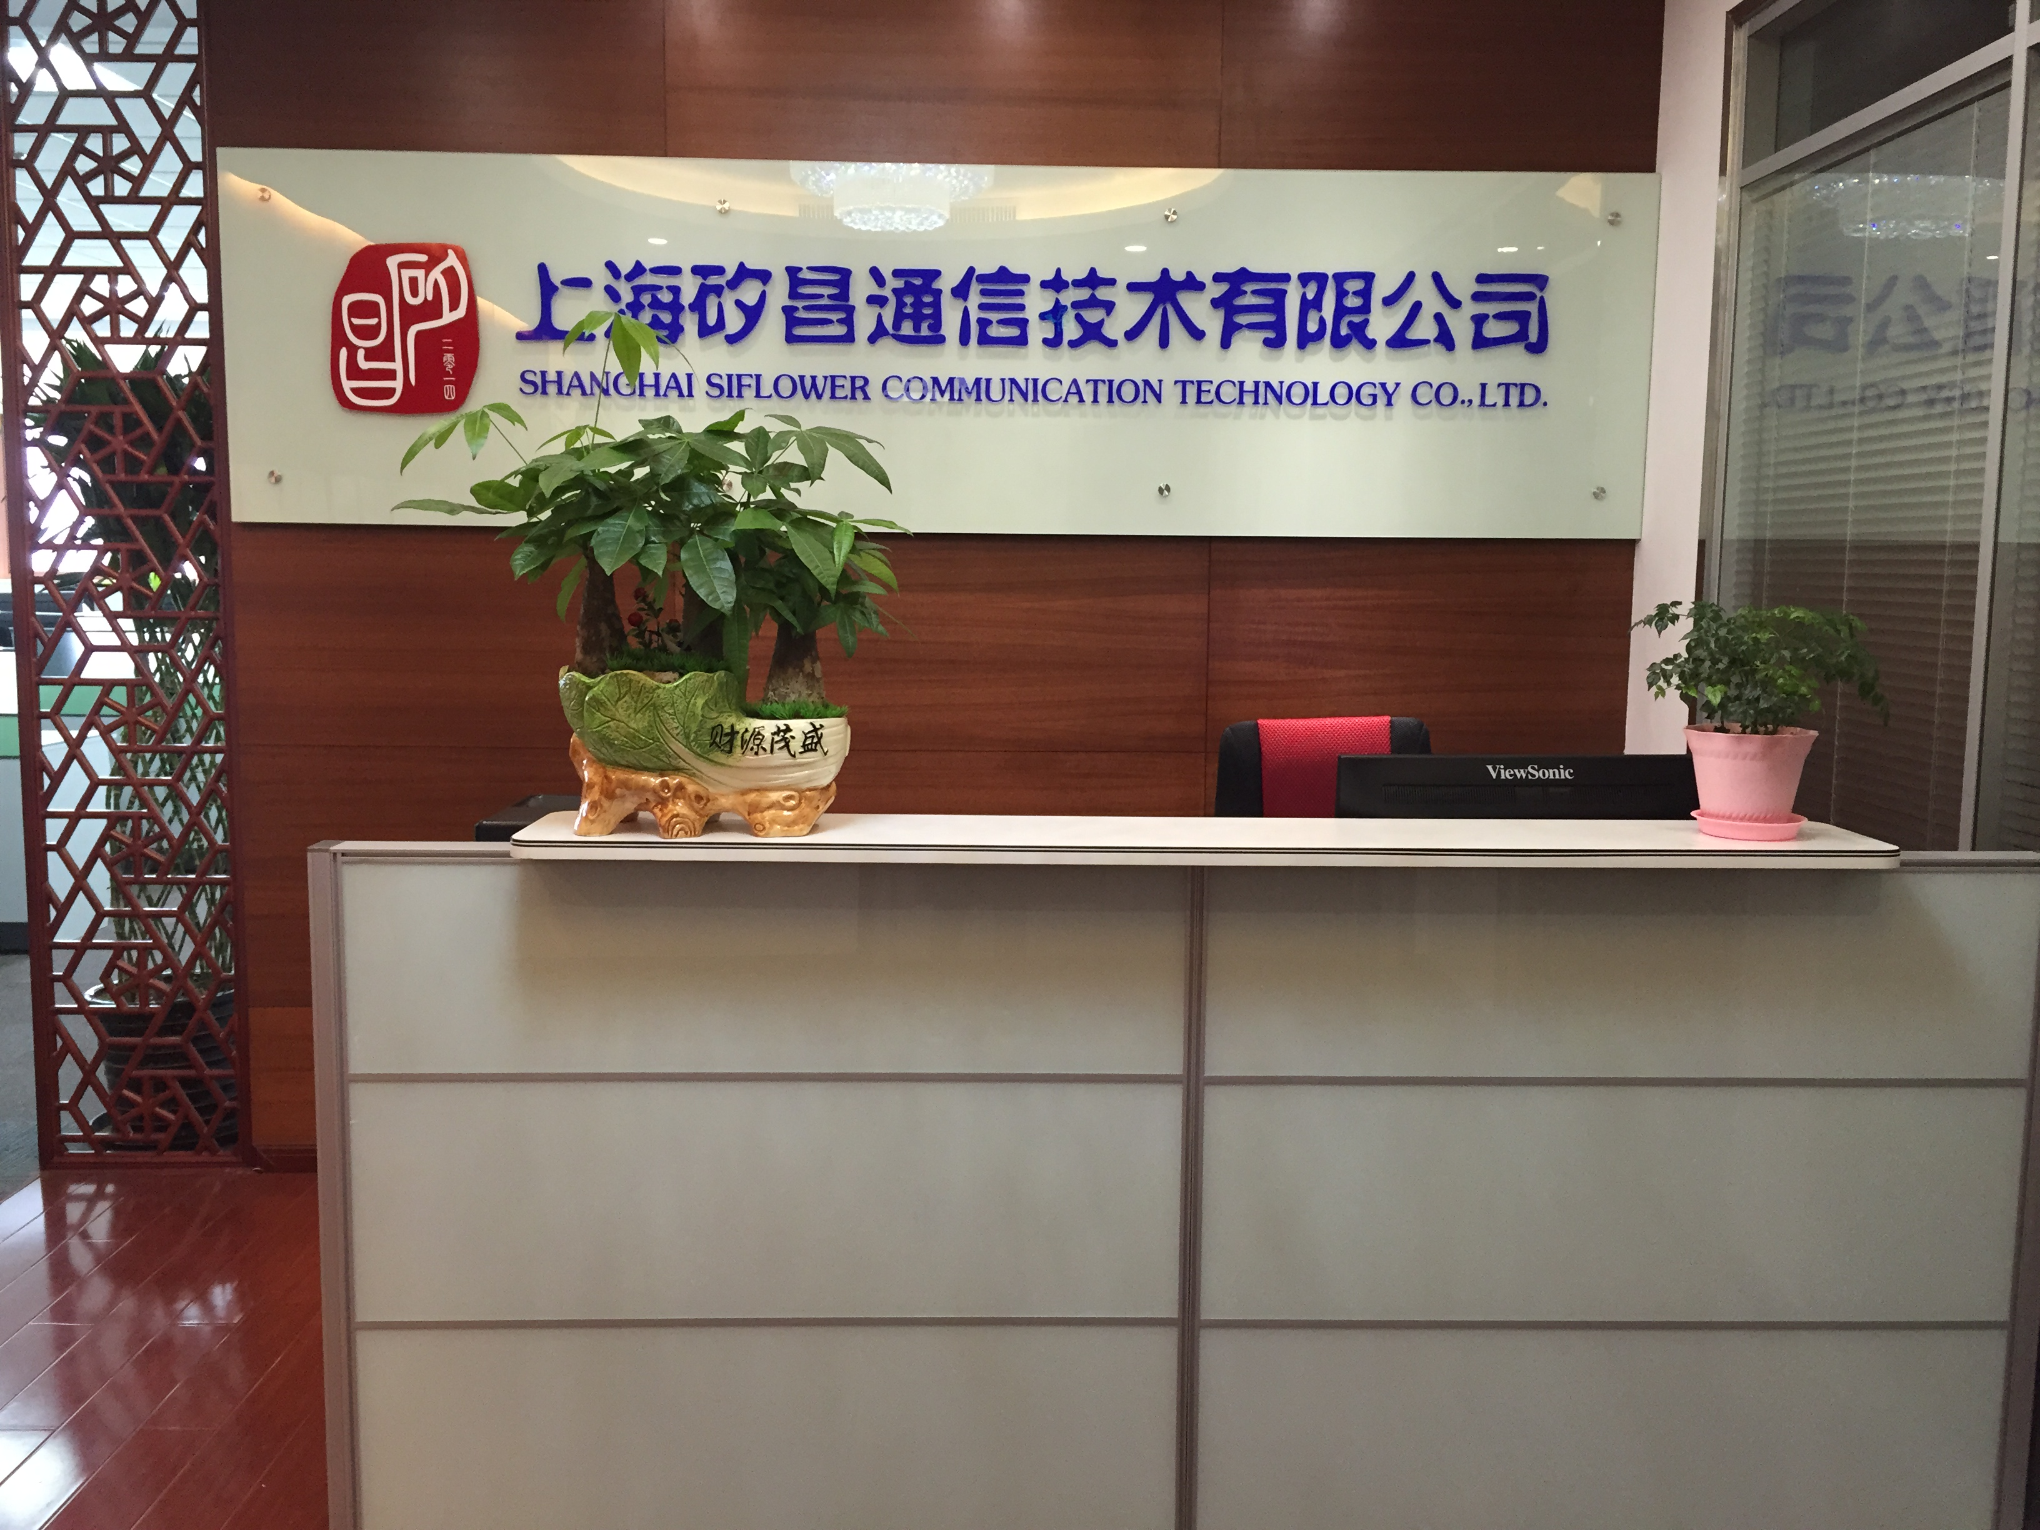
Doc No：20170224-1
Version：V1.0
Writer：Phoenix
Release Date：
2017/2/24
Verification：
Verification Date：

Revisions

Version | Writer | Date Modified | Description
V1.0 | Phoenix | 2017-02-21 | First Release

Contents
Revisions 1
Contents 2
1 Overview 3
1.1 Document overview 3
1.2 Architecture 3
1.3 Scope 3
2 Software Component Overview 4
2.1 Network Applications 4
2.2 Network Stack and Flow Setup 5
2.2.1 Forwarding Model 5
2.2.2 MAC Learning / Aging function 6
2.3 Switch Debug Interface 7
2.4 Fast Path Control && Control handler 7
2.4.1 Flow Table (MAC table) Access 7
2.4.2 Access to Peripherals 7
2.5 Base device driver 8
3 Data interface 8
3.1 Buffer descriptors 8
3.2 TX/RX packet Structure 10
3.3 NPU Interrupts 12
4 Flow Setup 13
4.1 Action entry 13
4.2 Action 14
5 Program Guide 15
5.1 Switch initialization 15
5.2 Data transceiver 15
5.3 Mac learning/ageing 18

User Manual

Overview

Document overview
This document would describe the functionality of multi-port Ethernet Switch in SF16A18. The content includes configuring the hardware and the driver implements switch && route in Open WRT.

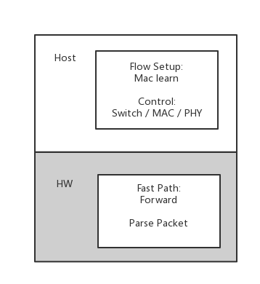
Architecture
The figure shows the hardware-based forwarding and a host-based L2 MAC learning and aging function.

Figure 1: management
This is the best choice when aiming to minimize the area beyond an existing host. All forwarding is performed by the hardware, and it is the responsibility of the host to learn addresses and write them into the MAC tables used by the forwarding engine.

Scope
The scope of this document is to provide an overview of the L2 software components for the models described in the previous section. The document is addressed to Software developers or any person wishing to have an overview of the Ethernet Switch functionality.

Software Component Overview
The reference software implementation contains drivers which provide a set of APIs for controlling the hardware (kernel sysfs), The reference drivers are written for the linux kernel environment, but the dependence upon linux is relatively low, so the drivers are readily portable to other OS environments.
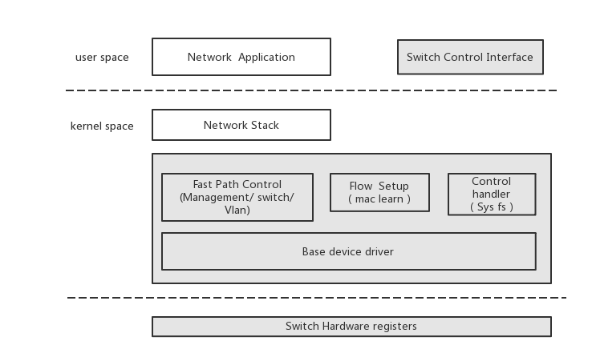
The software components are shown in the figure below. The white blocks are provided in the NPU software deliverable. The grey blocks are third party software components which are used to complete the full system.

Figure 2 Software overview

Network Applications
Network Applications refer which run at the user level within a linux system. Typically, these functions are targeted to run on the host because they require a fair amount of memory and generally do not operate at very high speeds.
Open source references for network application exist for many of these functions/protocols. These control plane functions can then in turn utilize the drivers. In general, the driver does not impose changes to applications at this level, and the customer is free to use unmodified open source for these modules and/or replace/extend them for custom requirements.
In the case of L2 switching, examples of these types of applications would be L2 control daemons for protocols such as PTP, MRP, STP, or others.

Network Stack and Flow Setup
Network Stack refers to the standard host-based software routing and switching stacks which run at
the kernel level within a linux system. In the case of L2 switching, an example Flow Setup function is the MAC learning and aging function in driver. (In a more general sense, the Flow Setup layer handles any exceptional packets, which correspond to new traffic flows, and adds entries to the hardware flow table, such that the fast path is ready to handle subsequent packets in the flow. In order to accomplish this, the NPU driver process packets in order to detect connections within supported protocols and then activate the “fast path” in the NPU.)
Together, the Network Stack and Flow Setup comprise the “slow path”.

Forwarding Model
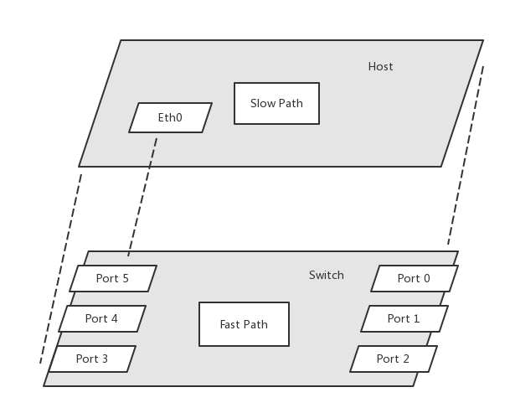
The Driver is responsible for creating and managing network device instances for the physical hardware. This allows the host OS and port-aware network stack applications to recognize and manage these interfaces as they would for any other network interface in the system. This then allows many third party or open source protocol stacks to be used in the system without modification. This model applies to L2 protocols (if supported).

Figure 3 Forwarding Model
Internally, the Driver uses only a single path to the hardware to send packets to/from each port.
The Driver may also need to provide or process “meta data” (BD descriptor && TX header && RX header) along with each packet. For example, if an exceptional frame is sent to the slow path, additional data may be needed by the slow path in order to determine the cause the “exception”. In the case of L2 MAC learning and aging, the “punt reason” is provided so that the learning/aging module react appropriately based on the reason.

MAC Learning / Aging function
This function is the traditional MAC address learning and aging function specified by the 802.1Q
standard. The L2 learning/aging function is performed by the host.
The behavior of this function can be summarized as below:
- Learn
Frames with unknown SA will be punted to the learning function
Learning function will create a MAC entry and record the ingress port for this SA
- Relearn
Frames with known SA seen on a port different from the learned port will be punted
Learning function will update the MAC entry with the new ingress port
- Age
Aging function will periodically mark MAC entries as stale
Frames with stale SA will be punted to the aging function
Aging function will update the MAC entry as fresh, otherwise MAC entry will be
eventually deleted
- Mac entry operation
If these entries are also marked as static, they will not age out
Upper layers can request to delete all MAC entries, or based on VLAN

Switch Debug Interface
The Switch Debug Interface provides a set of NPU-specific commands to control and monitor the NPU. Some of the purposes for these commands include:
Direct configuration of NPU-specific NPU enhancements which cannot be configured through open-source utilities
Display of NPU statistics beyond what is viewable through open-source utilities
Lower-level access useful for various testing and debugging purposes
The driver implements a sysfs node, the access from user space will directly deliver to the driver.

Fast Path Control && Control handler
The Fast Path Control && Control handler is used by Flow Setup or special requirements to control the fast path to accomplish the overall function of the system. The Fast Path Control Interface functions can loosely be divided into 2 categories: flow table access and access to peripherals.

Flow Table (MAC table) Access
The Flow Table Access portion of the interface allows the slow path to add, delete, and update entries in the tables. These tables in turn control how the fast path performs forwarding. In the case of L2 Switching, there are two tables: the MAC table, and the Vlan table. Functions are provided to add, delete, and update entries in each table.

Access to Peripherals
The Peripheral Access portion of the interface allows the host to access other peripherals in the NPU
such as EMAC ports, traffic manager unit (TMU).
Ports
- Port’s configuration
- Port tuple: (TPID, PVID, acceptable frame type)
- Block/unblock
Traffic Manager (TMU)
- QoS schedule parameters
- Shaper parameters
- Classification policy for frames

Base device driver
The NPU hardware is a single device residing on the bus for which there is a single base driver to map memory and registers. The base device driver is responsible for managing the low-level mapped memory and dispatching interrupts to the drivers for the logical Ethernet net devices. In the reference implementation, the base driver is modeled as a network device called “eth0”.
The base device driver is responsible for doing initialization of the various NPU hardware blocks.

Data interface

Buffer descriptors
The Switch has a built in DMA controller that will transfer the slow path packets to the Host, the Switch copies the packet completely and presents it to the Host processor in its memory. The DMA for slow path packets can support chained buffer descriptors. The host software prepares the buffer descriptors, allocates buffers associated and chains the buffer descriptors. The host software makes sure that invalid buffer descriptors have DESC_EN bit reset (set to 0) so that they will not be erroneously processed. There will always be a BD with DESC_EN set to 0 at the end of the BD chain.
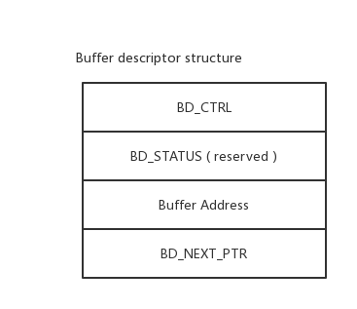
It’s recommend to ring the BD chain, so the buffer descriptors could be reused, after process the buffer descriptors, the Switch will copy packet from the Buffer Address, so this address should be a physical address and already be filled.

Table 1 Buffer descriptor structure
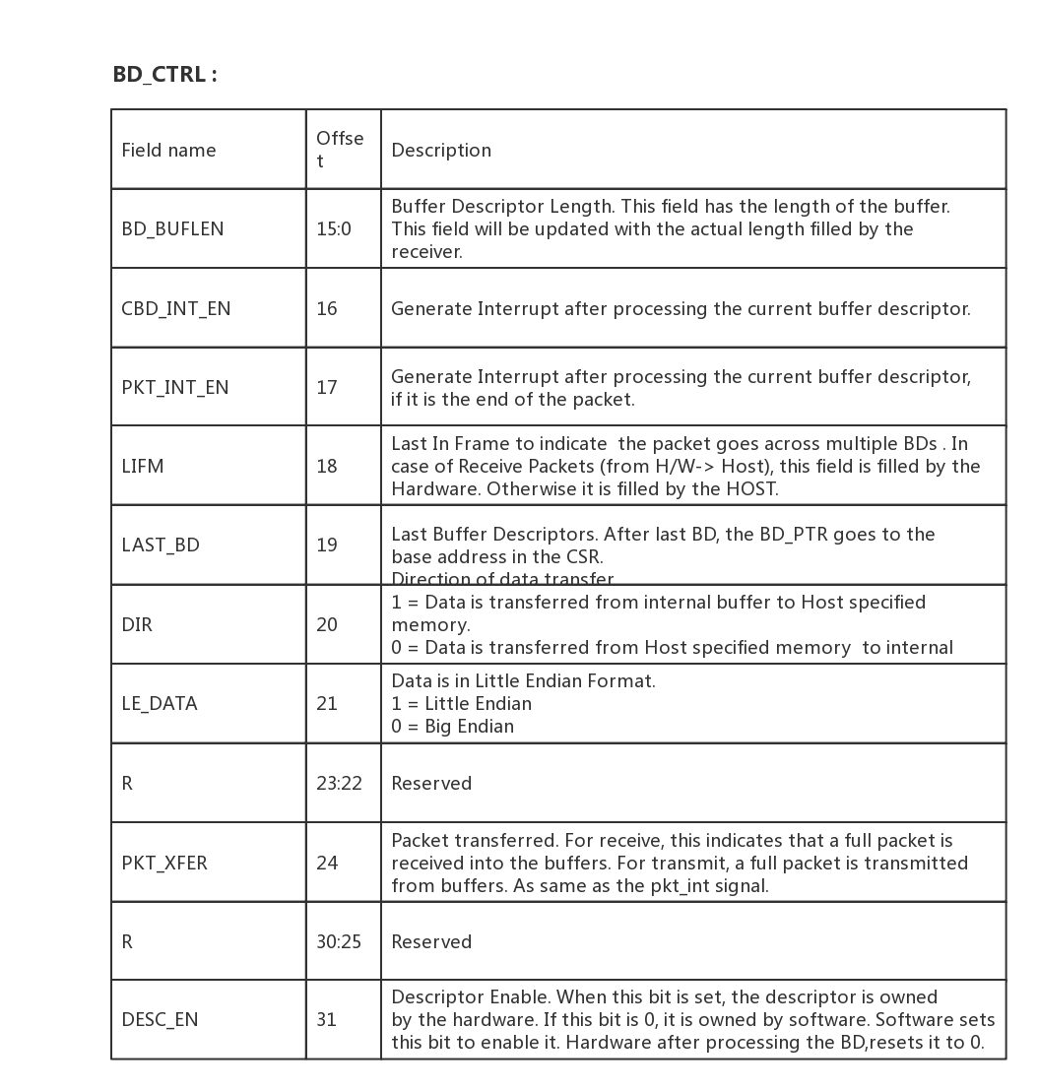

Table 2 BD CTRL
If the buffers are not available for transmission or reception, the hardware goes to an IDLE mode. When the host updates the buffer descriptors, it needs to write to the DMA control register to initiate the Buffer descriptor reads. Optionally the DMA controllers have a poll counter that will be reading the last descriptor location to see when ever the DESC_EN is set to 1.
Note: The buffer descriptor needs to be aligned on a 64 bit boundary.

TX/RX packet Structure
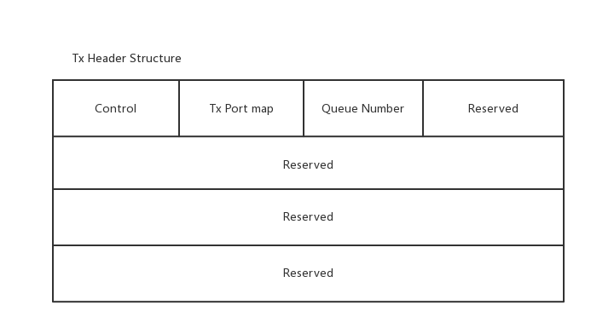
The Switch need extra info for Flow setup, transmit/receive packet would be add a header(16 bytes) for the info.

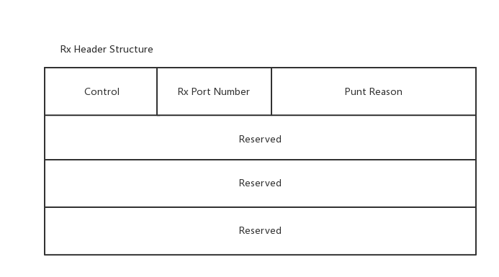
Table 3 Tx Header Structure

Table 4 Rx Header Structure

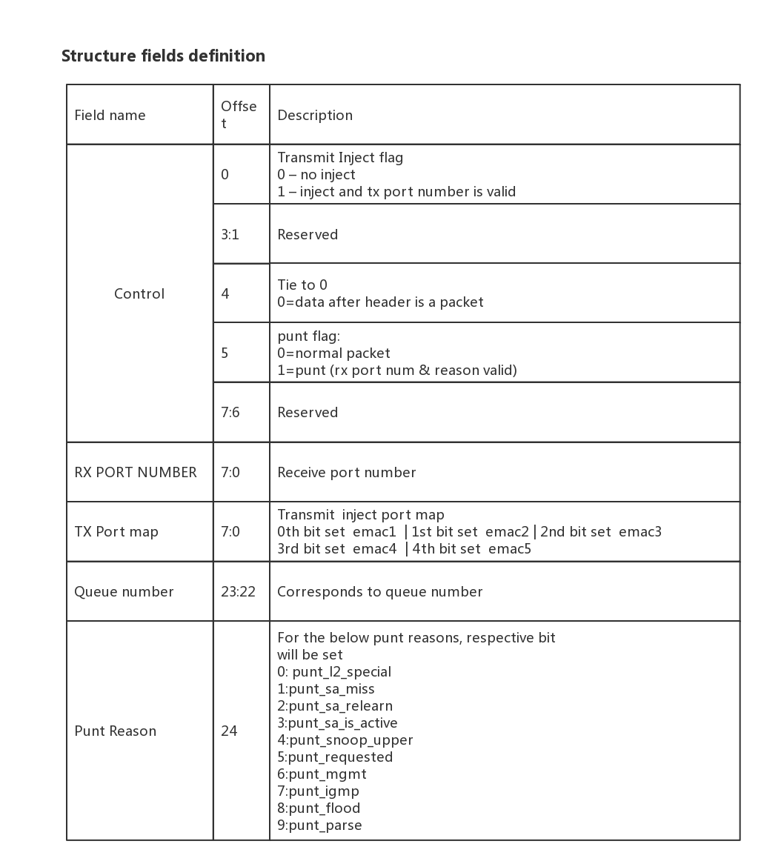

Table 5 Structure field definition

NPU Interrupts
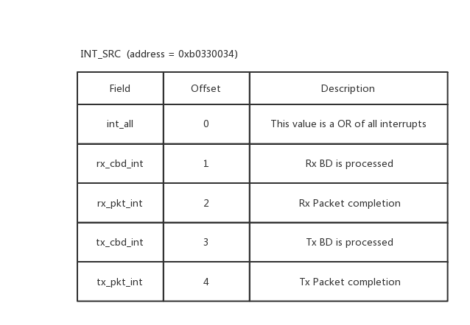
NPU interrupts is 9 bits wide. Below table lists the interrupt sources and Interrupt enable register details for each interrupt. These interrupts are level triggered(active high interrupts). These interrupts are write 1 clear registers (writing 1 to interrupt source register of the corresponding block, clears the interrupt).

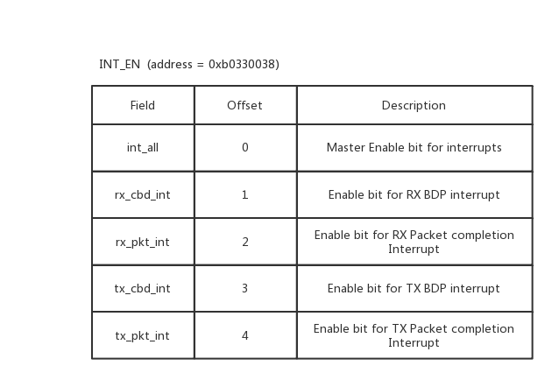
Table 6 INT_EN
Table 7 INT_SRC

Flow Setup
The Switch implements the L2 switching by hardware mac table / vlan table which managed by the Host. Hardware would transmit packets to destination port or punt to host by searching the mac && vlan table, Host processes the punt packets and runs a period timer to age the mac table. For instance the learning is performed in the host processor and the forwarding for the common cases are performed in the hardware.
The purpose of mac table is to rapidly determine which port(s) a frame should be forwarded to, based on the destination MAC
address and/or VLAN ID of the received frame.
Table operations support ADD, DELETE, UPDATE, SEARCH, FLUSH, the host driver maintains the MAC/VLAN table easily with those commands.

Action entry
In the fast path, packets are forwarded to the ports based on the MAC/VLAN hash table action entries. Every MAC address that gets added to the hash table is to be added with the following associated actions.
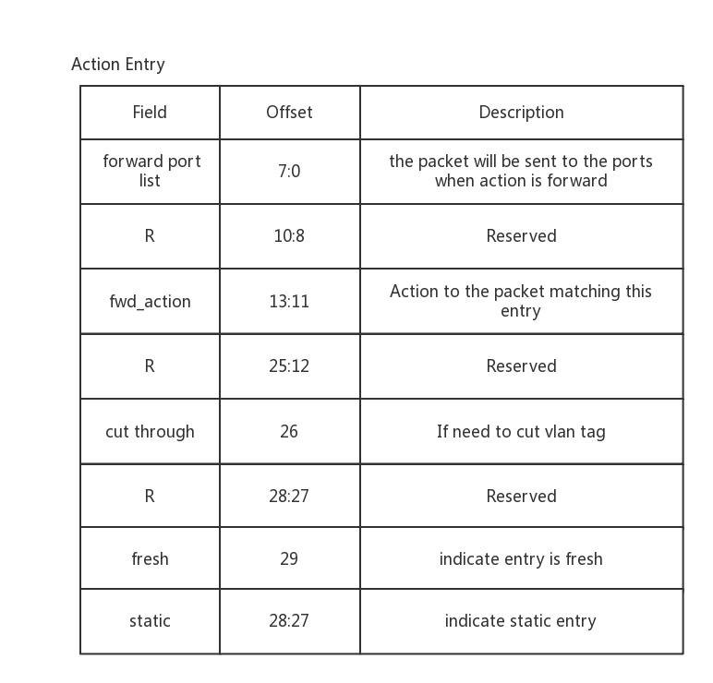
Note: Mac table keeps 1024 entries maximum, Vlan table keeps 128 entries maximum.

Table 8 Action Entry

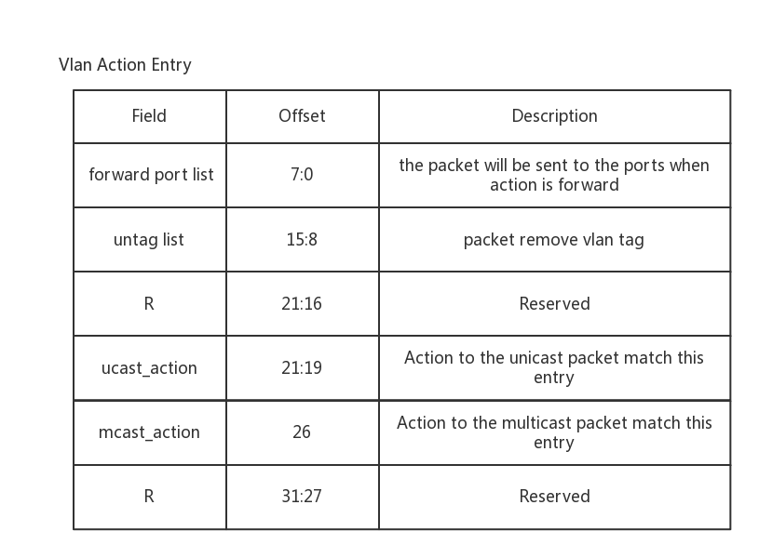
For every incoming packet, MAC hash table is searched with MAC+ VLAN for the associated actions.
If there is MAC hash table miss, then the VLAN table actions are used. If the frame is untagged, the default vlan id(coming from port configuration) is used while doing the search.

Table 9 Vlan Action Entry

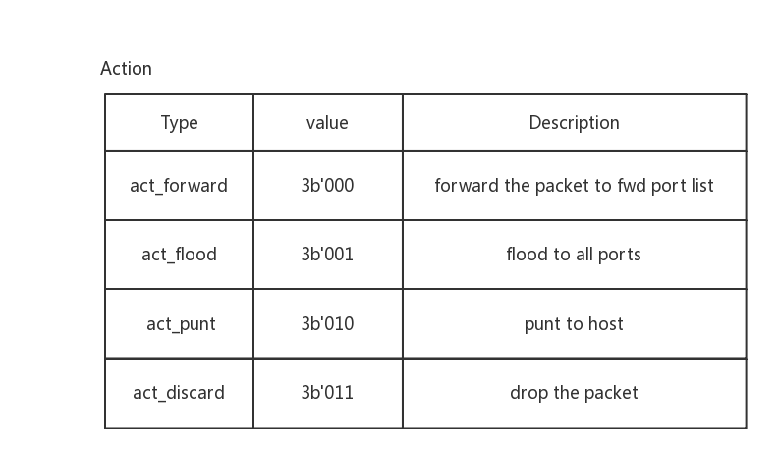
Action
There are several actions used for do specific operation for different packets.

Table 10 Action

Program Guide
The Software implements 3 modules at least to make the hardware working as a L2 switch.
- Switch initialization
- Data transceiver
- Mac learning/ageing
The code referenced in this chapter is based a driver developed under Linux. The driver is compiled into a single kernel loadable module (.ko). The driver also only has lightweight OS dependencies, and is readily portable to other OS environments.

Switch initialization
The Switch has 5 10 Base-T/100 Base-TX low-power Ethernet Physical Layer (PHY) transceiver which for 5 ports , and they can be configured through MII/ interfaces. The host need to prepare memory which is accessible by Switch , filled the buffer descriptors 3.1 and enable the interrupts 3.3.

Reference code: file sf_eth.c function sf_eth_open(*)

Data transceiver
There are 2 kinds of data flows in switch:
Slow Path: Host to Device or Device to Host. Besides the normal communication between the Host and the Device, some packets would send to Host for reasons like: manager packets, snoop packets, or punt packets(used to do flow setup 4 ). Host also can inject packets to specific ports for sending the processed packets again or for management.
Fast Path: Device to Device(include normal communication between Host and Device). The switch forward packet to correct port base the Flow setup.
Note: The packet with unknown DA(destination mac address) would be flood to all ports.

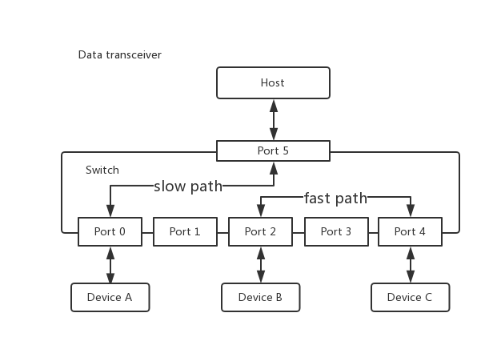

Figure 4 Data transceiver
For those reasons we need to handle normal packets and the punt packets in driver. Actually it is the same for data transceiver. Host transmit or receive packets by check BD is available and handle the interrupts.
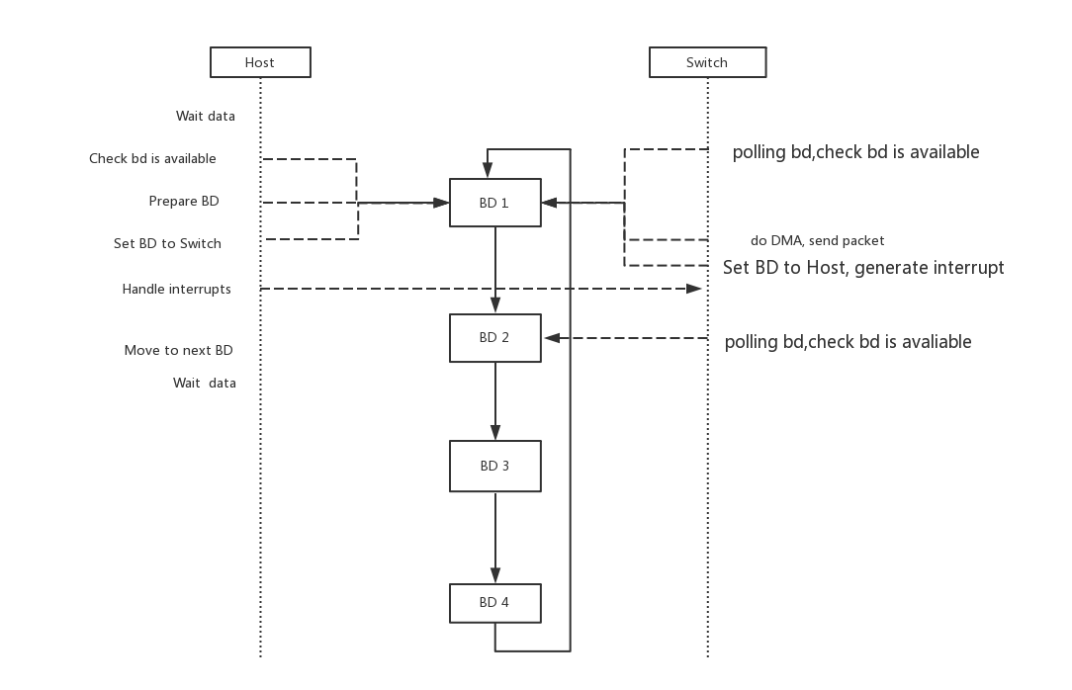

Figure 5 transmit

Figure 6 receive
Reference code: file sf_eth.c function sf_eth_xmit(*) sf_handle_irq(*) sf_eth_napi_poll(*)

Mac learning/ageing
Mac learning/ageing intents to build the Flow setup, Host Process packets with punt reason such as:
SA miss: failed to search the source mac address in MAC table
SA relearn: the packet comes from a different port with the MAC table shows.
SA is active: the source mac address is still active after ageing.
Mac learning process the punt packets, then parse the packets to get information like: mac address, vlan id.
According to the punt reason to add /update a entry to Mac table.
Mac ageing aims to remove the outdated mac entry for saving memory. After a period time like 5 minutes, traverse all mac table and clear the fresh flag in action entry, delete the entry which action entry is not fresh.

Reference code: file sf_switch.c function sf_process_packet (*) sf_switch_hash_learn(* ) host_ageing(*)

