Assignment-3

Abdul Basit Khan 2019004

4.A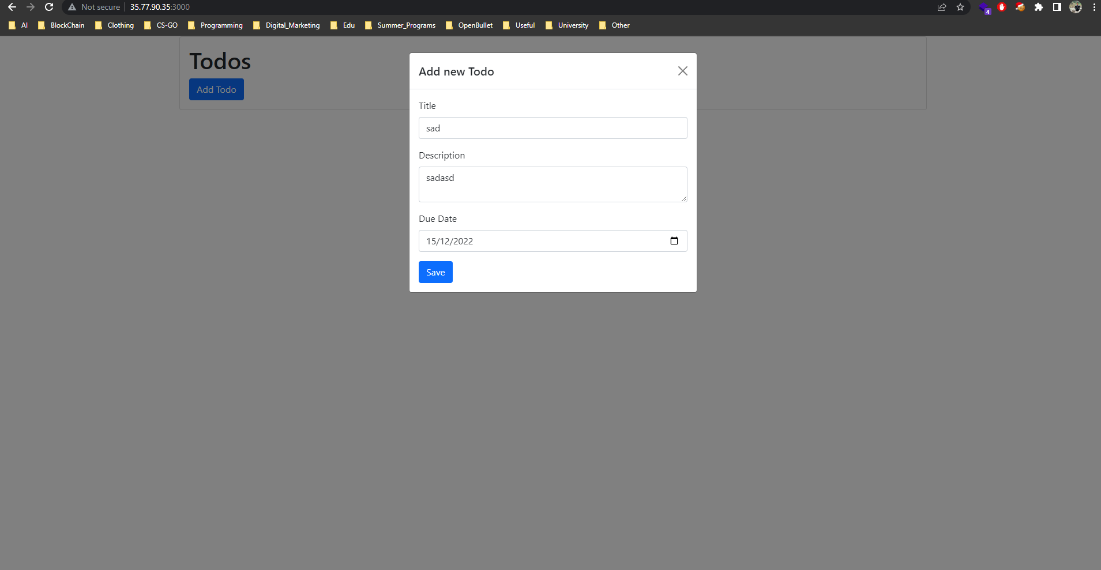

4.B

4.C) Application is Deployed without any major challenges.

4.E)



4.F)



