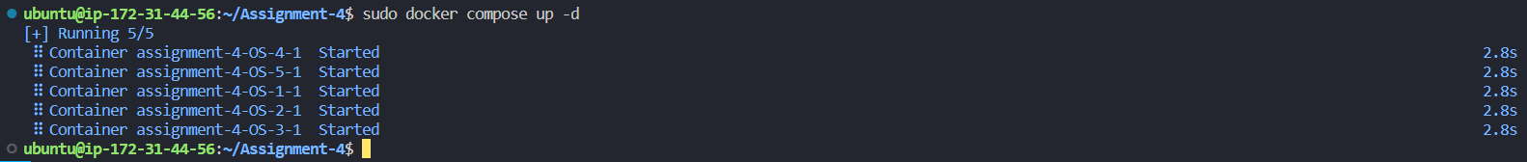**2019004-Abdul Basit Khan**