**AIM:**

To configure a basic Network Topology using Cisco Packet Tracer.

**PROCEDURE:**

1. **Place the devices:**

* From the **Devices menu**, select **Routers** and choose the **1841 Router**. Place it in the center.
* Go to **Switches**, select two **2960 switches**, and place them on the left and right of the router.
* From **End Devices**, select **PC** and place three PCs connected to the left switch and three PCs connected to the right switch.

1. **Configure Connections:**

* **Router to Switches:**
  + Use the **Copper Straight-Through Cable** tool to connect:
    - **Router FastEthernet0/0** to **Switch0 FastEthernet0/1** (left switch).
    - **Router FastEthernet0/1** to **Switch1 FastEthernet0/1** (right switch).
* **Switches to PCs:**
  + For **Switch0**, connect each of its **FastEthernet ports (e.g., FastEthernet0/2, FastEthernet0/3, and FastEthernet0/4)** to **PC0, PC1, and PC2**.
  + For **Switch1**, connect its **FastEthernet ports (e.g., FastEthernet0/2, FastEthernet0/3, and FastEthernet0/4)** to **PC3, PC4, and PC5**.

1. **Configure IP Addresses:**

* **Router Interfaces:**
  + Click on **Router0**, go to **Config** > **FastEthernet0/0**, and set:
    - **IP Address:** 192.168.10.1
    - **Subnet Mask:** 255.255.255.0
    - **Turn on** the interface by clicking on **Port Status**.
  + Go to **FastEthernet0/1** and set:
    - **IP Address:** 192.168.11.1
    - **Subnet Mask:** 255.255.255.0
    - **Turn on** the interface by clicking on **Port Status**.
* **PCs:**
  + For **PC0, PC1, and PC2** (connected to the left switch):
    - Set IP addresses within the 192.168.10.0 network (e.g., 192.168.10.2, 192.168.10.3, 192.168.10.4) with a **Subnet Mask** of 255.255.255.0.
    - Set the **Default Gateway** to 192.168.10.1.
  + For **PC3, PC4, and PC5** (connected to the right switch):
    - Set IP addresses within the 192.168.11.0 network (e.g., 192.168.11.2, 192.168.11.3, 192.168.11.4) with a **Subnet Mask** of 255.255.255.0.
    - Set the **Default Gateway** to 192.168.11.1.

1. **Test Connectivity:**

* Use the **Ping Tool** from **PC0** to **PC3** (or any PC on a different subnet) to verify connectivity.

**DIAGRAM**:

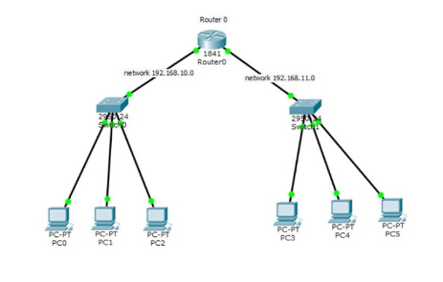

**RESULT**:

Thus the configuration of the basic Network Topology is successfully pings indicate proper configuration and connectivity between the subnets.