**DigiMarket_FrontEnd Repository**

**Requirements:**

Node js v16.17.1  
 yarn 1.22.11

1. First you have to add Google map places api key in index.html file.  
   The location of index.html file is **ClientApp\public\index.html.**

Here is how to activate Google Places Api and JavaScript Map Api and get the Key. <https://developers.google.com/maps/documentation/places/web-service/get-api-key>

Google Map Places API key

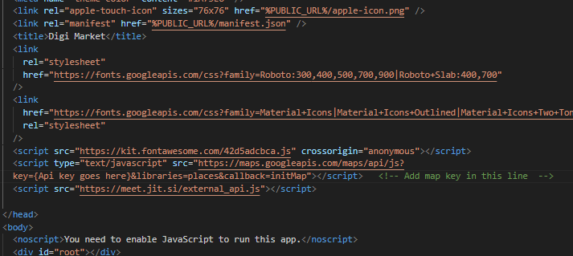

1. To run the app locally you have to add 4 configuration strings in the env.js file.  
   The location of the env.js file is **ClientApp/src/env.js.** You can leave these settings by default**.**  
     
   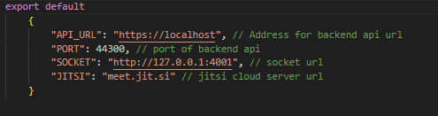

API_URL => https://localhost  
PORT => 44300  
SOCKET => http://127.0.0.1:4001  
JITSI =>meet.jit.si

1. Open the code in Visual Studio Code IDE or CMD and follow the below instructions to run the front-end app.

After configuration, you have to install all the packagesinside the ClientApp folder using the command:

3.1) **yarn install**   
And then run a command:

3.2) **yarn start**

This will start the app and you can open the front-end app.

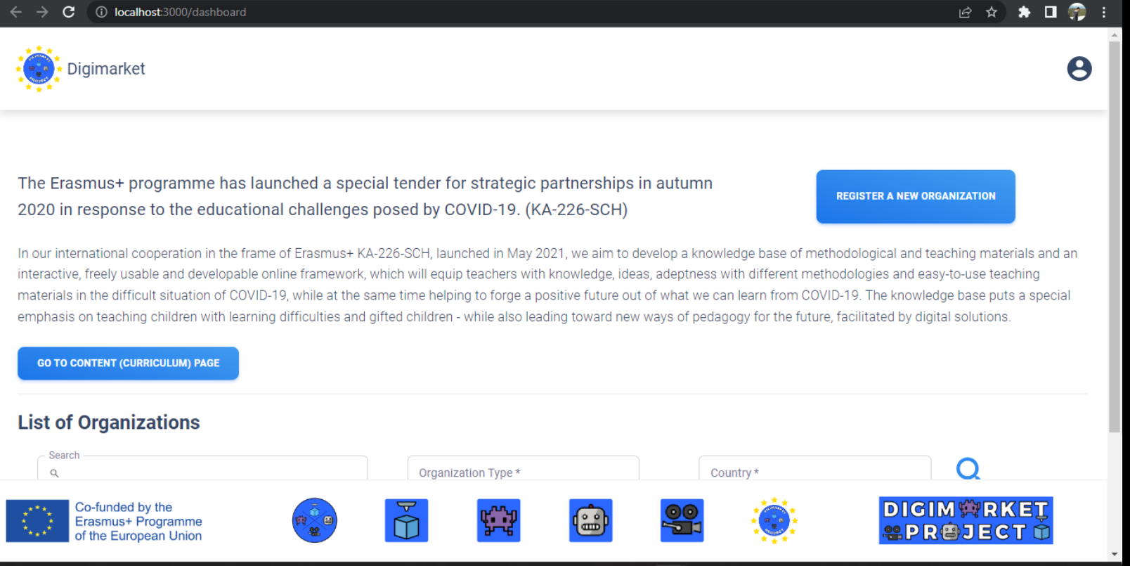

**Video Guide Below**

https://www.awesomescreenshot.com/video/17734593?key=c12e45bcfac3af1aab565f50f5a805cf