**DigiMarket_WebSocketHub Repository**

**Requirements:**

Node js v16.17.1

you have to install all the packages inside the socket folder using the command:  
**npm install**

To run socket server you just need to run a command in cmd i.e  
**node app.js**

You will see below as a success message

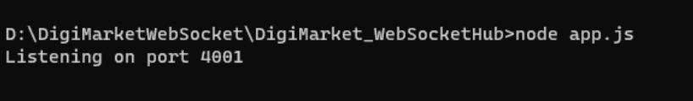

**Video Guide Below**

https://www.awesomescreenshot.com/video/17735146?key=f41ef6d2a4bc1e69f89d2772793e0de7