


Institute of Technology of Cambodia
Department of Applied Mathematics and Statistics

EDA AND UNSUPERVISED LEARNING REPORT
“Credit Risk EDA”
GROUP: I5-AMS-B (7)
Name | ID | Contributions
PHETH Soriyuon | e20210674 | Data Cleaning and Processing
PHOEURN Kimhor | e20210823 | EDA on Quantitative & Quantitative, Qualitative & Qualitative Columns.
Yin Sambat | e20210138 | EDA on Quantitative & Qualitative Columns, Clustering.

Lecturer: Dr. HAS Sothea

Academic Year 2025-2026
Table of Content

I. INTRODUCTION 1
1.1. Objectives of the Analysis 1
1.2. Dataset Overview and Descriptive Statistics 1
II. DATA PREPROCESSING 2
2.1. Handling Missing Values 2
2.2. Duplicate Removal 3
2.3. Outlier Detection and Treatment 3
III. EXPLORATORY DATA ANALYSIS 5
3.1. Quantitative vs Quantitative 5
3.2. Quantitative vs Qualitative 6
3.3. Qualitative vs Qualitative 9
IV. UNSUPERVISED LEARNING 11
4.1. Data Preparation for Clustering 11
4.2. Choice of Clustering Algorithm 12
4.2.1. K-Means Clustering 12
4.2.2. Hierarchical Clustering 12
4.2.3. Spectral Clustering 12
4.3. Determining Optimal Number of Clusters 12
4.3.1. Elbow Method 12
4.3.2. Silhouette Score 13
4.4. Cluster Profiling and Interpretation 13
V. CONCLUSION 14
5.1. Summary of Key Findings 14
5.2. Limitations of the Analysis 15
REFERENCES 16

INTRODUCTION

Objectives of the Analysis
The objective of this project is to analyze credit risk data to identify meaningful borrower segments and patterns associated with loan default. Specifically, the study aims to:
- Ensure data quality by addressing missing values, duplicates, and outliers.
- Explore borrower and loan characteristics through univariate and bivariate analyses.
- Apply unsupervised learning methods, such as K-Means and Hierarchical Clustering, to group borrowers with similar profiles.
- Use dimensionality reduction techniques to simplify visualization and interpretation of clusters.

Dataset Overview and Descriptive Statistics
The data used in this analysis is sourced from the Credit Risk Dataset available on OpenML (ID: 43454). This dataset is a standard benchmark in financial analytics, designed to help institutions evaluate the likelihood of loan defaults based on a borrower’s financial and demographic profile. It contains historical information on loan applications, encompassing borrower demographics, financial standing, and loan-specific attributes.
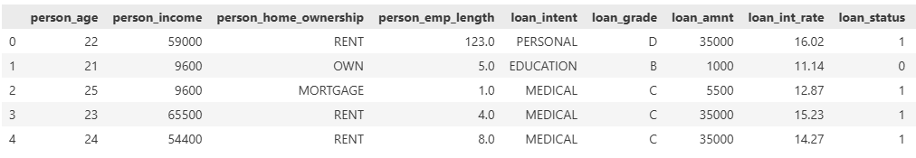
Figure 1: Five Rows of Data
The dataset contains 32,581 observations and 12 features that provide a comprehensive view of each applicant's creditworthiness:
Table 1: Features Overview
Feature Name | Description
person_age | Age of the borrower in years.
person_income | Annual income of the borrower.
person_home_ownership | Current housing situation.
person_emp_length | Total years of employment.
loan_intent | The specific purpose for the loan.
loan_grade | Risk-based grade assigned to the loan (A to G).
loan_amnt | Total amount of credit requested.
loan_int_rate | The annual interest rate for the loan.
loan_status | Target Variable: Indicates if a loan defaulted (1) or not (0).
loan_percent_income | The percentage of the borrower's income represented by the loan.
cb_person_default_on_file | Indicates if the borrower has a history of prior defaults.
cb_person_cred_hist_length | Number of years the borrower has had active credit history.

Descriptive Statistics
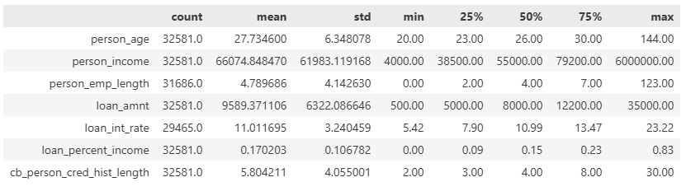
Figure 2: Descriptive Statistics of Data
From Figure 2, highlights data quality issues, with 895 missing values in person_emp_length and 3,116 missing values in loan_int_rate. Additionally, several variables show outliers. For instance, person_age has a mean of 27.73 and a median of 26, with a maximum value of 144, which is clearly implausible. Similarly, person_income reaches a maximum of $6,000,000, far above the 75th percentile of $79,200. These observations suggest the need for data cleaning.

DATA PREPROCESSING

Handling Missing Values
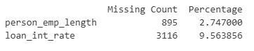
Figure 3: Output from Checking Missing Value Code
Based on the output shown in Figure 3, there are 895 missing values in person_emp_length and 3,316 missing values in loan_int_rate. To assess the potential impact of removing these records, we examined how dropping the missing values affects the distributions of both numerical and categorical variables.
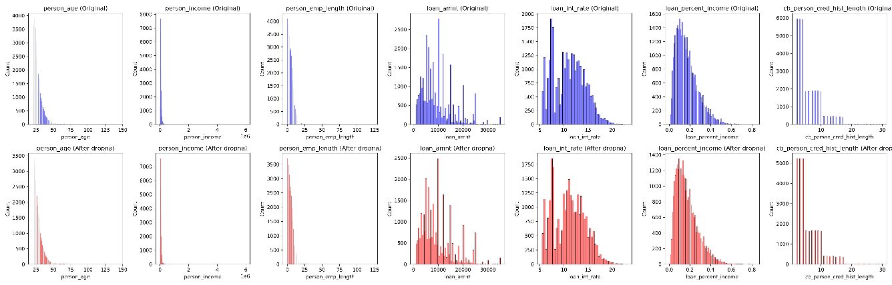
Figure 4: Comparison of Numerical Column Distribution before and after Dropping Missing Values
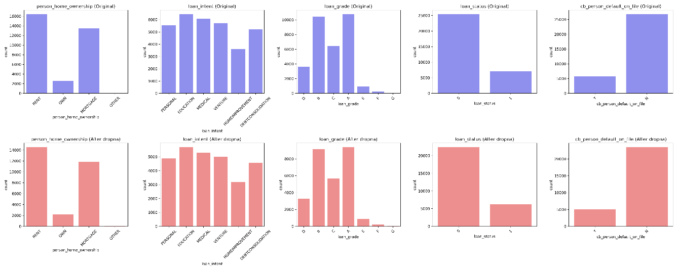
Figure 5: Comparison of Categorical Columns before and after Dropping Missing Values
Based on Figure 4 and Figure 5, dropping the missing values shows no significant impact on the distributions of the data. Therefore, the missing values were removed from the dataset.

Duplicate Removal
Ensuring the uniqueness of observations is critical to prevent bias in frequency counts and correlation coefficients. The dataset was scanned for identical entries across all 12 features. A total of 165 duplicate records were identified. These redundant rows were removed, resulting in a cleaner dataset where each row represents a unique loan application. This step ensures that the subsequent exploratory analysis is not skewed by over-represented borrower profiles.

Outlier Detection and Treatment
Using the boxplot in Figure 6, we investigate the extreme values in person_age, person_income, and person_emp_length.

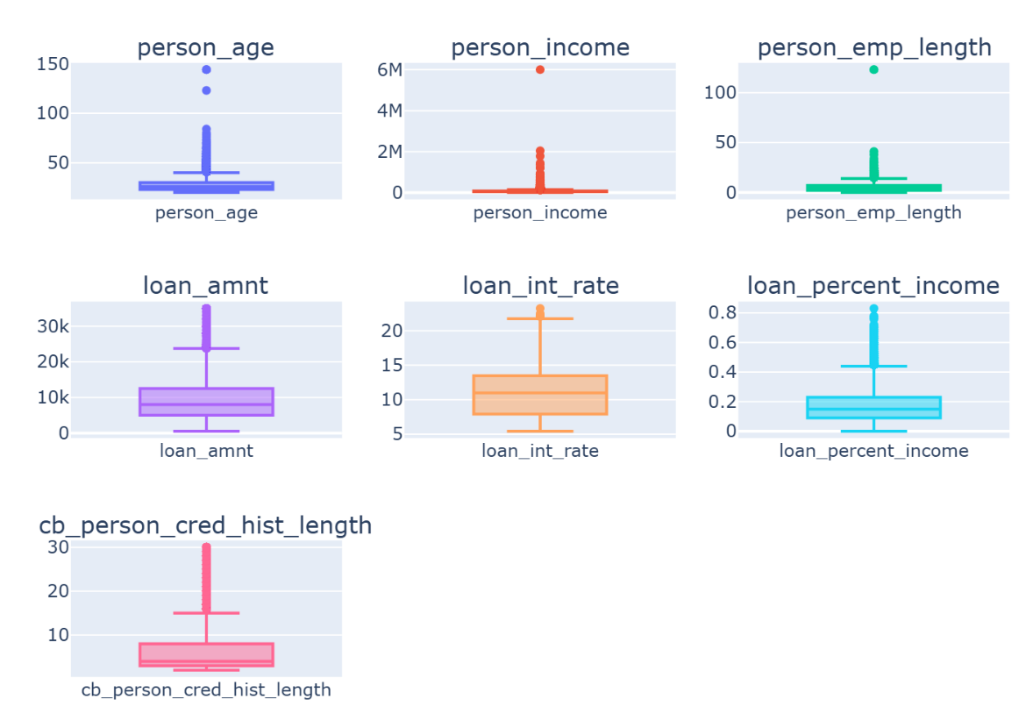
Figure 6: Boxplot of Numerical Columns
Figure 7 highlights six extreme outliers in the dataset: four rows with ages over 100 years but short employment lengths (≤4 years), and two rows with implausibly long employment tenures (123 years) despite ages of 22 or younger. These six records, representing less than 0.1% of the dataset, were removed to maintain data integrity.
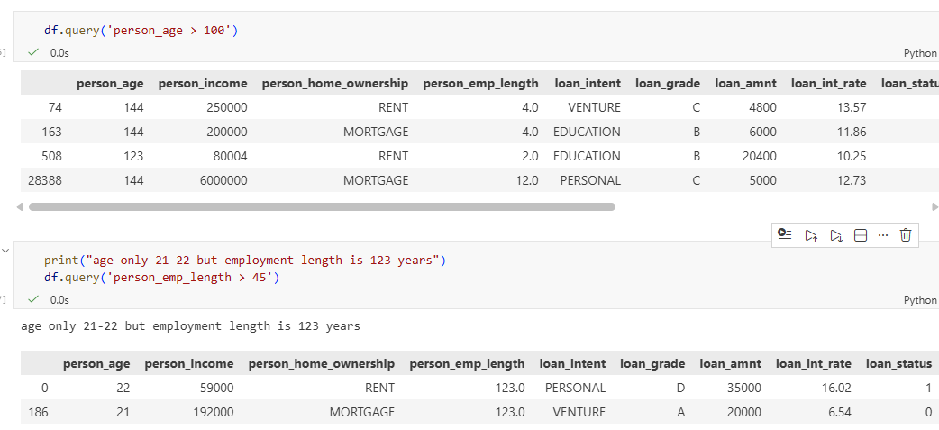
Figure 7: Rows with Extreme Values in person_age and person_emp_length

EXPLORATORY DATA ANALYSIS

Quantitative vs Quantitative
A pair plot shown in Figure 6 was used to visualize relationships among key numerical variables, including age, income, loan amount, loan interest rate, and credit history length. The plot highlights both variable distributions and inter-variable correlations.
Key Insights:
- Age and Credit History: A strong positive relationship is observed, as older individuals tend to have longer credit histories.
- Loan Percent of Income: Borrowers with lower incomes exhibit higher loan-to-income ratios, indicating greater lending risk.
- Skewed Distributions: Most variables are right-skewed, with concentrations at lower values for age, income, and employment length.
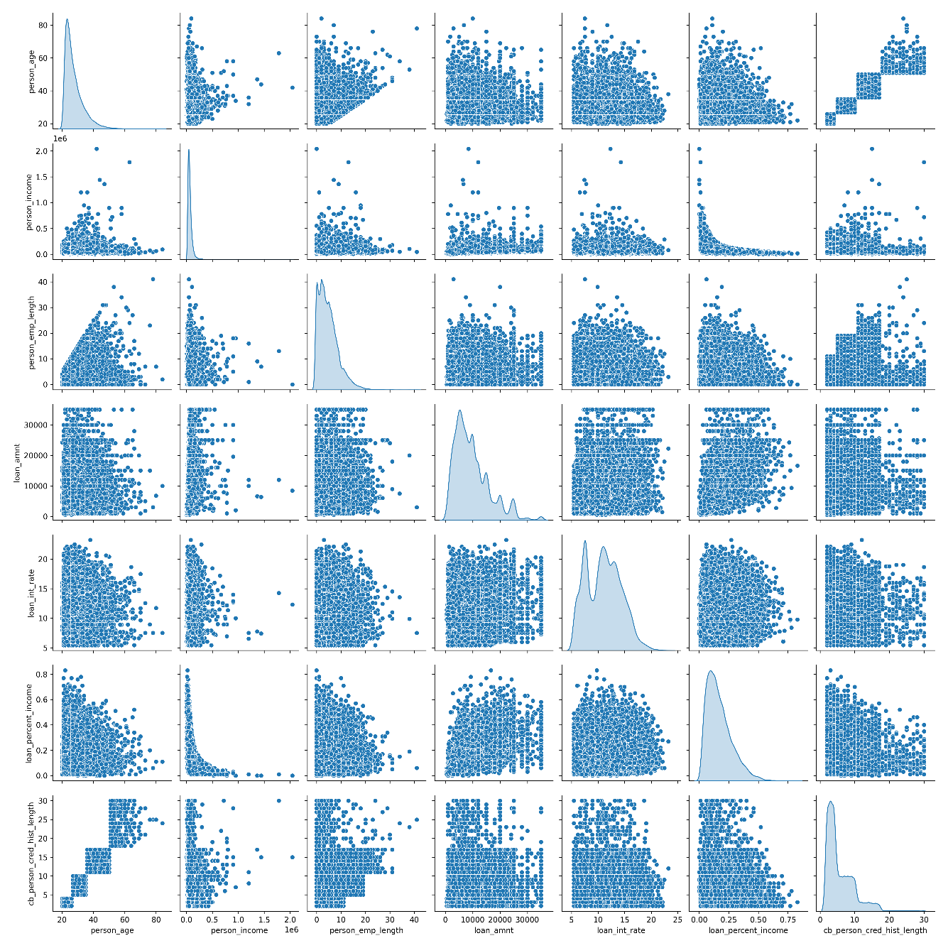
Figure 8: Pairplot of Quantitative Columns

Quantitative vs Qualitative
Before applying the Eta-squared test statistic to examine the relationship between numerical and categorical variables, it is necessary to first check for the presence of outliers, as the test is sensitive to extreme values. The results below show the outliers detected in the numerical columns of the dataset.
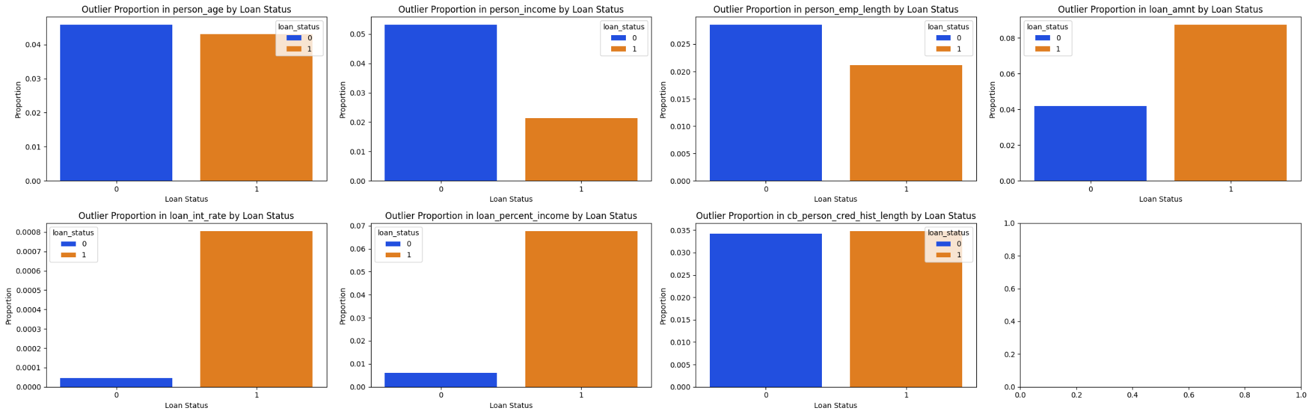
Figure 9: Outliers Ratio from Numerical Classes
From Figure 7, we observe that only Age and Credit History Length do not show dominance or imbalance between the two classes of Loan Status. In contrast, the remaining numerical variables exhibit noticeable imbalance between the two loan status classes. Therefore, we decided to address the outliers by capping the imbalanced classes at their lower and upper bounds, while removing outliers for the Age and Credit History Length variables. After this preprocessing step, we applied one-way ANOVA, and the results are shown below. It should be noted that we also experimented with removing outliers directly from all numerical columns; however, the results were consistent with those obtained using the capping approach.
Numeric Variable | Categorical Variable | Eta Squared | p-value
loan_int_rate | loan_grade | 0.902809 | 0.00E+00
loan_int_rate | cb_person_default_on_file | 0.250575 | 0.00E+00
loan_percent_income | loan_status | 0.141794 | 0.00E+00
loan_int_rate | loan_status | 0.114866 | 0.00E+00
person_income | person_home_ownership | 0.108553 | 0.00E+00
The analysis indicates that Loan Interest Rate is strongly influenced by Loan Grade, as clearly illustrated in the conditional box plot in Figure 8.
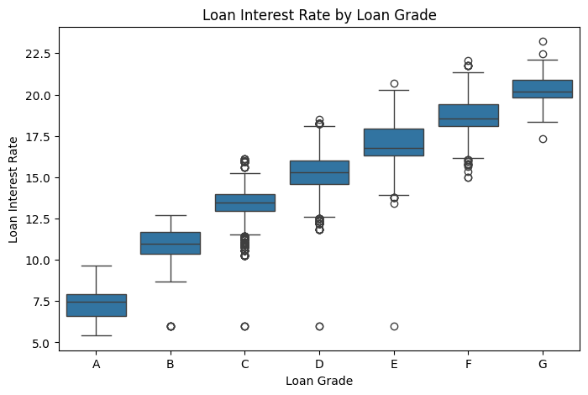
Figure 10: Relation of Rate and Grade
The conditional boxplots for the remaining variables indicate that the Eta-squared results are consistent with the visual analysis. Most categorical–numerical relationships appear weak, as the distributions across categories largely overlap. Notably, Loan Interest Rate shows a comparatively stronger association with Loan Grade, where clear differences in medians and spread can be observed across categories.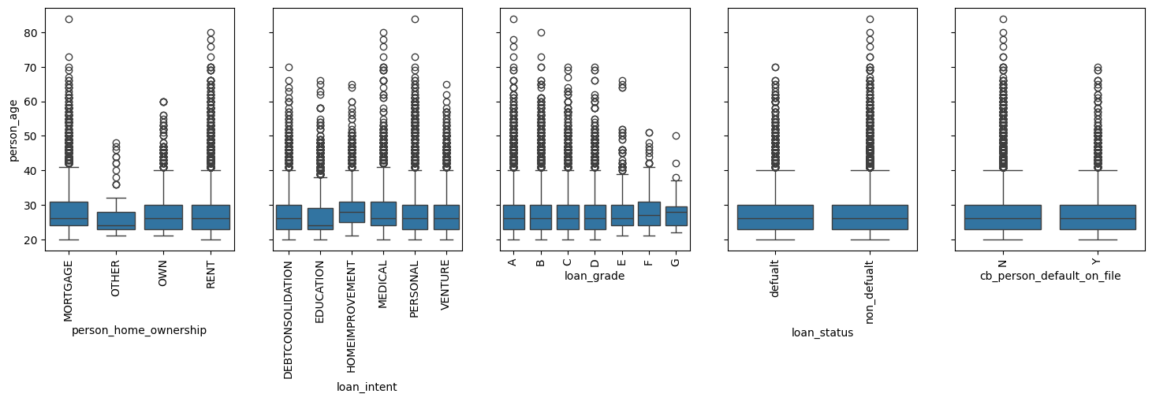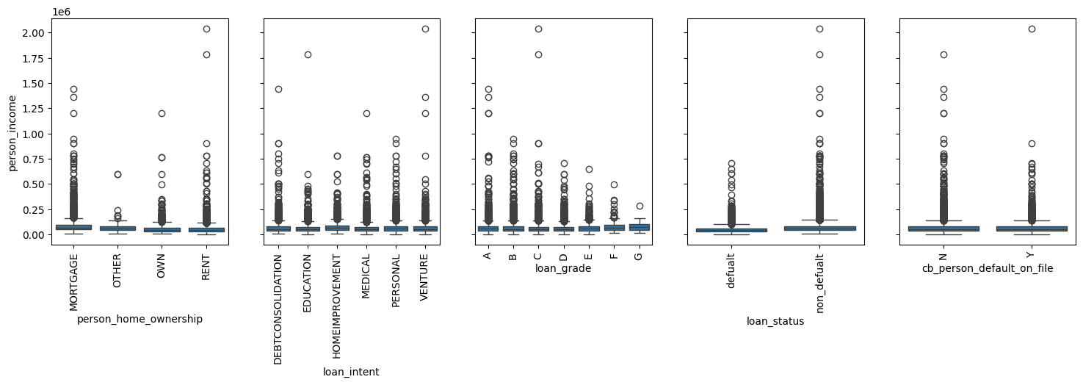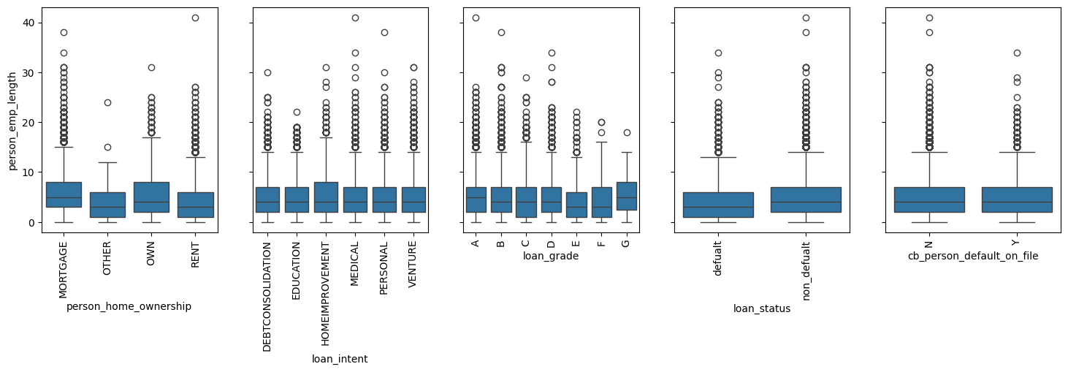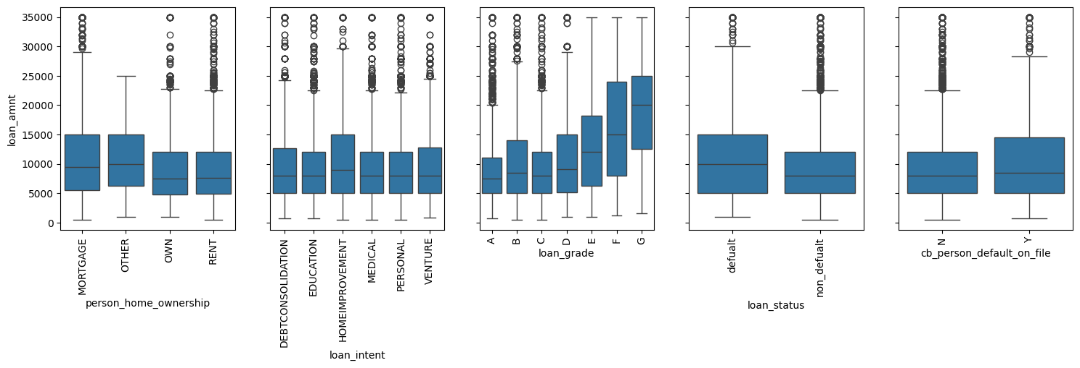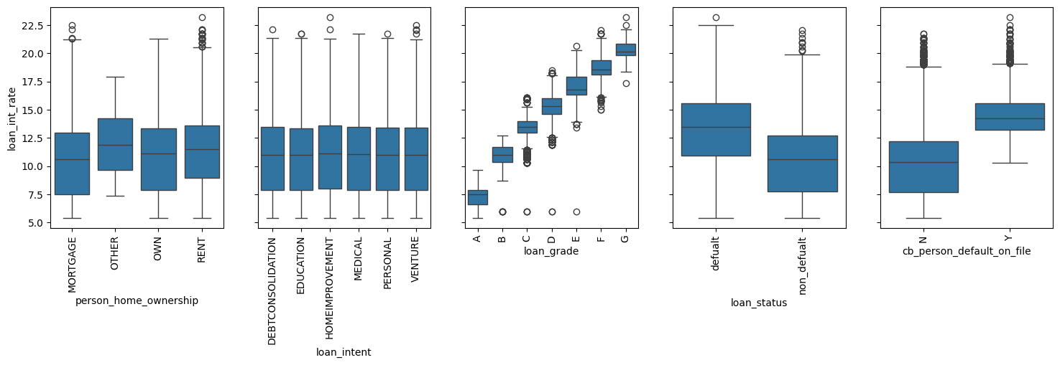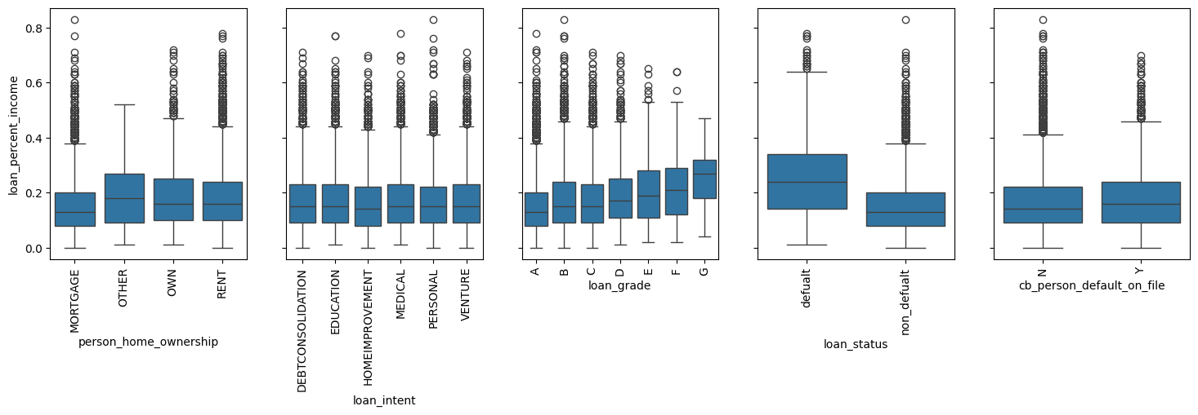
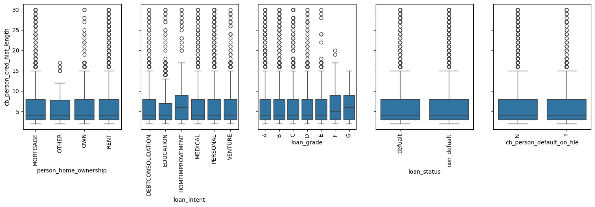
Figure 11: Conditional Boxplot across Category vs Numeric
Note that although outliers are visible in some boxplots in Figure 9, these represent within-group outliers rather than global outliers. Global outliers were previously identified and treated using the applied outlier handling techniques. Therefore, the remaining extreme values reflect natural variability within each categorical group and do not undermine the overall analysis.
Finally, the correlation plot below presents the relationships among the remaining numerical variables after preprocessing.
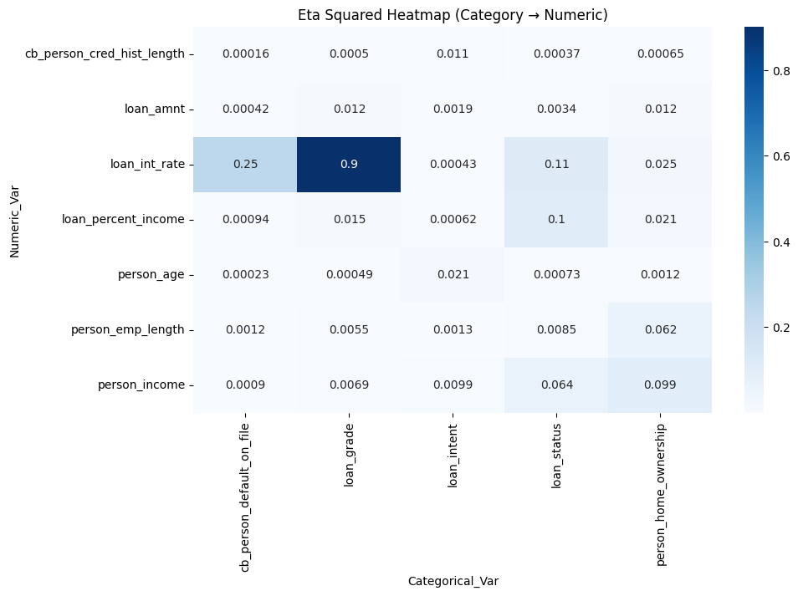
Figure 12: Heatmap of Relation Category vs Numerical

Qualitative vs Qualitative
As shown in Figure 7, grouped bar charts illustrate the relationships between categorical variables and loan status (default vs. non-default).
Key Findings:
- Previous Default History: Borrowers with a prior default record (‘Y’) show a noticeably higher tendency to default again compared to those without previous defaults (‘N’).
- Loan Grade: As the grade moves from A → G, the proportion of defaults increases significantly. In categories D, E, F, and G, the red bars (defaults) actually become comparable to or even surpass the blue bars in height, indicating much higher risk.
- Loan Intent: Loans for debt consolidation and medical purposes have higher default proportions, whereas education and venture loans exhibit lower risk.
- Home Ownership: Renters demonstrate the highest default rates, while mortgage holders and owners show greater repayment stability.
Overall, the figure suggests that home ownership and previous default history are strong qualitative indicators of credit risk, with loan intent acting as a moderate differentiating factor among borrowers.
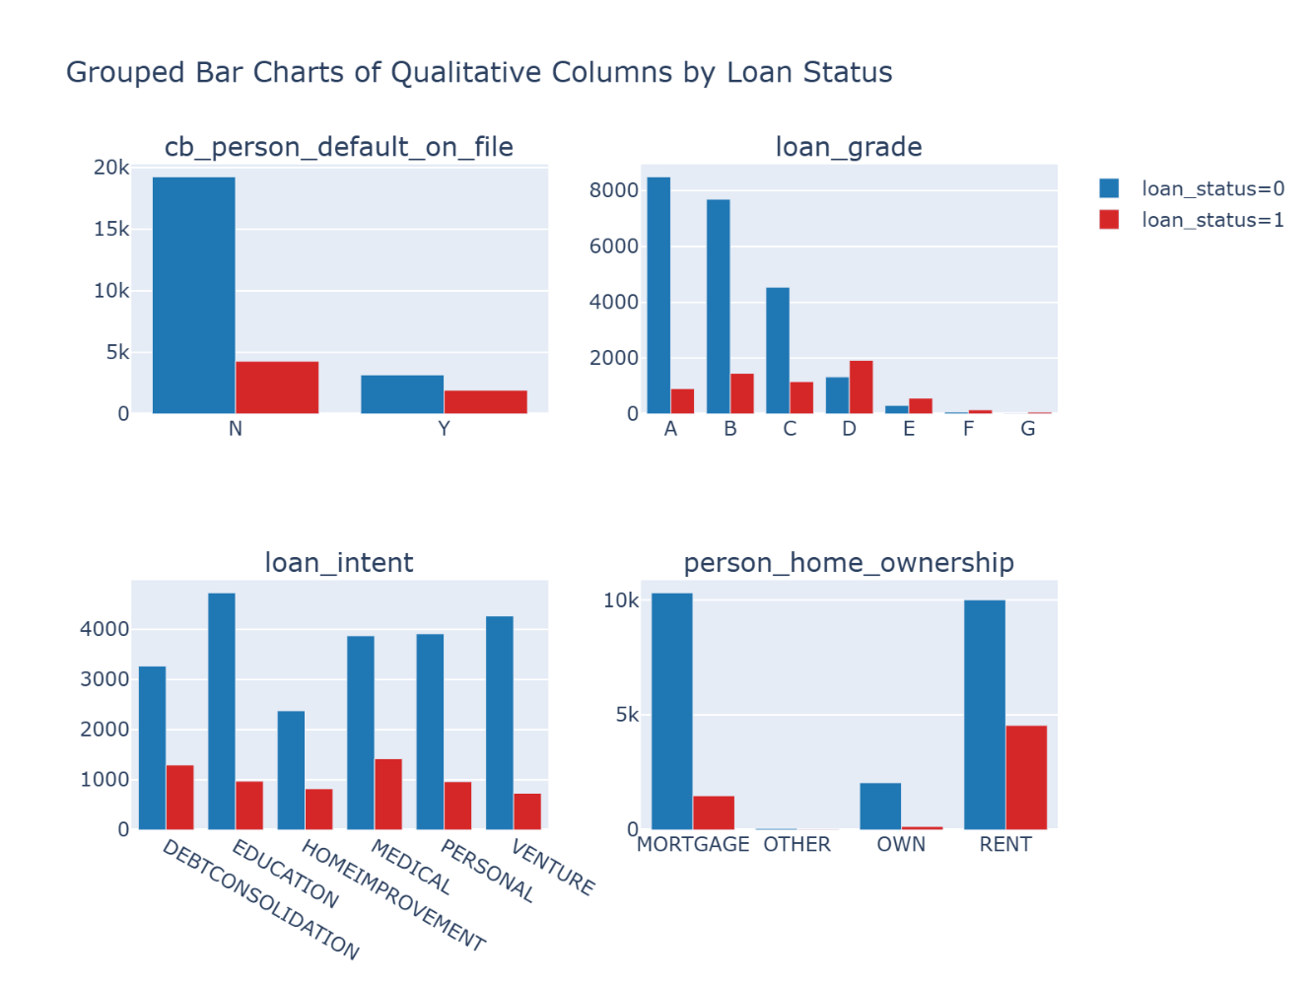
Figure 13: Grouped Bar of Qualitative Columns by Loan Status
Next, a Chi-square test of independence was performed between the categorical features to assess whether they are statistically associated. As shown in Figure 8, which displays the test output from the code, all categorical variable pairs have significant associations but only cb_person_default_on_file and loan_grade are strongly associated.
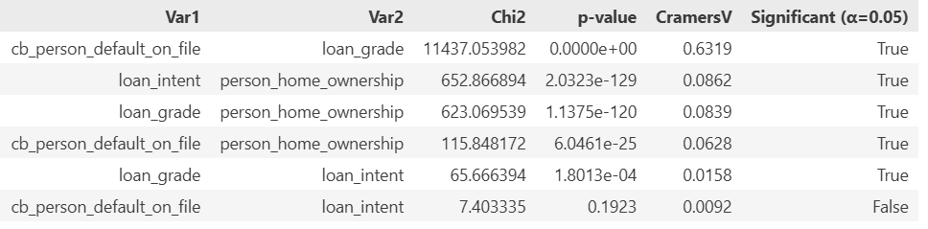
Figure 14: Output of the Chi-squared and Cramer’s V tests between categorical columns
As shown in Figure 9, the symmetric biplot from Correspondence Analysis visualizes associations between history default and loan grade.
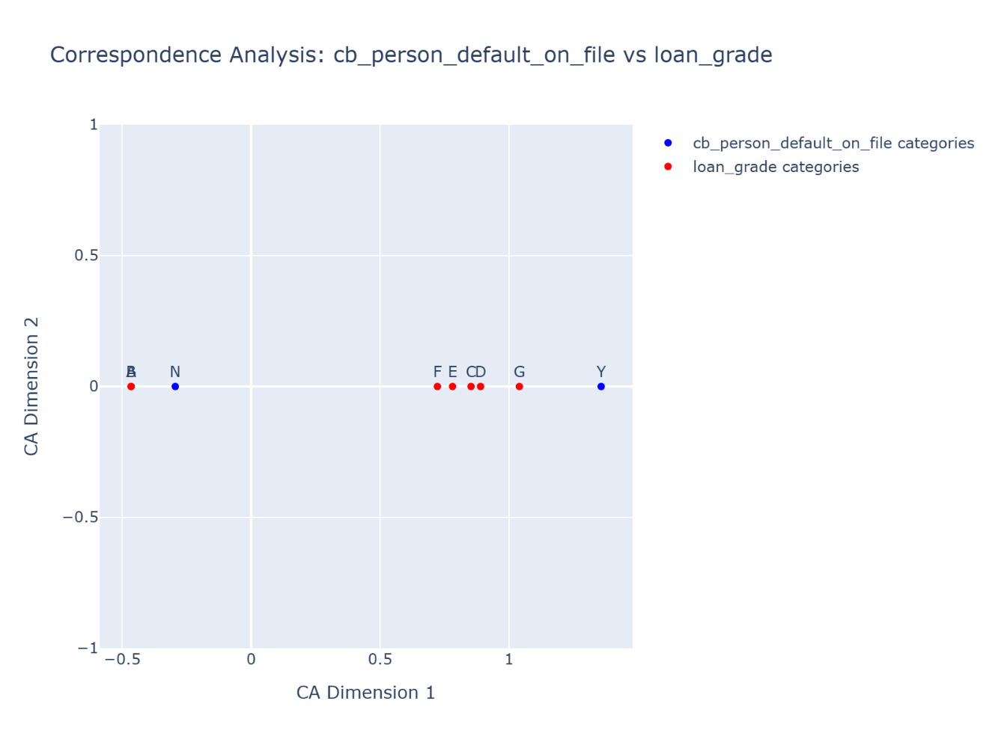
Figure 15: CA Symmetric Biplot

UNSUPERVISED LEARNING

Data Preparation for Clustering
Outlier Management
Two outlier-handling strategies were implemented:
- Capping: The Interquartile Range (IQR) method was used to cap extreme values for variables such as person_income and loan_amnt at their respective upper and lower bounds. This approach is consistent with the preprocessing applied during the Eta-Square analysis.
- Trimming: Extreme outliers were removed from person_age and cb_person_cred_hist_length to prevent unusually large values from disproportionately influencing cluster centroids.
Feature Engineering
- Encoding: Categorical variables were transformed using One-Hot Encoding, converting them into dummy variables suitable for distance-based clustering algorithms.
- Scaling: Numerical features were standardized using StandardScaler to ensure that all variables contribute equally to distance calculations, which is particularly important for K-Means clustering.
After preprocessing, the scaled numerical features and encoded categorical features were combined into a single feature matrix for clustering.

Choice of Clustering Algorithm

K-Means Clustering
K-Means clustering is a widely used unsupervised learning algorithm that partitions data into $k$ distinct clusters by minimizing the within-cluster sum of squared distances between data points and their assigned cluster centroids.
The algorithm iteratively assigns data points to the nearest centroid and updates centroid positions until convergence. K-Means is computationally efficient and commonly used for applications such as customer segmentation and pattern discovery.

Hierarchical Clustering
Hierarchical clustering is an unsupervised learning technique that organizes data points into a nested hierarchy of clusters, typically visualized using a dendrogram.
Unlike K-Means, it does not require the number of clusters to be specified in advance. This study employs agglomerative (bottom-up) hierarchical clustering, where individual data points are progressively merged based on similarity until all points form a single cluster.
Hierarchical clustering is useful for revealing natural relationships and cluster structures within the data.

Spectral Clustering
Spectral clustering is a graph-based clustering method capable of identifying clusters with complex or non-convex shapes. It works by constructing a similarity graph from the data, computing the graph Laplacian, and projecting the data into a lower-dimensional space using its eigenvectors.
Standard clustering algorithms, such as K-Means, are then applied in this transformed space. Spectral clustering is particularly effective when cluster boundaries are not well separated in the original feature space.

Determining Optimal Number of Clusters

Elbow Method
The Elbow Method is a visual technique commonly applied to K-Means clustering. It plots the Within-Cluster Sum of Squares (WCSS) against different values of $k$.
The optimal number of clusters is identified at the “elbow” point, where the reduction in WCSS begins to slow significantly, indicating diminishing returns from adding more clusters.

Silhouette Score
The Silhouette Score measures the quality of clustering by comparing a data point’s similarity to its own cluster (cohesion) with its similarity to other clusters (separation).
The score ranges from -1 to +1, where higher values indicate better-defined clusters. Values close to zero suggest overlapping clusters.
Although useful for selecting the optimal number of clusters, silhouette scores tend to work best for compact and well-separated clusters.

Cluster Profiling and Interpretation
Based on the K-Means results, the Elbow Method suggests that increasing the number of clusters continually reduces WCSS, without a clear elbow point. However, the Silhouette Score reaches its maximum at K = 2, indicating that a two-cluster solution provides the best separation among the tested values. Despite this, the highest silhouette score achieved is approximately 0.17, which is relatively low. This suggests that the clusters are weakly separated, and the underlying structure in the data may not be strongly clusterable.
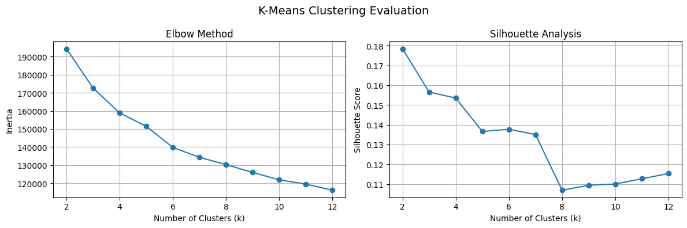
Figure 16: Elbow and Silhouette of K-Means
Applying Spectral Clustering yields similar results, with K = 2 again producing the highest silhouette score, though the value is even lower (approximately 0.12), reinforcing the observation of limited natural separation in the dataset.
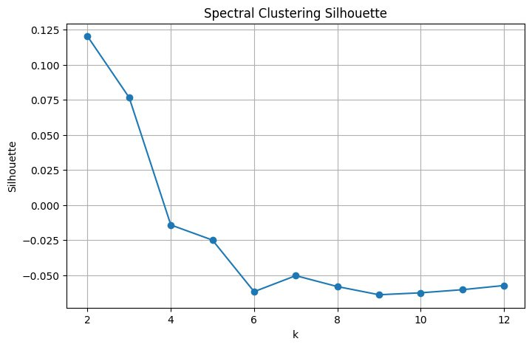
Figure 17: Silhouette score of Spectral Cluster
In contrast, Hierarchical Clustering produces a different outcome. By examining the dendrogram, a noticeable increase in linkage distance occurs around 150, suggesting a cut that results in three clusters. This indicates that hierarchical clustering may capture structural relationships in the data that are not evident using centroid-based methods.
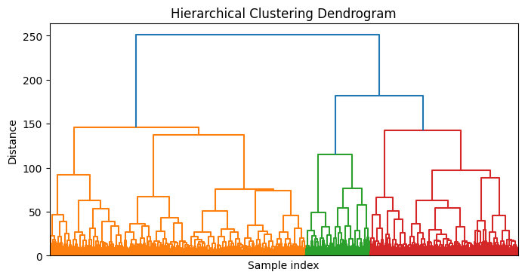
Figure 18: Dendrogram of Hierarchical Cluster
It is also worth noting that experiments were conducted using only a subset of selected features for clustering; however, these attempts did not lead to any noticeable improvement in clustering performance and, in some cases, resulted in poorer outcomes.

CONCLUSION

Summary of Key Findings
The exploratory analysis revealed important insights regarding data quality, borrower characteristics, and risk indicators. Missing values were identified in employment length (895 records) and loan interest rates (3,316 records) and were removed without significantly affecting overall data distributions. Extreme outliers, such as implausible ages up to 144 years and employment lengths of 123 years, were capped or removed to maintain data integrity.
Demographically, borrower age was positively correlated with the length of credit history, and lower-income borrowers typically exhibited higher loan-to-income ratios, indicating increased lending risk. Loan grades strongly influenced interest rates, with clear differences in medians across grades (Eta-squared = 0.90).
Key risk indicators included loan grade, prior default history, home ownership, and loan purpose. Borrowers with lower loan grades (D–G) and those with prior defaults were more likely to default again. Renters had the highest default rates, while mortgage holders and homeowners demonstrated greater repayment stability. Loans for debt consolidation or medical purposes carried higher risk compared to loans for education or business ventures.
Unsupervised learning analyses suggested that K-Means and Spectral clustering produced a two-cluster solution, but low silhouette scores (~0.17) indicated weak natural separation among borrowers. Hierarchical clustering, however, identified three clusters, capturing potential structural relationships that centroid-based methods may have missed.

Limitations of the Analysis
- The study relied solely on the OpenML Credit Risk Dataset, which may not fully represent real-world lending scenarios across different regions or institutions.
- Unsupervised methods struggled to identify distinct segments.

REFERENCES
Data Source: https://www.openml.org/search?type=data&id=43454&sort=runs&status=active
Source Code: https://github.com/phoeurnkimhor/credit-risk-eda

