**ENTREPRENEURSHIP DEVELOPMENT**

**MODULE -1 (INTR0)**

1. **Find Your Flow**

* When people find their fit, they experience a state of happiness and creativity called flow.

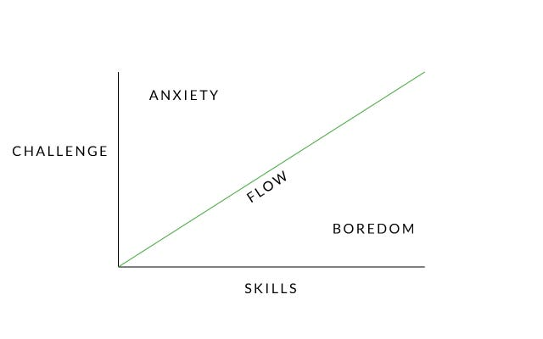

* Be honest about your strengths and weaknesses
* Don’t let yourself get too comfortable
* Learn to take risks

1. **Entrepreneurial styles**
2. Visionary Entrepreneur:
   1. Example: Elon Musk, the founder of SpaceX and Tesla, is known for his visionary approach to space exploration and sustainable energy.
3. Serial Entrepreneur:
   1. Example: Richard Branson, the founder of the Virgin Group, has started numerous businesses in various industries, including music, airlines, telecommunications
4. Lifestyle Entrepreneur:
   1. Example: Tim Ferriss, known for his book "The 4-Hour Workweek," promotes a lifestyle that combines entrepreneurship with personal freedom and travel.
5. Social Entrepreneur:
   1. Example: Blake Mycoskie, the founder of TOMS Shoes, built a business model around the concept of "One for One," where for every pair of shoes sold, a pair is donated to a child in need.
6. Opportunistic Entrepreneur:
   1. Example: Nick D'Aloisio created Summly, a news summarization app, when he was just 15 years old after recognizing the need for concise news summaries on mobile devices. Yahoo later acquired his company.
7. Innovator/Inventor:
   1. Example: Steve Jobs, co-founder of Apple Inc., was known for his innovative products such as the iPhone, iPad, and Macintosh computer.
8. Franchise Entrepreneur:
   1. Example: Ray Kroc, who turned McDonald's into a global fast-food franchise, is a classic example of a franchise entrepreneur.
9. Solo Entrepreneur/Solopreneur:
   1. Example: Pat Flynn, the creator of Smart Passive Income, runs a successful online business independently, focusing on passive income strategies.
10. Growth-Oriented Entrepreneur:
    1. Example: Jeff Bezos, the founder of Amazon, is a growth-oriented entrepreneur who aggressively expanded his company from an online bookstore into a global e-commerce and technology giant.
11. Niche Specialist:
    1. Example: Brian Dean, founder of Backlinko, specializes in search engine optimization (SEO) and provides in-depth content and resources to a niche audience within the digital marketing space.
12. Tech Entrepreneur:
    1. Example: Mark Zuckerberg, co-founder of Facebook (now Meta Platforms, Inc.), started a social media platform that has transformed the way people connect and share information online.
13. Collaborative Entrepreneur:
    * Example: Larry Page and Sergey Brin co-founded Google, which has formed numerous partnerships and collaborations with other technology companies and organizations over the years.
14. **Effectuation (pdf)**

* Principles of effectuation

1. Bird in the hand (Start with your means)
   * Effectuation starts with the resources, skills, and means that entrepreneurs currently possess ("what you have").
   * Instead of waiting for the perfect opportunity, entrepreneurs use their existing assets and capabilities to create opportunities.
2. Affordable loss (Focus on the down risk)
   * Entrepreneurs limit risk by understanding what they can afford to loose at each step
   * Instead of seeking large all-or-nothing opportunities.
3. Lemonade (Leverage surprise factor)
   * Effectuation acknowledges that setbacks and unexpected outcomes are part of the entrepreneurial journey.
   * Entrepreneurs using this approach view such situations as opportunities to pivot, adapt, and find new pathways forward.
4. Patch work quilt (Form Partnerships)
   * Expert entrepreneurs build partnerships with self-selecting stakeholders.
   * Entrepreneurs work closely with stake holders, including partner, customers, suppliers, jointly to create value.
   * This works mutual trust and shared goals.
5. Pilot in the plane (Be an active agent)
   * Entrepreneurs who adopt effectuation see themselves as active agents who can shape and influence the future rather than passive actors responding to external forces.
   * They control and steer their ventures.

**MODULE 2**

Design thinking is a problem-solving and innovation methodology that has gained popularity in various fields, including entrepreneurship. It offers a human-centered, iterative, and creative approach to developing products, services, and solutions. When applied to entrepreneurship, design thinking can help entrepreneurs identify opportunities, solve complex problems, and create user-centered solutions. Here's how design thinking is used in entrepreneurship:

1. **Empathize:** In the first stage of design thinking, entrepreneurs seek to deeply understand the needs, desires, and pain points of their target customers or users. They engage in empathetic activities such as user interviews, observations, and surveys to gain insights into user experiences and challenges.

2. **Define:** Based on the empathy phase, entrepreneurs define specific problem statements or opportunities that are framed from the user's perspective. This step involves synthesizing the information gathered to create a clear and focused problem statement that guides the design process.

3. **Ideate:** In the ideation phase, entrepreneurs generate a wide range of creative ideas and potential solutions to the defined problem. Brainstorming sessions, mind mapping, and other ideation techniques are used to encourage divergent thinking and generate innovative concepts.

4. **Prototype:** Prototyping involves creating low-fidelity, tangible representations of potential solutions. These prototypes can be physical models, sketches, wireframes, or even simple mock-ups of digital products. Prototyping allows entrepreneurs to quickly test and iterate on their ideas.

5. **Test:** The testing phase involves gathering feedback from users by exposing them to the prototypes. Entrepreneurs observe how users interact with the prototypes and gather feedback to refine and improve the solutions. This iterative testing process helps identify what works and what doesn't.

6. **Iterate:** Based on the feedback received during testing, entrepreneurs iterate on their prototypes and refine their solutions. This may involve going back to previous stages of the design thinking process to make necessary adjustments and improvements.

7. **Implement:** Once a solution has been thoroughly tested and refined, entrepreneurs move toward implementation. This involves developing a plan to bring the solution to market, which may include production, marketing, and distribution strategies.

8. **Launch and Scale:** After implementation, entrepreneurs launch their products or services into the market. Successful solutions can be scaled up to reach a larger audience, and entrepreneurs continue to gather feedback and make improvements as needed.

Design thinking in entrepreneurship emphasizes the importance of user-centered design and continuous iteration. It helps entrepreneurs avoid making assumptions about what users want and encourages them to actively involve users in the development process. This approach can lead to the creation of products and services that better meet user needs, resulting in increased customer satisfaction and potentially greater business success.

Furthermore, design thinking can foster a culture of innovation within entrepreneurial teams and organizations, encouraging creative problem-solving and a willingness to adapt to changing circumstances in the dynamic world of entrepreneurship.