**Software Engineering Lab Experiment No. 10**

**Aim:** Effort and Cost Estimation for the project.

**Objectives:**

The effort and cost estimation of a software project is a crucial aspect of project planning and management. The primary objectives of effort and cost estimation in a software project include:

* Project Planning
* Resource Allocation
* Budgeting
* Risk Management
* Schedule Management
* Client Communication

**Requirements:**

1. Computer with internet access.
2. Sample software project or problem statement for requirements analysis.
3. Word processing software for creating the lab report.

**Concept:**

**Effort estimation:** This involves predicting the amount of work or labour hours required to complete specific tasks, phases, or the entire software development project.

**Cost estimation:** involves predicting the financial resources needed to complete the software development project. It includes direct costs (e.g., salaries, software licenses) and indirect costs (e.g., overhead, administrative expenses).

**Tools:**

1. Excel

**Steps:**

1. Calculate efforts

Efforts = Size/Productivity (PDs)

Productivity =0.7 (taken from online data: average productivity of Java projects)

Estimated efforts = 174 PDs

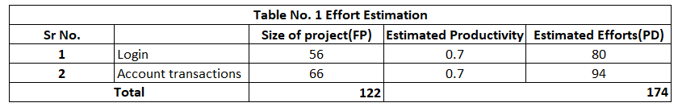

1. Suppose cost per PD is 100$ (8300 rupees)

Cost for 174 PDs = 174*8300 = 14,44,200

Total cost after adding 30% overhead cost and 15% margin = 20,94,090 rupees.

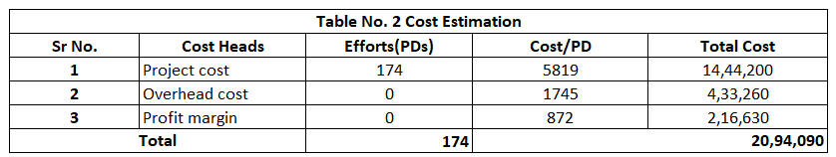3. Distribution of efforts across the project

Note: distribution of efforts taken from general data for java projects.

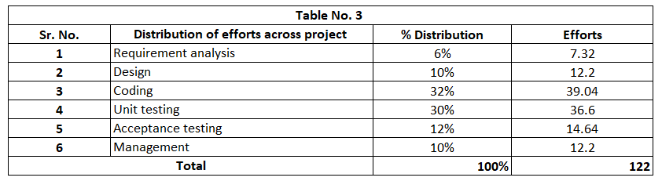

**Note:** Productivity, efforts distribution and cost/pd is taken from online data: average values for Java projects.

**Conclusion:**

In conclusion, effort and cost analysis are important project management in software development. Estimating the effort and cost for a project is a critical aspect of project planning. Several factors influence the estimation process, and it requires careful consideration of various elements.

**References:**

1. https://w3.cs.jmu.edu/bernstdh/web/common/webapps/oop/fpcalculator/FunctionPointCalculator.html
2. <https://birdeatsbug.com/blog/black-box-testing>