**Software Engineering Lab Experiment No. 2**

**Aim:** Creating Data flow diagram and use case based on any project.

**Objectives:**

1. UML class diagrams help in visualizing the key classes, their attributes, and relationships within the system.
2. Understanding Class Relationships.
3. Making use case diagrams to help and identify and document user needs.
4. To outlines the key actions that the customer can perform when using the system.

**Requirements:**

1. Computer with internet access.
2. A Figma account.
3. Sample software project or problem statement for requirements analysis.
4. Word processing software for creating the lab report.

**Concept:**

1. **UML** **Diagram**

* A UML (Unified Modeling Language) diagram is a visual representation of a system's structure and behaviour.
* It uses standardized symbols and notations to depict classes, objects, relationships, interactions, and more.
* UML diagrams help to model, document, and communicate complex software and system designs, making them easier to understand for stakeholders and developers.

1. **Use Case Diagram**

* A use case diagram is a specific type of UML diagram that focuses on the functional requirements of a system.
* It represents how users (actors) interact with a system by defining use cases (functionalities or services) and their relationships.
* Use case diagrams provide a high-level view of the system's behaviour and helps us capturing user requirements, system functionality, and the roles of different actors in the system.

**Tools:**

* **Figma:** Figma is a web-based design tool that allows users to create interactive user interface prototypes. It enables real-time collaboration and can be accessed from anywhere and on any device.

**About Project**

**Bank Application:** It is an online banking application which allows user to create a bank account and login. This application has different modules like login, account details, transactions and Loan. User can apply for loan using this application, upload documents, check approval status etc.

**Steps:** ***General steps for creating a UML diagram:***

1. **Identify the System or Process:**

* Clearly define the system, process, or concept that you want to model with the UML diagram.

1. **Identify the UML Diagram Type:**

* Choose the appropriate type of UML diagram based on what you want to represent.

1. **Gather Requirements and Information:**

* Collect all relevant information about the system, including classes, objects, relationships, behaviours, and interactions.

1. **Select UML Diagramming Tool:**

* **Figma:** Figma is a web-based design tool that allows users to create interactive user interface prototypes.

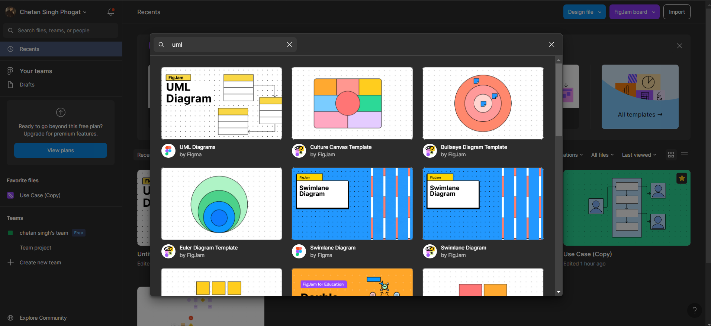

1. **Add Elements and Relationships:**

* Populate the diagram with elements and define their relationships. For example:

In a DFD diagram explain flow of project according to your project.

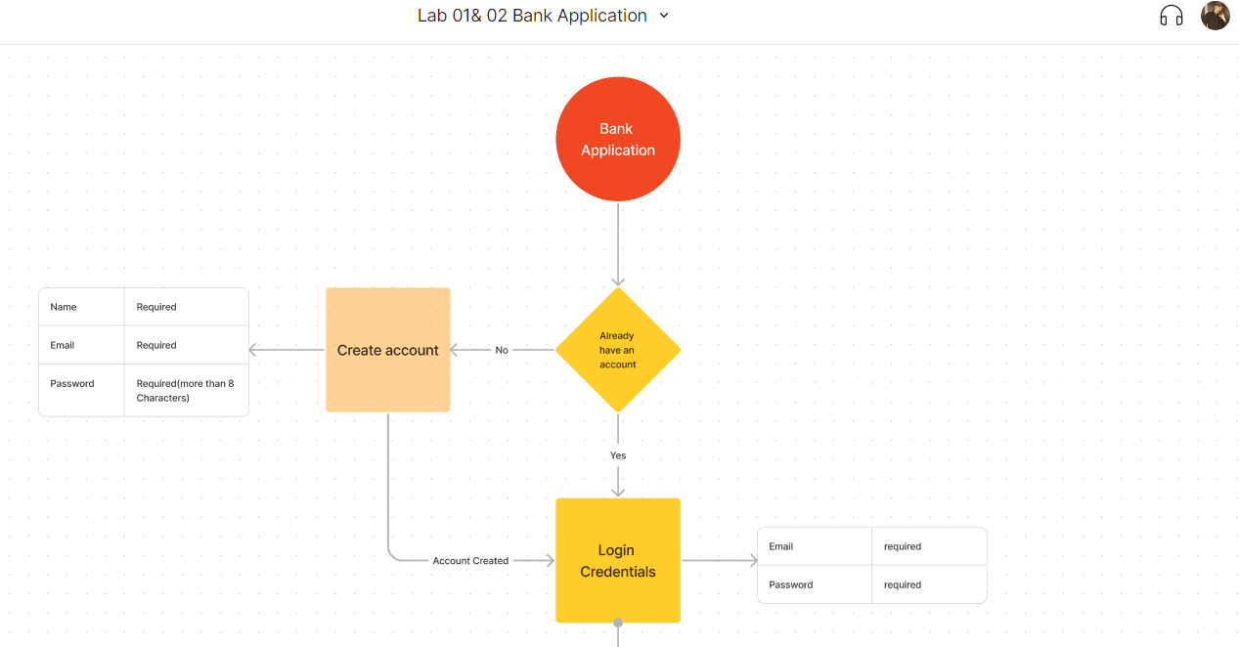

**Steps: *General steps for creating a Use Case:***

1. **Define the Purpose and Scope**

* Use case for an "Account Management" class for user management or authentication.
* This use case describes how a user can change their password.

1. **Identify Actors**

* **User**: Represents individuals who have user accounts and need to manage their passwords.

1. **Identify Use Cases**

* **Change Password:** The user can change their account password.
* **Reset Password:** The user can request a password reset their current password.
* **Unlock Account:** The user can request to unlock their account if it gets locked after multiple failed login attempts.

1. **Create the Use Case Diagram**

This use case describes how a user can change their password.

**Use Case**: Change Password

**Primary Actor**: User

**Precondition:** The User is authenticated and has access to their account.

**Main Success Scenario:**

* 1. The User selects the "Change Password" option in their account settings.
  2. The system prompts the User to enter their current password and the new password.
  3. The User enters the required information.
  4. If the validation is successful, the system updates the User's password.
  5. The system confirms the successful password change to the User.

**Exception Scenarios:**

1. Invalid Current Password
2. Weak New Password
3. Technical Failure (Database connection failure)

This use case describes the interaction between the User and the Account class when changing their password. It covers the main successful path as well as potential exception scenarios to ensure a comprehensive understanding of how this feature works.

**Conclusion:**

* This lab report aimed to provide a practical understanding of UML Data flow diagram provide a visual representation.
* The use case diagram outlines the main functionalities of the system as seen from the customer's perspective.

**References:**

- Figma - Collaborative interface design tool (https://www.figma.com/)

- Software Engineering: A Practitioner's Approach by Roger S. Pressman (For further reading on requirements analysis in software engineering).