**Software Engineering Lab Experiment No. 5**

**Aim:** Create sequence diagram for the project

**Objectives:**

1. The objective of this lab experiment is to create a sequence diagram for the software project.
2. The sequence diagram will serve as a visual representation of how different elements collaborate to specific tasks or scenarios in the software application.

**Requirements:**

1. Computer with internet access.
2. A Figma account.
3. Sample software project or problem statement for requirements analysis.
4. Word processing software for creating the lab report.

**Concept:**

* **Sequence Diagram -** A sequence diagram is another type of UML (Unified Modeling Language) diagram used to visualize and represent the interactions and flow of messages between various components, objects, or actors in a system over time.

**Tools:**

* **Figma:** Figma is a web-based design tool that allows users to create interactive user interface prototypes. It enables real-time collaboration and can be accessed from anywhere and on any device.

**Steps:** ***General steps for creating a Sequence diagram:***

* 1. **Identify the Scenario:** Begin by identifying the specific scenario or use case for which you want to create a sequence diagram. This scenario should represent a typical interaction within the system.
  2. **Identify Participants:** Identify the key participants in the scenario. These can be objects, classes, actors, or any other relevant entities that are involved in the interaction.
  3. **Define Lifelines:** Create lifelines for each participant on the diagram. Lifelines represent the existence of participants over time.
  4. **Sequence of Messages:** Define the sequence of messages exchanged between participants. Messages represent interactions and communication between participants.

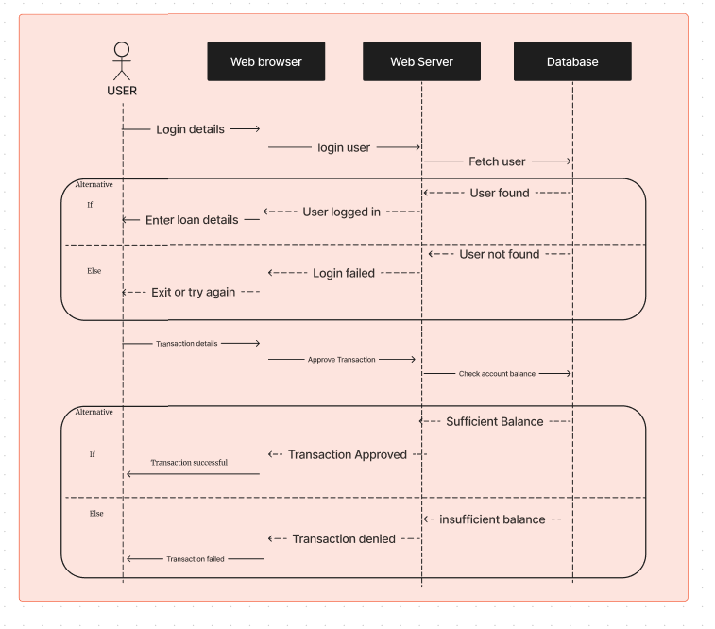

**Conclusion:**

* The sequence diagram created for this project serves as a valuable tool for understanding the dynamic behaviour and interactions within the software system.
* It provides a clear visual representation of how different participants collaborate to achieve specific tasks or scenarios.

**References:**

- Figma - Collaborative interface design tool (https://www.figma.com/)

- Software Engineering: A Practitioner's Approach by Roger S. Pressman (For further reading on requirements analysis in software engineering).