**Software Engineering Lab Experiment No. 9**

**Aim:** Project Size estimation using function point

**Objectives:**

1. The primary objective of Project Size Estimation using Function Point Analysis is to quantify the functional size of a software project based on the functionality it is expected to deliver.
2. Function points provide a standardized measure of the functional size of a software application. This size is independent of the technology or programming language used to implement the system.

**Requirements:**

1. Computer with internet access.
2. Sample software project or problem statement for requirements analysis.
3. Word processing software for creating the lab report.

**Concept:**

Function Point Analysis (FPA) is a method used for estimating the size of a software project based on the functionality provided by the system. The process involves identifying and quantifying the functionality of the software in terms of "function points." The function points are then used to estimate the size of the project in terms of lines of code or person-months.

**Tools:**

1. Function point calculator
2. FP, UFP, CAF

**Steps:**

1. Calculate function points for each module.

External Inputs (EI)

External Outputs (EO)

External Inquiries (EQ)

Internal Logical Files (ILF)

External Interface Files (EIF)

For login module

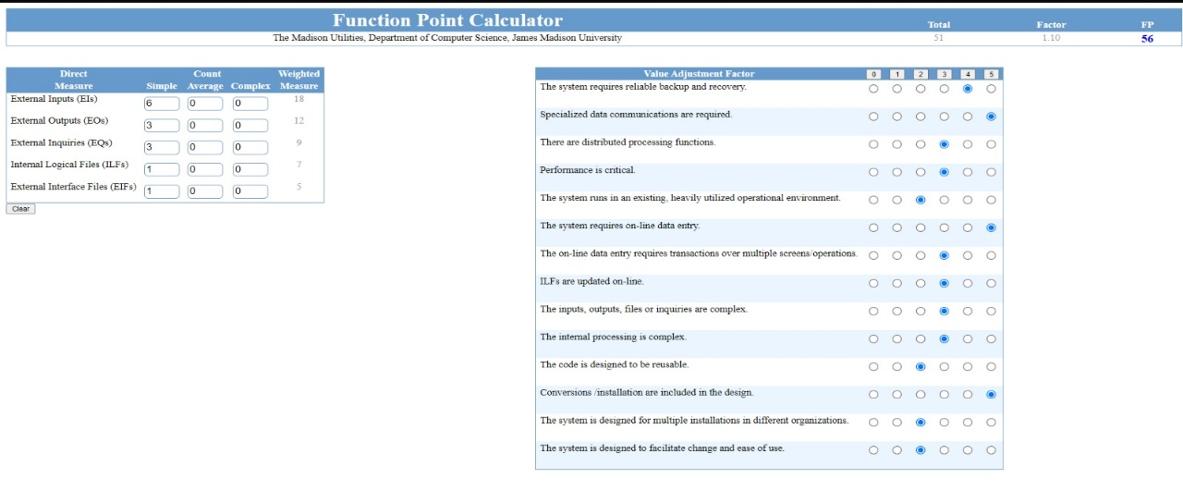

For account transaction module

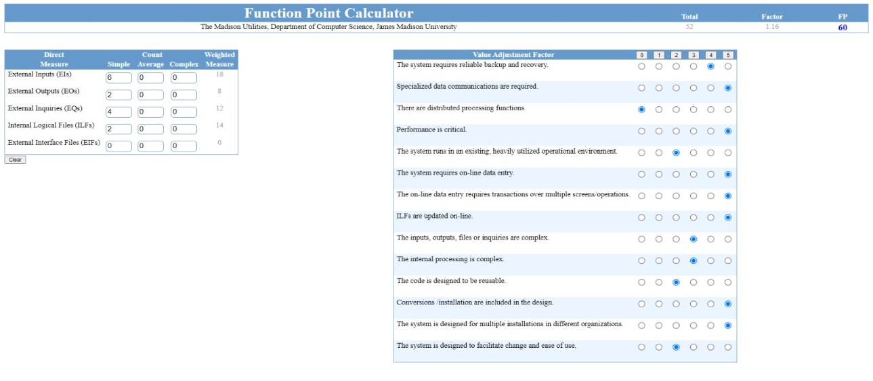

1. Calculate total function points for whole project. (add FP of all modules)

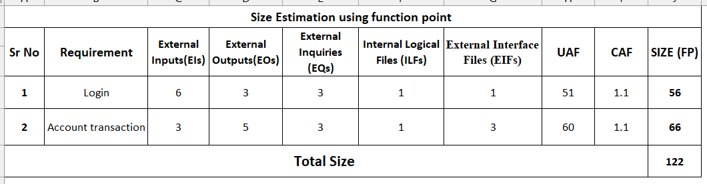

1. Multiply Unidentified Function Points with Complexity Adjustment Factor and calculate Function points. (FP=UFP*CAF)

**Conclusion:**

We learnt that Function Point Analysis (FPA) is a structured and widely used method for quantifying the functional size of a software application. It provides a standardized and objective way to measure the functionality provided by a system, independent of the technology or programming language used.

**References:**

* https://w3.cs.jmu.edu/bernstdh/web/common/webapps/oop/fpcalculator/FunctionPointCalculator.html - <https://birdeatsbug.com/blog/black-box-testing>
* <https://www.geeksforgeeks.org/software-engineering-functional-point-fp-analysis/>