**Software Engineering Lab Experiment No. 1**

**Aim:** Identify the tool for requirements analysis and installation and setup of the software.

**Objectives:**

1. To install and set up Figma for software requirements analysis.
2. To gain a theoretical understanding of requirements analysis in software development.
3. To perform requirements analysis using Figma.
4. To document the entire process and capture output screen shots for analysis and reporting.

**Requirements:**

1. Computer with internet access.
2. A Figma account.
3. Sample software project or problem statement for requirements analysis.
4. Word processing software for creating the lab report.

**Concept:**

Requirements analysis is a crucial phase in software development that involves identifying, documenting, and understanding the needs and constraints of a software project. The primary objectives of requirements analysis include:

- Understanding user needs and expectations.

- Identifying functional and non-functional requirements.

- Documenting clear and unambiguous requirements.

- Analysing, prioritizing, and validating requirements.

- Ensuring that the software solution aligns with the client's objectives.

The process of requirements analysis typically involves steps like gathering user stories, creating use cases, defining system requirements, and producing detailed documentation.

**Tools:**

* **Figma:** Figma is a web-based design tool that allows users to create interactive user interface prototypes. It enables real-time collaboration and can be accessed from anywhere and on any device.

**Steps:**

1. **Identifying the tool :-** Key reasons to choose Figma:

* **Real-time Collaboration:** Multiple team members can work on the same project simultaneously.
* **Cross-Platform Compatibility:** Accessible on the web and desktop for macOS and Windows.
* **Version Control:** Automatically saves and tracks design file versions.
* **Prototyping and Interaction Design:** Supports interactive and realistic prototypes.
* **Design Handoff:** Simplifies design-to-development communication.
* **Component Libraries:** Facilitates the creation and management of design components.
* **Third-Party Integrations:** Offers integration with various design and project management tools.
* **Design Systems:** Tools for creating and maintaining design consistency.
* **Community and Resources:** Access to a large user community and design resources.
* **Scalability:** Suitable for small and large design projects.
* **Security and Permissions:** Provides security features and user permission settings.
* **Regular Updates:** Consistently updated with new features and improvements.

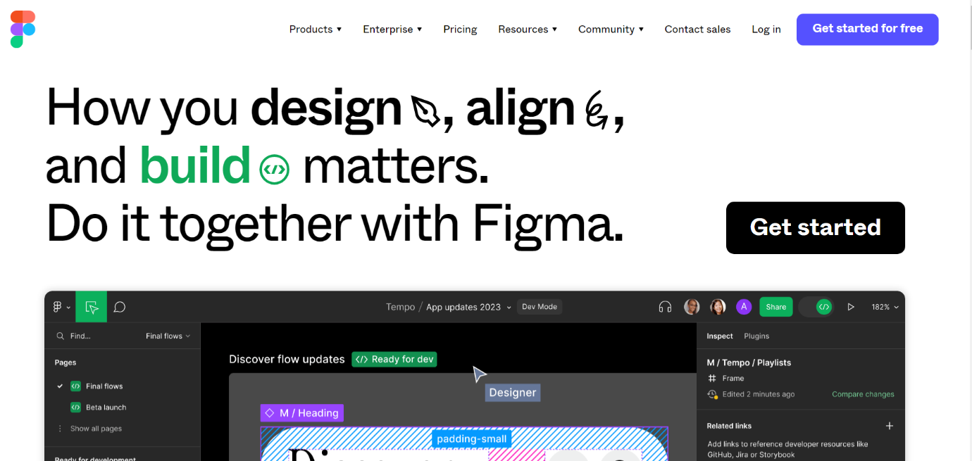

1. **Setting Up Figma:**
   1. Go to the Figma website *(https://www.figma.com/)* and sign up for an account if you don't already have one.
   2. Install the Figma desktop application (if required).
   3. Explore the Figma interface and understand its features for design and collaboration.

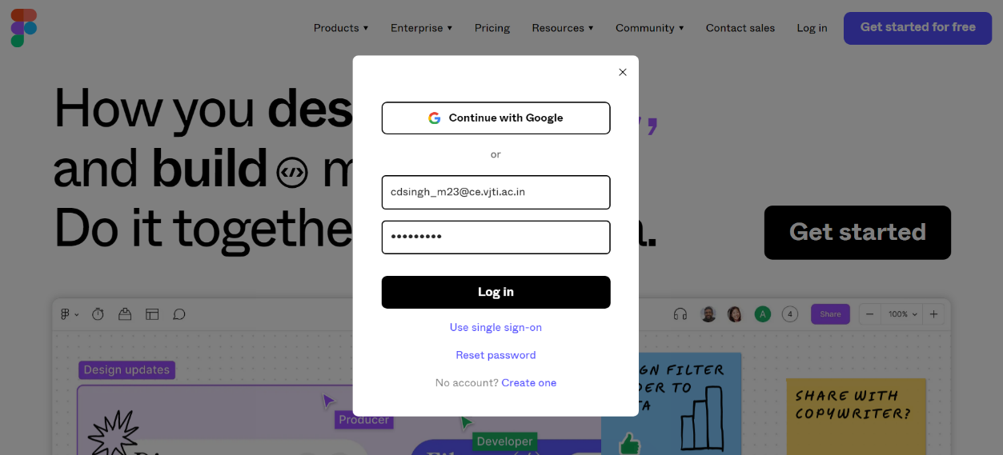

1. **Home Page after login**

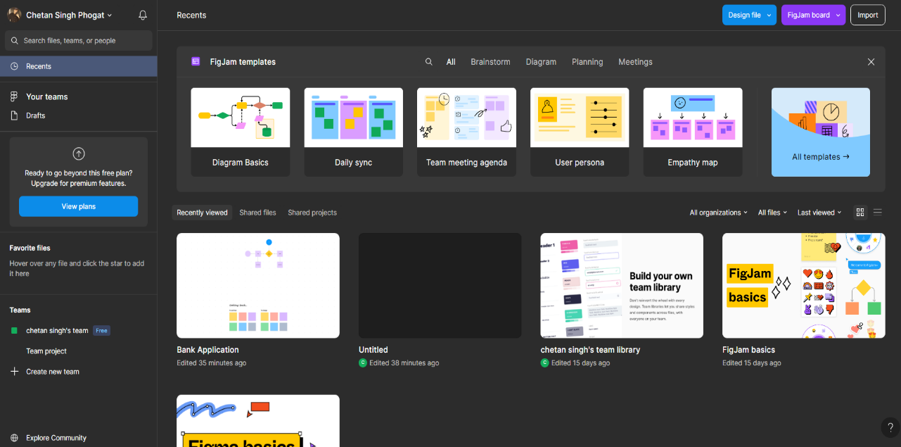

**Conclusion:**

This lab report aimed to provide a practical understanding of setting up Figma for software design and conducting requirements analysis using the tool. Figma is a valuable platform for creating, sharing, and collaborating on design and requirements-related tasks. The report also emphasized the importance of effective requirements analysis in the software development process, providing a theoretical foundation for this critical phase.

**References:**

- Figma - Collaborative interface design tool (https://www.figma.com/)

- Software Engineering: A Practitioner's Approach by Roger S. Pressman (For further reading on requirements analysis in software engineering).