Capstone Weekly Report
Name: Peyton Hollis
Date: 3/6/26
Individual Activities
- Reading and Writing of Capstone Paper Outline
Describe what articles you have read this week, and the writing you have contribute to the capstone paper outline.

After training a small demonstration model for the midterm capstone presentations, I have begun to implement and train our final model with our larger dataset. This required me to gain more knowledge about Ultralytics YOLO models and Google Colab.

The first article I read was an overview of YOLO26, YOLO11, YOLOv8, and YOLOv5. This article described architecture overview of each model in depth. It gave me a better understanding of what exactly is going on behind the scenes when training the YOLO models. Importantly, this article described the performance differences between the models and led me to deciding to use the YOLO26 model for our final Computer Vision Player Tracking model. However, the first training was conducted on YOLOv8n.

The next article I read was a direct comparison between YOLOv8 and YOLO26. It provides me with direct architecture comparisons and explained the notable differences between the two models. Additionally, it provided direct performance comparisons in the images seen below.

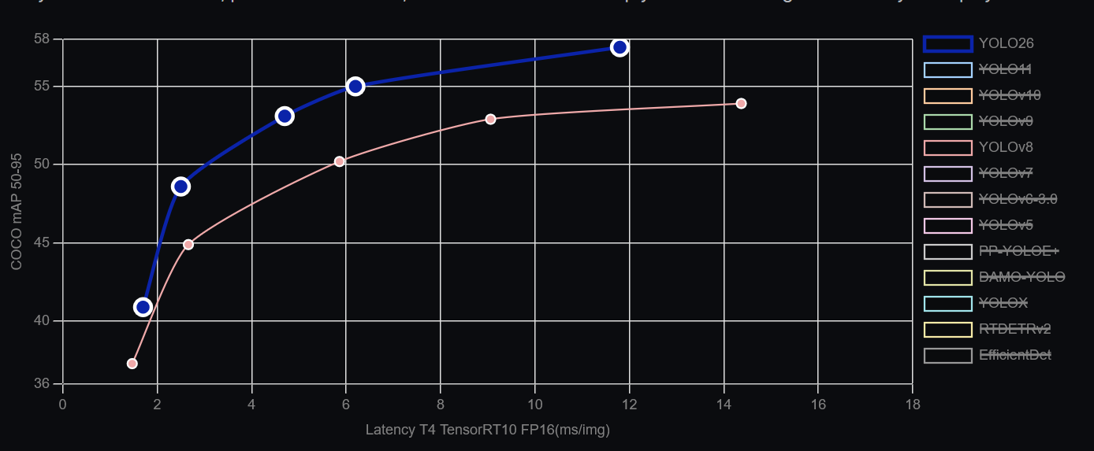

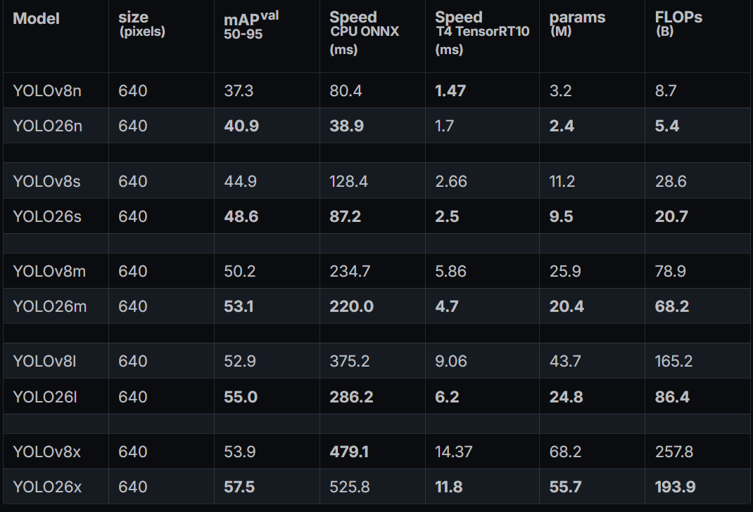

The last article that I read described how to use Google Colab for training AI models. It discussed steps for loading datasets, changing runtimes from CPU to GPU, and saving model weights from the training. This article was helpful for understanding how to perform initial model training in Google Colab.

- App Development Tutorial.
Most teams have assigned a tutorial about your demo app development. What progress have you made (this is for you, not your team). Attach the notes you have taken by learning from the tutorial if you have any. (It would be a good idea to put notes in your digital portfolio to show Professors the efforts you have put into your project.

We do not have one specific video that we are following for this project. Instead, we have a series of videos that each give us knowledge on specific concepts that we will combine to complete our project. The first video that I watched gave an overview about how creating a player tracker CV model would be conducted. It explained concepts like training the model and running tests and demos with the model. This stage has been implemented through the training of the YOLOv8n model and YOLO26 model.

The next video that must be watched demonstrates how to utilize the CV model annotations along with key point detection and homography to create the virtual game cast. This will allow our project to move from only a player tracking model to a real-time game cast. Additionally, this video will introduce us to using vectorization to split players on the field into teams for the virtual game cast.
Team Meetings
- Have your team met this week? If yes, when and where? If not, explain.
Our team has not met this week. Before midterm presentations, our group met to discuss the direction and goals that we had for our project. We defined that the project would need to implement the virtual game cast that was mentioned within the proposal. We outlined our goals and checkpoints for the coming weeks so that each of us understand what expectations we are trying to meet.
We have been in constant communication through phone messages and emails to ensure that we all complete work within the predefined timeframe. We are all working together to write the Capstone Paper Outline and to keep working on the demo application.

Capstone Project Progress
- Writing
How is your capstone paper outline writing going?

The group has started writing the capstone paper outline this week. The outline will be broken down into a handful of categories/headings including introduction, keywords, literature review, overview, computer vision architecture comparisons, yolo model types, key point detection and homography, implementation, future work, and references.

Each group member will coordinate as a team to complete writing for each category. We will work together to ensure that each members writing coordinates with the others and fits the over arching goal of the capstone paper outline.

- Demo App Development
What progress have your team made in developing the demo app?

The team is making progress towards creating the demo app by training CV models. The models presented during the midterm presentation were lackluster in metric testing. This was due to the small datasets and short trainings that were conducted for these models. For the final CV model, Google Colab will be utilized to allow for larger datasets and faster training times to create a better performing model.

Additionally, research is being conducted by group members to gain a better understanding of homography for the creation of a virtual game cast. This includes researching key point detection to pair with homography.

Below is two screenshots of training information. The first contains model training parameters and the second shows the training in progress.
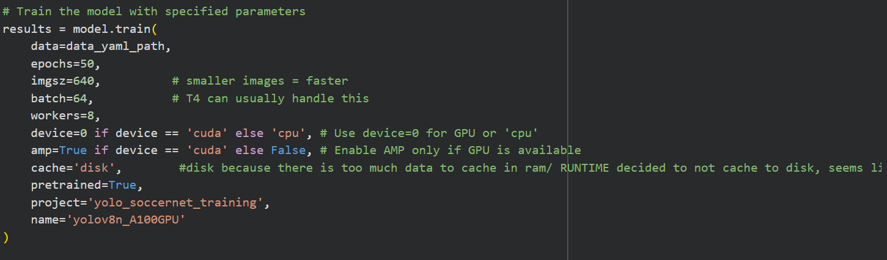

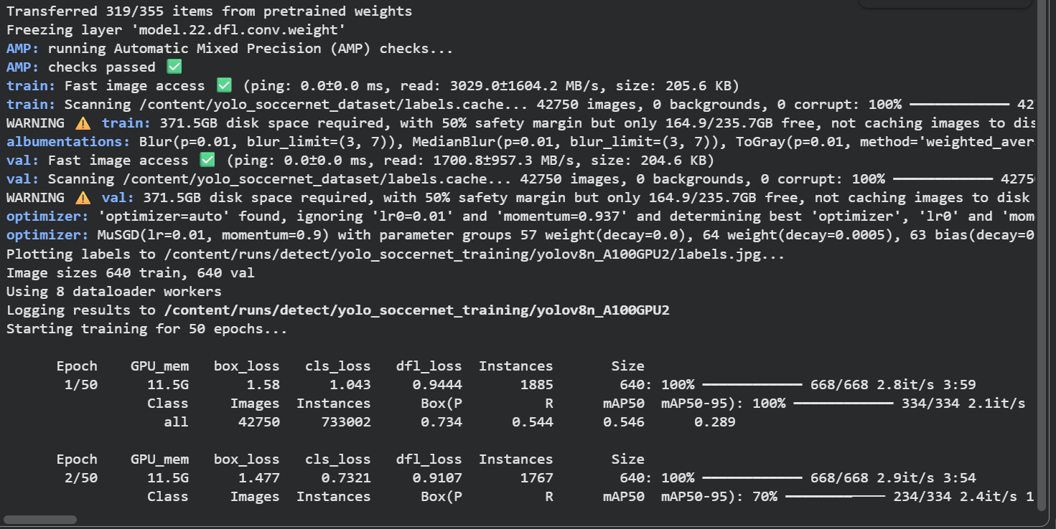

Below is two comparisons of computer vision models. The first is the newly trained YOLOv8n model which performs well for detecting players on the pitch. The model may be making overpredictions as well. This will need to be investigated. The second image is the previously trained YOLOv8n model. This model performs worse than the newer model and missed detection on a few players. It also struggled more with tracking players.
