Computer Vision in Sports:
Player Tracking for the Creation of Game Cast
Peyton Hollis, Curtis Canby, Uchenna Ibe

Introduction
Computer Vision (CV) is a subfield of artificial intelligence that enables computers and systems to derive information from images, videos, and other visual inputs, allowing them to take actions and make decisions from said visual inputs. CV is an ever-growing topic within computer science with many use cases, including facial recognition, object detection, medical imaging, security/surveillance, sports analytics, and more (AlwaysAI). This research will focus on CV for sports analytics, specifically utilizing player tracking and key point detection to create a virtual game cast for soccer games. Game cast means combining data from both player tracking and key point detection to accurately plot players, balls, and officials to a virtual field. This project intends to create models with inference and accuracy that is proficient enough to create said game cast in real time from a live stream video.
Figure 1
Basics of project demonstration, player tracking annotations using YOLO26n (fine-tuned).
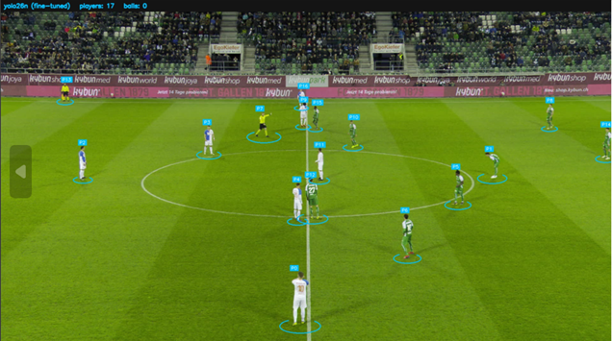
From sample testing during model trainings and research.
Project Focus
Within sports analytics, CV allows the automated extraction of meaningful information enabling insights into player movements, team tactics, and sport play tracking. The basis of extraction relies primarily on leveraging CV models for tasks including field registration, object tracking, action recognition and detection, pose estimation, etc. This paper will explore the most basic forms of CV tasks including player tracking and key point detection (field registration). A player tracking model was created to locate players on a soccer pitch during each frame of a video. A separate, key point detection model was created to map a virtual field. Running inferences with both models simultaneously creates the game cast system that plots players to a virtual field with real time capabilities.
Computer Vision Architectures
Player tracking and key point detection can be performed using a variety of different techniques and architectures within CV. These architectures include traditional models like Convolutional Neural Networks (CNNs), more modern techniques like Vision Transformers (ViTs), and an even newer model type of Shifting Window Transformer (SWIN). An analysis of these models is used to determine which model type is most appropriate for this project’s needs and objectives. The most popular of these models include Ultralytics YOLO models (CNN), Hugging Face’s ViT, and Microsoft’s SWIN-Tiny SWIN model.
Model Choices and Limitations
The choice between model types will be determined by a few key factors. These factors include availability, hardware/data limitations, and scores from performance metrics (accuracy and inference speed). Availability includes ease of use when training and making predictions with models and documentation surrounding the given models. Older CNNs often are easier to use and have more documentation than the new ViTs and SWIN models. Hardware limitations include lack of CPU/GPU speed and dataset processing limitations. Data processing limitations were a result of having to utilize Google Drive for storing large datasets and using Google Collab for training using said datasets. The transfer speed between these two systems created a noticeable bottleneck that affect how fast training was conducted. Finally, performance metrics include MOTA (Multi-Object Tracking Accuracy), HOTA (Higher Order Tracking Accuracy), IDF1 (ID F1 score) and inference speed for real time performance capabilities.
Keywords: Computer Vision, Sports Analytics, Player Tracking, Key Point Detection, Game Cast
Literature Review
‘ViTs Real World Applications’ by SJ Innovations
This article by Aftar Ahmad has some cursory information about what Vision Transformers are and discusses some practical ways ViTs can be used. The article begins by covering some background on Convolutional Neural Networks and ViTs, noting that CNNs are a “standard tool for image recognition, analysis, and object detection.” He says that Google introduced ViTs as a stronger alternative to CNNs in 2020. Vision Transformers parse pictures in segments much the same way that traditional transformers process sentences. By breaking the larger sentence structure into words and processing those as tokens the model can understand the relationships between them better. Similarly, ViTs break pictures into pieces and get a better understanding of the whole picture by processing each chunk. The article then goes over, step by step, how ViTs work through four steps. First the picture is divided into patches and flattened for the transformer, positional encodings are injected to help the transformer understand spatial arrangements, then the transformer uses selective attention to get an understanding of the picture as a whole and finally a classification token emerges as a whole.
‘Ultralytics YOLO Evolution:’ by Ranjan Sapkota, Manoj Karkee
This article explores the evolution of many popular Ultralytics YOLO models including YOLO26, YOLO11, YOLOv8, and YOLOv5. The article overviews key differences between model versions and what makes each unique. For example, the first widespread model YOLOv5, introduced anchors (predefined bounding box shapes) and easy implementations through PyTorch. YOLOv8 expanded on previous generations but removed anchoring to improve ease of use. The YOLOv8 model is still one of the most popular used today for simple object detection tasks. YOLO11 aimed to balance speed and accuracy by adopting hybrid task assignment strategies and redesigning modules for efficiency. The newest model, YOLO26, aims to redesign the standard detection pipelines used by most CNNs. Most CNNs make predictions for annotations by creating a bunch of bounding boxes and then removing the least confident scores from the predictions. This process enforces additional inference speed harming real time capabilities. YOLO26 redesigns this process by using NMS-Free detection which incorporates the fine tuning of creating only one bounding box per annotation during training. Other new pipeline redesigns with YOLO26 include Small-Target-Aware Label Assignment, Progressive Loss Balancing, Removal of Distribution Focal Loss, and MuSGD Optimizer.
‘Real-Time Player Tracking and 2D Field Mapping Using Homography for Football Analytics’ by Labs powered by moOngy
This article describes an in-depth study conducted by Labs that examines the use of homography for the creation of a 2d player tracking and mapping system. It begins by describing the choice of using the YOLOv3 model for speed and accuracy for real time object detection. The image processing allows for the tracking of players and key points on the field simultaneously. Homography is then used to convert the 3D camera footage into a 2D representation of the football field. A transformation matrix is used to accurately depict the players from a 3D view into a 2D plane. The studies goals were defined to create a non-intrusive (no GPS) tracking system, real-time analysis, and 2D field mapping. A more in-depth analysis that combined each study goal was then provided. This included a description of using homography and some of the challenges that arise when incorporating it into the system.
‘Football AI Tutorial: From Basics to Advanced Stats with Python’ by Roboflow
This is a video tutorial that describes the end-to-end process of creating a Football (soccer) AI pipeline. It begins by describing and providing training examples for a YOLO model on player tracking. Datasets are organized in a YOLO readable manner and models are then trained through Google Colab. Then, a similar process is shown for the creation of a key point detection system. Both the player tracking and key point detection models are then combined to create a 2D mapping system. This is done through the use of Roboflow libraries that contain logic for interpreting YOLO annotations, data, and homography. This article provides a clear roadmap for executing this project but lacks some necessary information for using older, deprecated libraries.
Overview
The advancement of computer vision and machine learning technologies has transformed the way sports analytics and broadcasting are operated forever. Computer vision allows systems to interpret and comprehend visual data for live videos, and images which turn into analytics of sporting events. In our project we focused on applying computer vision techniques to a worldwide sport, soccer, to accurately track players and create data that would support our creation of a “Game Cast” application. The goal is to create a system capable of identifying players and turning that into real life data updates as users watch the given video, or broadcast, adding to this detection of key points on the pitch that helps users understand distinct player movements and positioning occurring throughout the match. This project is a direct example of how modernized deep learning techniques can be applied to sports we all love, and broadcasting tools.
Figure 2
Player tracking and key point detection models are used to create 2D mapping system on Football (Soccer) video.
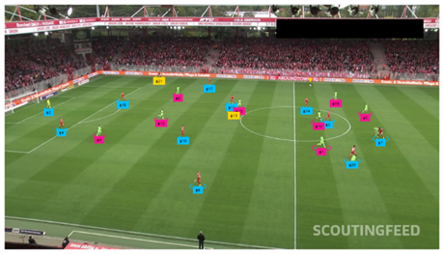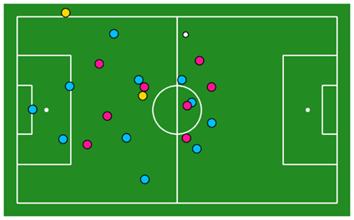
Sample project from Football AI Tutorial. Roboflow.
The first stage of our project involved detailed research into different computer vision model options and understanding exactly what data was required to proceed and train effectively. Computer vision models rely significantly on understanding the given data whether it’s large, medium, or small of labeled images or video frames. These labels can vary from bounding boxes around players, to key points of the field that help models understand space, and awareness. Our team explored several different options that best fit our desires. Among the datasets examined were Kaggle soccer datasets, and SoccerNet datasets. Each dataset has its flaws and positives in terms of given size, usability, and annotation types for our objective.
Specifically, the Kaggle dataset we explored included player tracking dataset and key point detection all around the pitch. This specific dataset had player tracking bounding boxes for players within broadcast style soccer footage. These notations allowed our model to learn how to distinguish players within the given video frame. The key point detection dataset provided annotations for 32 different points all over the field, which in turn drastically improved tracking accuracy and provided additional context for player motion. Although this dataset was very helpful, it was very small and required careful processing to ensure everything is consistent and trained up to par.
Another dataset we examined was SoccerNet dataset. This dataset is much larger and more comprehensive, designed for soccer video analysis specifically. SoccerNet had lots of detailed oriented notations including bounding boxes for players, referees, goalkeepers and even the ball. This specific dataset is divided into 30 second clips recorded at 25 frames per second, providing a very large number of images for training purposes for our model. However, this dataset required us to convert specifically to YOLO style annotation format to train.
This project explored different styles of computer vision model architectures to develop a system capable of tracking players and realizing important points all over the field. After evaluating several approaches, and which one worked best, including CNNs, Vision Transformers, and Swin Transformers, our team first selected YOLOv8 model because of the time, efficiency, and ability to perform well with very minimal complications. For midterm, using the YOLOv8n variant, we moved these models into a web application to demonstrate how it functions. Although challenges like limited hardware and different camera angles in datasets affected our training, the project successfully demonstrated exactly how computer vision and deep learning come together to be applied to sports and player tracking innovations.
After creating a simple demonstration for midterms, more research was conducted to improve training efficiency and accuracy. This uncovered a newer YOLO model, YOLO26, which outperforms YOLOv8 in both training efficiency and accuracy. This new model was implemented for both player and key point detection to work towards the goal of a real time game cast. Further comparison of YOLO models will be shown later.
Computer Vision Architecture Comparisons
There are three types of computer vision models that we considered. Convolutional Neural Networks (CNN), Vision Transformers (ViT), and Shifting Window Transformers (SWIN). Each of these have their own advantages and disadvantages to explore further which ultimately informed our decision about which one we would pursue for our project.
CNNs, as the name suggests, use convolution to break down an image for processing. According to Ultralytics (2026), “Convolution is a fundamental mathematical operation that serves as the core building block of computer vision and deep learning systems. In the context of image processing, convolution involves sliding a small filter—often called a kernel—across an input image to create a map of significant features. This process allows artificial intelligence models to automatically learn and identify patterns such as edges, textures, and shapes without human intervention.” These convolutional layers are what makes it distinct from the other two architectures. The key idea behind this that will make it unique from the approaches of the other two architectures is that the processing happens to the entire picture all at once instead of in patches.
ViTs take the same approach as regular transformers, which break down sentences into words so that the model can get a better understanding of the whole. ViTs break the picture into patches that act as the words and use self-attention to understand how they come together as a picture. Winland with IBM explain the self-attention mechanism best, “Self-attention is a type of attention mechanism used in machine learning models. This mechanism is used to weigh the importance of tokens or words in an input sequence to better understand the relations between them. It is a crucial part of transformer models, a powerful artificial intelligence architecture that is essential for natural language processing tasks.” (2026) Thankfully this mechanism also translates into photo-based transformers to achieve the same goal. It's this self-attention mechanism that SWIN models sought to improve, because breaking a big problem into smaller, more manageable tasks proves time and time again to benefit ai.
SWIN models use shifting window attention instead of self-attention like regular vision transformers. SWIN models explained by Gupta on Geeks for Geeks makes sense of the SWIN models, “Instead of computing attention globally the model computes attention within local windows. These windows act as small, focused regions capturing fine features while keeping computation manageable. Self-attention is applied within the window and captures local features.” It's this shifting window method that makes it better than the standard Vision transformer. Of the three types of models covered, this one is reportedly the best. However, there is a factor to consider that greatly affects our decision.
It's generally understood that CNNs require less data and training time than the other two models, and there are far more recourses for CNN’s available for free online. The YOLO model is the most popular pretrained CNN model, and we have chosen to use it for our project mostly due to time constraints and data availability.
YOLO Model Types
After the initial investigation of which CV architecture to choose, more research was conducted to determine which CNN model would be used, and specifically which YOLO version would be used. The most popular YOLOv8, offered fast inference and accuracy with Anchor-Free Detection, a Decoupled Detection Head, and CSP-style CNN backbone when compared to other CNN models. The newer YOLO26 model increased inference speeds and accuracy by redesigning the entire pipeline with NMS-Free detection, Small-Target-Aware Label Assignment, and Progressive Loss Balancing to name a few differences. These improvements made it easy to utilize YOLO26 over YOLOv8 even though the YOLO26 model is still unproven due to its extremely new age. Figure 3 shows a comparison of the YOLOv8 and YOLO26 models on mAP (mean average-precision) using the COCO dataset, a common dataset used for creating baseline performance ratings for CV models. Notably, the YOLO26 model makes inferences faster and more accurately, both desirable qualities for creating a real-time system.
Figure 3
Comparison of accuracy and inference speed for YOLOv8 vs YOLO26
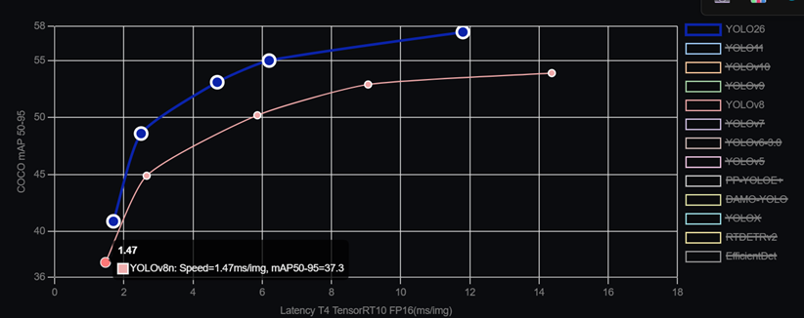
Ultralytics
Additional comparisons were made after each model was trained on player tracking datasets. Figures 4 and 5 both show side-by-side comparisons of the YOLO26n and YOLOv8n models. In Figure 4, both models perform similarly for players in the foreground with clear camera quality. Notably, the YOLO26n model accurately detects players that are far from the camera, while the YOLOv8n model does not make predictions. This difference is important to note as the model for this project must be capable of making predictions on players that are far away and with poor camera quality. Figure 5’s detections are the same for both the YOLO26n and YOLOv8n models. This is likely due to the camera view being zoomed in and the high camera quality. It is important to note that both models are able to make similarly accurate predictions in some contexts, while the YOLO26n outperforms in other contexts.
Figure 4
Side-by-side comparison of YOLO26n and YOLO8n, both fine-tuned on soccer player tracking.
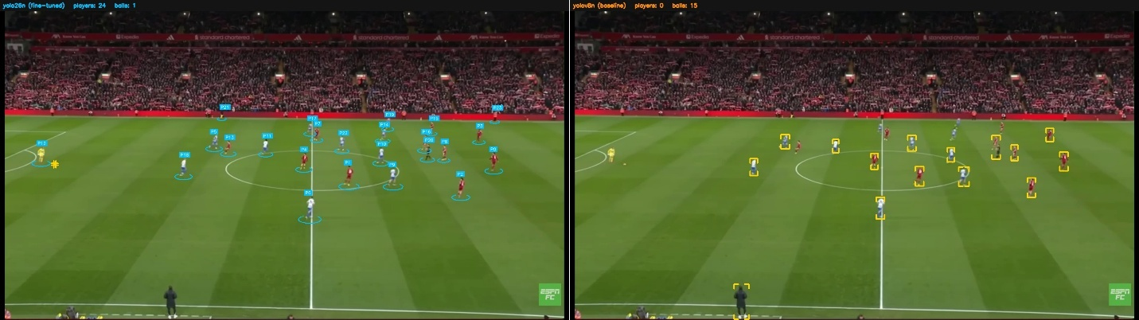
Images from Liverpool vs Brighton livestream from ESPN FC.
Figure 5
Side-by-side comparison of YOLO26n and YOLO8n, both fine-tuned on soccer player tracking
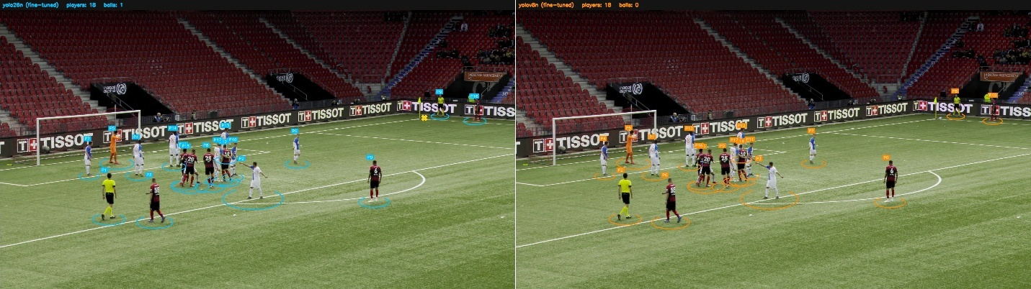
Images from SoccerNet Dataset.
Direct comparisons within a player tracking and detecting context are essential. As seen before, Figure 3 shows a comparison of the models on a general COCO dataset. With this data, one may assume that YOLO26 is a far superior model to YOLOv8. However, this assumption could lead to blindness to the real context that is desired. As shown in Figure 5, both models performed the same on the image, showing that the models' performances may be more similar than assumed. These similarities led to other performance metrics being used, including inference speeds. Individual testing of inference speeds confirmed the results shown in Figure 3. The YOLOv8n model is marginally faster than the YOLO26n model while performing worse on accuracy. However, for the larger v8 and 26 models (s, m, I, x), the inference speed of the YOLO26 began to outperform the YOLOv8. These differences could be examined in further detail within the future works section.
Key Point Detection and Homography
Key Point Detection is a critical part of our project, and along with that Homography will be an essential tool. With the goal of putting digital players into relative positions on a digital field based on where they are on the pitch, the computer vision model will need to identify where the players are on the pitch. It will begin with key point detection. Finding significant markers on the field that can be used to place the players accurately. If the model can idtentify the halfway marker of a field, or the edges of the field or the ends of the field ect, it will have useful information that can be used to map player locations. Homography is the mathmatical relationship between two images. It can be used to describe to a computer how what it is seing in a picture, translates to the digital field.
Key point detection is simply an object detection problem. In the specific case of football pitch key point detection, there are some considerations to be made. The field has two horizontal lines for the left and right of the field that look the same visually, and a model may have a hard time understanding what they are looking at. The center line with the circle in the middle is unique on the field, as are the top and bottom because of the corners and goal making it easier to tell what side you're on. Really, having good data with properly annotated key points should be good enough to allow for decent detection.
Homography is mathematics that can be used to relate the space on one image to another. The pitch in a picture will be at an angle and a certain distance and homography allows the computer to estimate how to relate what it sees in that image to the graphical field of our program. OpenCV (2026) explains passing perspective points to a module such as calib3d’s findHomography() will find the perspective transformation from one picture to another. OpenCV’s page about it provides more details about how to refine the process but this is what we will aim to do.
Implementations
The implementation of our project focused on building a computer vision system capable of detecting soccer players and identifying key sections on the field. The first step involved preparing several datasets, including Kaggle and SoccerNet. These datasets contained specific images with bounding boxes for each player and labeled parts of the field where key points are played. The data had to be organized and converted into the correct notation format required for our training, which is the YOLO Format. After processing the data, we used the YOLOv8 framework to instruct our models so they could recognize players and detect points on the field within the broadcasting angle. After initial training, for proof of concept using smaller Kaggle datasets and the YOLOv8 model, we began to prepare the SoccerNet dataset for training a YOLO26 model. Hardware limitations when training the YOLOv8 model guided this project to utilize a virtual GPU in Google Colab. This required the large SoccerNet dataset to be uploaded to google drive and then used by a runtime within Google Colab for training. Figures 6 and 7 show the steps taken to train the YOLO26 model on both player tracking and key point detection. The images also provide links to the Google Colab notebooks for viewing and use. Datasets are not provided.
Figure 6
Google Colab training example for player tracking. Right click the image to open the link to this notebook.
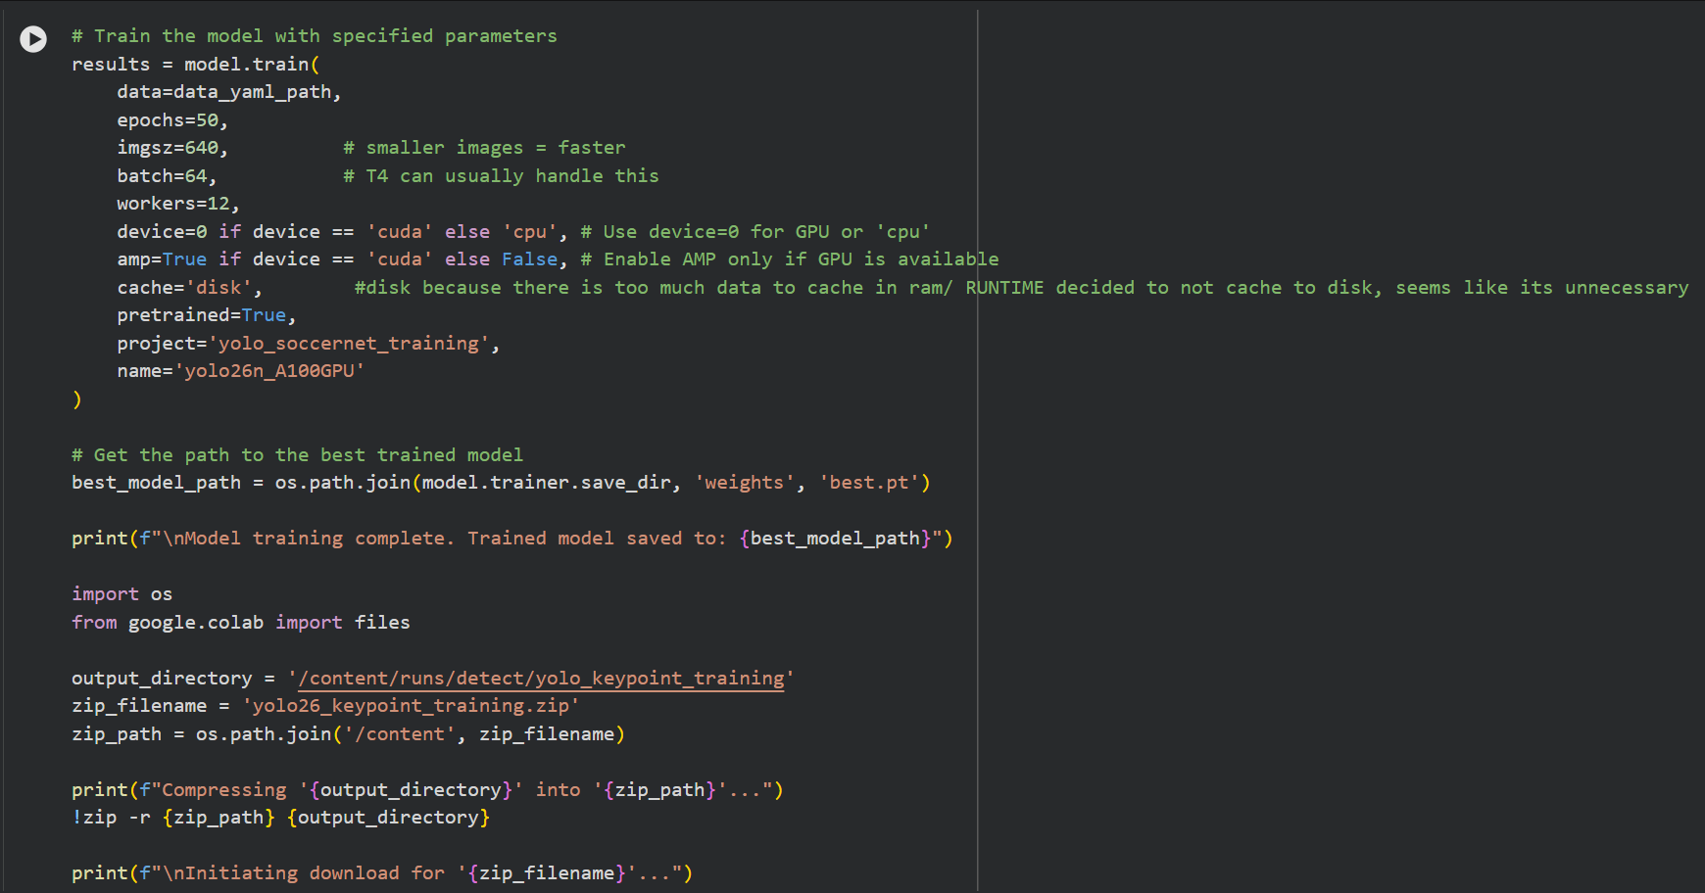
Figure 7
Google Colab training example for key point detection. Right click the image to open the link to this notebook.
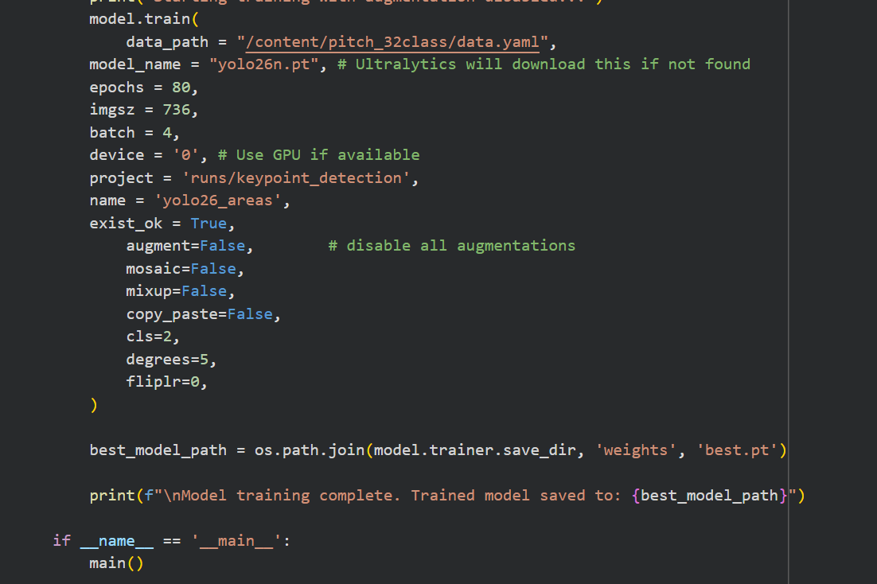
Once we trained the model, they were integrated into a web-based application that specifically demonstrated the functionality of our system. The web application allows users to upload soccer footage from wherever and run it through our trained models to generate displays with player bounding boxes and pitch key points. Training was performed using Google Collab in order to access GPU resources, since our own local machines are very limited. By combining dataset preparation, model training, and application development, the project was able to create a working prototype that ran locally on given hardware. This demonstrates how computer vision techniques can be used to support player tracking and data examination. Figures 8 and 9 show the main page of the web-based application and the example page of player tracking.
Figure 8
Web-based streamlit application homepage. Describes how to navigate the website and what resources are available to the user.
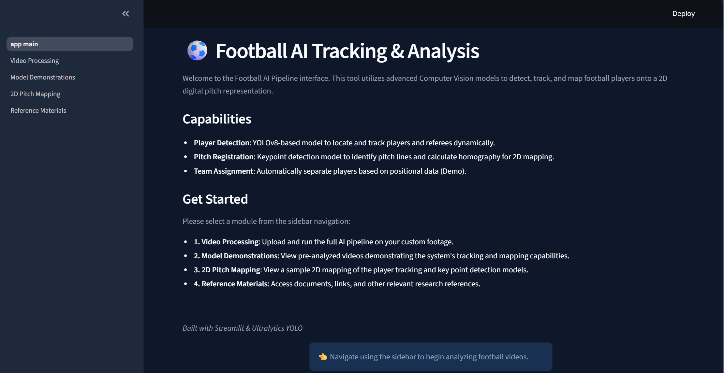
Figure 9
Shows the model demonstration page of the website. Must be updated with YOLO26 model as it is the one with the most recent use.
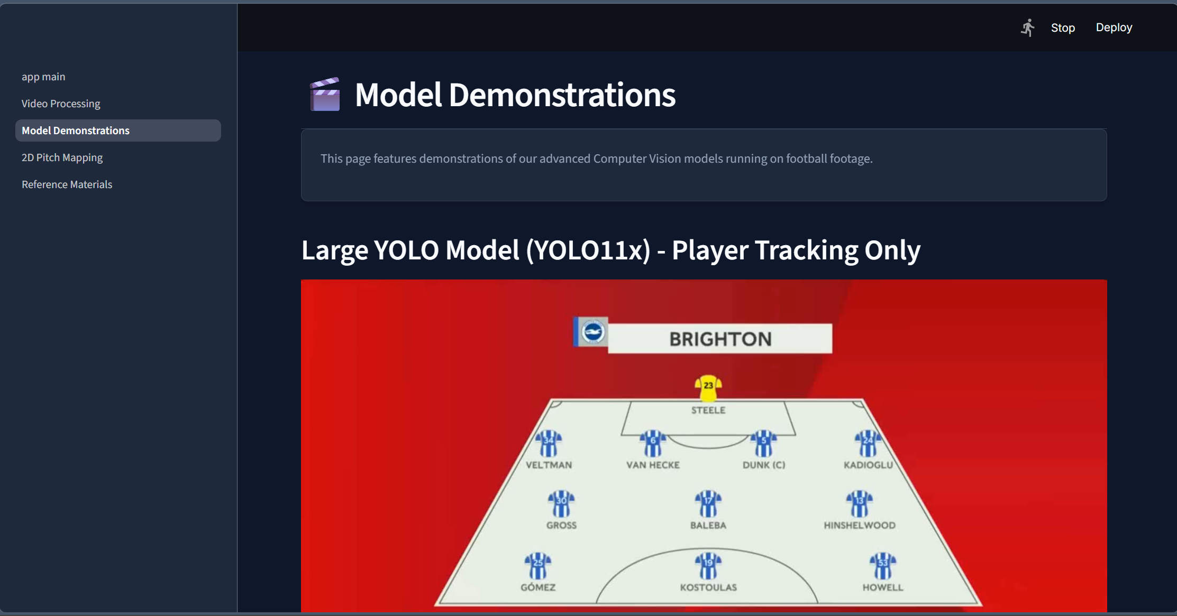
The web-based streamlit application provides pages that include video processing, model demonstrations, 2D pitch mapping demonstration, and reference materials. The video processing tab allows users to upload there own videos and run them with the player tracking and key point detection models. It then allows the users to download the annotated videos. The model demonstration tab allows users to view two pre-annotated videos to better understand the capabilities of the models. The 2D pitch mapping shows how annotated videos are converted to a virtual 2D mapping system. Finally, the resources tab allows users to view this projects resources and sources.
Future Works
Immediate future works for this project include the development and improvement of the key point detection model and 2D mapping system. The current key point detection model is not accurate enough to use in a system to create a 2D mapping system. This part of the project will be developed during the next few weeks before the final presentation.
Future works for our Game cast include improving the dataset chosen and tracking abilities of the computer vision system. Although Kaggle and Soccernet worked for now, that has limitations in size and consistency. Using larger and much more diverse datasets in the future would significally improve the accuracy and performance of the model across different games, lighting conditions, and camera angles. Another improvement would be implementing mutli object tracking methods that allow our system to detect players over multiple frames instead of what we have currently which is one. This would provide the system with the ability to maintain player identifies throughout the match and provide more specifics about players and there movement.
Another area for future reference is expanding the functionality of the system and improving real time performance. Our current web application has very basic player detection and key points, but we could add features that could make the system much more useful for sports analysis and broadcast teams. For example, we could include player heat maps, movement tracking, and performance based statistics that hover over players heads as they move. Improving our real-time processing through better hardware accessibility or even optimizing our models could allow the system to analyze live games as users watch. Additionally, adding ball detection throughout the match and defining events could help automatically identify important moments throughout the game like goals, crutch time, passes, and shots on goal. All these future options would take our project to the next level.

References
AlwaysAI. (2026, March 12). 12 game-changing applications of computer vision. alwaysAI. https://alwaysai.co/blog/computer-vision-applications
Labs. (2025, October 3). Real-time player tracking and 2D Field mapping using Homography for football analytics. MoOngy Labs: Pioneering Innovation in Engineering and Digital Technology. https://labs.moongy.group/articles/real-time-player-tracking-and-2d-field-mapping-using-homography-for-football-analytics
OpenCV. (2026). Feature Mapping + Homography to Find Objects. docs.opencv.org. https://docs.opencv.org/4.x/d1/de0/tutorial_py_feature_homography.html
Roboflow. (2024, August 22). Football AI Tutorial: From Basics to Advanced Stats with Python [Video]. YouTube. https://www.youtube.com/watch?v=aBVGKoNZQUw
Sapkota, R., & Karkee, M. (2025, October 15). Ultralytics YOLO evolution: An overview of YOLO26, YOLO11, YOLOv8, and YOLOv5 object detectors for computer vision and pattern recognition. arXiv.org e-Print archive. https://arxiv.org/html/2510.09653v2
Soccernet. (n.d.). SoccerNet. GitHub. https://github.com/SoccerNet
Ultralytics. (2025, March 12). YOLOv8 vs YOLO26: The evolution of Ultralytics real-time object detection. Ultralytics YOLO Docs. https://docs.ultralytics.com/compare/yolov8-vs-yolo26/
Ultralytics. (2026, March 10). Convolution. Ultralytics | Revolutionizing the World of Vision AI. https://www.ultralytics.com/glossary/convolution
Winland, V. (2026). What is self-attention? IBM. https://www.ibm.com/think/topics/self-attention

