

**High-Level Business Requirements**

Drug and Health Product Register Renewal (DHPR Renewal)

|  |  |
| --- | --- |
|  | **RMOD, Health Products and Food Branch**  **July 9, 2021**  **Version 1.0** |

# Revision History

| **Version Number** | **Description** | **Author** | **Date** |
| --- | --- | --- | --- |
| 01 | Initial Draft of Requirements | Michelle O’Keefe  Sarah-Emily Carle | July 9, 2021 |

**Table of Contents**

0 Revision History 2

1 Authority Signatures 5

1.1 Contacts 5

1.2 Recommended by: 5

1.3 Approved by: 5

2 Executive Summary 6

2.1 Purpose 6

3 Detailed Business Context 7

3.1 Background 7

3.2 Business Need 7

3.3 Stakeholder Analysis 8

3.4 Current Applications and Technology 9

3.5 Business Context Diagram (AS IS) 11

4 Solution Vision - Desired Outcomes 12

4.1 Business Outcomes 12

4.2 Business / Stakeholder Requirements 13

4.2.1 In Scope 13

4.2.2 Out of Scope 13

4.3 Information Management Considerations 13

5 Scope Diagrams (TO BE) 15

5.1.1 Data Sources / Data Flow Diagram (TO BE) 15

5.1.2 Entity Relationship Diagram (ERD) (TO BE) 16

6 Future State Business Processes 17

6.1 Content Publication 17

6.1.1 Drug Data Publication 17

6.1.2 XML Product Monograph and Consumer Information Publication (R1.1) 17

6.1.3 Review Decision Publication R1.1 17

6.2 Content Management and Data Governance 17

7 Site Map 18

7.1 User Interface Design 18

7.1.1 DHPR User Interface Guidelines 18

7.1.2 DHPR Landing Page R1.0 English 18

7.1.3 DHPR Search Results Page 21

7.1.4 DHPR Selected Drug Page 22

7.1.5 DHPR Company Page 24

7.1.6 DHPR About Page 25

8 Roles and Users 25

9 Appendix A 26

9.1 References – Technical Standards 26

10 Appendix B Data Mapping 27

11 Appendix C Static Text and Translations 44

# Authority Signatures

This document conveys the current understanding of the business objectives and scope of the required solution of the Drug and Health Product Register Renewal.

## Contacts

|  |  |
| --- | --- |
| **Contacts for HL-BRD** | |
| **Client Contact** | Sarah-Emily Carle, Project Manager, RMOD, Health Products and Food Branch, Health Canada |
| **Lead Business Analyst** | Michelle O’Keefe, Contract Business Analyst, NTT DATA Services (Sierra Systems Group Inc.) |

## Recommended by:

| **Name** | **Title** | **Description of Expertise (Optional)** |
| --- | --- | --- |
| Daniel Buijs | Manager, Data Science, HPFB | Drupal and HRE SME |
| Pauline Gaudry | Senior Export, Programme Development, HPFB |  |
| Scott Kennedy | Program Support | DHPR Publishing SME |
| Pete Pedersen | Consultant | Mobile App SME |
| Katerina Paschakis | Project / Portfolio Manager | Business Authority |

## Approved by:

By signing below, the individuals listed are indicating they approve the content of this document.

| **Name** | **Title** | **Signature** | **Date** |
| --- | --- | --- | --- |
| Nick Karitsiotis | Business Owner  A/Associate Director, RMOD, HPFB |  |  |
| Shannon Laforce | Accountable Project Director  Executive Director, RMOD, HPFB |  |  |
| Etienne Ouimette | Project Sponsor  Director General, RMOD, HPFB |  |  |
| Sarah-Emily Carle | Project Manager  Project Manager, RMOD, HPFB |  |  |

# Executive Summary

Health Canada plays an important role in protecting the health and safety of Canadians and is committed to greater transparency and openness to further strengthen trust in our regulatory decisions. The Drug and Health Product Register (DHPR) is an important tool to share information on the products that HPFB regulates and their associated regulatory decisions.

The DHPR was launched in 2015 (IP106b) and included drug and consumer information for the top 100 prescribed drugs in Canada. It was developed using manual processes and the ability to scale has been limited.

Since its initial release, the scope of the DHPR has expanded to include:

* Drug information for approx. 4800 drug products (Product Monographs / Consumer Information and Review Decision documents)
* Medical Device Incidents (MDI)
* Adverse Event Reporting (AER) forms
* Prescription Drug List (PDL)

The DHPR Renewal project will provide:

* An updated user interface that improves search functionality and delivers content in a user-centric way, by displaying information based on audience selection
* The introduction of automated publication processes to enable timely publication of new information to Canadians and reduce the risk of manual errors
* A solution that is scalable, allowing additional layers of content and functionality to be added in future phases

This document focuses on Release 1.0 of the DHPR, which will include:

* The updated user interface and platform, setting the foundation for future, iterative releases
* The high-level scope for the initial release of the Drug and Health Project Register Renewal includes the following:
  + Drug Data
  + Publication of the following drug-related resources:
    - Product Monograph (Release 1.0)

The next iteration of this document will expand on the scope for Release 1.1, described in section 4.2.1 In Scope

## Purpose

The purpose of this document is to capture the high-level business requirements (business/stakeholder) to perform preliminary options analysis on possible technical solutions.

The resulting document should be read and understood by all key stakeholders and project team members in order to build consensus on the scope of the technical solution.

In addition, this document contains a subset of the information used to build the business case.

# Detailed Business Context

## Background

Health Canada plays an important role in protecting the health and safety of Canadians and is committed to greater transparency and openness to further strengthen trust in our regulatory decisions. The Drug and Health Product Register (DHPR) is an important tool to share information on the products that HPFB regulates and their associated regulatory decisions.

The DHPR was launched in 2015 (IP106b) and included drug and consumer information for the top 100 prescribed drugs in Canada. It was developed using manual processes and the ability to scale has been limited.

Since its initial release, the scope of the DHPR has expanded to include:

* Drug information for approx. 4800 drug products (Product Monographs / Consumer Information and Review Decision documents)
* Medical Device Incidents (MDI)
* Adverse Event Reporting (AER) forms
* Prescription Drug List (PDL)

The DHPR Renewal project will provide:

* An updated user interface that improves search functionality and delivers content in a user-centric way, by displaying information based on audience selection
* The introduction of automated publication processes to enable timely publication of new information to Canadians and reduce the risk of manual errors
* A solution that is scalable, allowing additional layers of content and functionality to be added in future phases

## Business Need

Health Canada's Health Products and Food Branch (HPFB) works to promote the health and safety of Canadians by being a trusted scientific and regulatory authority for health products and food in Canada. Part of HPFB's mandate is to manage the health-related risks and benefits of health products and food products while providing information to Canadians so they can make healthy, informed choices about their health. More specifically, the DHPR exists to provide information to Canadians about Health Products.

Over the past six years, Health Canada has been undergoing substantive business, information and technological transformation to realize benefits associated with an information-driven economy. Existing systems, such as the DHPR, are no longer meeting stakeholder expectations for more services and faster delivery. There is a growing need to support a variety of applications and technologies; improved regulatory transparency and openness; increased volume, complexity and availability of data; and for stakeholders to interact and communicate using multiple channels for data exchange.

The current DHPR uses technology that is not easily managed, therefore, any changes to content, data or user experience, requires a large amount of work. Additionally, the manual processes built to publish information are disjointed, labor intensive, have become unsustainable and have a high risk of human error. This is currently an issue given the increased traffic, visibility and content because of new COVID-19 treatment information.

Health Canada needs to capture the minds of Canadians as an authoritative, trusted and unbiased source for Health Product information and develop systems that are horizontally integrated and based on a common language and information model. The goal is to automate the publishing of the information as much as possible, giving more control to the content owners over their content to publish and revise as needed, while providing Canadians better access to health product information and resources in a more timely manner.

The public-facing solution needs to be:

* Trusted
* Easily located by a search engine
* Current
* Device agnostic
* Compliant with WCAG guidelines
* Scalable
* Integrated with source systems

## Stakeholder Analysis

The information below is from the DHPR Project Charter – any updates required should be done in both documents.

| **Stakeholder Type** | **Description** | **Responsibilities** |
| --- | --- | --- |
| End Users | Health Product Consumers  Health Care Professionals  Researchers | Looking for trusted, reliable, and timely information on health products available in Canada to make informed health decisions and recommendations. |
| Content Owners | Therapeutic Product Directorate (TPD)  Marketed Health Product Directorate (MHPD)  Biologics and Genetic Therapies Directorate (BGTD)  Office of Submissions and Intellectual Property (OSIP) | Ability to publish regulatory documents in an automated way that provides a user experience that is meaningful to the end user |
| DHPR Owners and Supporters | Resource Management and Operations Directorate (RMOD) | Provide automated tools to Resource Authors to be able to self-publish approved Resources with the ability to maintain resource to product cross-references |
| Web Content and Accountability Guidelines (WCAG) and IT security | Information Management Services Directorate | Ensuring product is in compliance with GoC policies and standards |
| Public-facing communications and standards owners | Communications and Public Affairs Branch (CPAB) | Focus on alignment with Canada web publishing standards, consistency, language. |

## Current Applications and Technology

| **System or Interface** | **Description** |
| --- | --- |
| Current Drug and Health Product Register (DHPR) | * The current DHPR (<https://hpr-rps.hres.ca/>) contains content distributed across seven tabs:   + Four tabs display content (drugs, medical device incidents, review decisions, and prescription drugs).   + One tab links to a separate Health Canada site/pages (natural health products).   + One tab captures content (adverse reactions/incidents for drugs and medical devices) for storage in ArisG.   + One About tab. * The DHPR uses primarily manual processes to gather, create and manage the DHPR content. * For DHPR publication the DHPR database is wiped and repopulated in its entirety every time there are changes. Even small changes (e.g. a change to a few drugs or Product Monographs (PM)) require the full DHPR to be republished. * A single resource manages the DHPR operations with added support as required from three part-time students. * Aggregation (i.e. linking) of different content types (e.g. drug information, Review Decision reports, Product Monographs Part III etc.) from different content sources is performed manually by the DHPR team. Aggregation is performed by the DHPR team according to defined business rules. * Aggregation based on manually linking is not sustainable and cannot scale upwards based on current processes and resources. Additionally, there is the potential to misrepresent the data and linkages between content types. * The following data aggregation challenges have been identified:   + The DHPR team members are not subject matter experts (SME). Performing content linkages is best performed by content and business area SME’s.   + Aggregation of content is not always a 1 to 1 relationship between different content types. This increases the complexity of linking content.   + Linking of DIN’s (E.G. four different strengths of a single drug grouped together), is being done by the DHPR team (the DPD is the content provider). Linking DIN’s is based on DHPR manual procedures e.g. if drug is on same PM and for the same company then link together. There are risks that the DIN’s are being grouped incorrectly as the DHPR is not the business owners or SME’s of the data involved. |
| High Resiliency Environment (HRE) | * The Current DHPR is hosted in the High Resiliency environment (HRE) * The HRE is a Shared Services Canada (SSC) data centre. * Health Canada owns the hardware and manages perimeter security. Management of the HRE infrastructure is outsourced to a third party, Xelerance. * The HRE is a highly redundant data centre but is not currently configured to be highly available (i.e. no automatic failover). * Currently the entire experimental and data science operation is on the HRE. The DHPR and DPD both run operationally on the HRE. * The HRE includes environments for Demo, Development, QA, Staging, Production. * RMOD’s Data Science team has taken on HRE operational tasks and infrastructure support. The manager for Data Science, has direct access to hardware / the HRE. * The HRE is also where the Product Monograph PDFs are hosted for public access |
| Drug Product Database (DPD) | * The Drug Product Database provides product specific information made available by Health Canada for products approved for use in Canada. This includes approved, marketed, pre-market cancelled, post-market cancelled and dormant products. The DPD does not include products in the approval stage. * The DPD includes human pharmaceutical and biological drugs, veterinary drugs, radiopharmaceutical drugs and disinfectant products. The DPD contains product-specific information on approximately 15,000 marketed health products approved for use in Canada. * The DPD is considered a master data set and the Office of Submissions and Intellectual Property (OSIP) is the business owner. * The DPD is updated nightly and includes: * Availability of the drug in Canada. * Product monograph (PM) for human drugs. * Labels for animal drugs. * The DPD produces a monthly extract which is used by several groups including the DHPR |
| Common Tracking Solution (CTS) | While not a current state solution, the Common Tracking Solution (CTS) will be replacing the DPD as the source for Drug Product Information. IP400D |
| Excel Spreadsheets | Various Excel spreadsheets are used for converting information from the various data sources (word documents, databases, etc.) into .html. The process is labour intensive, non-value-add, and prone to errors. |

## Business Context Diagram (AS IS)



Figure - Business Context Diagram

# Solution Vision - Desired Outcomes

## Business Outcomes

Priority:

Core (M): “Must have” requirements

Desirable (D): “Consider on a cost-benefit basis” requirements

Optional (O): “Might accept if exceptionally low in cost” requirements

|  |  |  |
| --- | --- | --- |
| **Ref.** | **Business Outcome** | **Priority** |
| BO-01 | Timely, trusted information provided to Canadians. By automating the publishing of Drug content and Regulatory Documents (Review Decisions, Product Monographs etc.) on the DHPR, Health Canada will be providing trusted, timely information to Canadians on Health and Food Products approved by Health Canada, with less chance of error being introduced by manual publishing processes. | M |
| BO-02 | Positive user experience when looking for Health Canada Drug and Review Decision information. Users can easily search for Health Canada Drug and Review Decision information using industry standard search engines | M |
| BO-03 | Reducing manual, labor intensive processes. Creating publication workflows with built-in automation. This will reduce risk of human error and will require less resources to do manual conversion and publishing activities. | M |

## Business / Stakeholder Requirements

### In Scope

The high-level scope for the initial release of the Drug and Health Project Register Renewal includes the following:

* Drug Data
* Publication of the following drug-related resources
  + Product Monograph (Release 1.0)
  + Review Decisions (Release 1.1)
    - Summary Safety Review
    - Summary Basis of Decision
    - Regulatory Decision Summary
* Migration (data conversion) of the above resources to the new DHPR site
* Decommissioning of the above resources from the current DHPR site
  + Includes decoupling drug and medical device data and resources and regression testing

All requirements for Releases 1.0 and 1.1 can be found in the following location:

Y:\HC\HPFB\_Common - Commun\HPFB Project Management Framework\1 - PPMO\Project Files- Working Folder\DHPR Renewal\1 - DHPR Renewal\Project Management\Requirements\

The filename is DHPR Renewal-Requirements_Vx.xlsx (where x is the most recent version number).

### Out of Scope

The following is out of scope:

* Migration of any items from the existing DHPR not explicitly stated as in scope (will be part of future DHPR releases)

## Information Management Considerations

DHPR Renewal R1.0 and R1.1 will not be capturing and storing any new information, however information that is currently stored in excel spreadsheets will be migrating to new data storage methods, TBD as part of solution design. .

1. Have you consulted your BIMA/RIMA?

No

If yes, who is your contact (Name & Date of contact):

2. Will this application contain Information Resources of Business Value (IRBV)?

Yes

3. Will this application contain transitory information?

No

4. Has the ownership of the information stored in the application been determined?

Yes

If yes, please identify: Ownership of the information remains with the individual business units responsible for creating and maintaining the information. The DHPR will publish this information, and will not create new information.

5. Has a retention period* been identified for the information?

*A retention period should be identified for transitory information to ensure it is not kept longer than is necessary. A retention period based on an authority must be identified for IRBV.

Not applicable. DHPR is publishing information from other sources, and is not creating new information.

6. Will this application replace an existing tool and/or a paper based process?

Yes

# Scope Diagrams (TO BE)

Release 1 of the Drug and Health Product register will focus on re-platforming the drug, product monograph (R1.0, PDF only, R1.1 XML PM), and review decision documents (R1.1).

### Data Sources / Data Flow Diagram (TO BE)

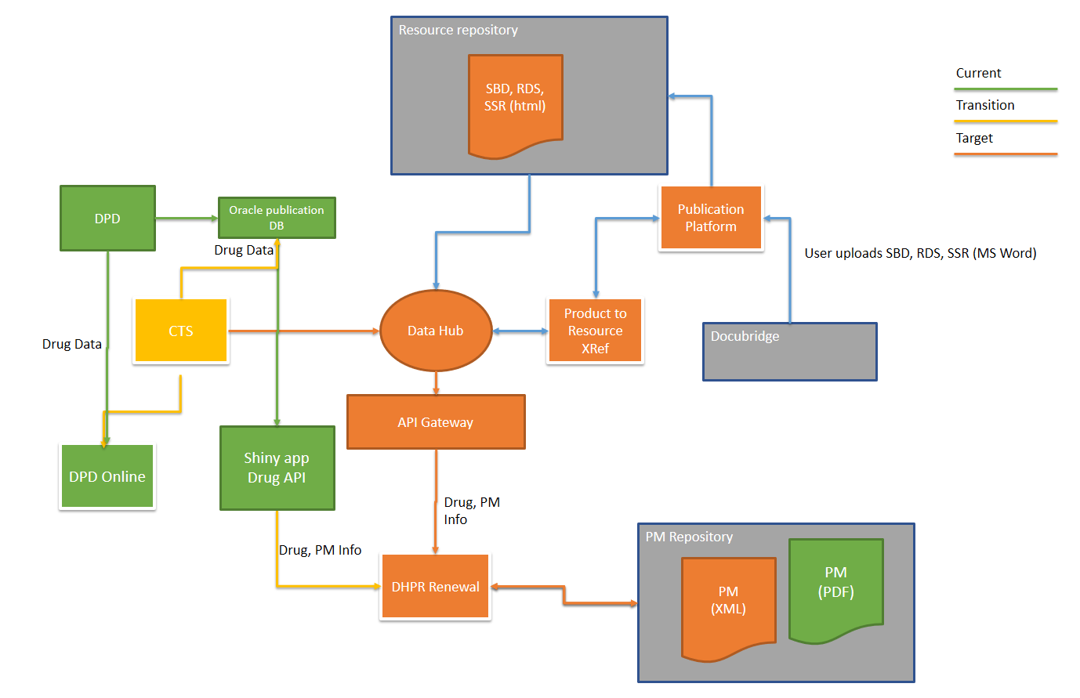

**Drug Data**

* DPD (Drug Product Database) is the current source for drug data, which is copied to an Oracle publication database
* CTS (Common Tracking Solution) – IP400D will be replacing DPD, with drug data copied to the Oracle publication database
* The Oracle Database is the source of data for the Shiny App Drug API, which will be the data source to DHPR for Release 1.0
* The Data Hub project is being introduced and will be the target state source of information for the DHPR, via an API Gateway (design to be determined by Data Hub Project IP803)

**Product Monograph**

* For Release 1.0, the Shiny App Drug API will provide a link to the PDF of the Product Monograph in the Product Monograph Repository
* For Release 1.1, where available, a link to the XML will be provided, and possibly a link to just the Consumer Information section of the XML PM

**Review Decisions**

* For Release 1.1, a solution will be developed to automatically convert Microsoft Word documents into a format that is ready for publishing, such as .html.
* Publishing-ready versions of Review Decision will be stored in a new Resource Repository

### Entity Relationship Diagram (ERD) (TO BE)



# Future State Business Processes

## Content Publication

### Drug Data Publication

* Drug data will be provided through the Shiny App Drug API (<https://shiny.hres.ca/dpd/>)
  + The drug data is currently in DPD, migrating to CTS
  + CTS migration expected in August 2021
  + Content will eventually come from the data hub, timeline unknown
  + CTS will continue to feed DPD Online
  + CTS will not expose public APIs – there is information in CTS that is not public
* For Release 1.0, no changes are required to the Shiny App Drug API. See appendix E for data mapping
* Release 1.1 will require some additions to the API for Review Decision Publication, TBD

### XML Product Monograph and Consumer Information Publication (R1.1)

***Under Development for future version of the BRD.***

### Review Decision Publication R1.1

#### Metadata

| **Metadata** | **Summary Safety Review** | **Summary Basis of Decision** | **Regulatory Decision Summary** |
| --- | --- | --- | --- |
| Link ID | e.g. SSR00011 | e.g. SBD00001 | e.g. RDS00001 |
| Language | English / French | English / French | English / French |
| Control Number |  | Control Number | Control Number |
| Title | Text Narrative  e.g. Summary Safety Review - GALEXOS (simeprevir) - Assessing the Potential Risk of Severe Liver Problems |  |  |
| Safety Issue Title | Safetyissue_title  (appears to have only a select number of values   * Potential safety issue * Potential safety issues * Problème de la sureté potentiel * Problème de sûreté * Problème de sûreté potentiel * Problème d’innocuité potentiel * Problèmes d’innocuité potentiels |  |  |
| Safety Issue | Narrative text |  |  |
| Issue | Narrative text |  |  |
| Background | Narrative text |  |  |
| Objective | Narrative text |  |  |
| Key Findings | Narrative text |  |  |
| Date Issued |  | Date Issued  Updated date (on search results screen) |  |
| Submission Date |  | Date_Submission (in .xls)  Date of Submission (Product and Submission Information area) |  |
| Authorization Date |  | Date_Authorization (in .xls)  Date of Submission (Product and Submission Information area) |  |
| Decision Date |  |  | Date_decision |
| Date Filed |  |  | Date_filed |
| Created Date |  |  | Field exists in excel, but all dates are blank |
| Modified Date |  |  | Field not populated for approx. half the RDS’s. No date newer than 2018 exists |
| (new) Product Identifier   * Groups of IDMP products / family or group of specific devices you can buy. |  |  |  |
| Product | Drug_name (doesn’t appear to be from DPD, e.g. Over-the-counter topical acne products containing either BENZOYL PEROXIDE or SALICYLIC ACID) | Drug/Device Name (on search results screen)  Brand name (in .xls and in product and submission information area) | Drugname |
| Ingredient  (med_ingredient) |  | Medicinal Ingredient (on search results screen and in Product and Submission Information Area) | Active Ingredient, e.g. lubiprostone  Multiple ingredients separated by commas |
| Contact name |  |  | e.g. Bureau de la gastroentérologie et des maladies infectieuses et virales (BGMIV) |
| Contact |  | URL, e.g. http://www.hc-sc.gc.ca/dhp-mps/contact/tpd-dpt/contact_bcans_bcasn-fra.php"> Bureau de cardiologie, allergologie et des sciences neurologiques   * Unique contact for english or French | Contacturl, e.g., http://www.hc-sc.gc.ca/contact/dhp-mps/hpfb-dgpsa/bgivd-bgmiv-fra.php |
| Summary Drug |  |  |  |
| Manufacturer |  | Manufacturer / sponsor (product and submission information area) | manufacture |
| International non-proprietary name  (nonprop_name) |  | International non-proprietary name (product and submission information area) |  |
| Strength |  | Multiple, e.g. 2 mg, 5 mg, etc. (product and submission information area) |  |
| Dosage Form  (dosageform) |  | (product and submission information area) |  |
| Route of administration  (route_admin) |  | (product and submission information area) |  |
| Drug Identification Number(s) |  | Display on product and submission information area includes DIN, strength, and dosage form concatenated, e.g. 02322374 - 2 mg/tablet  02322382 - 5 mg/tablet  02322390 - 10 mg/tablet  02322404 - 15 mg/tablet  02322412 - 20 mg/tablet  02322455 - 30 mg/tablet | Linked to RDS ID (RDS00001), some with multiple records and descriptions, with values for English and French  Values include:   * 8 digit DIN * N/A or s.o. * 02444852 - Basaglar KwikPen * DIN 02443805, <abbr title="intravenous">IV</abbr>, <abbr title="solution">SOL</abbr>, 10 <abbr title="milligrams per millilitre">mg/mL</abbr> |
| Therapeutic Classification  (thera_class) |  | (product and submission information area)  e.g. Antipsychotic | Therapeutic area  e.g. Selective ClC-2 chloride channel activator |
| Non-medicinal ingredients  (nonmed_ingredient) |  | (product and submission information area) |  |
| Submission type and control no |  | (product and submission information area)  e.g. New Drug Submission, Control Number: 120192 |  |
| Trademark |  | (product and submission information area)  e.g. * TM of Otsuka Pharmaceutical Co., Ltd. Used under licence by Bristol-Myers Squibb Canada |  |
| Notice of Decision |  | Narrative, unique to SBD |  |
| Scientific and Regulatory Basis of Decision |  | Narrative, unique to SBD  Contains tables, sub-headings |  |
| Submission Milestones |  | Table, unique to SBD |  |
| Purpose |  |  | Narrative text |
| Reason_decision |  |  | Narrative text |
| Decision |  |  | List includes:   * Annulé / Cancelled * Annulé par le sponsor / Cancelled by sponsor * Présentation annulée / Application withdrawn * Approuvé / Approvée / Approbation / Médicament approuvé / Approved * Autorisé / Autorisée / Authorized * Rejeté / Refusé / Rejected * Retrait d’application / Submission cancelled / Submmission cancelled |
| Decision Description |  |  | Narrative text with hyperlinks  e.g. ; issued Notice of Compliance in accordance with the &nbsp;<a href="http://laws-lois.justice.gc.ca/eng/regulations/C.R.C.%2C_c._870/?showtoc=&amp; instrumentnumber=C.R.C.,_c._870" title="Food and Drug Regulations (External link)"><em>Food and Drug |
| Prescription status |  |  | Narrative text |
| Type of Submission |  |  | Narrative text  e.g. New Drug Submission (New Active Substance) |
| Application Number |  |  | Field exists in excel, but only populated for three RDS’s |
| Licence Number |  |  | Field exists in excel but only values are N/A and S/O for the RDS’s that have an application number |
| Device Class |  |  | Field exists in excel but only values are CLASS IV / CLASSE IV and only for the RDS’s that have an application number |
| Footnote |  |  | Field exists in excel, but all values are blank |
| Summary Title |  |  | Only populated for 98 of 1662 records  e.g. Summary of Cancellation for panobinostat (*Farydak) |
| Summary Sub-Title |  |  | Only populated for 94 of 1662 records. Sole values include:   * Aperçu * Enjeu * Overview * Vue d’ensemble |
| Summary_text1 |  |  | Only populated for 98 of 1662 records  e.g. <h4>Decision issued</h4><p>A Notice of Deficiency was issued by Health Canada. The company cancelled its submission before a final decision was issued. </p><h4>Date of cancellation </h4>2016-06-23</p><h4>What was the purpose of this submission?</h4><p>A New Drug Submission (NDS) was filed to obtain market authorization for panobinostat, a histone deacetylase (HDAC) inhibitor, to be used in combination with bortezomib and dexamethasone, for the treatment of patients with multiple myeloma who have received bortezomib and an immunomodulatory agent.</p><h4>What did the company submit to support its submission?</h4><p>The submission included a clinical and non-clinical package, a risk management plan, and the European Medicines Agency (EMA) and the United States Food and Drug Administration (FDA) reviews. </p><p>The panobinostat clinical development program in multiple myeloma focused on panobinostat in combination with bortezomib and dexamethasone, and includes a Phase III study, one supportive Phase II study, and safety and preliminary efficacy data from the dose expansion phase of a Phase Ib study. The Phase III study was a randomized, double-blind, placebo controlled study in patients with relapsed or relapsed and refractory multiple myeloma who had received one to three prior lines of therapy, and who were not refractory to prior bortezomib treatment. In the control arm, placebo was given on top of standard of care (bortezomib and dexamethasone). Of important note, the indication for use of panobinostat proposed by Novartis is not in line with the overall Phase III study population.</p><h4>What was the status of the submission when it was cancelled? What was Health Canada's assessment of the submission at the time of cancellation?</h4><p>At the time of the cancellation, the review of the submission was not complete; however Health Canada had identified a major deficiency in the information provided that precluded continuation of the review. Specifically, there was a significant gap in the benefit/risk assessment provided in the NDS. The benefit/risk assessment had made a positive conclusion for the overall study group (that is, patients with relapsed and refractory multiple myeloma who have received one to three prior lines of therapy), but did not explain why the proposed indication was restricted to patients with multiple myeloma who have received bortezomib and an immunomodulatory agent. As a result, Health Canada issued a Notice of Deficiency outlining this major objection in addition to a number of other concerns identified during the review.</p><p>Following issuance of the Notice of Deficiency, Novartis withdrew the submission for panobinostat for the treatment of patients with multiple myeloma. This withdrawal was without prejudice to a resubmission when data from new studies will be available. </p><h4>What consequences does the cancellation have for patients accessing the drug under the Special Access Programme (SAP), or via clinical trials?</h4><p>There is no expected impact for patients using SAP or in clinical trials.</p><p>Requests for special access to panobinostat will continue to be considered on a case-by-case basis. For more information about the Special Access Programme refer to the programme's web site: <a href = "https://www.canada.ca/en/health-canada/services/drugs-health-products/special-access/drugs.html">http://www.healthcanada.gc.ca/sap</a>.</p><p>There are two approved clinical trials underway in Canada for the use of panobinostat in the treatment of multiple myeloma. No impact is expected for patients participating in these studies.</p><h4>Additional information</h4><p><b>*Proposed Brand Name</b><br />Farydak </p> |
| Summary_text2 |  |  | All blank |
| Sumary_text3 |  |  | All blank |
|  |  |  |  |

Precondition: The User has been assigned a “Publisher” security role.

This process starts when an approved regulatory document is ready to publish on DHPR. The tool to be developed is the DHPR Resource Publishing Tool (DHPR-RPT). This process introduces the concept of a Publisher role and requires authentication to the solution.

1. The User logs in to the DHPR-RPT
2. The DHPR-RPT authenticates the user.
3. The User selects one of the following options:
   1. Publish a new resource
   2. Modify an existing resource

#### Publish a new resource

This sub process starts when the user selects to publish a new resource

1. The DHPR-RPT presents the screen for publishing a new resource.
2. The User uploads the English and French MS Word documents.
3. The User selects the Resource Type:
   1. Summary Basis of Decision
   2. PAAT?
   3. Summary Safety Review
   4. Regulatory Decision Summary
   5. XML PM?
4. The User adds the following metadata to be added to the resource
   1. Complete list TBD including whether some of this detail can be read from the MS Word document properties
   2. Approved Date
   3. Issue / Publication Date
   4. Document Author
   5. If the document type is “Summary Safety Review”
      1. SSR specific metadata (to be confirmed)
   6. If the document type is “Summary Basis of Decision”
      1. SBD specific metadata (to be confirmed)
5. The User selects one of the following types of cross-reference metadata to be added to the resource
   1. Drug Code
   2. Ingredient
   3. ATC Group (need discussion / confirmation)
6. The DHPR-RPT presents the selected search screen for the cross reference data.
7. The User searches for the drug/ingredient/ATC group.
8. The DHPR-RPT searches and presents the search results.
9. The User selects the search result(s) to link to the resource.
10. The User indicates that they are finished tagging metadata and proceeds to the next step.
11. The DHPR-RPT saves the metadata.
12. The DHPR-RPT converts the MS Word document to Markdown
13. The DHPR-RPT presents a publishing preview to the User.
14. The User reviews the preview, validates that the content is presented as expected, and proceeds to the next step
15. The DHPR-RPT performs a WCAG assessment / scoring and presents the results to the User.
16. The User review the results and proceeds to the next step.
17. The DHPR-RPT updates the resource status to “Pending Approval”.
18. The User reviews the Resource and approves the Resource for publication.
19. The DHPR-RPT changes the status to “Published” and adds an initial publication date to the metadata.

The resource can now be viewed in the DHPR.

#### Modify an existing resource

This sub process starts when the user selects to modify an existing resource

1. The User searches for the existing resource.
2. The DHPR-RPT returns the search results (filtering, etc.)
3. The User selects the resource to be modified
4. The DHPR-RPT presents the user with the following options:
   1. Replace Resource
   2. Update Resource Metadata
5. The User selects the preferred option

##### Replace Resource

This sub-process starts when the user selects to replace an existing resource:

1. The DHPR-RPT presents the options to upload and replace the existing resource in both English and French.
2. The User uploads the English and/or French Resources
3. The DHPR presents the metadata, including updated metadata from the newly uploaded file(s) and existing metadata that was previously entered.
4. The User reviews the previously entered metadata and updates as appropriate.
5. Refer to steps 10-19 for publishing a new resource.
6. The DHPR sets the status of the previous resource(s) to “Not Current”

##### Update Resource Metadata

This sub-process starts when the user selects to Update Resource Metadata:

1. The DHPR presents the metadata.
2. The User reviews the previously entered metadata and updates as appropriate.
3. Refer to steps 10-19 for publishing a new resource.

#### Summary Basis of Decision

***Under Development for future version of BRD.***

#### Summary Safety Review

***Under Development for future version of BRD***

#### Regulatory Decision Summary

***Under Development for future version of BRD***

#### Holding place for notes

* Does OSIP play a role in validating the accessibility
* Like the idea of being able to move ahead with compliance issues
* RDS – supplements – new patient population – product doesn’t get issued a new DIN, but behind the scenes, when the RDS is published, they will say it’s associated with the DIN. There will always be a link to DIN that doesn’t appear in a word document
* RDS – pulling info from DSTS, executive summary WORD doc., WHO website. – may be a bigger issue. Might be able to change some of the formatting. Laura has oversight of the templates RDS for Approval, RDS for Rejection, Summary of Cancellation.
* PAATs often added after SBD is published. Original vision was that every month, PAATs would be updated. They are not updated as frequently as they need to be. Word doc that had the SBD with changes tracked to the PAAT. It’s always within a table, but the text within the table changes depending
* SBD not revised once posted. PAAT is a table with a row for every activity / change since it’s been published. We added the PAAT in 2012, and thought it would be posted as two separate documents, them combined so that they were together. Functionally we could split them.
* Not every SBD has a PAAT.
* An SBD has one PAAT, and can have multiple rows.
* Every PAAT is associated with only one SBD.
* PAAT is in docubridge. SBD remains in docubridge as a static entry. Normally PAATs in docubridge with original submission control number (original new drug submission number) unless product is sold / company changes, then saved with parent submission. Approvals varies on type of update covered in the PAAT. Other end is where a submission was rejected, go through review and director approval.
* Once we’re in a CTS world, PAAT could be automated. PAAT is in docubridge as a document, but all the data is workflow tracking information that comes from DSTS. When we have CTS with DSTS as a part of it, can we automate the pulling of all of that information. DSTS will soon be replaced by CTS. Once CTS is stood up, can this be release 2. Less clear about summary of activities (each row in a PAAT), but if we keep it as a standalone document, leans towards automating as much as we can.
* For PAAT rows that speak to submissions – type, date, outcome, decision date, could all be extracted. Not sure about the summary. Not every PAAT row is related to something that happens in DSTS, e.g. SSR, new safety reviews, status of DIN changes. We don’t have to include all of that in a PAAT. They were created to be a one stop shop to find everything that happens since the product was approved. If we were to create something like EMA where it’s all accessible, that PAAT may not need to keep its current form.
* Decision required: Can we split an SBD from the PAAT. Right now it will depend on how the searches will work in the new DHPR, and need to understand how it would look if we were to split them.
* Is the plan still to keep RDS split / separate for SBDs? Right now, yes,. Laura – the distinction between these isn’t evident. It’s not intuitive for people to search for one or the other. It’s not something that needs to be changed at this point, but would be hesitant to add another Review decision document with the PAAT – a
* Running outreach program in June to consult with target audience – healthcare practitioners, informed patients, etc. and are asking about structure and content. What can we add, etc.
* Timelines and workload need to be understood, but willing to work together with SBD as an initial POC

## Content Management and Data Governance

Release 1.0 is not creating any new content, so formal content management and data governance not required. Will need to be addressed for 1.1.

# Site Map

## User Interface Design

### DHPR User Interface Guidelines

The DHPR User Interface will be developed in alignment with the following:

* Canada.ca design system (<https://www.canada.ca/en/government/about/design-system.html>)
* Web Experience Toolkit (<https://www.canada.ca/en/treasury-board-secretariat/services/government-communications/web-experience-toolkit.html>)
* The User Interface will be designed in a way that enables easy changes to revisions to the Canada.ca styles, such as changes to fonts, headers, colours, etc.

### DHPR Landing Page R1.0 English

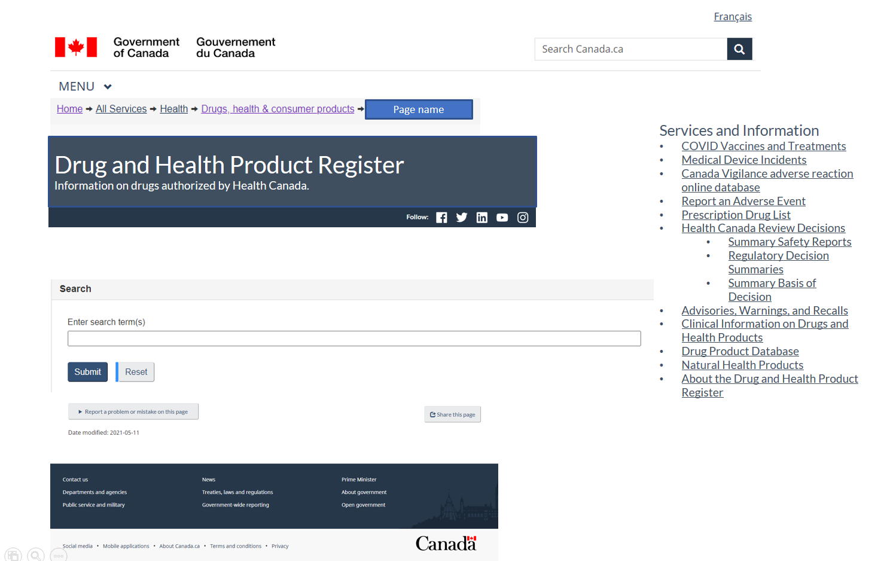

* The DHPR Landing page uses standard Health Canada Headers
* Title: Drug and Health Product Register
* Sub-Title: Information on drugs authorized by Health Canada

**Standard Workflow: Search**

1. The User enters a search term in the search bar and hits enter from the keyboard or the *Submit* button.
2. The DHPR, using the Shiny App Drug API, searches for the keywords entered by the User.
3. The DHPR presents the Search Results Landing Page

**Alternate Flow 1: Reset Search**

1. The User clicks on the *Reset* button
2. The DHPR clears any information entered in the Search bar and is ready for a new search

**Alternate Flow 2: Services and Information**

1. The User selects one of the items listed in Services and Information and navigates to the embedded URL.
   1. COVID Vaccines and Treatments (<https://covid-vaccine.canada.ca/>)
   2. Medical Device Incidents (<https://hpr-rps.hres.ca/mdi_landing.php>)
   3. Canada Vigilance Adverse Event Reaction online database (<https://www.canada.ca/en/health-canada/services/drugs-health-products/medeffect-canada/adverse-reaction-database.html>)
   4. Report an adverse event (<https://www.canada.ca/en/health-canada/services/drugs-health-products/medeffect-canada/adverse-reaction-reporting.html>)
   5. Prescription Drug List (<https://hpr-rps.hres.ca/pdl.php>)
   6. Health Canada Review Decision Search
      1. Summary Safety Review (<https://hpr-rps.hres.ca/reg-content/summary-safety-review.php>)
      2. Regulatory Decision Summary (<https://hpr-rps.hres.ca/reg-content/regulatory-decision-summary.php>)
      3. Summary Basis of Decision (<https://hpr-rps.hres.ca/reg-content/summary-basis-decision.php>)
   7. Advisories, Warnings, and Recalls (<https://www.canada.ca/en/health-canada/services/drugs-health-products/advisories-warnings-recalls.html>)
   8. Clinical Information on Drugs and Health Products (<https://www.canada.ca/en/health-canada/services/drug-health-product-review-approval/clinical-information-drugs-health-products.html>)
   9. Drug Product Database (<https://www.canada.ca/en/health-canada/services/drugs-health-products/drug-products/drug-product-database.html>)
   10. Natural Health Products (<https://health-products.canada.ca/lnhpd-bdpsnh/index-eng.jsp>)
   11. About the Canada Health Product Information Centre (link tbd)

**Alternate Flow 3: Report a Problem or Mistake on this Page**

1. The user selects to Report a Problem or Mistake on this Page. The selection expands and provides the user with the following options.

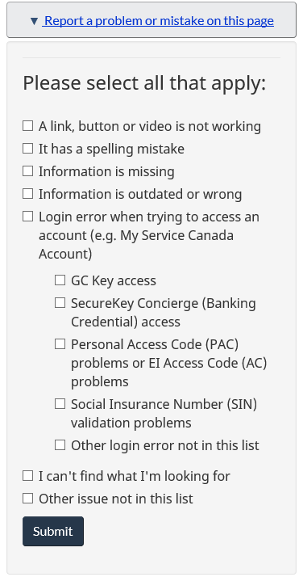

1. The User checks all applicable options and clicks “Submit”
2. The following is presented:

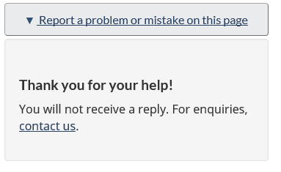

1. The User selects “contact us” and is redirected to <https://www.canada.ca/en/contact.html>.

### DHPR Search Results Page

The DHPR Search Results Page uses the same Header, Footer, and Services and Information section as the DHPR Landing Page.

When a user enters search criteria into the search bar on the DHPR landing page, and results are found, the following will be displayed.

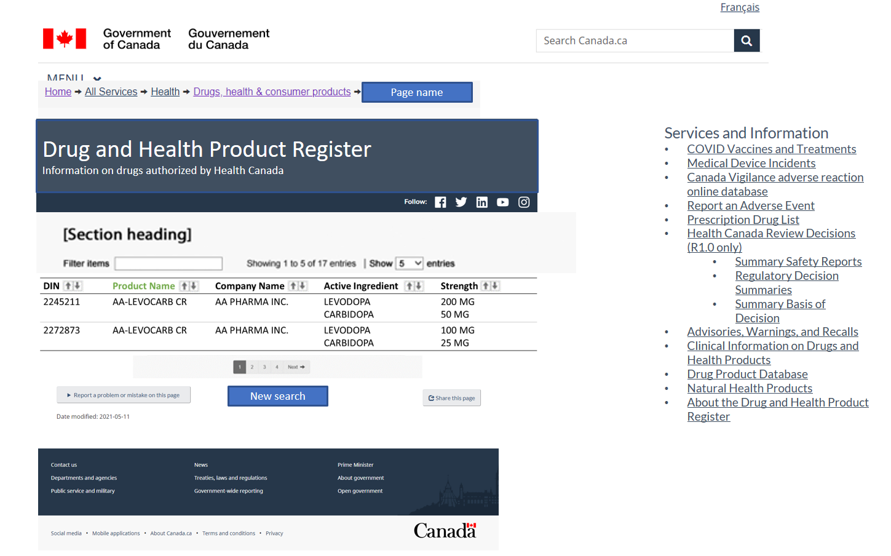

* The search results table will use the Stable Data Tables design from <https://design.canada.ca/common-design-patterns/tables.html>

**Standard Workflow: Search Results Found**

Search results will include Drugs with a status of Marketed, as well as drugs with a status of Approved and previously had a status of Marketed

1. The DHPR presents the search results from keywords entered by the user in the Search Results Landing Page. Keywords can be used to search Product Name, Ingredients, and/or Company Name. DHPR displays the following columns, with each row being a unique DIN:
   1. DIN (secondary sort order, ascending)
   2. Product Name (default sort order, ascending)
   3. Company Name
   4. Active Ingredient(s)
   5. Strength

Note that for Active Ingredient(s) and Strength, several drugs have multiple active ingredients, in some cases more than twenty (20). When designing the search results screen, this should be considered. The results table must display all the active ingredients and strengths, and should allow the active ingredients to be collapsed if the design constraints allow for it (WCAG, Canada.ca guidelines, etc.)

1. The User selects the row they want to view.
2. The DHPR displays the selected row on the Selected Drug Result Page

**Alternate Workflow: Filter Search Results**

Precondition: The Standard Workflow for “Search Results Found” has been executed and multiple search results are displayed

1. The user types in the filter term in the Filter Items text box.
2. The DHPR filters the data table with each character entered in the Filter Items text box and updates the total number of items displayed. The DHPR filters based on all columns displayed in the data results table including:
   1. DIN
   2. Product Name
   3. Company Name
   4. Active Ingredients
   5. Strength

**Alternate Workflow: No Search Results Found**

1. The DHPR presents the following message instead of table: “No results found for <search term(s)>” where <search term(s)> is the value entered by the user in the search bar on the DHPR landing page.

**Alternate Workflow: New Search**

1. The User clicks on the “New Search” button.
2. The DHPR navigates the User to the DHPR Landing Page.

### DHPR Selected Drug Page

The DHPR Selected Drug Page uses the same Header, Footer, and Services and Information section as the DHPR Landing Page.

When a user selects a drug from the DHPR Search Results Page, the following will be displayed for the selected drug.

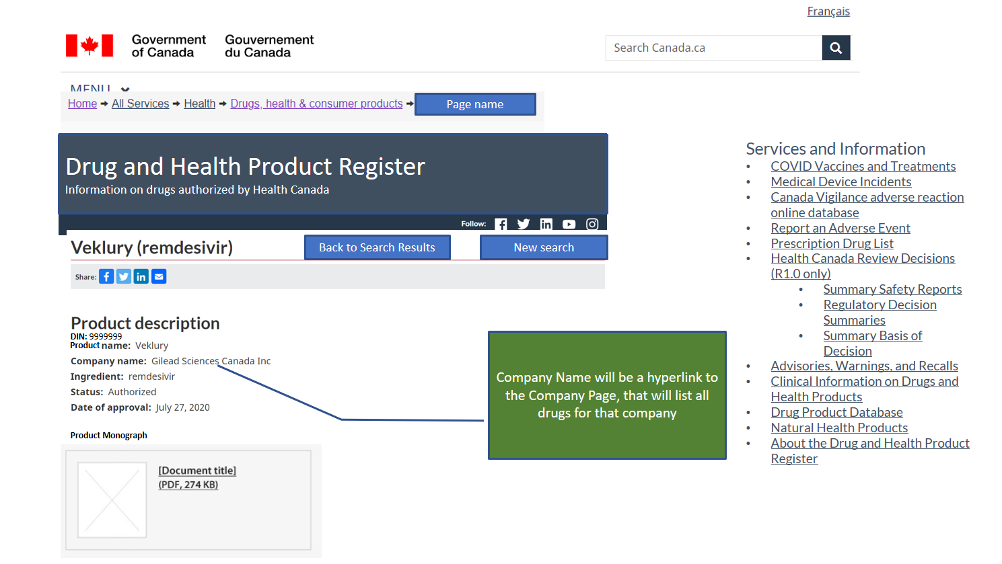

**Standard Workflow: Display Drug Details**

1. The DHPR displays the drug information for the selected row in the DHPR Search Results. The following fields are displayed under the Product Description Heading (note that the fields above are for illustrative / formatting purposes only. The fields below are what should be displayed):
   1. Drug Information Number
   2. Product Name
   3. Company Name (includes hyperlink to DHPR Company Page for that company, link using company_code)
   4. Route of Administration
   5. Active Ingredient(s) Table (one row per Active Ingredient, sorted ascending by Active Ingredient, with the following columns)
      1. Active Ingredient(s)
      2. Strength
      3. Strength Unit
2. Release 1.0 – include link to PM PDF

**Alternate Workflow: Display Company Page**

1. The User clicks on the Company Name displayed for the drug
2. The DHPR displays the DHPR Company Page

### DHPR Company Page

The DHPR Company Page uses the same Header, Footer, and Services and Information section as the DHPR Landing Page.

When a user clicks on a company name on the DHPR Selected Drug Page, the following will be displayed.

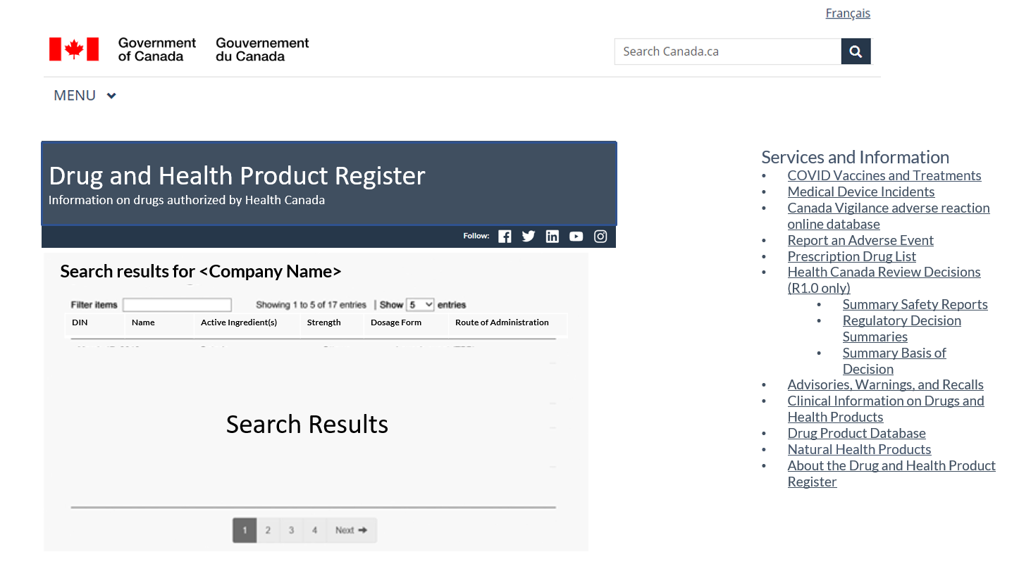

**Standard Workflow: Display Company Information**

1. The DHPR displays the company information for the selected Company. The following fields are displayed under the “Search Results for <Company Name>” Heading:
   1. Company Name
   2. Company Address (formatted as an address)
      1. Company Suite Number
      2. Company Street Name
      3. Company City Name
      4. Company Province
      5. Company Country
      6. Company Postal Code
      7. Company Post Office Box
2. The DHPR displays a list of all drugs associated with that company, formatted in the same manner, with the same fields as the DHPR Search Results Page

### DHPR About Page

For Release 1.0, the DHPR About Page will link back to the current DHPR About Page at the following link: <https://hpr-rps.hres.ca/static/content/about-propos.php>

For Release 1.0, the following statement will be removed from the current About page:

“We’re asking for ongoing [feedback](https://hpr-rps.hres.ca/static/content/feedback-retroaction.php) on how easy and fast it is to search for the information you want. This feedback will help us to improve the DHPR for future releases.”

# Roles and Users

For Release 1.0, the following roles are in scope:

Administrator / Developer

* Responsible for maintaining the solution

Anonymous User (anyone who visits the site)

* Consumers
* Health Care Professionals
* Researchers
* Industry

# Appendix A

## References – Technical Standards

The following documentation is related to these High-Level Business Requirements:

|  |  |  |
| --- | --- | --- |
| **Document Title** | **Date of Version Referenced** | **Location of Document** |
| HC/PHAC Technical Standard | 2018-10-10 | <https://gcdocs.gc.ca/health-sante/llisapi.dll/open/1438045> |

# 

# Appendix B Data Mapping

| Category | Field Label | Format | Example Data | Include in DHPR Renewal  (R1.0) | Shiny App API | Comment |
| --- | --- | --- | --- | --- | --- | --- |
| All Products | Product Type |  | Drug Medical Device Natural Health Product Vaccine? (as per COVID Portal) Treatment (as per COVID portal) | Y (Drugs Only) |  | The information is required, but how it is used will depend on UI design, data design. Releases 1.0 and 1.1 are focused on displaying drug information only, but future iterations will include different product types. |
| Drugs | New / updated Indicator |  |  |  |  | What are our business rules over what constitutes "New" and how long it remains as new? Not in scope for Releases 1.0 and 1.1 |
| Drugs | Manufacturer Code |  |  |  | companies.mfr_code (string(5)) |  |
| Drugs | Company Code |  |  | Y | companies.company_code (primary key) (integer) |  |
| Drugs | Company / Company Name |  | MCNEIL CONSUMER HEALTHCARE DIVISION OF JOHNSON & JOHNSON INC 88 Mcnabb Street (DPD Detail) Markham Ontario Canada L3R 5L2 | Y | companies.company_name (string(80))  dpd_lookup.company_name (string(80)) |  |
| Drugs | Company Type |  |  |  | companies.company_type (string(40)) |  |
| Drugs | Company Mailing Address Info (multiple fields)  ADDRESS_MAILING_FLAG ADDRESS_BILLING_FLAG ADDRESS_NOTIFICATION_FLAG ADDRESS_OTHER SUITE_NUMBER STREET_NAME CITY_NAME PROVINCE COUNTRY POSTAL_CODE POST_OFFICE_BOX PROVINCE_F COUNTRY_F |  |  | Y | companies.suite_number companies.street_name companies.city_name companies.province companies.country companies.postal_code companies.post_office_box companies.street_name_f companies.province_f companies.country_f |  |
| Drugs | DRUG_CODE |  |  | Y (Primary Key) | drug_product.drug_code (primary key) (integer) active_ingredient.drug_code (foreign key) (integer) companies.drug_code (foreign key) (integer) dpd_json.drug_code (integer) dpd_lookup.drug_code (integer) dpd_search.drug_code (integer) packaging.drug_code (foreign key) (integer) pharmaceutical_form.drug_code (foreign key) (integer) pharmaceutical_std.drug_code product_monograph.drug_code (foreign key) (integer) route.drug_code (foreign key) (integer) schedule.drug_code (foreign key) (integer) special_identifier.drug_code (foreign key) (integer) status.drug_code (foreign key) (integer) therapeutic_class.drug_code (foreign key) (integer) |  |
| Drugs | DIN  DRUG_IDENTIFICATION_NUMBER |  | 2186934 | Y | dpd_lookup.drug_identification_number (string(8))  dpd_json.drug_identification_number (string(8))  dpd_search.drug_identification_number (string(8))  drug_product.drug_identification_number (string(8)) |  |
| Drugs | DIN name / Product Name / Brand Name  BRAND_NAME BRAND_NAME_F |  | MOTRIN (DHPR Summary) MOTRIN 200MG (DHPR Detail and DPD Online) | Y | dpd_lookup.brand_name (string(400))  drug_product.brand_name (string(400))  drug_product.brand_name_f (string(600)) | • DPD Online Summary, label is "Product" • DPD Online Search & DPD Online Detail & Mobile APP, label is "Product name" * COVID portal is "Brand Name" on one page and "DIN name" on another.  * DHPR will standardize on the label "Product Name" |
| Drugs | Active Ingredient(s)  INGREDIENT INGREDIENT_F | string($ character varying) | IBUPROFEN | Y | active_ingredient.ingredient (string(480))  active_ingredient.ingredient_f (string(480))  dpd_lookup.ingredient (string(480)) |  |
| Drugs |  |  |  |  | drug_product.risk_man_plan (string(1)) |  |
| Drugs | INGREDIENTS STRENGTH |  | 200 MG | Y | active_ingredient.strength (string(20)) |  |
| Drugs | INGREDIENTS STRENGTH_UNIT STRENGTH_UNIT_F |  |  | Y | active_ingredient.strength_unit (string(80))  active_ingredient.strength_unit_f (string(160)) |  |
| Drugs | INGREDIENTS STRENGTH_TYPE STRENGTH_TYPE_F |  |  |  |  |  |
| Drugs | INGREDIENTS DOSAGE_VALUE |  |  |  | active_ingredient.dosage_value (string(20)) |  |
| Drugs | INGREDIENTS BASE |  |  |  |  |  |
| Drugs | INGREDIENTS DOSAGE_UNIT DOSAGE_UNIT_F |  |  |  | active_ingredient.dosage_unit (string(80))  active_ingredient.dosage_unit_f (string(160)) |  |
| Drugs | INGREDIENTS NOTES |  |  |  |  |  |
| Drugs | Dosage Form |  | TABLET Dispersion etc. |  |  |  |
| Drugs | PHARM_FORM_CODE |  |  |  | pharmaceutical_form.pharmaceutical_form_code (integer) |  |
| Drugs | PHARMACEUTICAL_FORM PHARMACEUTICAL_FORM_F |  |  |  | pharmaceutical_form.pharmaceutical_form (string(80))  pharmaceutical_form.pharmaceutical_form_f (string(80)) |  |
| Drugs | ROUTE_OF_ADMINISTRATION_CODE |  |  |  | route.route_of_administration_code (integer) |  |
| Drugs | Route(s) of Administration  ROUTE_OF_ADMINISTRATION ROUTE_OF_ADMINISTRATION_F |  | ORAL 0-UNASSIGNED INTRAMUSCULAR etc | Y | route.route_of_administration (string(80))  route.route_of_administration_f (string(160)) |  |
| Drugs | CURRENT_STATUS_FLAG |  |  | Y | status.current_status_flag |  |
| Drugs | Status (Current)  STATUS STATUS_F |  | Approved Authorized by interim order Cancelled (Safety Issue) Cancelled (Unreturned Annual) Cancelled Post Market Cancelled Pre Market Dormant Marketed | Y (Authorized by interim order and Marketed only)  Also need to show drugs that have a status = Approved and a previous status = Marketed. | status.status (string(40)) status.status_f (string(80)) | • DPD Online Detail, label is "Current status"  Other Examples Approved Cancelled Post Market Dormant Authorized by Interim Order (from COVID portal) Under Review (from COVID portal) Authorized (from COVID portal)  Recommend showing only current status, and not history |
| Drugs | Class   CLASS_F |  | Disinfectant Human Radiopharmaceutical Veterinary | Y (Human only), not displayed | drug_product.class (string(80))  drug_product.class_f (string(160)) | • DPD Online Search, label is "Class(es)"  Other Examples Disinfectant Radiopharmaceutical Veterinary |
| Drugs | PRODUCT_CATEGORIZATION |  |  |  | dpd_json.drug_product (string($jsonb))  dpd_search.drug_product (string($jsonb)) |  |
| Drugs | PM |  | Y/N (DPD Summary) |  |  |  |
| Drugs | Schedule(s)  SCHEDULE SCHEDULE_F |  | Prescription OTC  COVID-19 - IO - Authorization Vaccine etc. (need list of different schedules) | Y (Prescription only) | schedule.schedule schedule.schedule_f | • DPD Online Search & DPD Online Detail, label is "Schedule(s)"  Other Examples COVID-19-IO-Authorization Prescription |
| Drugs | Schedule Code |  |  |  | schedule.schedule_code |  |
| Drugs | Special Identifier ID |  |  |  | special_identfier.id (integer) |  |
| Drugs | special identifier code |  |  |  | special_identifier.si_code (integer) |  |
| Drugs | Special Identifier Description |  |  |  | special_identifier.desc_e special_identifier.desc_f |  |
| Drugs | Special Identifier Date Assigned |  |  |  | special_identfier.date_assigned |  |
| Drugs | Number of Active Ingredients |  | 1 |  |  |  |
| Drugs | Current status date |  | 2013-02-15 |  |  |  |
| Drugs | HISTORY_DATE |  |  |  | status.history_date (string($timestamp without time zone)) |  |
| Drugs | LOT_NUMBER |  |  |  | status.lot_number (string(50)) |  |
| Drugs | EXPIRATION_DATE |  |  |  | status.expiration_date (string($timestamp without time zone)) |  |
| Drugs | Original market date |  | 1972-12-31 |  | status.original_market_date (string($timestamp without time zone)) |  |
| Drugs | First Marketed Date |  |  |  | status.first_marketed_date (string($timestamp without time zone)) |  |
| Drugs | Date of Approval |  | 2021-02-26 |  |  | How does this date differ from current status date and/or original market date? Do we need a strategy for how to handle all the different dates and date types across product lines? |
| Drugs | Biosimilar Biologic Drug |  | Yes / No |  |  |  |
| Drugs | American Hospital Formulary Service (AHFS) |  | 28:08.04.92 OTHER NONSTEROIDAL ANTIIMFLAMMATORY AGENTS |  |  |  |
| Drugs | TC_AHFS_NUMBER |  |  |  | therapeutic_class.ahfs_number (string(20)) |  |
| Drugs | TC_AHFS TC_AHFS_F |  |  |  | therapeutic_class.ahfs (string(160)) therapeutic_class.ahfs_f (string(320)) |  |
| Drugs | Anatomical Therapeutic Chemical (ATC): |  | M01AE01 IBUPROFEN |  |  |  |
| Drugs | TC_ATC_NUMBER |  |  |  | therapeutic_class.atc_number (string(8)) |  |
| Drugs | TC_ATC TC_ATC_F |  |  |  | therapeutic_class.atc (string(240)) therapeutic_class.atc_f (string(320)) |  |
| Drugs |  |  |  |  | active_ingredient.active_ingredient_id (primary key) (integer) |  |
| Drugs | Active Ingredient Code (Is this the same as Active Incredient Group Number below?)  ACTIVE_INGREDIENT_CODE | NUMBER(6) |  |  | active_ingredient.active_ingredient_code (integer) |  |
| Drugs | Active ingredient group (AIG) number:  AI_GROUP_NUMBER |  | 108883004 |  |  | • DPD Online Search, label is "Active ingredient group number" |
| Drugs | Same active ingredient group number |  | Same active ingredient group number *(This is a link drugs with the same AIG number)* |  |  | • DPD Online Details, links a display of all drugs products that have the same active ingredient(s) and ingredient strength(s).  Do we want to replicate this behaviour in DHPR? |
| Drugs | Ingredient Supplied Indicator |  |  |  |  |  |
| Drugs | Description  DESCRIPTOR DESCRIPTOR_F |  | Vial contains 10 doses of 0.5 ML |  | drug_product.descriptor (string(400))  drug_product.descriptor_f (string(400)) |  |
| Drugs | PEDIATRIC_FLAG |  |  |  |  |  |
| Drugs | ACCESSSION_NUMBER |  |  |  |  |  |
| Drugs | NUMBER_OF_AIS |  |  |  | drug_product.number_of_ais (integer) |  |
| Drugs | LAST_UPDATE_DATE |  |  |  |  |  |
| Drugs | UPC / Scan Code UPC |  |  |  | packaging.upc (string(12)) | Nice to have for future iterations of DHPR, but more relevant for the mobile app. Needs solution. Data not currently available |
| Drugs | PACKAGE_SIZE_UNIT PACKAGE_SIZE_UNIT_F |  |  |  | packaging.package_size_unit (string(40)) |  |
| Drugs | PACKAGE_TYPE PACKAGE_TYPE_F |  |  |  | packaging.package_type (string(40)) |  |
| Drugs | PACKAGE_SIZE |  |  |  | packaging.package_size (string(5)) |  |
| Drugs | PRODUCT_INFORMATION |  |  |  | packaging.package_information (string(80)) |  |
| Drugs | PHARMACEUTICAL_STD |  |  |  | pharmaceutical_std.pharmaceutical_std (string(40)) |  |
| Drugs | Data Matrix |  |  |  |  | On some product, in addition to a bar code, there is also a QR code / data matrix code. |
| Drugs | Product Image |  |  |  |  | Nice to have for future iterations of DHPR, but more relevant for the mobile app. Needs solution. Data not currently available |
|  |  |  |  |  |  |  |
| Resources | Key (identifier for the product being searched) |  | Drug Code | Y (hidden) | product_monographs.drug_code | Drugs can use the Drug Code, but for future consideration will need to consider what the primary key should be for NHP, medical devices? |
| Resources | Resource Type |  | Multiple |  |  |  |
| Resources | Resource Type |  | Consumer Information |  |  | This is taken from Part 3 of the Product Monograph. To be included from XML PM for Release 1.1 |
| Resources | Resource Type |  | Regulatory Decision Summary |  |  | Release 1.1 |
| Resources | Resource Type |  | Product Monograph | Y | product_monograph | This document type may be different from the others as we have some where we want to link to a PDF, plus XML PM may change this as well. Release 1.0 is PDF of the PM only. Release 1.1 is likely to include the XML PM where available. |
| Resources | Resource Type |  | Summary Safety Review |  |  | SSR is unique as it references multiple products. Release 1.1. |
| Resources | Resource Type |  | Adverse Events Following Immunization |  |  |  |
| Resources | Resource Type |  | Advisories |  |  |  |
| Resources | Resource Type |  | Interim Canadian Reference Label |  |  |  |
| Resources | Resource Type |  | Product Label |  |  |  |
| Resources | Resource Type |  | Summary Basis of Decision |  |  | Release 1.1 |
| Resources | Resource Type |  | Post-authorization activity table (PAAT) |  |  | Release 1.1 |
| Resources | Resource Type |  | Health Product Risk Communications |  |  |  |
| Resources | Resource Type |  | Risk Management Plan |  |  |  |
| Resources | Resource Type |  | Clinical Information |  |  |  |
| Resources | Resource Type |  | Authorization terms and conditions |  |  |  |
| Resources | Resource Identifier |  |  | Y | product_monograph.pm_number (integer) | Release 1.0 for PDF PM only |
| Resources | Version Number |  |  | Y | product_monograph.pm_version_number (integer) | Release 1.0 for PDF PM only |
| Resources | Control Number |  |  | Y | product_monograph.pm_control_number (string(30)) | Release 1.0 for PDF PM only |
| Resources | Resource Date |  |  | Y | product_monograph.pm_date | Release 1.0 for PDF PM only |
| Resources | Resource English Name |  |  | Y | product_monograph.pm_english_name (string(15)) | Release 1.0 for PDF PM only |
| Resources | Resource French Name |  |  | Y | product_monograph.pm_french_name (string(15)) | Release 1.0 for PDF PM only |
| Resources | Hyperlink to PM PDF |  |  | Y | Solution needs to add leading url: https://pdf.hres.ca/dpd_pm/ | Derived from PM_english_name or pm_french_name with prefixed URL in dpd_json from shiny app API |
| Resources | New / updated Indicator |  | - New - Updated - Null |  |  | Discussion re. business rules for what identies a resource as new / updated, and how long this status remains? Is it different if it's viewed on the app vs. a web page. Not in scope for Release 1.0 |
| Resources | Resource Audience |  | - Consumer - Health Care Practitioner - Researchers - All | Y |  | For Release 1.0, the only resource displayed is the Product Monograph, and the table to display resources by audience will not be included until Release 1.1. For reference, the Product Monograph will be applicable to all audiences (Consumer, Health Care Professional, and Researchers) |
| Resources | Resource Format |  | - Link - PDF - "Sections", e.g. html / xml | Y (link to PDF only) |  | Future content types might be .html or Markdown, etc. |

# Appendix C Static Text and Translations

To be completed upon approval of English Text.