

# PLIS LAB SOLUTION

## Quarterly Report 2022-01-01 – 2022-03-31

Prepared By: Quest Diagnostics

2022/04/08

This document contains information proprietary to Quest Diagnostics. Any disclosure, use or duplication of this document, or of any of the information contained herein, for other than the specific purpose for which it was disclosed is expressly prohibited, except as Quest Diagnostics may otherwise agree to in writing.

### TABLE OF CONTENTS

Report Summary 3

RPT 1.1 Release Quality - Deployment 4

RPT 2.1 Problem Management SLA Report 6

RPT 2.2 Root Cause Analysis 8

RPT 3.1 Performance of PLIS Lab Get against SLA Commitment 10

RPT 3.2 Performance of PLIS Lab Summary against SLA Commitment 12

RPT 3.3 Performance of PLIS Lab Put against SLA Commitment 14

RPT 3.4 PLIS Availability in Production and Production Support 16

**REPORT SUMMARY**

Stabilization efforts in 2021 are complete, and the next big piece of work – resolving remaining issues with the CRI connection timeout and improvements to PLIS with BC.v8.1 (R10) and HIAL/POSIA (R11) are well underway to address Software Currency in 2022. Discussions are also underway about future improvements to PLIS (FHIR API) and HIAL (Health*Ideas* and IDAM).

This report covers Service Level Commitments for PLIS Lab Put, Lab Get and Lab Summary interactions for January to March, 2022. Although the performance SLA for Lab Put is based on an expectation of 90 seconds or less, the LA Extract for Lab Puts naturally uses a 60 second buckets. In any case, Lab Put times are still very good, and since Lab Puts do not require real-time processing in the same way that Lab Get and Lab Summary interactions do, Lab Put times are less of a concern than other interactions, like Detailed Lab Gets.

|  |
| --- |
| Overall, PLIS LAB Repository is meeting a 95% SLA expectation for performance for all PLIS interactions – Lab Put, Lab Get, and Lab Summary – as you can see below, and we anticipate further improvements in PLIS performance and stability with our BC.v8.1 release, which will result in a substantial improvement in overall performance compared to the current legacy Glassfish build of PLIS LAB. |

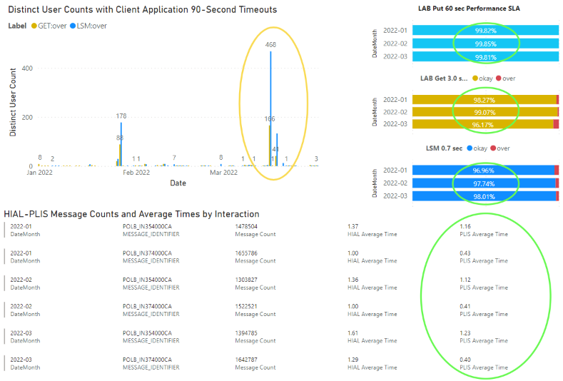

From an end-to-end perspective, we are still seeing a relatively high number of Lab Get and Lab Summary requests taking more than 90 seconds (at which point, CareConnect will resend the request), which can be shown to be driven by elevated CRI times. The numbers shown for average HIAL time and for distinct users experiencing a 90-second timeout are relatively stable, with a couple spikes in January and March. Any resulting timeouts were most likely not observable by clinicians.

Elevated average CRI times appear to happen more often with Lab Get than Lab Summary interactions, likely because of the way CareConnect interacts with HIAL and PLIS in parallel “bursts” of non-detailed Lab requests for Observation Trending information, as opposed to Lab Summary data, which is loaded one page at a time. It would be useful to be able to separate LA Events for detailed and non-detailed Lab Gets, which we currently cannot do (this would require a small change to the information sent in PLIS LA Events).

|  |
| --- |
| To ensure that Clinicians are not experiencing delays when they retrieve a PDF Results Report, these could be retrieved without relying on HIAL – ie, these could be loaded using a FHIR-based API as has been discussed. Our best estimate is that about 20% of Lab Gets contain a PDF, and the remainder support Observation Trending. RFC-000546 addresses elevated HIAL-CRI times. |

***There have been no major incidents from a PLIS perspective.***

# PLIS LAB SOLUTION

## RPT 1.1 Release Quality - Deployment From 2022-01-01 00:00 to 2022-03-31 23:59

Prepared By: Quest Diagnostics

2022/04/08

RPT-1.1 Release Quality - Deployment

From 2022-01-01 00:00 to 2022-03-31 23:59

**PLIS LAB SOLUTION**

### SUMMARY

There was a PLIS Production candidate release in January (BC.v8.1.1), which has completed preliminary testing in the DEV environment, and is now promoted to the TEST environment for further testing, targeting the client-facing non-Production environments soon, and targeting Production Support and Production deployment mid-Summer.

|  |  |  |  |  |  |  |  |  |
| --- | --- | --- | --- | --- | --- | --- | --- | --- |
| **Environment** | **Number of Releases** | | **Releases with Defects (by Severity)** | | | | | |
| **Critical** | | **High** | | **Medium** | |
| **INT2** | 0 | 0% | 0 | 0% | 0 | 0% | 0 | 0% |
| **UAT** | 0 | 0% | 0 | 0% | 0 | 0% | 0 | 0% |
| **KDC-PS** | 0 | 0% | 0 | 0% | 0 | 0% | 0 | 0% |
| **PROD-KDC** | 0 | 0% | 0 | 0% | 0 | 0% | 0 | 0% |
| **PROD-CDC** | 0 | 0% | 0 | 0% | 0 | 0% | 0 | 0% |
| **Total** | 0 | 0% | 0 | 0% | 0 | 0% | 0 | 0% |

**Incidents, Defects and Problems**

There have been no PLIS-specific Incidents, Defects or Problems in this quarter.

|  |  |  |  |  |  |  |  |
| --- | --- | --- | --- | --- | --- | --- | --- |
| **JIRA** | **Description** | **Type** | **Severity** | **Status** | **Response Time** | **Resolution Time** | **Within SLA** |
| **#** |  |  |  |  |  |  |  |

Note: When there are reports, there will also need to be excel extracts provided as well.

**From Exhibit B:**

1. Response to Severity Level Critical (Number and Response Time <= 15 minutes)
2. Response Severity Level High (Number and Response Time <= 30 minutes)
3. Response Severity Level Medium (Number and Response Time <= 120 minutes)
4. Resolution Severity Level Critical (workaround or patch release in <= 6 hours)
5. Resolution Severity Level High (workaround or patch release in <= 12 hours)
6. Resolution Severity Level Medium (workaround or patch release in <= 48 hours)
7. Resolution Severity Level Low (workaround or patch release in <=120 hours)

©2022 Province of British Columbia and its licensors (including Quest Diagnostics),

all rights reserved Quest Diagnostics Confidential

# PLIS LAB SOLUTION

## RPT 2.1 Problem Management SLA Report From 2022-01-01 00:00 to 2022-03-31 23:59

Prepared By: Quest Diagnostics

2022/03/12

3

RPT-2.1 Release Quality – Problem Management

From 2022-01-01 00:00 to 2022-03-31 23:59

**PLIS LAB SOLUTION**

### SUMMARY

There are no PLIS problems resolved in this report, although the Quest team was consulted on some problem resolution.

|  |  |  |  |  |
| --- | --- | --- | --- | --- |
| **Status** | **Total** | **Problem Count (by Severity)** | | |
| **Critical** | **High** | **Medium** |
| **Received** | 0 | 0 | 0 | 0 |
| **Assigned** | 0 | 0 | 0 | 0 |
| **In Progress** | 0 | 0 | 0 | 0 |
| **Closed** | 0 | 0 | 0 | 0 |
| **Total** | 0 | 0 | 0 | 0 |

# PLIS LAB SOLUTION

## RPT 2.2 Root Cause Analysis From 2022-01-01 00:00 to 2022-03-31 23:59

Prepared By: Quest Diagnostics

2022/04/08

RPT-2.2 Release Quality – Problem Management

From 2022-01-01 00:00 to 2022-03-31 23:59

**PLIS LAB SOLUTION**

### SUMMARY

No PLIS-specific Incidents are resolved in this report, and so no root cause analysis is required at this point.

**Root Cause Analysis**

None Required.

# PLIS LAB SOLUTION

## RPT 3.1 Performance of PLIS Lab Get against SLA Commitment From 2022-01-01 00:00 to 2022-03-31 23:59

Prepared By: Quest Diagnostics

2022/03/12

### PLIS Lab Get Performance against SLA Commitment – MET

Shown here is cumulative PLIS Lab Get performance against SLA between January and March 2022. The performance expectation for these interactions is:

* PLIS Lab Get “LAB DAL” time <=3.0s for 95% of messages with response message size <= 150K
* We expect the number of Lab Get requests each month to be upwards of 1M, which is quite high due to “bursting” which supports CareConnect Observation Trending.

“LAB DAL” time here refers to the time elapsed between the LAB component receiving a request message from the HIAL and sending a corresponding response message back. This does not include time that the message spent on a request or response queue.   
These calculations also exclude any LA events that were not correctly aggregated.

|  |
| --- |
| You can see here that Lab Get performance meets the expectations for Lab Get at more than 96% for this quarter, with an average LAB DAL time of around 1.2 seconds for Lab Gets. Overall, these numbers are a little higher than usual, but still quite good. There were almost 1.4 million Lab Get requests processed in March, with just over 20K distinct users for the month. |

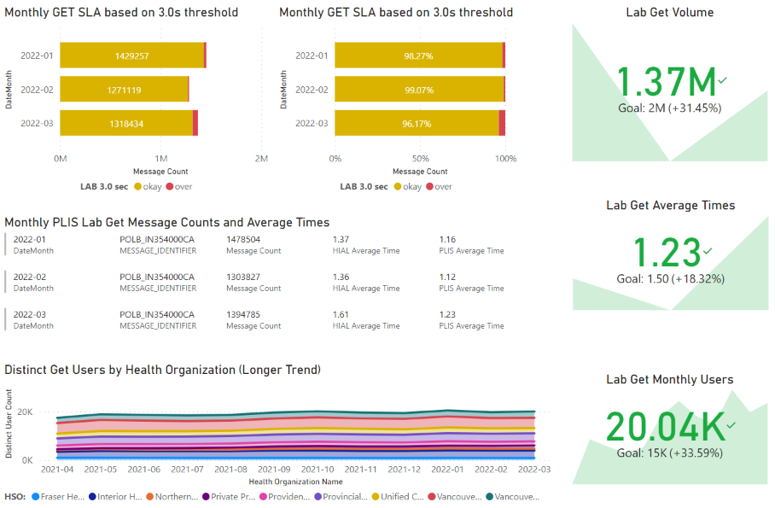

Also shown here (bottom left) we can see that the number of monthly distinct clinical users is trending up slightly this quarter, as compared to November and December, which saw a slight decline. HIAL average time is still somewhat elevated.

# PLIS LAB SOLUTION

## RPT 3.2 Performance of PLIS Lab Summary against SLA Commitment From 2022-01-01 00:00 to 2022-03-31 23:59

Prepared By: Quest Diagnostics

2022/03/12

### PLIS Lab Summary Performance against SLA Commitment – MET

Shown here is PLIS Lab Summary against SLA between January and March of 2022. The performance expectation for these interactions is:

* PLIS Lab Summary “LAB DAL” time <=0.7s for 95% of messages with responses with <= 200 batteries
* We expect the number of Lab Summary requests each month to be about 1.5M, which is quite high due to precaching.

“LAB DAL” time here refers to the time elapsed between the LAB component receiving a request message from the HIAL and sending a corresponding response message back. This does not include time that the message spent on a request or response queue.  
These calculations also exclude any LA events that were not correctly aggregated.

|  |
| --- |
| You can see here how Lab Summary exceeds the 95% target for Lab Summary at more than 96% this quarter, and you can also see a consistent average LAB DAL time of around 0.4 seconds for Lab Summary messages. Overall, these numbers are quite good. There were around 1.6 million Lab Summary requests processed in March, with just 23K distinct users, typical over the previous months. |

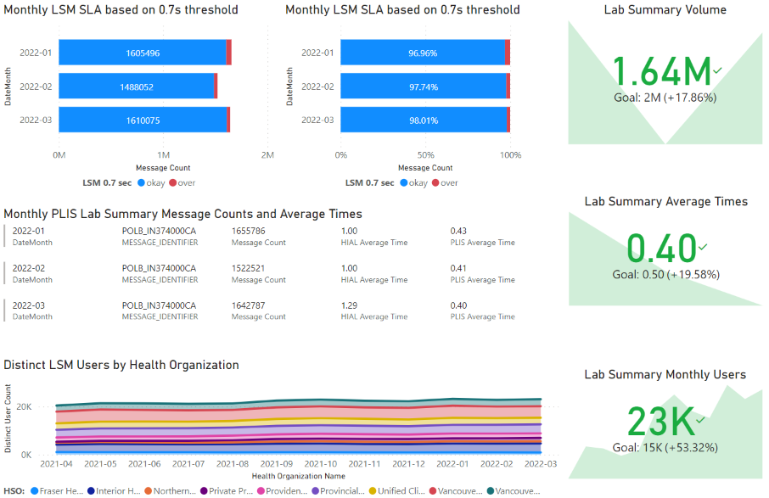

Also shown here (bottom left), we can see distinct users for Lab Summary still trending up slightly. HIAL time is also elevated for Lab Summary interactions, although not as drastically as for Lab Get, which can be attributed to the way Observation Trending Gets are sent in parallel “bursts”. CRI is the HIAL component aspect invoked most frequently, since CRI is involved with Lab Put, Lab Get and Lab Summary.

It is also worth noting that even though Summary response is quite quick from the HIAL perspective, an LSM thread spends a substantial amount of time sending accumulated LA Distributions, which happens outside of the LA transaction. This may result in a message backlog under heavy traffic, and we should be prepared to see this as part of the nightly integration with CareConnect Cache/Health Gateway.

# PLIS LAB SOLUTION

## RPT 3.3 Performance of PLIS Lab Put against SLA Commitment From 2022-01-01 00:00 to 2022-03-31 23:59

Prepared By: Quest Diagnostics

2022/02/12

### PLIS Lab Put Performance against SLA Commitment – MET

The performance expectation for Lab Put interactions is:

* “LAB DAL” time <=90s for 95% of messages for all Lab Put interactions
* We expect the number of Lab Puts each month to be around 10 million

“LAB DAL” time here refers to the time elapsed between the LAB component receiving a request message from the HIAL and sending a corresponding response message back. This does not include any time a message spends on a request or response queue.

|  |
| --- |
| Because of the way the Lab Put Extracts from Log/Audit work, it is not currently possible to calculate percentage of Lab Puts that fall within 90 seconds, but the number of Lab Puts that take less than one minute (60s) is calculated, which should be acceptable for use as a surrogate measure, since 60s < 90s. We are reporting more than 99% of Lab Puts are processed within PLIS Lab in 60 seconds or less, and a volume of around 9.7 million Lab Puts for March of 2022. An average end to end time of around 1.7 seconds is also quite reasonable. |

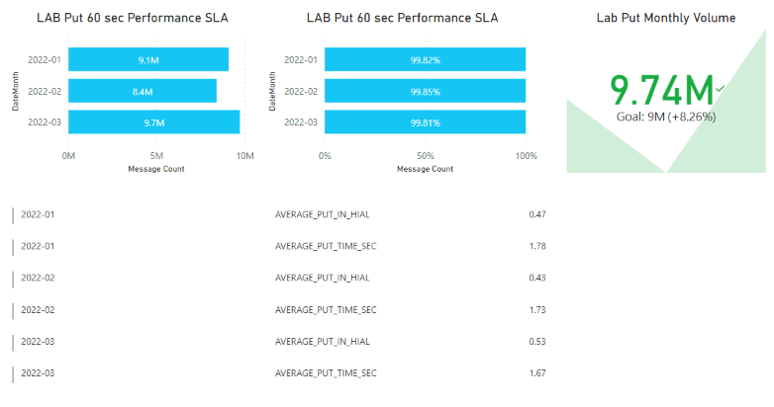

The attached Word document contains information about the Power BI Queries used.



# PLIS LAB SOLUTION

## RPT 3.4 Availability of Production and Production Support From 2022-01-01 00:00 to 2022-03-31 23:59

Prepared By: Quest Diagnostics

2022/03/08

## PLIS Availability – Production and Production Support – MET

|  |  |  |  |  |  |  |
| --- | --- | --- | --- | --- | --- | --- |
| **SLA Name** | **Environment** | **Timeframe** | **Hours Available** | **Service Baseline** | **Availability** | **SLA Met** |
| **Availability -**  **Production** | **Production** | **Business Hours** | 276.0 | 276.0 | 100.0% | YES |
| **After Business Hours** | 451.0 | 451.0 | 100.0% |
| **Production Support** | **Business Hours** | 276.0 | 276.0 | 100.0% | YES |
| **After Business Hours** | 468.0 | 468.0 | 100.0% |