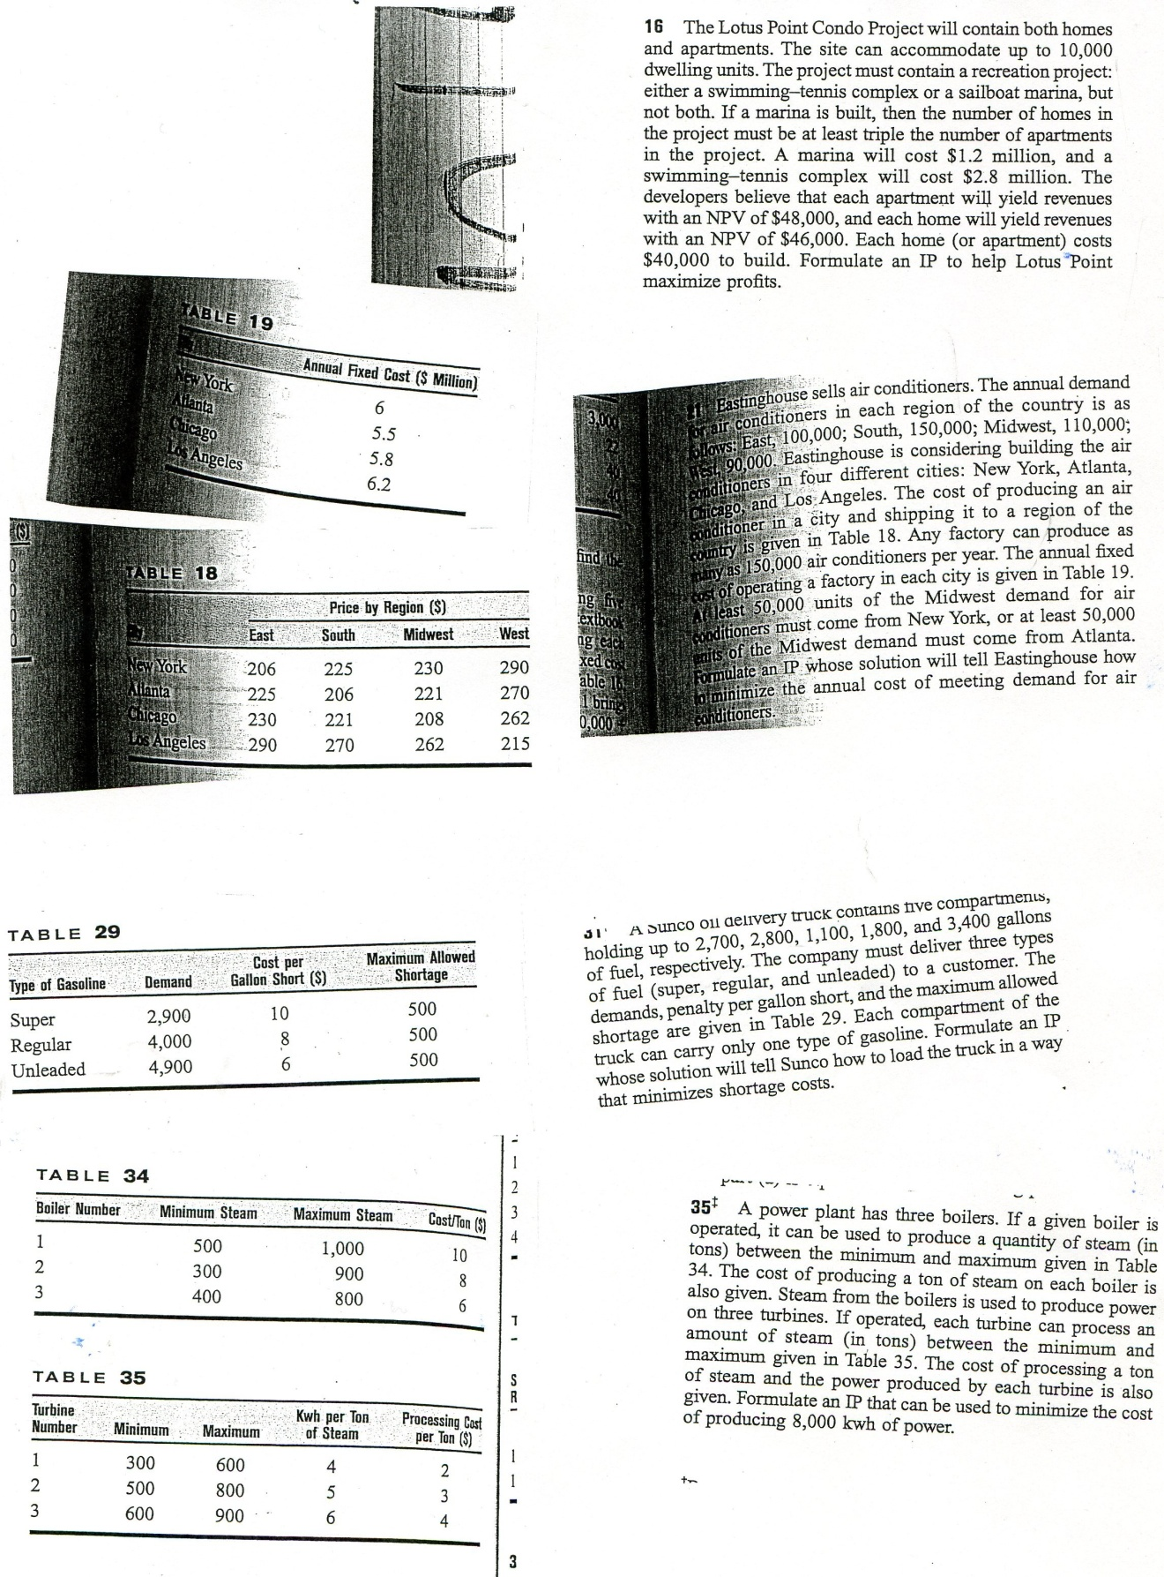

**These problems are taken from Operations Research by Winston.**

**9.2.16**

16. Let H = homes built and A = apartments built. Also let y1 = 1 if marina is built, y1 = 0 otherwise and y2 = 1 if tennis court is built, y2 = 0, otherwise. Then a correct IP formulation is

(objective function is in thousands of dollars of NPV)

max z = 48A + 46H ‑ 40A ‑ 40H ‑ 1200y1 ‑ 2800y2

st A + H≤10,000, y1 + y2 = 1

3A ‑ H≤30,000y3, y1≤30,000(1 ‑ y3)

A, H non‑negative integers and yi = 0 or 1

We chose M = 30,000 because 3A ‑ H ≤30,000 will always hold.

**9.2.21**

21. Let xij = number of air conditioners (in thousands) produced in city i for region j ( i = 1 is NY, j = 1 is East, etc.). Also let yj = 1 if factory is operated in city j, yj = 0 otherwise. Then the appropriate IP is(z is in thousands of dollars)

min z = 6000y1 + 5500y2 + 5800y3 +6200y4 + 206x11 + 225x12 + 230x13 +290x14 + 225x21 + 206x22 + 221x23 + 270x24 + 230x31 + 221x32 + 208x33 + 262x34 + 290x41 + 270x42 + 262x43 + 215x44

st x11 + x21 + x31 + x41≥100 (East)

x12 + x22 + x32 + x42≥150 (South)

x13 + x23 + x33 + x43≥110 (Midwest)

x14 + x24 + x34 + x44≥90 (West)

x11 + x12 + x13 + x14≤150y1 (NY)

x21 + x22 + x23 + x24≤150y2 (Atl)

x31 + x32 + x33 + x34≤150y3 (Chic)

x41 + x42 + x43 + x44≤150y4 (LA)

(Either x13≥50 or x23≥50)

50 - x13≤50y

50 - x23≤50(1 - y)

All xij integer; y, all yi = 0 or 1

**9.2.31**

31. Let xic = 1 if product i is assigned to compartment c, xic = 0 otherwise. ei = shortage of product i (1 = super 2 = regular, 3 = unleaded), gic = gallons of product i in compartment c.

min z = 10e1 + 8e2 + 6e3

st g11 + g21 + g31≤2700

g12 + g22 + g32≤2800

g13 + g23 + g33≤1100

g14 + g24 + g34≤1800

g15 + g25 + g35≤3400

g11 + g12 + g13 + g14 + g15 + e1 - f1 = 2900

g21 + g22 + g23 + g24 + g25 + e2 - f2 = 4000

g31 + g32 + g33 + g34 + g35 + e3 - f3 = 4900

gi1≤2700xi1, gi2≤2800xi2, gi3≤1100xi3, gi4≤1800xi4

gi5≤3400xi5 ( i = 1,2,3)

x1j + x2j + x3j≤1 (j = 1, 2, 3, 4, 5)

All xij = 0 or 1 All other variables ≥0

e1≤500,e2≤500,e3≤500

**9.2.35**

38. Let Xij = 1 if size i box is used to meet demand for type i,i+1,...j boxes. Let Yi = 1 if type i box is used at all and Yi = 0 if type i box is not used. Answer is on LINDO printout

Section 9.2 Problem 35 Printout

MIN 13200 X11 + 9900 X12 + 16500 X13 + 23100 X14 + 6600 X15

+ 13200 X16 + 6600 X17 + 9000 X22 + 15000 X23 + 21000 X24 + 6000 X25

+ 12000 X26 + 6000 X27 + 13000 X33 + 18200 X34 + 5200 X35 + 10400 X36

+ 5200 X37 + 16800 X44 + 4800 X45 + 9600 X46 + 4800 X47 + 3800 X55

+ 7600 X56 + 3800 X57 + 7200 X66 + 3600 X67 + 3400 X77 + 1000 Y1

+ 1000 Y2 + 1000 Y3 + 1000 Y4 + 1000 Y5 + 1000 Y6 + 1000 Y7

SUBJECT TO

2) X11 = 1

3) X12 + X22 = 1

4) X13 + X23 + X33 = 1

5) X14 + X24 + X34 + X44 = 1

6) X15 + X25 + X35 + X45 + X55 = 1

7) X16 + X26 + X36 + X46 + X56 + X66 = 1

8) X17 + X27 + X37 + X47 + X57 + X67 + X77 = 1

9) X11 - Y1 <= 0

10) X12 - Y1 <= 0

11) X13 - Y1 <= 0

12) X14 - Y1 <= 0

13) X15 - Y1 <= 0

14) X16 - Y1 <= 0

15) X17 - Y1 <= 0

16) X22 - Y2 <= 0

17) X23 - Y2 <= 0

18) X24 - Y2 <= 0

19) X25 - Y2 <= 0

20) X26 - Y2 <= 0

21) X27 - Y2 <= 0

22) X33 - Y3 <= 0

23) X34 - Y3 <= 0

24) X35 - Y3 <= 0

25) X36 - Y3 <= 0

26) X37 - Y3 <= 0

27) X44 - Y4 <= 0

28) X45 - Y4 <= 0

29) X46 - Y4 <= 0

30) X47 - Y4 <= 0

31) X55 - Y5 <= 0

32) X56 - Y5 <= 0

33) X57 - Y5 <= 0

34) X66 - Y6 <= 0

35) X67 - Y6 <= 0

36) X77 - Y7 <= 0

END