# **CHAPTER 4**

# **RESULTS AND DISCUSSION**

1. **Hardware**
2. **Software**
3. **The Graphical User Interface**

Connection between the camera and MATLAB program was established before starting the application with the helpof imaqtool. Once the program was run, the designed user interface appeared with the live video feed from the USV. The start button was pressed in order to form connection between the RF transceiver.

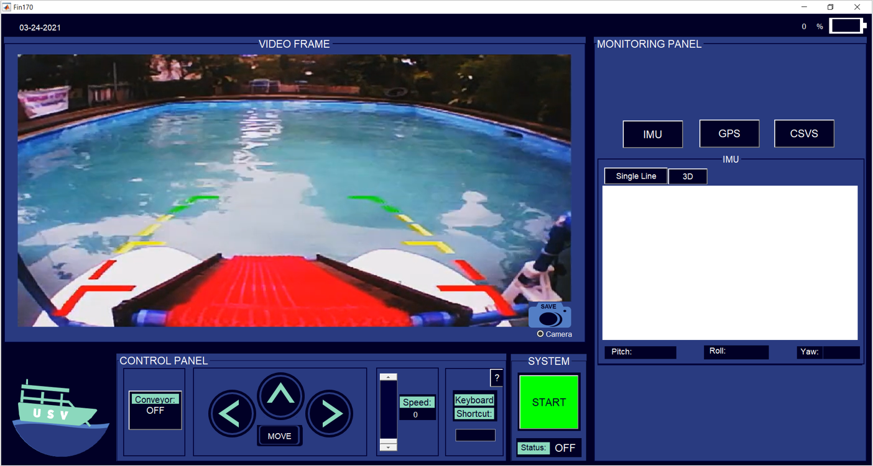

Figure 4.3 User-Interface once program is run

After the connection was set up, the control and monitoring functions of the Unmanned Surface Vehicle were fully functional. The control panel consisted of conveyor, maneuver, and propeller speed control. The monitoring panel, on the other hand, consisted of GPS mapping, IMU measurements, and voltage and current readings.

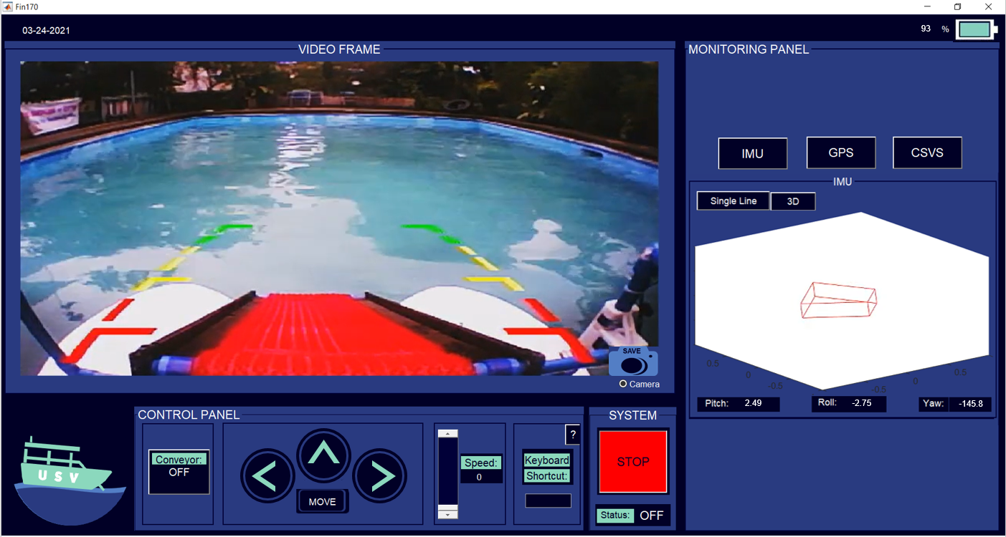

Figure 4.4 User-Interface once start button is pressed

1. **Video Streaming and Capture**

Wireless camera transmission was received by the user interface through a radio AV receiver. A USB to RCA cable interfaces the receiver to the computer and allowed real-time video transmission. The 640x480 pixels video input was displayed in an axis. A camera button was provided in order to capture what was on the camera axis. This captured image was automatically saved to a designated file in the computer. A radio button is also provided to allow the user to decide whether to show the video frame or hide it.

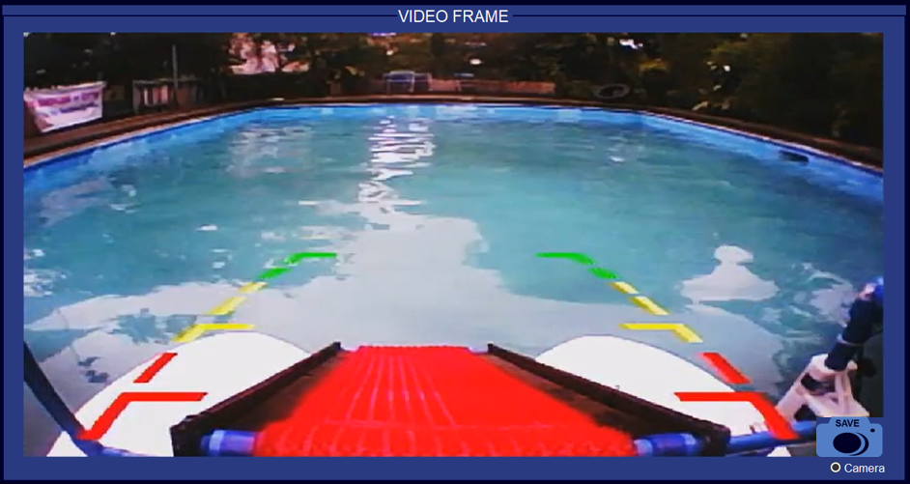

Figure 4.5 Real-time Video Transmitted

1. **Control Panel**

The control panel consisted of maneuver control, conveyor control, speed control and keyboard shortcut. Push buttons were used in maneuvering the surface vehicle. The maneuver panel consisted of buttons for move, stop, center, left and right movement. When the ‘move’ button was pressed the speed is automatically set to 1. The speed was later changed to desired level by using a slider. A static text displayed the propeller’s current speed. A toggle button, on the other hand, was used in order to turn the conveyor either on or off.

An edit text was also provided to enhance the USV’s accessibility by controlling it through keyboard keys. A help button was placed at the right top corner which contained information on what keys corresponded to specific USV control.

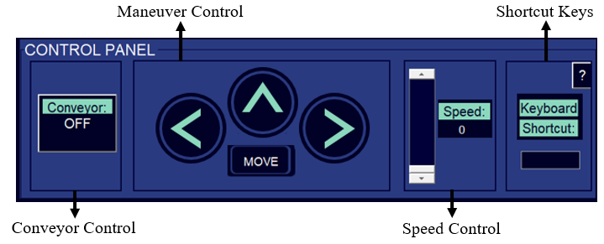

Figure 4.6 Control Panel

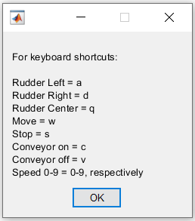

Figure 4.7 Shortcut Keys

1. **Monitoring Panel**

The monitoring panel consisted of three tabs, IMU tab, GPS tab, and CSVS tab, which contained the IMU measurements, GPS mapping, and voltage and current readings, respectively. When one tab was clicked the other two tabs were concealed, correspondingly. The default tab shown was the IMU measurements.

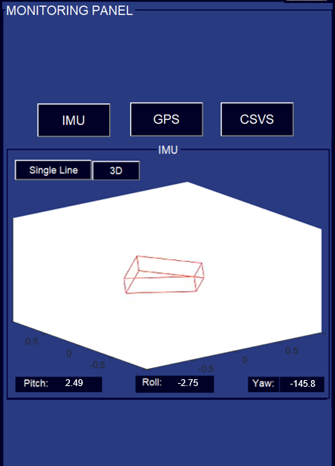

Figure 4.9 IMU measurements and graphs

The IMU measurement had two representations, single line and 3-dimension. The pitch, roll and yaw angles are updated and transmitted by the firmware every second to facilitate real-time monitoring of the surface vehicle’s orientation. When there is a change in orientation, the graph moves to the updated angles received by the software in single line or 3-dimension.

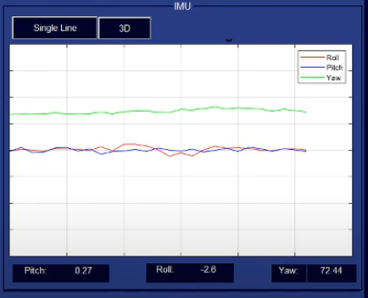

Figure 4.8 Single line representation of IMU measurements

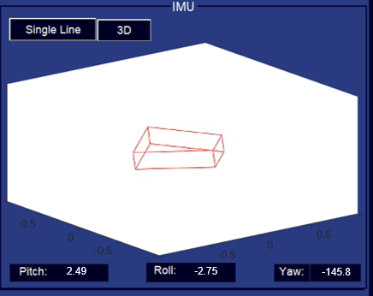

Figure 4.9 3D representation of IMU measurements

The geographic coordinates namely; longitude and latitude, from the GPS module was mapped using geoplot function from matlab. A green marker was displayed to locate the current position of the USV.

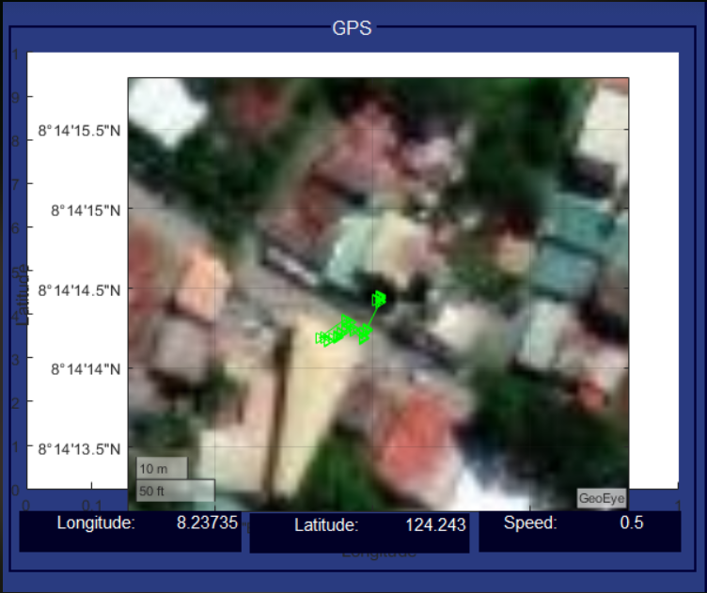

Figure 4.10 GPS Mapping

The voltage and current readings was provided. The voltage sensor showed the terminal voltage of the battery, while the current sensor showed the total current drawn by the system real time

1. **Date and Battery Status Panel**

On the top-left corner of the user interface the date in mm-dd-yyyy format was shown. While on the top-right corner, the battery status is provided. This is obtained from the current and voltage sensors.



Figure 4.11 Date and Battery Status