1. Software Design Process

In order to make the USV easy to operate, the use of a graphical user interface was of great assistance. The existence of controls such as menus, toolbars, buttons, and sliders in MATLAB GUI makes it convenient for a wide range of applications. In this project, the MATLAB GUI was used to implement the software application for monitoring and control.

1. Graphical User Interface

The graphical user interface design consisted of user control panels, video frame and monitoring panels. It had additional features: namely battery status and time. A special button was provided to allow the user to capture images from the video frame. The captured images were automatically saved into a designated file.

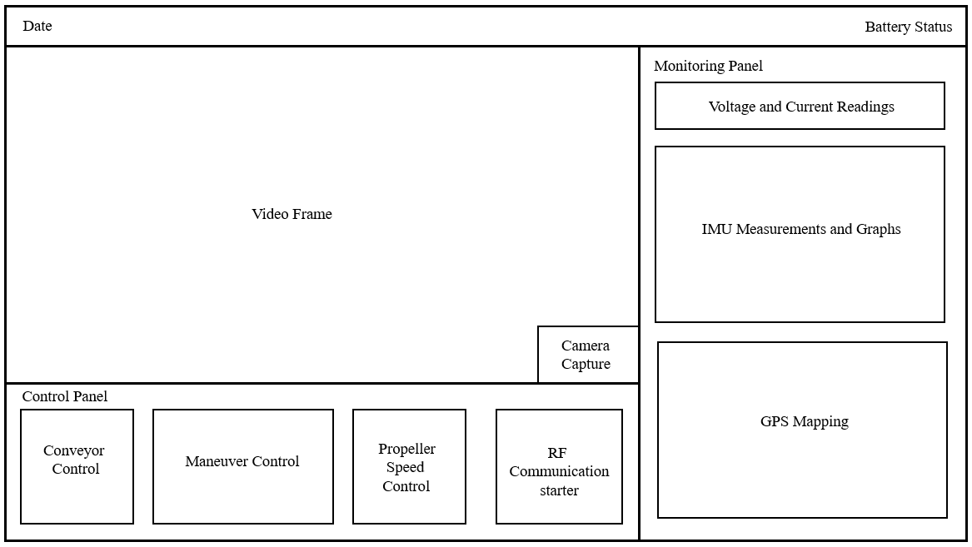

Figure 3.3.1 Human-Machine Interface

3.3.2 Serial Port Communication

To receive and transmit data, the software application utilized the ‘serial’ function to create a serial port object with the specified property name and property value. The baud rate was set to 9600, similar to the USV. The COM port is selected by the use of the ‘instrhwinfo('serial')’ function which provided the available serial hardware. To start obtaining and editing data, the function ‘fopen’ is used.

Once the communication between the USV and graphical user interface was established, receiving and transmitting data were done using the “fscanf” and “fprintf” functions, respectively. The ‘fscanf’ function reads the data from the open text file. The ‘fprintf’ function returns the number that ‘fprintf’ writes to the open text file, using any of the input arguments in the preceding syntaxes. Additionally, in order to sort the string of data received by the software, the ‘strtok’ function was used. This function parses string from left to right, using the specified character, in this case, ‘,’ as delimiters, and returns part of the text in token. Lastly, the data received was monitored and set to zeros (0) when it reached the maximum allowed rows and columns to avoid cluster of data.

3.3.3 Video Streaming and capture

In accessing the wireless camera from the USV, the ‘imaqtool’ command was utilized. The command showed all the available video input devices attached to the computer and its properties. This allowed the connection of the right video input. The video was then shown in an axis in the user interface.

A button on the bottom-right corner of the video frame was provided. This button served to capture images from the video frame by the use of ‘getframe’ function. The images are then saved in a specified file in the computer with the name of the time format ‘yyyy-mm-ddTHHMMSSZ’. It was necessary to name the images this way, since every name should be unique for each image to avoid overwriting.

3.3.4 User Controls (Keyboard Shortcut for Control)

The graphical user interface consisted of buttons that allowed the user to control the USV. The set of buttons were either push buttons, toggle buttons or slider, depending on which is more convenient. Each of these buttons had a specific function and pressing it transmitted a specific character to the USV through wireless serial communication to perform its corresponding function. In addition, shortcut keys to these buttons were provided to enhance accessibility, shown in table 3.3.1.

3.3.4.1 Maneuver Control

For maneuvering, push buttons allowed the forward, stop, left, right and center movement of the USV. Pressing these buttons sent data to the firmware to perform the specific maneuver command. Sending a ‘w’ moved the USV forward, ‘a’ turned it to the left, ‘d’ turned it to the right, and ‘s’ stopped it.

3.3.4.2 Conveyor Control

A toggle button was used to control the conveyor of the USV, since it was either on or off. Sending a ‘c’ turned the conveyor on, while sending a ‘v’ turned the conveyor off.

3.3.4.3 Propeller Speed Control

A slider is used to control the propeller’s speed. The length of the slider is divided into 5 corresponding speed. From bottom to top of the slider, the corresponding speed is 0 to 4, respectively.

|  |  |  |
| --- | --- | --- |
| Data Sent | Shortcut Keys | Action |
| w | Up arrow key | Move USV forward |
| s | Down arrow key | Stop USV |
| a | Left arrow key | Turn USV to left |
| d | Right Arrow key | Turn USV to right |
| q | Q | Turn USV to center |
| c | C | Turn conveyor on |
| v | V | Turn conveyor off |
| 0 | 0 | Set propeller speed to 0 |
| 1 | 1 | Set propeller speed to 1 |
| 2 | 2 | Set propeller speed to 2 |
| 3 | 3 | Set propeller speed to 3 |
| 4 | 4 | Set propeller speed to 4 |

Table 3.3.1 Control Commands

3.3.5 Sensor Data Interpretation

Through wireless communication, strings of data were sent from the USV to the ground station by the firmware. These strings of data were decoded by the software. As mentioned in section 3.3.2, these strings were parsed and then tokenized. The tokenized data was then represented through textual or graphical representation.

3.3.5.1 GPS Mapping

-Work in progress-

3.3.5.2 Battery Monitoring

-Work in progress-

3.3.5.3 IMU

-Work in progress-