Executive brief: profit-aware retention targeting
To: Head of Customer Retention | From: Retention analytics team | Decision requested: approve a 90-day retention pilot
The issue. Churn puts about $468,468 of 12-month customer margin at risk across the 7,043 customers of the sample company (IBM's fictional US telco; USD). Today's rule spends the budget on the customers most likely to leave, ignoring what they are worth and what an offer costs.

Recommendation
1. Target by expected value, not by risk alone. Make an offer only where churn risk x customer value x the offer's save rate (the share of would-be leavers it keeps) exceeds its cost. Here that means fibre customers on month-to-month contracts with high bills: 100% of the recommended list have fibre and 97% a monthly contract, with a median bill of $89 against $70 overall. Low-risk and low-bill customers are left out.
2. Match the offer to the segment: $35 credit for moving to a 1-year contract (150), 6 months free TechSupport + OnlineSecurity (150), One-time $20 bill credit (24).
3. Test before scaling: one randomised pilot wave of 1,620 customers, half held out, and scale up only if the measured save rate clears that list's 13.8% break-even.

Why: the same budget returns more
1,409 test customers (held out from every choice), fixed $3,500 budget:
Option | Customers contacted | Expected net value | ROI | Precision among contacted | High-risk/high-value coverage
Do nothing | 0 | $0 | n/a | n/a | 0%
Call highest churn risk (today) | 140 | $1,301 | 37% | 71% | 12%
Call highest value | 140 | -$1,037 | -30% | 29% | 30%
Expected value, one standard offer | 140 | $2,340 | 67% | 60% | 96%
Expected value + segment offers (recommended) | 153 | $2,668 | 76% | 60% | 98%

- The recommended rule is expected to add $1,368 for the same spend: $1,039 from choosing customers by expected value and $328 from matching offers. Valued with actual churn (at the assumed save rates), the gain is $1,077 (95% interval $229 to $2,002); the part from matching offers is not proven.
- Risk-only is more precise but spends on risky customers whose value cannot repay an offer. Calling the most valuable customers loses money: risk and value are needed together.

How much to spend
Each extra budget step returns less (figure). Keeping only steps that still return at least 10% (decided on validation data) gives about $45,737 for the whole base ($6.49 per customer). On the test customers this buys 324 offers for $9,150: expected net value $4,145, ROI 45%. Beyond 26% of customers nobody has positive expected value.
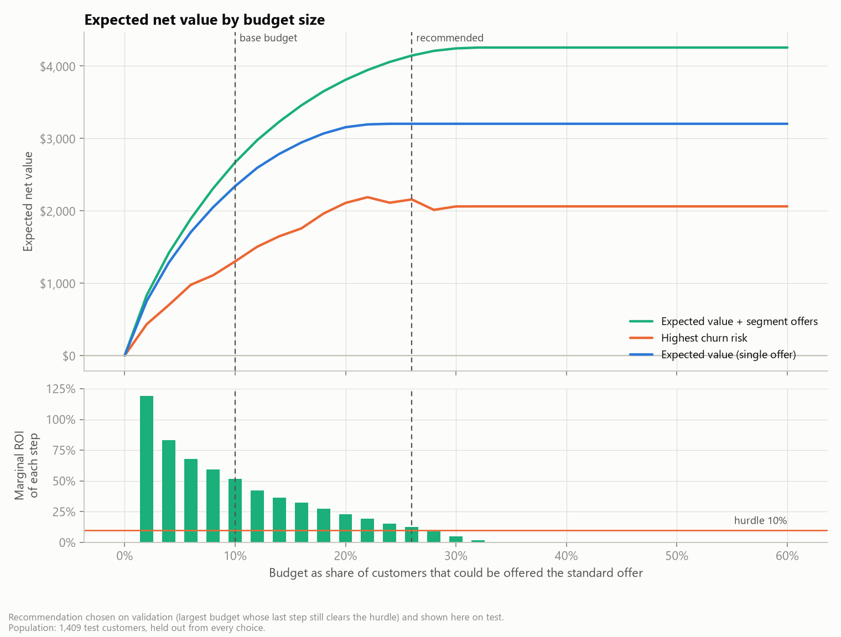

How sure are we?
- Who to target is robust. The model ranks churners well (ROC-AUC 0.83) and its probabilities are within 1.9 points of observed churn. With all assumptions drawn at once, expected-value targeting beats risk-only in 100% of draws.
- How much an offer saves is not. Lists break even at a save rate of 11.3% (base budget) and 13.8% (recommended); we assume 20%. Only 46% of churners left for price or a competitor's offer, so 20% means keeping 43% of those an offer can reach.
- Downside: the recommended list loses money in 17% of draws, and in the worst 5% it loses more than $12,217 across the base; the smaller base-budget list loses in 9%.

Risks and guardrails
- No causal evidence yet. Save rates are assumptions and contact can even raise churn, so the pilot keeps a random control group.
- Sample data. Real operators lose far fewer customers than this sample's 27%. At 15% average churn only 7% of customers would be worth this offer, so offers and contact must get cheaper (for example SMS); retrain on our own data (Vietnam deployment note).
- Fairness. Seniors are contacted 3.3x as often as others (2.6x under today's rule), 1.7x after adjusting for risk. Age and gender are not model inputs; Legal/DPO reviews each wave.
- Compliance. Consent, Do-Not-Call checks, contact limits and a data-protection impact assessment.

Decisions requested
1. Approve one pilot wave: 810 customers offered, 810 held out; offer and contact cost about $22,875, expected net value of the offered half $10,363, worst case (no one saved) -$22,875.
2. Name owners: Retention (offers), Call centre (capacity), Finance (margin, offer cost), Legal/DPO (consent, DPIA).
3. Agree the rule now: after 90 days, go if the effect is statistically significant and at least 13.8%; stop if clearly below; otherwise extend, at most 2 more waves. At a true save rate of 20% the rule says go 95% of the time. Decision about 19 weeks after approval.

