|  |  |
| --- | --- |
|  | **FPT ACADEMY INTERNATIONAL**  **FPT – APTECH COMPUTER EDUCATION** |

**Centre Name: ACE-HCMC-2-FPT.**

**Address: 590 Cach Mang Thang 8, District 3, Ho Chi Minh City, Viet Nam.**

ASTRONOMY

|  |  |  |
| --- | --- | --- |
| **Supervisor.** | Phạm Thị Lánh | |
| **Batch.** | T1.2111.M1 | |
| **Group.** | Group 1 | |
| **Serial No.** | **Enrolment Number** | **Student Name** |
| 1. | Student1350800 | Trần Nam Trung |
| 2. | Student1350323 | Trần Hải Phong |

March 2022

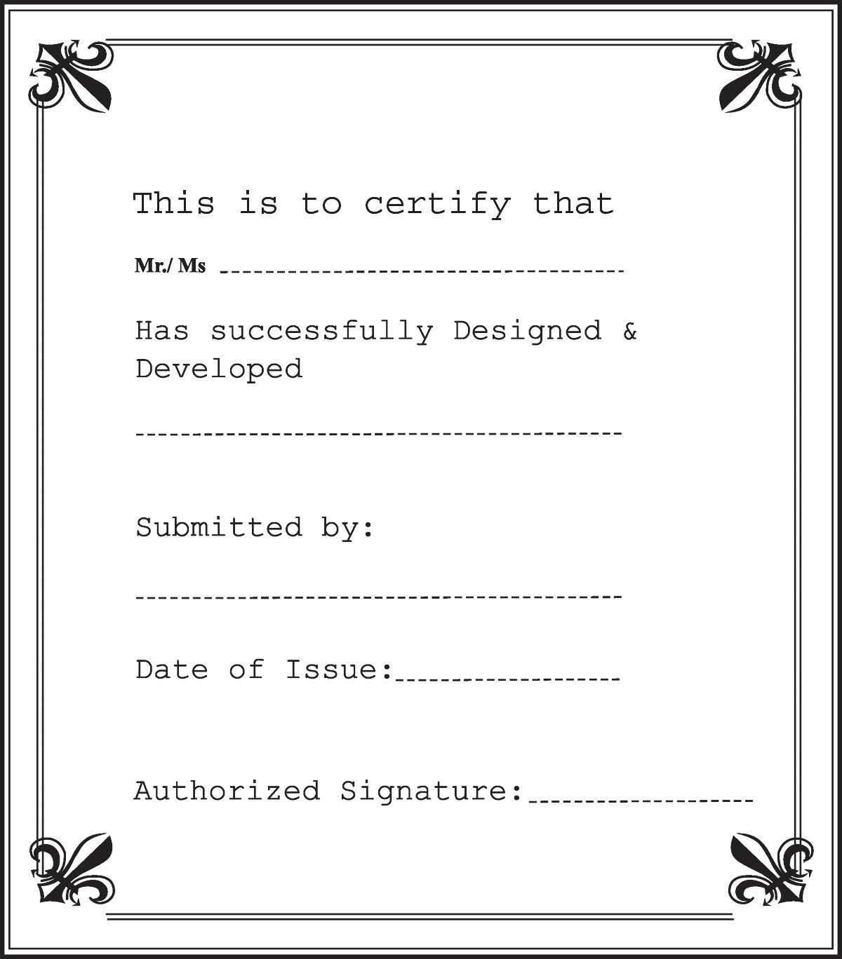

**Contents**

Contents

1 ACKNOWLEDGEMENT 4

2 SYNOPSIS 5

3 REVIEW 1 6

3.1 REQUIREMENT SPECIFICATION 6

3.2 SITEMAP 7

3.3 WEBSITE LAYOUT 8

3.3.1 HOMEPAGE 8

3.3.2 ABOUT US 9

3.3.3 CATEGORIES 10

3.3.4 OBSERVATORIES 11

3.3.5 CONTACT 11

3.4 TASK SHEET 1 13

4 PROJECT SNAPSHOTS 15

4.1 HOME PAGE 15

4.2 ABOUT US 16

4.3 CATEGORIES 17

4.4 OBSERVATORIES 18

4.5 CONTACT 19

5 TASK SHEET 2 20

6 CHECKLIST VALIDATION 21

7 REFERENCES 22

# 1 ACKNOWLEDGEMENT

The world is a better place thanks to people who want to develop and lead others. What makes it even better are people who share the gift of their time to mentor future leaders. We would like to acknowledge all those who have given us their support and knowledge sharing in the making of this project.

We wish to express our gratitude to the e-Project Team at the Head Office in India, who provided us with guidance and instructions. We would like to thank all the staff members at the Center in India for providing us the opportunity to work on this project and offering us their upmost encouragement through out the process.

We would like to express our special thanks of gratitude to our instructor, Mrs. Pham Thi Lanh at the Aptech Computer Education HCMC for her able guidance and support in completing our project. We would also like to extend our gratitude to the staff at the Aptech HCMC office for providing us with all the facility that was required.

Our acknowledgement to several people whom also helped with: the collections of pictures samples, CSS & JS libraries, the preparation of web development, sample code snippets and tutorials and they are all thanked for their contributions. Special mentions goes to the contributors of Bootstrap 4, the contributors and admins for tutorials sites such as W3C school, Tutorialspoint.com, GeeksforGeeks, and many other learning sites.

And Lastly, to our many friends and family, you should know that your support and encouragement was worth more than we can express on paper. Thank you to our moms and dads for breakfasts, lunch and dinners – we could not have finished the project without being provided with love and daily nourishments.

# SYNOPSIS

The thirst for learning, upgrading technical skills and applying the concepts in real life environment at a fast pace is what the industry demands from IT professionals today. However busy work schedules, far-flung locations, unavailability of convenient time-slots pose as major barriers when it comes to applying the concepts into realism. And hence the need to look out for alternative means of implementation in the form of laddered approach.

The above truly pose as constraints especially for our students too! With their busy schedules, it is indeed difficult for our students to keep up with the genuine and constant need for integrated application which can be seen live especially so in the field of IT education where technology can change on the spur of a moment. Well, technology does come to our rescue at such times!!

Keeping the above in mind and in tune with our constant endeavour to use Technology in our training model, we at Aptech have thought of revolutionizing the way our students learn and implement the concepts using tools themselves by providing a live and synchronous eProject learning environment!

So what is this eProject?

eProject is a step-by-step learning environment that closely simulates the classroom and Lab based learning environment into actual implementation. It is a project implementation at your fingertips!! An electronic, live juncture on the machine that allows you to

Practice step by step i.e. laddered approach.

Build a larger more robust application.

Usage of certain utilities in applications designed by user.

Single program to unified code leading to a complete application.

Learn implementation of concepts in a phased manner.

Enhance skills and add value.

Work on real life projects.

Give a real life scenario and help to create applications more complicated and useful.

Mentoring through email support.

The students at the centre are expected to complete this eProject and send complete project along with the documentation to eProjects Team

Looking forward to a positive response from your end!!

# REVIEW 1

## REQUIREMENT SPECIFICATION

Humans have long gazed toward the heavens, searching to put meaning and order to the universe around them. Although the movement of constellations — patterns imprinted on the night sky — were the easiest to track, other celestial events such as eclipses and the motion of planets were also charted and predicted.

Astronomy is the study of the sun, moon, stars, planets, comets, gas, galaxies, gas, dust and other non-Earthly bodies and phenomena.

We are here looking at a website which will provide brief details about few facts and details about astronomy

The website is supposed to provide user friendly environment and navigation. The important menu must be stated in the top section of the webpage. Also a decent look out and color combination is expected.

The website is to be developed for the Windows Platform using HTML5, JavaScript and Geolocation. The site should work well in all leading browsers including Chrome, IE, Firefox etc.

**The Web site is to be created based on the following requirements:**

1. The home page about the description/images about various planets should be provided. If user clicks on the same, navigational link must be available.
2. There should be categories providing details about big bang theory, evolution of earth etc
3. The site should also list and explain various planets available as well as details about them as :

* When discovered
* Size
* Atmosphere there
* Distance from sun and earth
* Other available important details about them.

1. There should be information on constellations as what is it/how it is formed and various constellations.
2. There should also be a section on comet giving information related.
3. Also include a section which will provide details on various latest developments in the field of astronomy related to planets and stars.
4. List of Few top Observatories with details and location displayed using GeoLocation API (eg. GoogleMaps).
5. Also each link must be properly hyperlinked; images must be used wherever necessary.

## SITEMAP

HOME

YERKES OBSERVATORY

PARANAL OBSERVATORY

OBSERVATORIES

CATEGORIES

BIG BANG THEORY

EVOLUTION

CONTACT

ABOUT US

## WEBSITE LAYOUT

The website layout must be designed in a SIMPLE but DELICIOUS style. Since the goal is to provide information FAST and SYSTEM to website visitors, the focus of our website. Our website helps all curious people about the stars in this galaxy to increase their understanding of the planets and this vast universe.

### HOMEPAGE

Our website layout consists of the following basic parts:

- The navigation bar is a place for us to conveniently search. This search bar helps us link to other closely related items that will tell you more about the universe and planets in the system. sun v. v. ...

- Main content: Are information images about planets or the formation of certain planets such as earth. This will be a useful place for you to refer to fact-finding material.

Home Abou Us Categories Observatories Contact

Img

Sun Mercury Venus Earth Mars Jupiter Saturm Urauns Neptune Pluton

Image

Video Big Bang

Evolution

### 3.3.2 ABOUT US

Contact Us On Trần Nam Trung

Trần Hải Phong

Home About Us Categories Observatories Contact

Information about our project team

Information about our topic

Information about T1.M1.2111

This page give user some informations about our class, team and the topic. It also shows our passion on this project to the user.

### CATEGORIES

Home About Us Categories Observatories Contact

Img Information

Img Information

Contact Us On Trần Nam Trung

Trần Hải Phong

Information about the Big Bang and the Formation of the Earth

### OBSERVATORIES

Home About US Categories Observatories Contact

Img NOTE

Contact Us On Trần Nam Trung

Trần Hải Phong

Where we help you learn about a number of astronomical stations. With a simple but quite informative website.

### CONTACT

Your hosting account helps you to work together more than web hosting.

Gives you convenience in usage.

Home About US Categories Observatories Contact

CONTACT FORM

Contact Us On Trần Nam Trung

Trần Hải Phong

## TASK SHEET 1

|  |  |  |  |  |  |  |
| --- | --- | --- | --- | --- | --- | --- |
| **Project Ref No.** | **Project Title – Astronomy** | **Activity Plan Prepared**  **by** | **Date of preparation of Activity Plan** | | | |
| **Task** | **Actual Start Date** | **Actual Days** | **Teammate Names** | **Status** |
| Brainstorming ideas for  layouts, and Project Objective | | Trung, Phong | 05/03/2022 | 1 day | Trung, Phong | Completed |
| Draw site maps and  architecture design | | Trung, Phong | 07/03/2022 | 2 days | Trung, Phong | Completed |
| Wire framing general page  layout. | | Trung | 10/03/2022 | 4 days | Trung, Phong | Completed |
| Collect static assets (pictures,  video, documentation) | | Trung, Phong | 15/03/2022 | 3 days | Trung, Phong | Completed |
| Design & Build Home Page | | Trung | 20/03/2022 | 5 days | Trung, Phong | Completed |
| Design & Build Contact Us  Page | | Trung, Phong | 25/03/2022 | 2 days | Trung, Phong | Completed |
| Design & Build About Us Page | | Phong | 25/03/2022 | 2 days | Phong | Completed |
| Design & Build Categories | | Trung, Phong | 25/03/2022 | 2 days | Trung, Phong | Completed |
| Design & Build Observatories | | Trung | 27/03/2022 | 2 days | Trung | Completed |
| Design & Build Sigle post  (Big bang theory, Evolution of Earth,…) | | Phong | 27/03/2022 | 2 days | Phong | Completed |
| Write project report Review 1 | | Trung, Phong | 29/03/2022 | 2 days | Trung, Phong | Completed |

|  |  |
| --- | --- |
| Signature of Faculty | Signature of Team Leader |
|  |  |

# PROJECT SNAPSHOTS

## 4.1 HOME PAGE

The following snapshots illustrate the creation home page:

## ABOUT US

## 4.3 CATEGORIES

The following snapshots illustrate the creation contact us page:

## Graphical user interface, application Description automatically generatedA picture containing text, monitor, screenshot, screen Description automatically generated OBSERVATORIES Graphical user interface Description automatically generated

## A screenshot of a computer Description automatically generated with medium confidenceCONTACT

# TASK SHEET 2

|  |  |  |  |  |  |  |  |
| --- | --- | --- | --- | --- | --- | --- | --- |
| **Project Ref No.** | **Project Title – Astronomy** | **Activity Plan Prepared**  **by** | **Date of preparation of Activity Plan** | | | | |
| **Task** | **Actual Start Date** | **Actual Days** | **Teammate Names** | **Status** |
| Brainstorming ideas for layouts and Project Objectives. | | Trung, Phong | 05/03/2022 | 1 day | Trung, Phong | Completed |
| Draw site maps and  architecture design. | | Trung, Phong | 07/03/2022 | 2 days | Trung, Phong | Completed |
| Wire framing general page  layout. | | Trung | 10/03/2022 | 4 days | Trung | Completed |
| Collect static assets (pictures,  mp4, documentation) | | Trung, Phong | 10/03/2022 | 3 days | Trung, Phong | Completed |
| Design & Build Home Page. | | Trung, Phong | 20/03/2022 | 5 days | Trung, Phong | Completed |
| Design & Build Contact Us  Page. | | Trung, Phong | 25/03/2022 | 2 days | Trung, Phong | Completed |
| Design & Build About Us  Page. | | Phong | 25/03/2022 | 2 days | Phong | Completed |
| Design & Build Categories | | Trung, Phong | 25/03/2022 | 2 days | Trung, Phong | Completed |
| Design & Build Observatories | | Trung, Phong | 25/03/2022 | 2 days | Trung, Phong | Completed |
| Write project report Review 1 | | Trung, Phong | 27/03/2022 | 2 days | Trung, Phong | Completed |
| Testing UI. | | Trung, Phong | 27/03/2022 | 1 days | Trung, Phong | Completed |
| Testing Responsiveness. | | Trung, Phong | 27/03/2022 | 1 days | Trung, Phong | Completed |
| Final Testing. | | Trung, Phong | 27/03/2022 | 1 days | Trung, Phong | Completed |
| Write project report Review 2 | | Trung, Phong | 29/03/2022 | 2 days | Trung, Phong | Completed |

# CHECKLIST VALIDATION

|  |  |  |
| --- | --- | --- |
| **Task**  **No.** | **Requirement** | **Validation** |
| 1 | The home page about the description/images about various planets should be  provided. If user clicks on the same, navigational link must be available. | Yes |
| 2 | There should be categories providing details about big bang theory, evolutionof earth etc | Yes |
| 3 | The site should also list and explain various planets available as well as  details about them as  a. When discovered  b. Size  c. Atmosphere there  d. Distance from sun and earth  e. Other available important details about them. | Yes |
| 4 | There should be information on constellations as what is it/how it is formed  and various constellations. | Yes |
| 5 | There should also be a section on comet giving information related. | Yes |
| 6 | Also include a section which will provide details on various latest  developments in the field of astronomy related to planets and stars. | Yes |
| 7 | List of Few top Observatories with details and location displayed using  GeoLocation API (eg. GoogleMaps).. | Yes |
| 8 | Also each link must be properly hyperlinked; images must be used wherever  necessary. | Yes |

# REFERENCES

1. Information and images about planets, solar system, Big Bang theory, Evolution of Earth, observatories <https://www.wikipedia.org/>
2. Design ideas from <https://freewebsitetemplates.com/>
3. Featured video from <https://www.youtube.com/watch?v=libKVRa01L8>
4. Carousel idea from <https://viblo.asia/p/cach-tao-carousel-bang-js-6J3ZgxOxlmB>
5. Observatories location from <https://www.google.com/maps>