|  |  |  |  |  |  |  |  |  |
| --- | --- | --- | --- | --- | --- | --- | --- | --- |
| |  |  | | --- | --- | |  | **MINISTRY OF EDUCATION AND TRAINING** |  |  | | --- | | **FPT UNIVERSITY** | | **Quadrocopter Flight Capability Study** | | FPT UNIVERSITY FLYING OBJECT  Project code: FUFO  D:\Study\Do an FPT\FUFO\Other\03.Logo\logo_final.png | | Hanoi, August 9th,2012 | | **Authors:**  Vu Minh Phong - 00885  Hoang Duc Hung - 60115  Vu Duc Thang - 60124  Ly Khoi Nguyen - 60206  Tran Thi Yen - 01269 | | **Supervisor:**  Phan Duy Hung - Instructor/Supervisor | |
| Abstract Unmanned Aerial Vehicle[1], also referred as UAV, are providing an increasing importance role in many aspect of human life today. As in the past few decades, UAV would be classified as an military area only due to the extremely high cost in both development and operation. However, due to the evolution of technology which lead to the reduction in price of technology equipments and parts, small UAVs are being researched and developed among the technology Universities and companies.  A simple low cost UAV solution will provide an attractive alternative to many civilian and even military applications where human, plane or helicopter would traditionally be used. These application could include: traffic/urban surveillance, aiding search and rescue operations, forest fire detection, national border protection, cross-border smuggling control, etc.  The objective of this project is to build and experiment with a low cost prototype UAV. This involves constructing a Quadrocopter[2], a vehicle control system, as well as evaluating various design features and building materials.  This UAV is a Quadrocopter model, which is propelled using four motors and propellers in opposite directions. The detail of this model will be discussed more intensively later in this report.  The basic theory will mainly consist of modeling and control theory. However, there is some extents in filtering and controller constants finding technique which is crucial and valuable for every Quadrocopter related project. These extents will be discussed both theoretically and practically.  It is important to emphasize that existing solution on the market today are result of projects with far greater budgets than the one available here. Hence, the goal is to experiment with a low-cost UAV and to determine what is possible to archive with small resource. |
|  |

Table of Contents

[Abstract 2](#_Toc332500782)

[1 Introduction 4](#_Toc332500783)

[1.1 Study objective 4](#_Toc332500784)

[1.2 Definitions and Acronyms 4](#_Toc332500785)

[2 History 4](#_Toc332500786)

[3 Quadrocopter Dynamic 5](#_Toc332500787)

[3.1 Inertial frame and Body frame 5](#_Toc332500788)

[3.2 Quadrocopter assumptions 6](#_Toc332500789)

[3.3 Quadrocopter dynamic 7](#_Toc332500790)

[4 Modeling the Quadrocopter 11](#_Toc332500791)

[4.1 IMU 11](#_Toc332500792)

[4.2 Euler angular movement measurement 12](#_Toc332500793)

[4.3 Mathematical Filter 14](#_Toc332500794)

[4.4 Altitude measurement 17](#_Toc332500795)

[4.5 PID Controller 19](#_Toc332500796)

[4.6 PID Tuning 21](#_Toc332500797)

[4.7 System design 23](#_Toc332500798)

[5 Experimental results 25](#_Toc332500799)

[5.1 Experimental setup 25](#_Toc332500800)

[5.2 Experiments and results 25](#_Toc332500801)

[6 Conclusion 26](#_Toc332500802)

[7 List of References 26](#_Toc332500803)

# Introduction

## Study objective

This study involves in making a low cost Quadrocopter with a restricted resource and evaluate its flight capability both indoor and outdoor. To some extent, this study will also include some aspect of Filtering technique and vehicle control method to determine what is the best achievable solution for this type of UAV without increasing the budget for development.

## Definitions and Acronyms

|  |  |  |
| --- | --- | --- |
| **Acronym** | **Definition** | **Note** |
| ESC | Electronic Speed Controller[3] |  |
| UART | Universal Asynchronous Receiver/Transmitter |  |
| SPI | Serial Peripheral Interface |  |
| PID | Proportional-Integral-Derivative[4] |  |
| INS | Inertial Frame |  |

**Table 1: Definition and acronyms**

# History

Research into the initial development of quad rotors began in the early twentieth century. One of the first engineers to attempt to design a quad rotor was Etienne Oemichen. Oemichen began his research in 1920 with the completion of the Oemichen No.1. This design consisted of four rotors and a 25 Horsepower motor; however, during tests flights the Oemichen No.1 was unable to obtain flight. Two years later Oemichen completed his second design; the Oemichen No.2. His second design consisted of four rotors and eight propellers along with a 125 Horsepower motor. Five of the propellers were used to achieve stable flight while two were used for propulsion and the final propeller being used to steer the aircraft. In April of 1914, the Oemichen No.2 achieved an FAI distance record for helicopters of 360m, which the Oemichen No.2 broke with a distance of 525m.

While Oemichen had begun working on his early designs in France, Dr. George de Bothezat and Ivan Jerome began their own research in January 1921 for the United States Army Air Corps. They completed their design in mid 1922, and the first test flight took place in October of 1922 in Dayton, Ohio. Bohezat‟s and Jerome‟s design weighed around 1700 kg at the time of take off and consisted of four six-bladed rotors along with a 220-HP motor. After many tests, the quad rotor was only able to achieve a maximum flight time of 1 minute 42 seconds and maximum height of 1.8 meters.

Following the research of Oemichen, Bothezat and Jerome, other researchers have attempted to create their own successful vertical flying machines. One such was being the Convertawings Model “A” quad rotor. The Convertawings Model “A” quad rotor was designed and built in the mid 1950‟s with civil and military purposes in mind. This particular quad rotor consisted of four rotors, two motors as well as wings. Due to lack of interest, however, the Convertawings Model “A” quad rotor was never mass produced.

Currently Bell Helicopter Textron and Boeing Integrated Defense Systems are doing joint researched on the development of the Bell Boeing Quad Tilt Rotor. The initial design consists of four 50-foot rotors powered by V-22 engines. The main role of the Bell Boeing Quad Tilt Rotor will be that of a cargo helicopter with the ability to deliver pallets of supplies or also deploy paratroopers. The first wind tunnel tests were completed in 2006 and the first prototype is expected to be built in 2012.

# Quadrocopter Dynamic

In order to understand how to control the Quadrocopter, it is important to understand how it behaves first. This report assumes that the readers do not have many knowledge in aero space area, therefore, explanation on some aspect of this area is provided as clear as possible with as less math as possible. It is possible for the reader to be confused, so it is recommended to bypass this part if it is not necessary.

For readers who are interested in this subject, please take "*Accurate modeling and robust hovering control for a Quad-rotor VTOL aircraft"[*5] by Jinhyun Kim, Min-Sung Kang and Sandeok Park as a reference.

## Inertial frame and Body frame

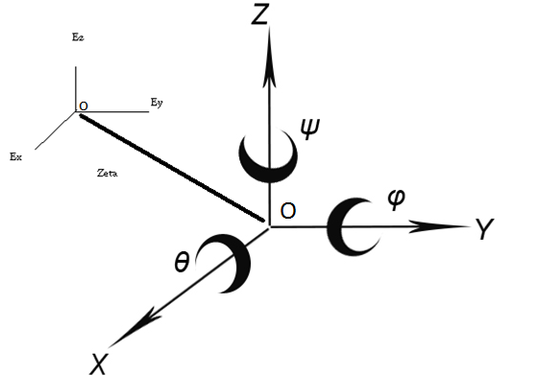

**Figure 1: Inertial frame OExEyEz and Body frame OXYZ**

Inertial Frame of Reference[6], some time called Reference Frame or Navigation Frame, denoted as INS, is a 3-axis frame for referencing purpose of a spectacular object in space.

Body Frame is a 3-axis frame that represents the object in space. It is always located with regard to an Inertial Frame.

The body of a Quadrocopter is assumed as a rigid body, the Origin of its Body Frame is located at the mass center.

The inertial frame of a Quadrocopter is earth. How is this possible? The answer is simple: Because the earth is giant compares to the size of a Quadrocopter, therefore it can be assumed as flat. Oz vector of Inertial frame points toward the center of gravity.

In a complex Quadrocopter navigation system, there must be at least two INSs. The first one has the same Origin with the Body frame and the second one has an Origin located on earth surface. This separation is necessary because a Quadrocopter has two general behaviors:

- Maintains its Euler angular positions.

- Maintains its position in space.

To maintain its Euler angular positions, a Body frame need an INS that has the very same Origin with it, that is how Euler Angles are measured. This INS is denoted as INS1. However, the body frame will eventually need to know its position in a space, or to be more detailed, its Origin position in space. In order to archive this, a INS with a fixed Origin on the earth surface is defined. This INS is denoted as INS2.

As the two INS are existed together, a body frame now will have to vectors of position in space:

𝜂1 = [x,y,z]; (1)

𝜂2 = [𝜃,𝜑,𝜓]; (2)

(1) is the position of Body Frame's Origin with regard to INS2. x, y ,z are also called the linear translational unit vectors.

(2) is the Euler Angular[7] position of Body Frame with regard to INS1. 𝜃,𝜑,𝜓 is also called the rotational unit vectors.

NOTE: all the Euler Angles must follow a general direction rule which could be either Right-Hand rule or Left-Hand rule [8].

## Quadrocopter assumptions

The following assumptions have to be made before further discussing on Quadrocopter dynamic:

- The Earth is flat, stationary and therefore an approximate Inertial Frame.

- The atmosphere is at rest relative to the ground (zero wind).

- The motors respond rate is fast enough to neglect.

- The flapping angles of the rotors is negligible.

- Force are symmetric in flight and act at center of mass.

- Change in relative air velocity is negligible.

## Quadrocopter dynamic

With regard to (1) and (2), the followings state vectors of the Quadrocopter can be defined:

𝜂 = [𝜂1, 𝜂2]; (3)

= [ 1,  2]; (4)

1 = [ x, y, z]; (5)

1 = [ωx,ωy,ωz]; (6)

where (3) are described relative to the Inertial Reference Frames while (5) and (6) represent the velocity vector of linear translational movement and rotational movement of Quadrocopter Body Frame , respectively.

The inertial and body-fixed velocity relation can be represent with a Quadrocopter Jacobian matrix[9]:

=  <=> 𝜂' = J(𝜂)(7)

where

J1(𝜂2) = (8)

J2(𝜂2) = (9)

In above equations, c and s and t denote sin, cos and tan, respectively.

For the moving base system which is not fixed in an inertial frame, it is not convenient to derive the dynamic formulation using the Lagrangian in terms of the velocities expressed in a body-fixed frame. In this Quadrocopter system, the strap-down sensor approach is used, so it is more natural to write up the dynamics using body-fixed velocities. To supplement this, the Quasi-Lagrange approach is used[10]. The quasi-Lagrange method can give the equations of motion in terms of the body-fixed velocities.

The Quasi-Lagrange in general form is defined as:

L = T - V (10)

T = vTMv = mv1Tv1 + mv2T I v1 (11)

V = - mgz (12)

where m and I are mass and system inertia, respectively. Normally, a Quadrocopter body is designed axisymmetric[11], so the inertia is defined as the following equation, and especially, Ixx=Iyy.

I = (12)

With the extended Hamiltonian principle[12], equation 10 give the following differential equations:

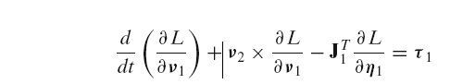(13)

(14)

Then,

**Mv' + Cv + g = τ**

Finally, the 6 independent equations of motions are obtained as following:

m[vx' - vyωz + vzωy - g sinϴ] = 0 (15)

m[vy' - vzωx + vxωz - g sinϴ sinϕ] = 0 (16)

m[vz' - vxωy + vyωx - g sinϴ cosϕ] = u1 (17)

Ixxὠx + (Izz - Iyy­) ωyωz = u­2 (18)

Iyyὠy + (Ixx - Izz­) ωzωx = u­3 (19)

Izzὠz = u­4 (20)

where

τ = = (21)

is the distance between motor and the center of mass, or it is usually called moment arm. Equation (21) can be rewritten as the form of matrix like below:

= = T (22)

F1, F2, F3, F4 are the force on each related motor. τ is the torque vector of the Quadrocopter.

The above equations now can finally be explained in physical aspect as below:

- The total force created by four motors is the force that lifts the Quadrocopter, as shown in equation (17)

- Force created by two opposite motors is capable of rotating in left/right or front/back directions the Quadrocopter, as shown in equation (18) and (19).

- Force created by four motors but two opposite one will rotate in a particular direction and two others will rotate in the reverse direction is capable of rotating the body around itself.

Figure 2 below shows the motor alignment scheme of a Quadrocopter and its motion which is induced by the combination of 4 motors.

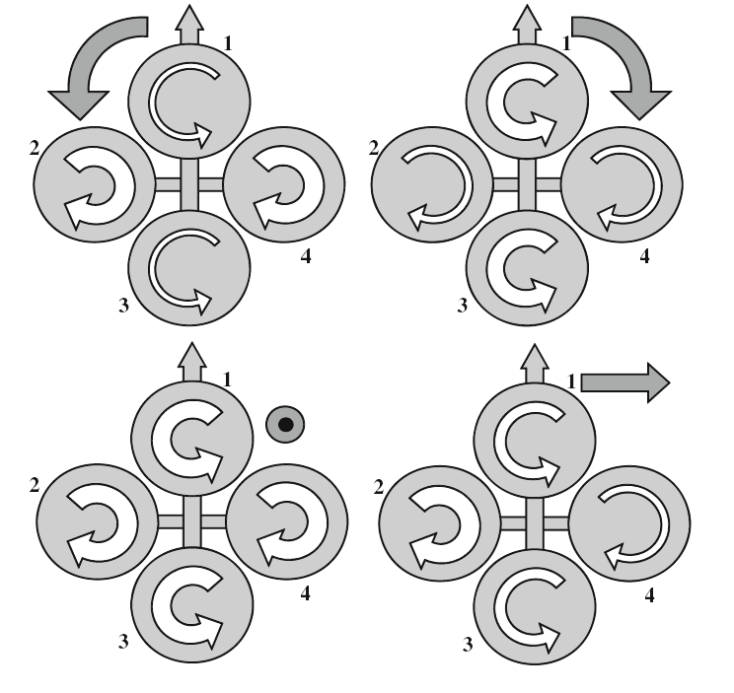

**Figure 2: Motors alignment scheme**.

Until now, only the dynamic equations of motion related to the body fixed INS1 are derived,. However, for the control purpose, it is more convenient to use the dynamic equations derived in earth-fixed coordinate frame like below:

Mη(η) η'' + Cη(ν, η) η '+ gη(η) = τ η(η) (23)

To express the dynamic equations in earth-fixed coordinate frame like Equation 23, the following relationship is needed:

η' = J(η)ν ⇐⇒ ν = J−1(η) η'

η' = J(η) ν' + J'(η)ν ⇐⇒ ν' = J−1(η)[η'' − J'(η)ν] (24)

Then, the system matrices are defined as below:

Mη(η) = J−T(η)MJ−1(η)

Cη(ν, η) = M'η(η)

gη(η) = J−T(η)g(η)

τ η(η) = J−T(η)τ

(25)

Finally, the equations of motion in earth-fixed coordinate frame can be derived.

mx'' = (sψsφ + cψcφsθ)u1 (26)

my'' = (−cψsφ + sθsψcφ)u1 (27)

m(z'' + g) = cθcφu1 (28)

M η2 η''2 + M' η2 η'2 =  (29)

where

M η2 = (30)

As shown in previous subsections, the linear equations of motion of a Quadrocopter are simple in earth-fixed reference frame, while the angular equations are advantageous to express in Body-fixed INS. According to the above analysis, finally, the following equations are derived.

mx'' = (sψsφ + cψcφsθ)u1,

my'' = (−cψsφ + sθsψcφ)u1,

m( z'' + g) = cθcφu1,

Ixxω'x + (Izz − Iyy)ωyωz = u2,

Iyyω'y+ (Ixx − Izz)ωzωx = u3,

Izzω'z = u4.

(31)

As shown in the equation 31, for the linear motions, all the states are subordinated to the control parameter *u*1, hence only one state is controllable and the others are subjected to the controlled linear motion and angular motions. In this paper, for the hovering control, we only consider and control the *z*−directional linear motions. Especially, the hovering control with *φ* ≈ 0 and *θ* ≈ 0 can make the dynamics much simpler form like equation 32, and it is easy to design the controller.

m(z''+ g) = u1,

Ixxφ'' = u2 − (Izz − Iyy)θ'ψ' ,

Iyyθ''= u3 − (Ixx − Izz)ψ'φ',

Izzψ'' = u4

(32)

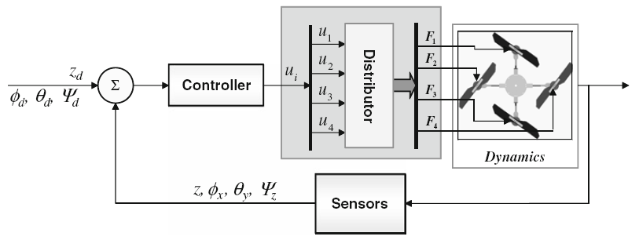

**Figure 3: Basic structure of the controller for the UAV**

To satisfy the conditions where equation 32 is valid, *φ* and *θ* have to stay near the neutral positions, which are zeros.

# Modeling the Quadrocopter

This part will mainly talk about the aforementioned dynamic model in embedded system term.

As mentioned in (2), there are three variables that need to be considered in INS1 system: 𝜓 (yaw), 𝜃 (roll), 𝜑(pitch). Hence, measuring the change in those angle and control the speed of each motor are important.

There are many approach to archive this, and the most commonly used method is using a strap-down Inertial Measurement system, where body frame are axisymmetric with the Quadrocopter body as in figure 4.

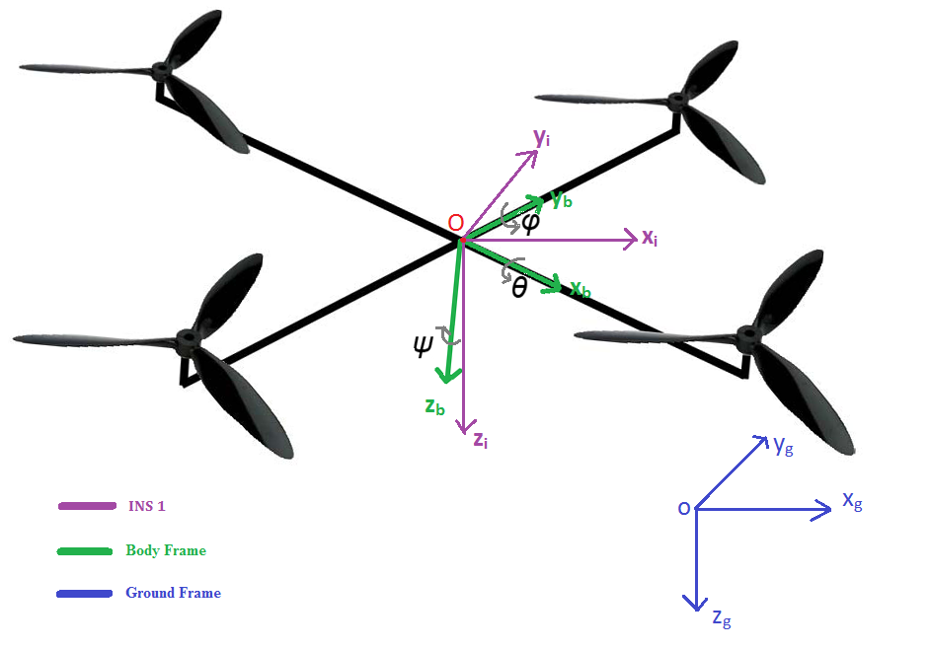**Figure 4: Strap-down Inertial Measurement system.**

## IMU

A good and cheap choice for small UAV system nowadays is the Inertial Measurement Unit (IMU)[13]. It is a packet comes with an accelerometer, a gyroscope, a magnetometer and a barometer. For the prototyped version of Quadrocopter which is developed to evaluate rotational movement and altitude movement aspect, all of the sensors above are used which an exception of the magnetometer because of time issue.

Furthermore, the data that can be mined from an IMU are:

- Yaw angle.

- Pitch angle.

- Roll angle.

- Altitude in meter.

The question on how to get these data will be answered in the next sections.

## Euler angular movement measurement

Using a direction cosine transformation matrix with a little modification in "*Tilt Sensing using linear accelerometer*"[14] by Laura Salhuana, the body acceleration movements which is recorded by an Accelerometer sensor can be converted to Euler angular movements by the following equations:

𝜑 =(180/π) \* Arctan[ -Rx / SQRT(Ry2 + Rz2) ] (33)

𝜃 =(180/π) \* Arctan[ Ry/SQRT(Rz2 + µRx2) ] (34)

where Rx, Ry and Rz are acceleration movement on x, y, z vector, respectively. µ is a fraction of Rx2 that needed to be bigger than zero to prevent the denominator in equation (34) ever being zero.

Unfortunately, the Yaw angle cannot be able to calculate using accelerometer data.

Another approach to calculate Euler angles is using Gyroscope's data, which is just angular velocity. This approach is fairly simple: just integrate the instant angular changes over time.

𝜓 **=** (35)

𝜃 **=**  (36)

𝜑 **=**  (37)

The tested results of equations (33) to (37) are shown in the figures below:

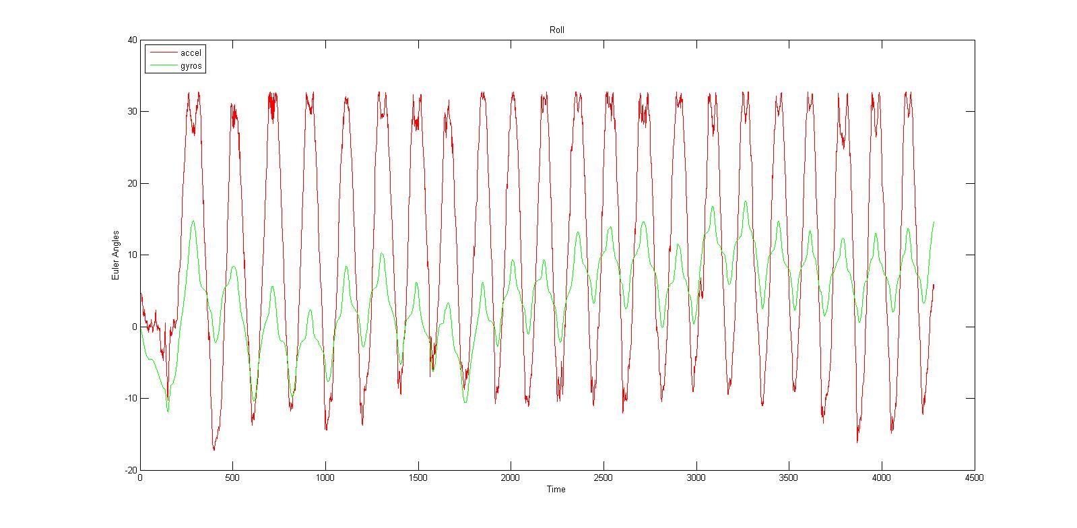

**Figure 5: Roll Angle**

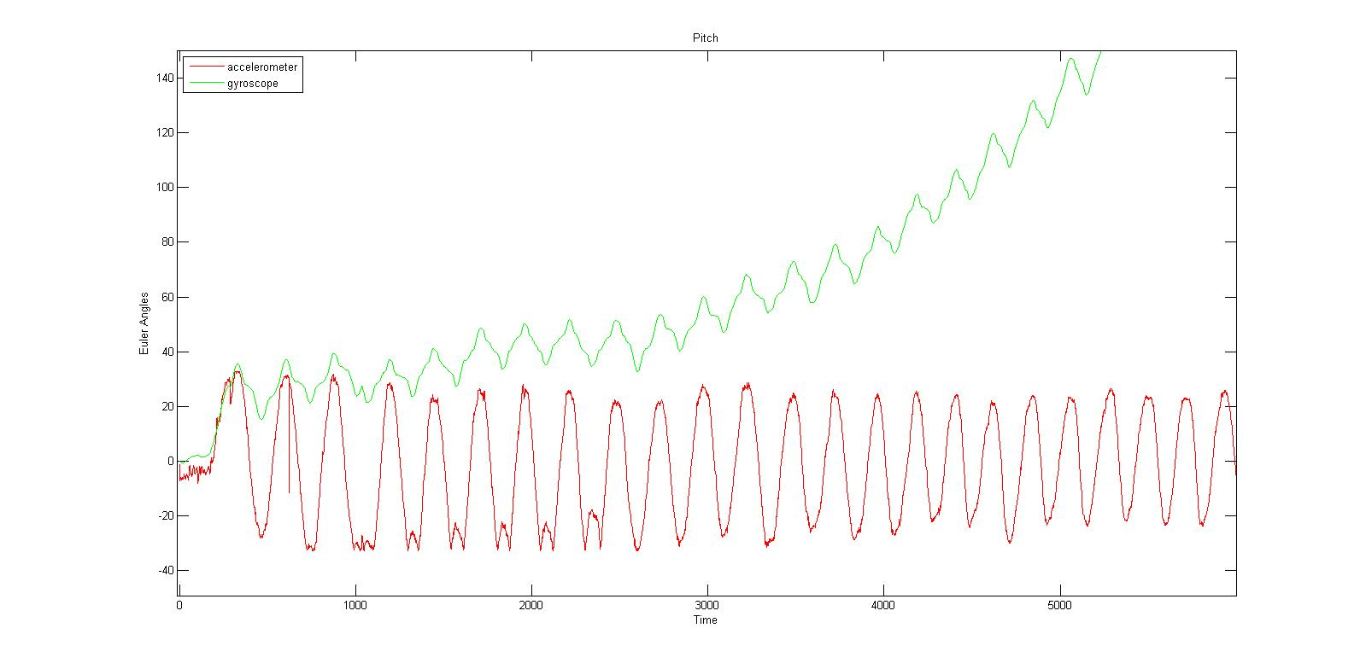

**Figure 6: Pitch Angle**

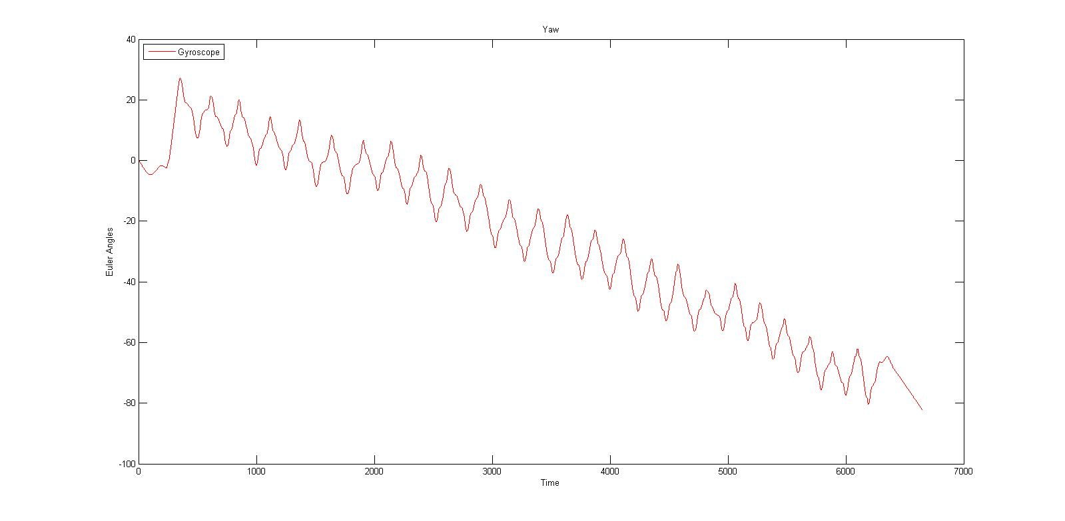

**Figure 7: Yaw Angle**

All of the testing setups are the same: keeping the body of the IMU oscillates around a point. However, the results do not seem to be good enough. The accelerometer calculated angles are too noisy and the Gyroscope calculated angles are drifted to much.

After a throughout investigation on the problem, the truth has been revealed:

- Due to the extremely sensitive characteristic of the gyroscope sensor, the noise in angular velocity data are generally unavoidable and when the gyro data is integrated, the noise will also be integrated together. Furthermore, the gyroscope has its limitation where the output is not a constant offset when it is in static condition. In fact, this value will keep changing especially when there is temperature change. This condition is called **drift**. Although the drifting is very small, when we are dealing with integration, even the smallest offset will cause the integrated data to grow to infinity. To cut the long story short, the angular movement calculated by Gyroscope data is nice at a moment but extremely inaccurate in a long run.

- In contrast, accelerometer data is quite good in a long run but fluctuating too much in a short period. The reason behind this is lying in the assumption of equation (23) and equation (24)which assumes the only force affect Accelerometer is Gravity Force. However, in operating environment, there are many other random forces that may be included in the calculated data such as wind, vibration... Therefore the angular movements measured by accelerometer have quite a lot of random noise.

A solution for this problem is proposed: mathematical Filters.

## Mathematical Filter

As mentioned above, angular data measured from Gyroscope is acceptable at a moment but become extremely inaccurate after being integrated. Naturally, a high-pass filter[15] can be applied to regulate the long-run data with reasonable values.

Nevertheless, the noisy characteristic of accelerometer's angular data can be adjusted with a low-pass filter[16], in which the signals that is much longer than the time constant pass through unaltered while signals shorter than the time constant a filtered out.

In the following figures, the test data in part 4.2 are recalculated using Low-pass and High-pass filter:

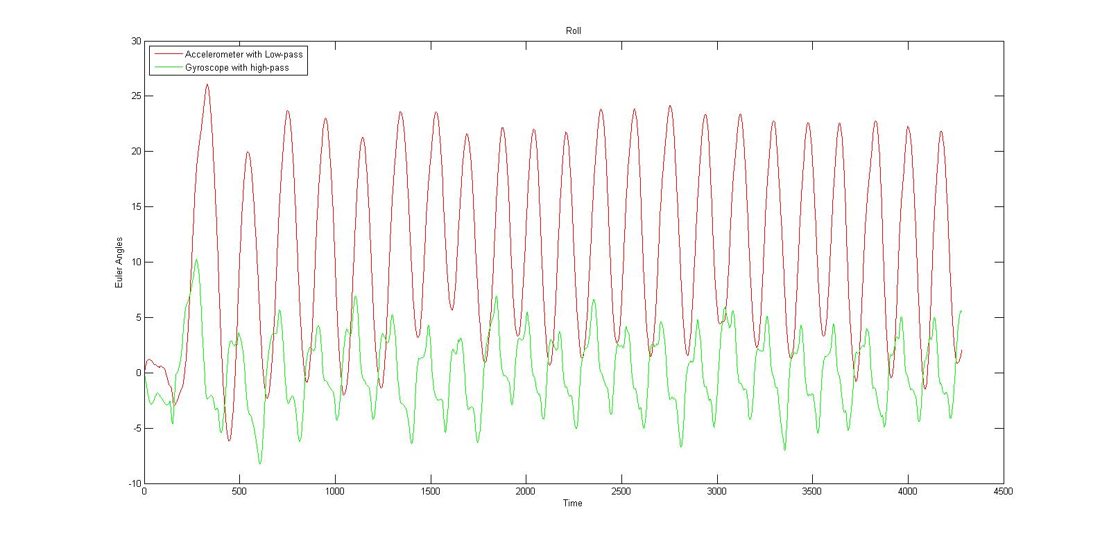

**Figure 8: Roll Angle with low-pass and high-pass filter.**

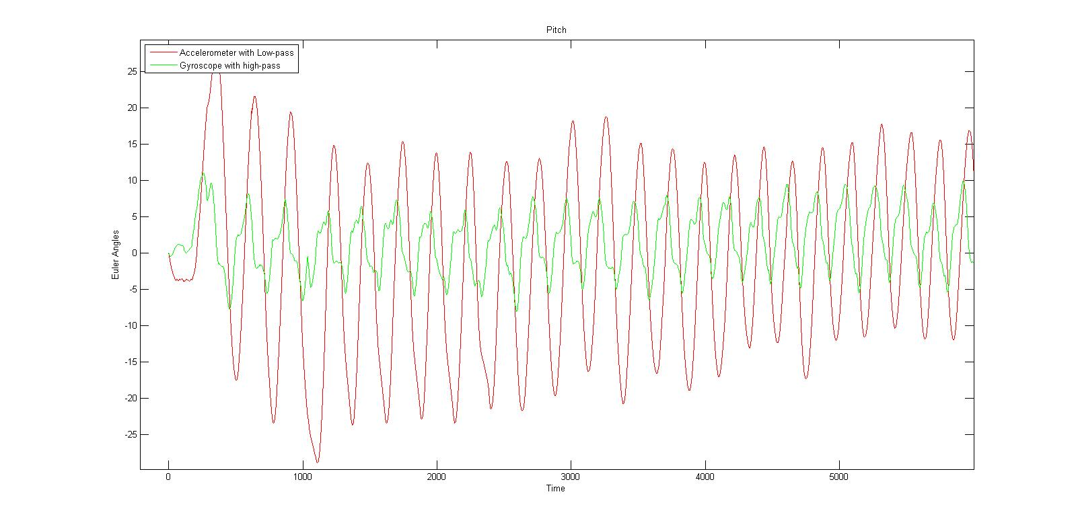

**Figure 9: Pitch Angle with low-pass and high pass filter.**

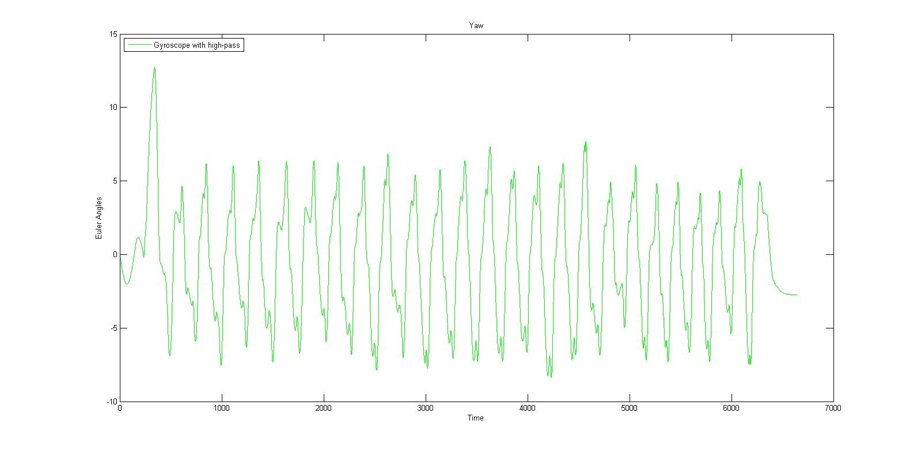

**Figure 10: Yaw angle with a high-pass filter.**

The results are became more reasonable after applying these filter now. However, the low-pass filter will increase the latency and slow down the response time of the measurement while high-pass filter require a lot of change in the input data to change its output a little bit and tend to forget prior output value quickly. Consequently, a data fusion filter of the two sensors sounded promising.

In this spectacular case, a Kalman filter is what the data need. However, implementing such a complex filter will be far too much for a regular MicroController to handle, an alternative solution has proposed: Complementary filter [17].

A Complimentary filter is just a fusion of a Low-pass and a High-pass filter with a mathematical expectation of influence between them. More information on this filter can be found in "*The Balance Filter*" by Shane Colton, MIT[18].

The figures below shown the result when applied Complementary filter to Pitch and Roll angles.

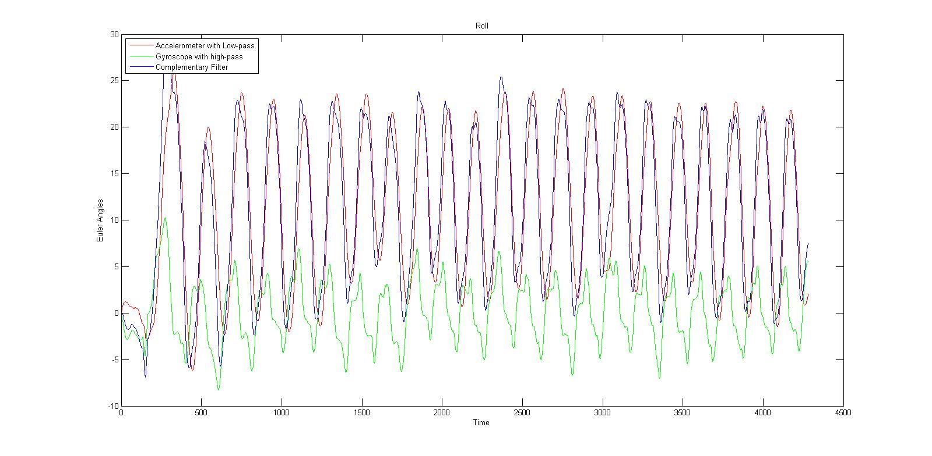

**Figure 11: Roll angle with Complementary, High-pass and low-pass filter**

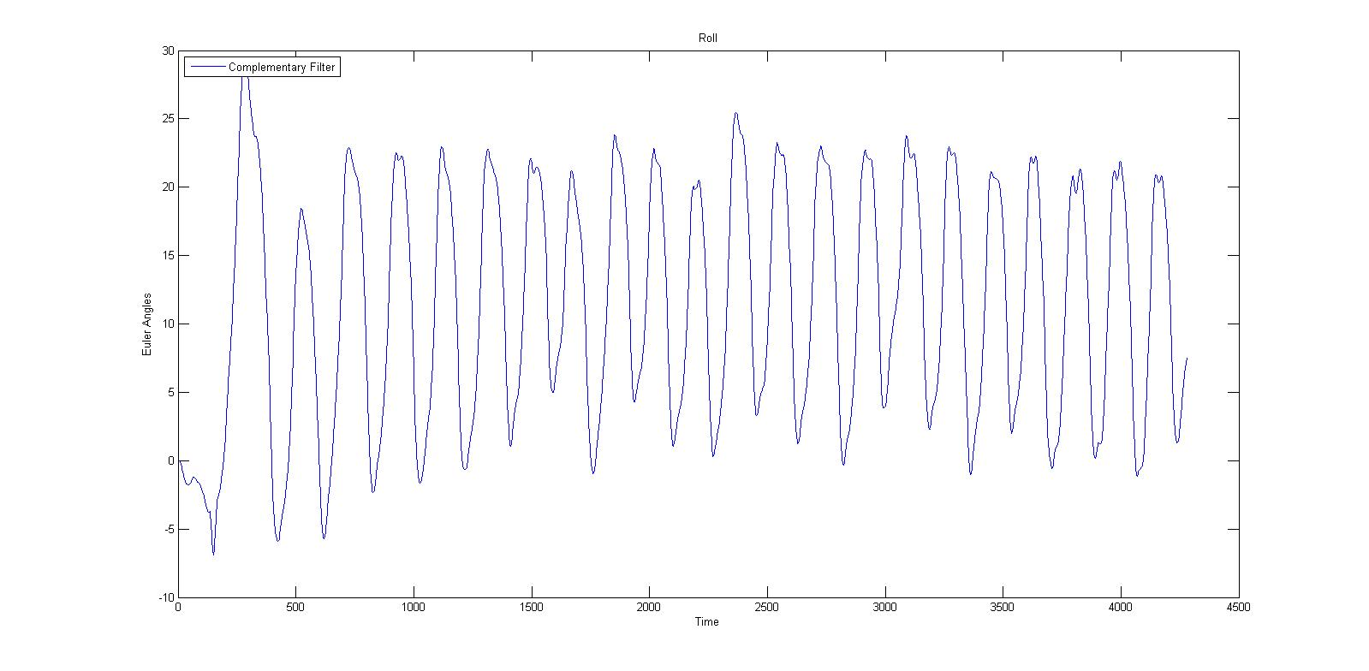

**Figure 12: Roll angle with complementary filter only**

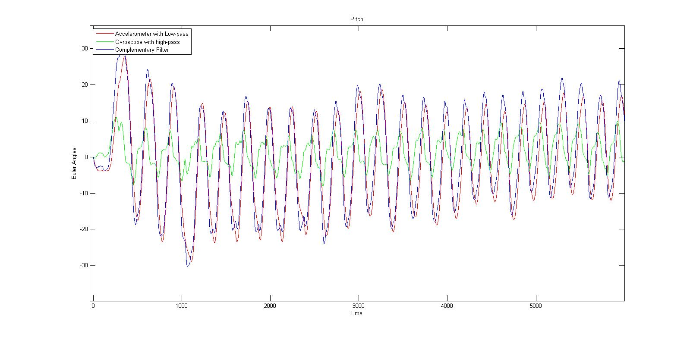

**Figure 13: Pitch angle with Complementary, High-pass and low-pass filter**

**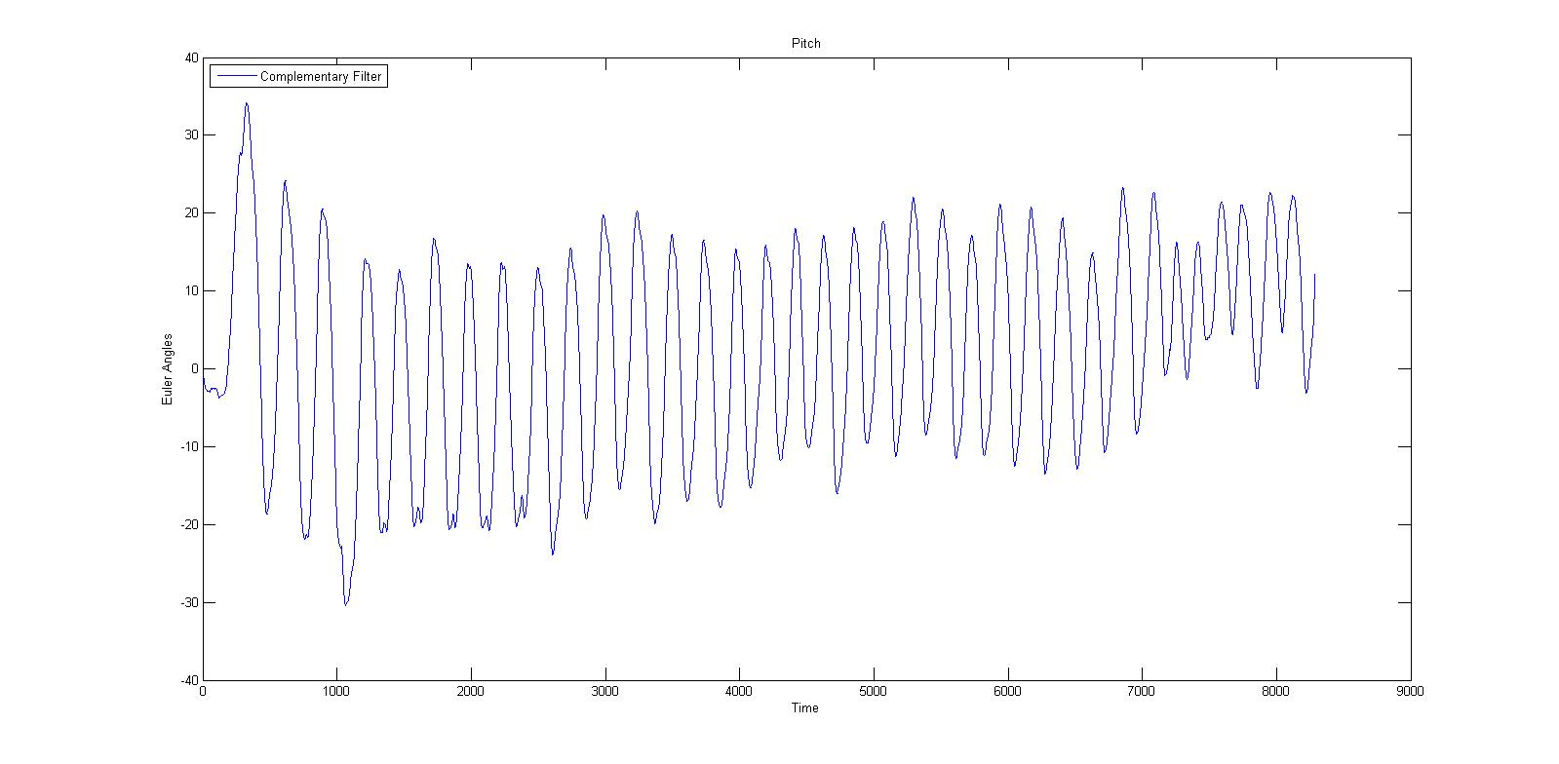**

**Figure 14: Pitch angle with Complementary filter only**

There is no complementary filter for yaw angle in this case because only gyroscope data is used in the calculation process. However, if a magnetometer sensor is implemented, the complementary filter for yaw angle could be used as well. Moreover, in this prototyped system, small drifts in yaw angle is acceptable since it will not affect the movement much.

## Altitude measurement

The altitude of an IMU can be measured with a barometer. In theory, with the pressure and temperature, current altitude compare with sea-level can be calculated. Figure below using the equation provided by manufacturer of BMP085 barometer to calculate height.

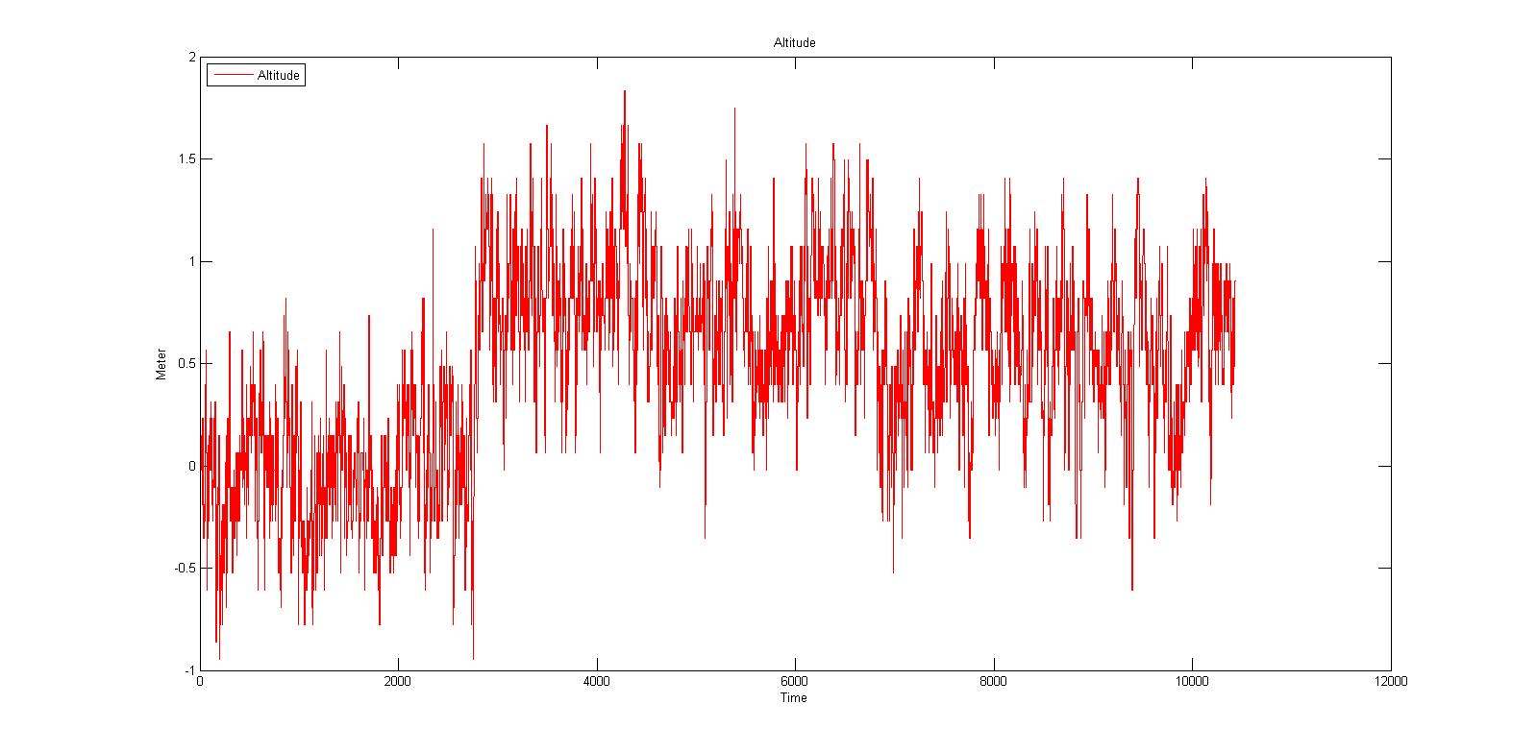

**Figure 15: Altitude measurement using barometer.**

The result reveals a noisy characteristic of this signal. There are many possible cause for this. A sudden change in temperature is one good example. In operating environment, temperature may varies in space.

To solve this problem, a simple Low-pass Filter has been applied. Despite the incorrect values a low-pass filter could lead, almost noise has been filtered out of the data. This results in a more meaningful form of data.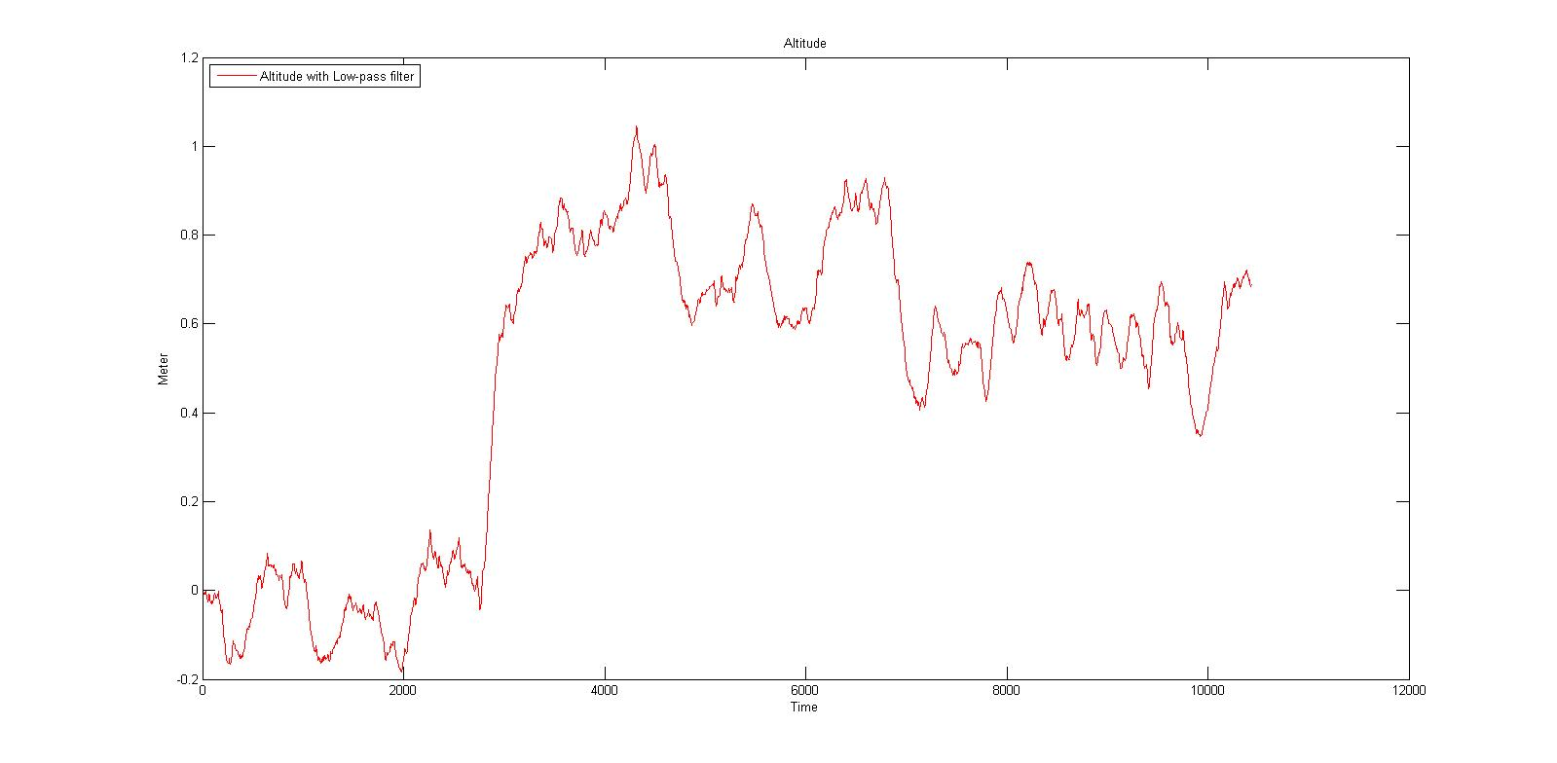

**Figure 16: Altitude measurement with Low-pass filter**

Even the data now seem to be less noisy, in fact, it still has an error of 0.5 m to 1m. Another method has to be suggested to correct this data. However, due to the shortage of study time, the team could not try any other method but this.

## PID Controller

A classic approach for a controller is using Proportional-Integral-Derivative (PID) control system. The PID controller is a closed-loop feedback system which will output a control signal *u* and receive feedback from the inertial sensors. The controller then calculated the difference between the desired position and orientation and the current position and orientation and adjusts *u* accordingly. The equation for a PID controller can be found in "*The PID Algorithm - how it work and how to tune it"*[19]*-*John A.Shaw is as follows:

u = Kpe(t) + Ki + Kd (38)

Define:

e(t) = ed(t) - ea(t) (39)

where ed is the desired condition and ea is the actual condition measured by sensors and e(t) is the difference (error) between the two at each individual time step.

The following dynamic equations of motion are rewritten from equation 32 in matrices.

+ ∆ = (40)

where the disturbance, ∆, is defined as:

∆ = (41)

where δi mainly come from the dynamic inconsistency. Hence, it does not give instability, but poor performance, which may violate the assumption, *φ* ≈ 0 and *θ* ≈ 0. This phenomenon can be resolved using Disturbance Observer control input. However, Disturbance Observer method will make the prototype Quadrocopter becomes too complex to be done in study period, therefore it is not discussed in this study. Moreover, the impact of lacking Disturbance Observer is still acceptable in the scope of this study.

Finally, the PID control system of the Quadrocopter can be derived from equation 30 to 40 as in the follow figure:

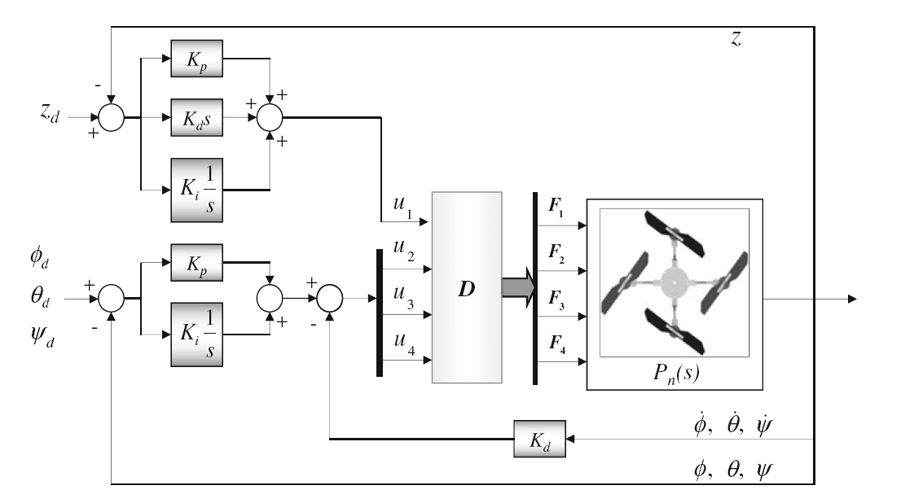

**Figure 17: PID controller for controlling the Quadrocopter.**

Nevertheless, this is just theory and it still makes no sense for software engineer. Therefore, a further explanation in software term will be discussed base on figure 17.

Firstly, the following equations are derived from equation 38 and 40 in discrete term:

u1 = Kp\*Ezn + Ki\*i\*dt + Kd\*dEz/dt (42)

u2 = Kp\*E𝜑n + Ki\*i\*dt + Kd\*d E𝜑' (43)

u3 = Kp\*E𝜃n + Ki\*i\*dt + Kd\*dE𝜃' (44)

u4 = Kp\*E𝜓n + Ki\*i\*dt + Kd\*dE𝜓' (45)

where Ez, E𝜑, E𝜃, E𝜓 are:

Ez = Ezd - Eza (45)

E𝜑 = E𝜑d - E𝜑a (46)

E𝜃 = E𝜃d - E𝜃a (47)

E𝜓 = E𝜓d - E𝜓a (48)

E𝜑', E𝜑', E𝜑' are angular velocity measured from Gyroscope.

Secondly, in a real Quadrocopter system, F1, F2, F3, F4 cannot be calculated because each motor has an unique motion equation that depends on the manufacture process or even the age of the motor. In addition, the speed of the motor should be controlled via an Electronic Speed Controller (ESC) system. In the prototype Quadrocopter, the ESCs is controlled via Pulse Width Modulation (PWM) method. This leads to the assumption that each PWM level will map to a force level of a motor.

PWM1 => F1,

PWM2 => F2,

PWM3 => F3,

PWM4 => F4

(49)

Finally, the following equation is derived from equation 22 and 49 for distributing inputs into four motors.

PWM1 = u1 + u3 + u4 (50)

PWM2 = u1 - u2 - u4 (51)

PWM3 = u1 - u3 + u4 (52)

PWM4 = u1 + u2 - u1 (53)

## PID Tuning

One of the most frustrate part in designing an embedded system is tuning the controller values. There are many approach to optimize those values. At first, the team chose a classical PID Tuning method: Ziegler-Nichols second method[20].

However, during the PID tuning process of the Quadrocopter, Ziegler-Nichols second method begins to reveal its weakness in this kind of system: there is no way to find a perfect Ultimate Gain because the Quadrocopter will never oscillate perfectly in operating environment which have too many other random forces.

The PID tuning process has to use another approach which is based on practical meanings of the PID controller:

|  |
| --- |
| Derivative term:  D = Kd (54)  The derivative of the process error is calculated by determining the slope of error over time and multiplying this rate of change by the derivative gain Kd. It slows down the rate of change of the controller output, which is used to control the magnitude of the overshoot produced by the integral component and improve the combined controller-process stability.  This leads to a hypothesis that if only Derivative term with a big enough Kd is used in the Controller system, the Quadrocopter will likely to stay in the approximately same position given how many time it is affected by an external force. The faster the rate of change is the faster the derivative term react, and if the changing rate is low, so the reaction. (I) |
| Proportional term  P = Kpe(t) (55)  The proportional term produces an output value that is proportional to the current error value. The proportional response can be adjusted by multiplying the error by a constant *Kp*. A high proportional gain results in a large change in the output for a given change in the error. If the proportional gain is too high, the system can become unstable and may oscillate.  An important characteristic of this term is the high speed of change given a high enough gain value. This is called a fast respond. (II) |
| Integral term  I = Ki (56)  The contribution from the integral term is proportional to both the magnitude of the error and the duration of the error. The integral in a PID controller is the sum of the instantaneous error over time and gives the accumulated offset that should have been corrected previously. The accumulated error is then multiplied by the integral gain (Ki) and added to the controller output.  The most important characteristic of this term is: it will always try to get the error be equal to zero. (III) |

With the characteristics I, II and III, a good PID tuning strategy for Quadrocopter system can now be illustrated by three steps:

**Step 1**: Tuning only the Derivative Term by setting Ki and Kp to zeros then slowly increasing Kd until the Quadrocopter keeps its angle/altitude in a specific level without moving or oscillating around. If Kd is high enough, the Quadrocopter will return to its specific level aggressively after being pushed/pulled suddenly.

**Step 2**: Tuning Proportional Term by setting Ki to zero but still use Kd which was found in step 1, then slowly increasing Kp. Please keep increasing Kp until you experience a fast and stable respond from the Quadrocopter toward the Set-point. May be the Derivative Term you found on the previous step will try to slow down the rate of change made by Proportional Term, but it is just because Kp is not high enough and you can keep increasing it. When to stop this step is just your decision in real practice.

**Step 3**: Tuning Integral Term by slowly increasing Ki until the Quadrocopter reach its Set-point with a reasonable speed, which only can be evaluated in real practice. A too high Ki value could make the Quadrocopter become extremely unstable under certain circumstance.

Pros and cons of this tuning strategy:

|  |  |
| --- | --- |
| Pros | Cons |
| - Easier to apply than any classic PID tuning method.  - Ensure the safety of the Quadrocopter during the tuning of Proportional Term. | - Cannot be applied in mass production.  - Depend much in experience of tester.  - Is not a mathematical recommended method for tuning PID. |

Conclusion: This strategy is a good start for beginner, however it will soon become unusable when it comes to mass production of Quadrocopter. Another method which involves more complex math should be applied to tune PID in the future.

The following figures illustrate the result of PID tuning using this strategy with Pitch angle:

+++++++++++++

+++++++++++++

+++++++++++++

+++++++++++++

+++++++++++++

## System design

The prototyped Quadrocopter in this study is controlled via Bluetooth by an Android Phone. The schematic view and control flow of the embedded controller is as below:

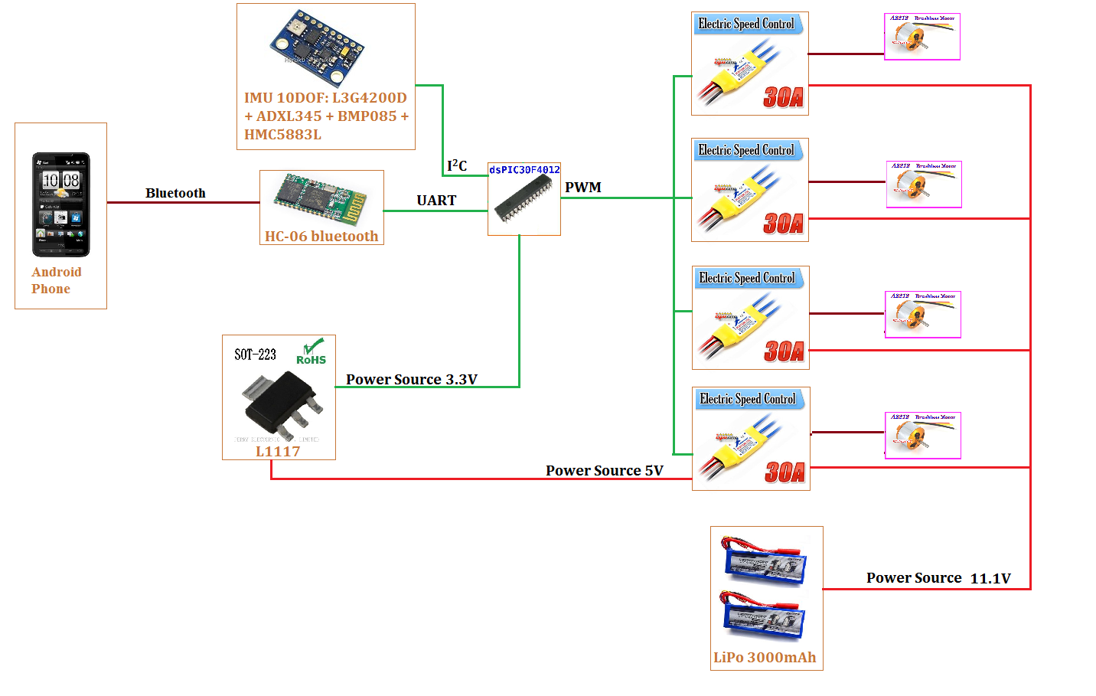

**Figure 18: Schematic view of the embedded controller.**

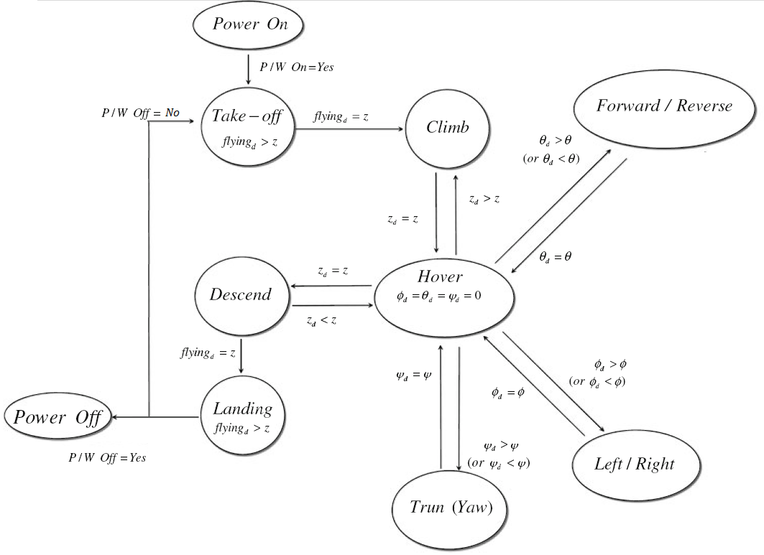

**Figure 19: Control flow of the controller**

The prototyped Quadrocopter:

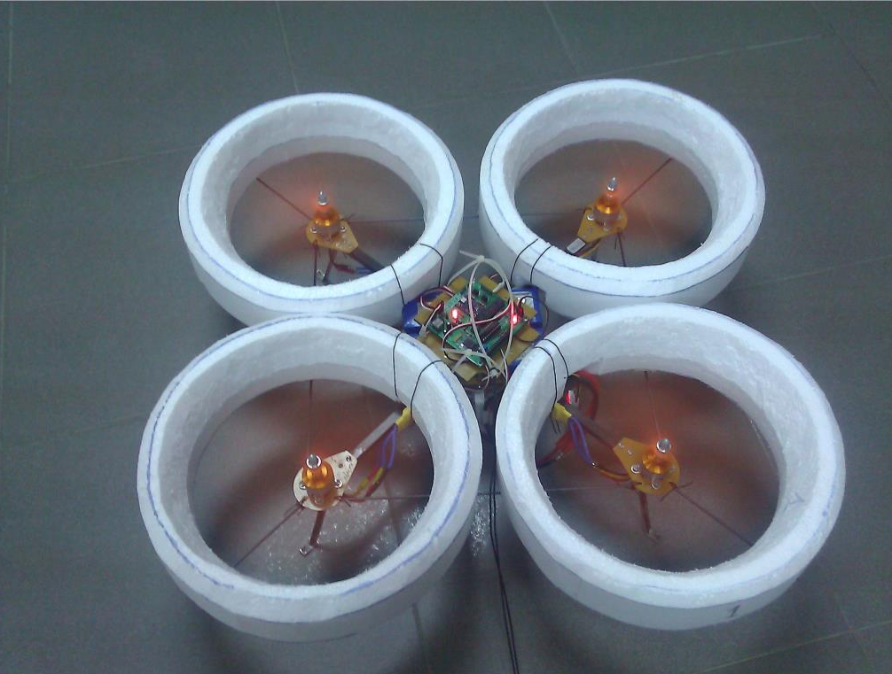

**Figure 20: The Prototyped Quadrocopter**

# Experimental results

## Experimental setup

Figure 20 shows the fabricated Quadrocopter for purpose of testing its flight capability regards to the theory. It has 4 rigid propellers driven by 4 brushless motor mounted at the end of a crossing body frame. An IMU which has a accelerometer, gyroscope and barometer is equipped to the main circuit for sensing angular and altitude changes.

Table 1 gives the specification and parameters of the Quadrocopter frame:

|  |  |
| --- | --- |
| Description | Value |
| Weight | 1.4 Kg |
| Diameter | 490 mm |
| Height |  |
| Distance between the motor and the Center of Mass | 220mm |
| Propeller | 8" x 4" |

**Table 1: Quadrocopter frame specification**

Figure 18 shows the schematic view of the embedded controller using a dsPIC30F4012 MicroController.

Figure 19 shows the control flow of the robot system. All flying movement except for take-off start on the hovering state, and if a certain movement is finished, it will come back to the hovering state again.

The environments for experiments are both indoor and outdoor.

## Experiments and results

Figures ....... show the experimental results for indoor hovering performance in term of roll, pitch, yaw angles and altitude.

+++++++

+++++++

+++++++

+++++++

Figures ....... show the experimental results for outdoor hovering performance in term of roll, pitch, yaw angles and altitude.

+++++++

+++++++

+++++++

+++++++

The results declare that the proposed algorithm and theory for both angular movements and altitude control of the Quadrocopter work well as expected.

# Conclusion

In this study, a low-cost prototyped Quadrocopter is developed to evaluate its flight capability using a proposed control theory and algorithm. The rigorous dynamic models of a Quadrocopter were obtained both in the reference and body frame coordinate systems using the quasi-Lagrange equation. The experiments were carried out to show the validity of the proposed control algorithm. The results show the angular movements and height control results are as stable as expected.

# List of References

|  |  |
| --- | --- |
| **No.** | **Source** |
| [1] | "**UAV**" - http://en.wikipedia.org/wiki/UAV |
| [2] | "**Quadrotor**" - http://en.wikipedia.org/wiki/Quadrocopter |
| [3] | "**Electronic speed control**" - http://en.wikipedia.org/wiki/Electronic\_Speed\_Controller |
| [4] | “**PID Controller**” - http://en.wikipedia.org/wiki/PID\_controller |
| [5] | Jinhyun Kim, Min-Sung Kang and Sandeok Park (2009) - "***Accurate modeling and robust hovering control for a Quad-rotor VTOL aircraft***". |
| [6] | Albert Einstein (1920) - "***Relativity: The Special and General Theory*** ". |
| [7] | "**Euler Angles**" - http://en.wikipedia.org/wiki/Euler\_Angles |
| [8] | *Tutorials, Magnet Lab U.*. National High Magnetic Field Laboratory. Retrieved 2008-04-30 - " ***Right and left hand rules*** ". |
| [9] | Fossen, T.I., Wiley, New York (1994) ***" Guidance and Control of Ocean Vehicles***". |
| [10] | Meirovitch, L., Wiley, New York (1990) " ***Dynamics and Control of Structures* ".** |
| [11] | Weyl, Hermann , Princeton: Princeton University Press. ISBN 0-691-02374-3. "***Symmetry*** " |
| [12] | " **Hamiltonian (control theory)"** - http://en.wikipedia.org/wiki/Hamiltonian\_(control\_theory) |
| [13] | "**Inertial Measurement Unit**" - http://en.wikipedia.org/wiki/Inertial\_Measurement\_Unit |
| [14] | Laura Salhuana , AN (2012), Frescale Semiconductor - "***Tilt Sensing using linear accelerometer***" |
| [15] | "**High-pass Filter**"- http://en.wikipedia.org/wiki/High-pass\_filter |
| [16] | "**Low-pass Filter**"- http://en.wikipedia.org/wiki/Low-pass\_filter |
| [17] | "**Kalman Filter Vs Complementary Filter**" - http://robottini.altervista.org/kalman-filter-vs-complementary-filter |
| [18] | Shane Colton, MIT (2007) - "***The Balance Filter***" |
| [19] | John A.Shaw ,Process Control Solution (2001) -"***The PID Algorithm - how it work and how to tune it****"* |
| [20] | Ziegler, J.G and Nichols, N. B. (1942). "**Optimum settings for automatic controllers***"*. Transactions of the ASME. **64**. pp. 759–768. |
|  |  |
|  |  |