

FUFO

System Architecture

Project Code: FUFO

Document Code: FUFO_SA >– v1.1

**Hanoi, August 6th, 2012**

Record of change

*A - Added M - Modified D - Deleted

|  |  |  |  |  |
| --- | --- | --- | --- | --- |
| Effective Date | Changed Items | A* M, D | Change Description | New Version |
| Aug 6th | The whole document | A | Newly created | 1.0 |
| Aug 7th | Software architecture | A | Added | 1.1 |
|  |  |  |  |  |
|  |  |  |  |  |
|  |  |  |  |  |
|  |  |  |  |  |
|  |  |  |  |  |
|  |  |  |  |  |
|  |  |  |  |  |
|  |  |  |  |  |
|  |  |  |  |  |
|  |  |  |  |  |
|  |  |  |  |  |
|  |  |  |  |  |
|  |  |  |  |  |
|  |  |  |  |  |

SIGNATURE PAGE

**ORIGINATOR:** Phongvm August 6th, 2012

Project Manager

**REVIEWERS:** YenTT

Quality assurance

**APPROVAL:** HungPD

Supervisor / Professor of FPT University

TABLE OF CONTENTS

1 Introduction 5

1.1 Purpose 5

1.2 Scope 5

1.3 Definitions, Acronyms and Abbreviations 5

1.4 References 6

2 Hardware architecture 7

2.1 Quadrocopter 7

2.2 Mechanical design 8

2.3 System overview 9

2.4 Hardware components 9

2.5 Hardware context 11

3 Software Architecture 12

3.1 Use case model of the whole system 12

3.2 Component model of the whole system 13

3.3 Finite state machine 17

4 Architectural Goals and Constraints 21

5 Quality 21

6 Other Considerations 21

# Introduction

## Purpose

This document provides a comprehensive architectural overview of the system of FUFO project, using a number of different architectural views to depict different aspects of the system. It is intended to capture and convey the significant architectural decisions that have been made on the system, including both hardware and software.

## Scope

This document describes the highest level architecture of the software and hardware regards to the System Requirement Specification document. However, the mechanical design will be specified as clearly as possible. The following aspects of the system will be discussed:

- Hardware:

+ Quadrocopter overall design and guides.

+ A clearly described Mechanical design.

+ A list of hardware components with little descriptions.

+ A context diagram of the influenced hardware components.

- Software:

+ A component diagram of the whole software system that shown the connection of each independent software.

+ Component diagrams of every independent software.

+ Descriptive specification of each independent software.

## Definitions, Acronyms and Abbreviations

[This subsection should provide the definitions of all terms, acronyms, and abbreviations required to properly interpret the **Software Architecture Document**.  This information may be provided by reference to the project Glossary.]

|  |  |
| --- | --- |
| Acronym/Abbreviation | Definition |
| AOC | Application on Personal computer |
| AOP | Application on Phone |
| FUFO | FPT Unidentified Flying Object |
| IMU | Inertial Measurement Unit |
| SA | System Architecture |
| 10DOF | Ten Degree Of Freedom |
| FSM | Finite State Machine |
| UART | Universal Asynchronous Receiver/Transceiver |
| PWM | Pulse Width Modulator |
| SPI | Serial Peripheral Interface |
| I2C | Inter-Integrated Circuit |
| ESC | Electronic Speed Controller |
| VCC/VDD | IC power Supply Pins |
| I/O Pin | IC Input/Output Pin |
| TCP/IP | Transmission Control Protocol / Internet Protocol |
| UDP / TP | User Datagram Protocol / Internet Protocol |

## References

[This subsection should provide a complete list of all documents referenced elsewhere in the **Software Architecture Document**. Each document should be identified by title, report number (if applicable), date, and publishing organization. Specify the sources from which the references can be obtained. This information may be provided by reference to an appendix or to another document.]

# Hardware architecture

## Quadrocopter

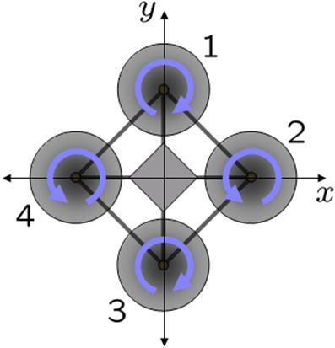

Figure 2.1.1

This Quadrocopter is a multicopter lifted and propelled by four motors. The motors are mounted on the same plane, forming a square.

As shown in **Figure 2.1.1,** the rotational direction of the four motors is not the same. Two opposite motors are having the same rotational direction while the other two are inversed. This design is necessary to compensate the angular acceleration generated by the motors. This way the total angular acceleration should be zero given the same speed of the propellers, ensure the "stable" characteristic of this flying structure.

The flight dynamic of a Quadrocopter is the rotation in three dimension of the plane about its center of mass, all of which depends solely on the momentum generated by the motors. More information on this matter can be found in the Quadrocopter Hovering Capability report.

## Mechanical design

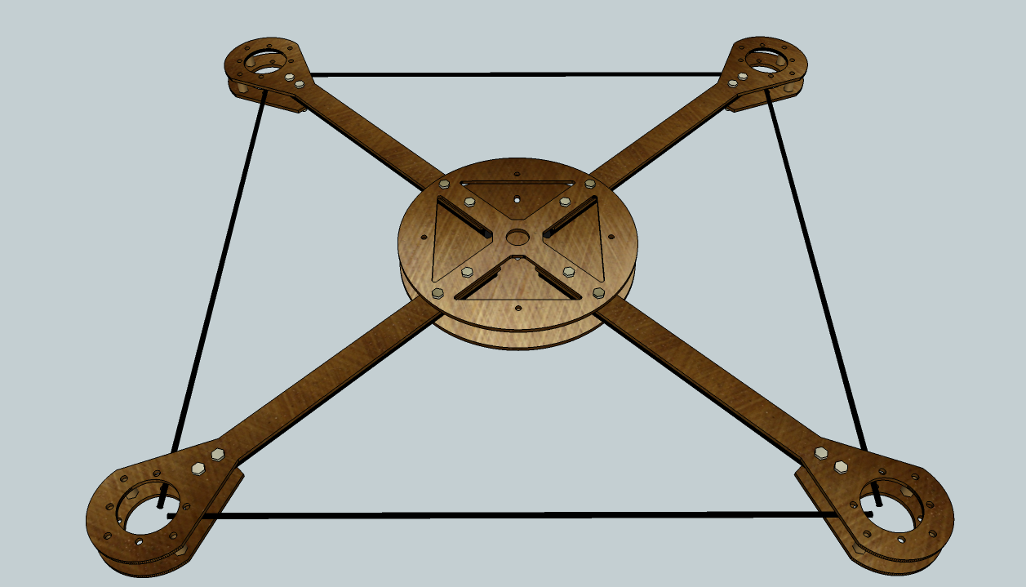

Figure 2.2.1

A 3D mechanical design has been sketched as shown in **Figure 2.2.1**. The main materials are being used in this design are 2mm Glass Fiber plates and 10mm Carbon Fiber tubes. The latter can be also replaced with Glass Fiber tubes in case of scarcity of Carbon Fiber tubes in Vietnam. The exact dimensions of each component in this design can be found in the Mechanical Design document in AutoCad format.

A realized version of this design may not have to be exactly the same in every aspect of the sketched design because of the poor capability in mechanic of software student. Due to the dynamic nature of the Quadrocopter, the hovering capability will not be affected if the moment arms are remained the same.

## System overview

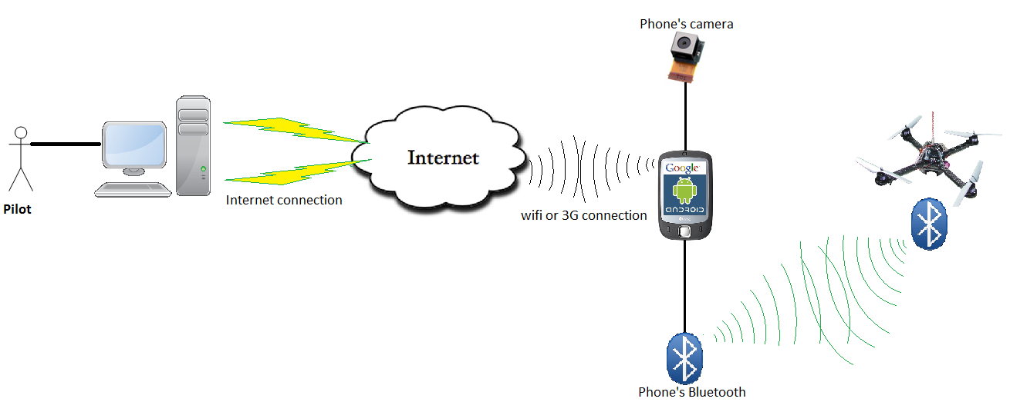

Figure 2.3.1

Figure above shows the context of the whole system.

## Hardware components

|  |  |  |  |
| --- | --- | --- | --- |
| Component Name | Quantity | Interface | Descriptions |
| dsPIC30f4012 | 1 | 3 PWM Generators  5 Timers  2 UART Interfaces  1 SPI/I2C Interface  40 Pins in total | - 16-bit wide data path.  - 48 Kbytes on-chip Flash program space.  - Up to 30 MIPs operation.  ­- 16 x 16-bit working register array. |
| Gyroscope L3G4200D | 1  (IMU Unit) | I2C | - 16 bit-rate value data output  - Integrated low- and high-pass filters with user selectable bandwidth  - supply voltage: 2.4 V to 3.6 V  - Working temperature range: -40 to +85 Celsius degree.  - 3 Dimensions Euler angle Velocity. |
| Acceleration ADXL345 | I2C | - 3-axis accelerometer.  - Measurement at up to ±16 *g*.  - supply voltage: 2.4 V to 3.6 V |
| Barometer BMP085 | I2C | - Pressure range: 300 - 1100 hPa.  - supply voltage: 2.4 V to 3.6 V |
| L1117 | 1 | VCC/VDD | - 3.3v Regulator.  - Input voltage up to 15V. |
| 74HC245 | 1 | I/O pins | - For communication between 5V LCD and 3.3V Microcontroller. |
| LCD 16x2 5V | 1 | I/O pins | - need 74HC245 to communicate with Microcontroller. |
| HC-06 Bluetooth module | 1 | UART | - supply voltage: 2.4 V to 3.6 V |
| HW30A ESC | 4 | PWM | - Motor speed controller module.  - Can provide a 5V 1A power source. |
| 1400Kv Motor | 4 | Indirect PWM via ESC |  |
| 8x4 Propeller | 4 |  | - 2 normal and 2 inverse |
| 3S1P 3000mAh LiPo Battery | 2 | Power source | - Need to be parallel connected to form a 3S2P battery system. |
| Android 2.2 phone | 1 | Bluetooth | - Has a 320x240 image supported camera.  - Has a 2.0 Bluetooth module.  - Has Wifi connection. |

Table 2.4.1

## Hardware context

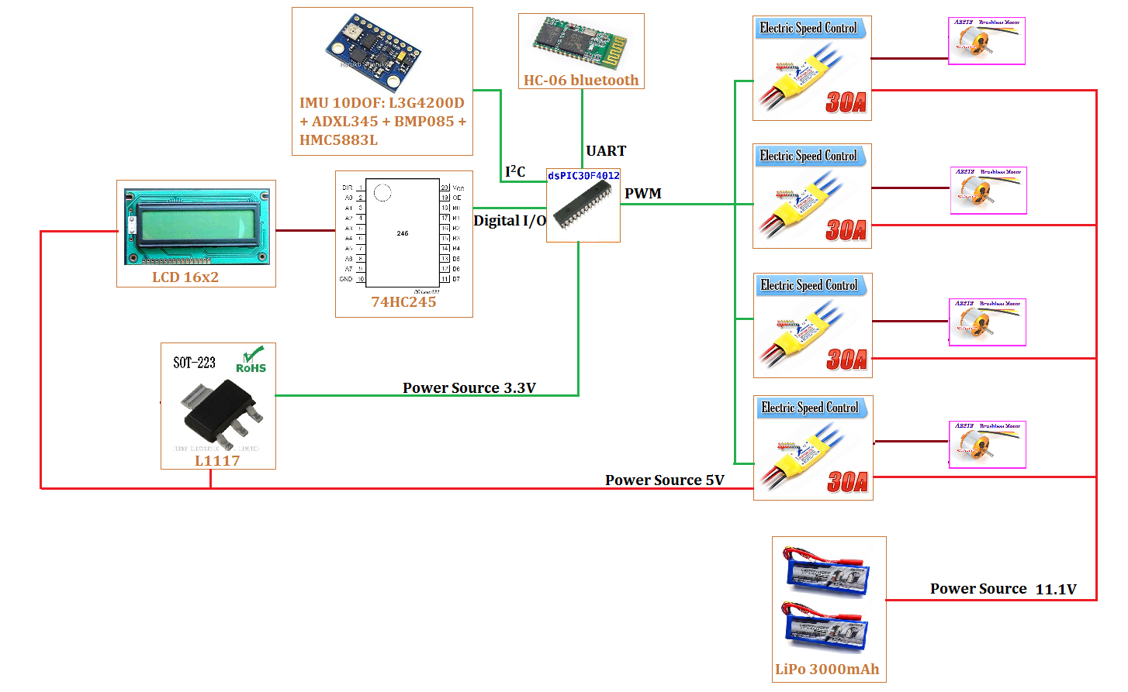

Figure 2.5.1

Context of the FUFO Quadrocopter has been shown in **figure 2.5.1**. The electronic schematic must be designed from this context.

# Software Architecture

## Use case model of the whole system



## Component model of the whole system

It is clear to see that there are three big software components for this system:

- The Application on PC.

- The Application on Phone.

- The firmware of Quadrocopter.



Figure 3.2.1

The diagram below presents a more detailed view of the system regards to the Component model:

**Figure 3.2.2**

AOP and AOC contain the following components:

Video Control: use to control streaming video from AOP to AOC. It uses camera on Android phone to record video and send frames to AOC by UDP protocol.

Command Control: use to control command from AOC to AOP. It receives commands from users via keyboard and sends these commands to AOP through TCP protocol. This AOP is also send commands to Quadrocopter via Bluetooth why receiving commands from AOC.

Status Control: use to control status sent from Quadrocopter to AOP via Bluetooth and from AOP to AOC via TCP protocol. These statuses will be shown on user screen.

These components on AOP application and on AOC application are classes can work independent with other components. Component on two applications communicate together by their instance component.

The following activity diagrams illustrate the activity of every set of component in AOP and AOC:

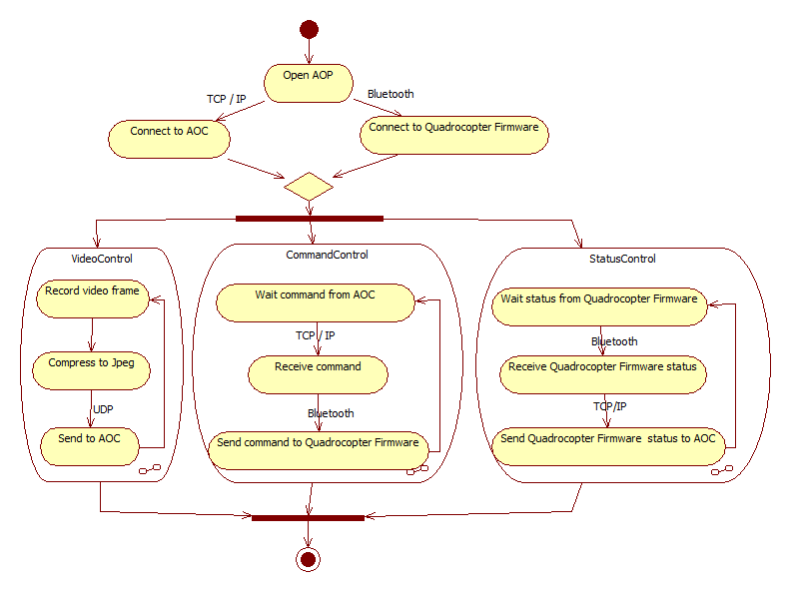

**Figure 3.2.3**

Three components on AOP application is run by three threads work parallel and independent.

VideoControl thread: use to control video. After record video frame from camera phone, it will compress this frame to JPEG type, packages it, uses Datagram Socket to send to AOC, then return record other video frame.

CommandControl thread: use to control command. It waits commands from AOC via TCP protocol and sends these commands to Quadrocopter via Bluetooth. It uses same socket with thread control status.

StatusControl thread: use to control status. It waits status from Quadrocopter via Bluetooth and sends to AOC via TCP protocol.

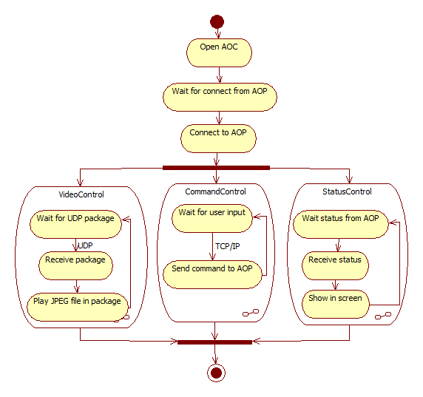

**Figure 3.2.4**

Three components on AOC application is run by three threads work parallel and independent.

VideoControl thread: use to control video. It waits UDP package from AOP, then gets picture frame from package and show it on screen.

CommandControl thread: use to control command. It waits commands from users via keyboard and then sends it to AOP via TCP protocol.

StatusControl thread: use to control status. It waits status from AOP and shows it on screen. It uses same socket with thread command control to receive status via TCP protocol.

## Finite state machine

FSM of the whole system is described in the follow diagram:



**Figure 3.3.1**

However, due to the nature of each component in the system, they will have their own separate FSM, most of which share some similarities after the state "Connecting".

The diagram below shows the FSM of AOP component:



**Figure 3.3.2**

The diagram below show the FSM of AOC Component:



**Figure 3.3.3**

The diagram below show the FSM of Quadrocopter Firmware Component:



**Figure 3.3.4**

# Architectural Goals and Constraints

Safety of the system is one of the most concerned issues in the development process of this system. Every design and tool that involved in the development process has to be clarified by all team members and supervisors.

# Quality

In this system, reliability and safety has a significance impact on the performance. The system must be able to maintain its hovering state in normal condition. In extreme condition, a landing state has to be carefully implemented to reduce the damage at maximum possible.

# Other Considerations

Other considerations will be classified during the development process.