**Feasibility report:**

**Module Bluetooth HC-06**

**Author: Vũ Minh Phong**

# Overall module Bluetooth HC-06:

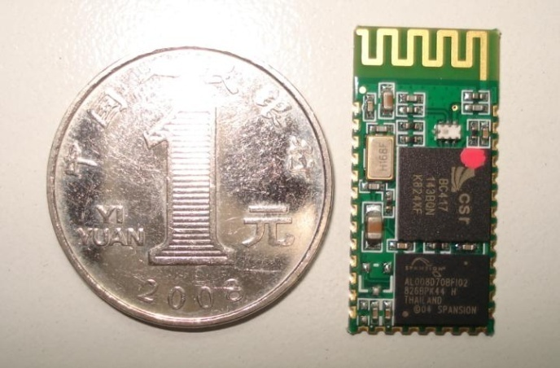 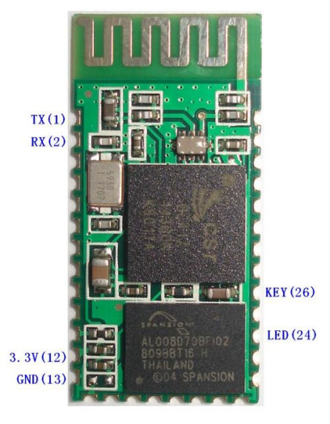

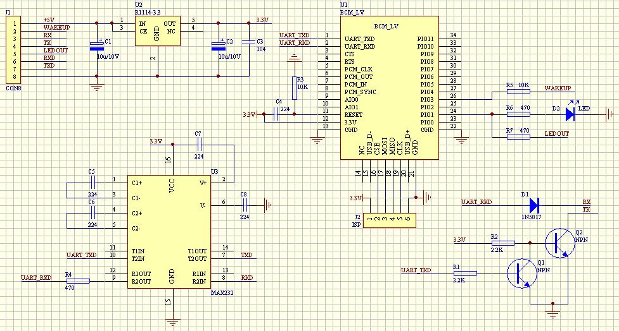

Feature:

* Use the CSR Bluetooth chip, compatible with the Bluetooth V2.0 protocol
* Slave
* Operating Voltage 3.3V
* Adjustable baud rate : 1200，2400，4800，9600,19200，38400，57600，115200
* Size: 28mm x 15 mm x 2.35mm
* Operating Current 40 mA
* Sleep Current < 1mA
* Program with AT command language
* UART interface
* Range 30ft ~ 9,1m
* Made in China

Price: 280.000 VND

# Why it is suitable for FUFO project:

What is expected in FUFO project:

* Use a Bluetooth module to establish UART connection between Android phone and MicroProccessor.
* 10m range is enough.
* Baud rate = 9600
* Small size.
* UART interface

What module HC-06 provide:

* Use the CSR Bluetooth chip, compatible with the Bluetooth V2.0 protocol
* Adjustable baud rate : 1200，2400，4800，9600,19200，38400，57600，115200
* Range ~9.1m
* Size: 28mm x 15 mm x 2.35mm
* Program with AT command language
* UART interface
* The only Bluetooth module can be found in Vietnam market at this time.

# How to use:

## 1. Default setting of HC-06:

 Slave, 9600 baud rate, N, 8, 1. Pincode 1234

## 2. AT Command:

After connect HC-06 module with the MicroProcessor, we can send the AT Commands to HC-06 module through UART interface to control it. These are the basic commands:

* **Communications Test :**

Sent : AT

receive : OK

* **Change baud rate :**

Sent : AT+BAUD1

receive : OK1200

Sent : AT+BAUD2

receive : OK2400

1---------1200  
2---------2400  
3---------4800  
4---------9600  
5---------19200  
6---------38400  
7---------57600  
8---------115200

Baud rate setting can be save even power down.

* **Change Bluetooth device name:**

Sent : AT+NAMEdevicename

receive : OKname

(devicename is the name you want the device to be , and it will be searched with this name)

Name setting can be save even power down.

* **Change Pincode:**

Sent : AT+PINxxxx

receive : OKsetpin

(xxxx is the pin code you set)

Pin code can be save even power down.