

FPT UNIVERSITY FLYING OBJECT
DETAIL DESIGN DOCUMENT
Class design

Project Code:
Document Code: FUFO-DD – v.1.0.1

Ha Noi, July 08, 2012
Record of change
*A - Added M - Modified D – Deleted
Effective Date | Changed Items | A*  M, D | Change Description | New Version
08/07/2012 | Create new document | A |  | 1.0.1

SIGNATURE PAGE

ORIGINATOR: NguyenLK 08/ 07/ 2012
Developer

REVIEWERS: <Name> <Date>
<Position>

<Name, if it’s needed> <Date>
<Position>

APPROVAL: <Name> <Date>
<Position>

TABLE OF CONTENTS
1 Introduction 5
1.1 Purpose 5
1.2 Definitions, Acronyms and Abbreviations 5
2 COMMON package and mechanism 6
2.1 Application on Computer 6
2.1.1 Class diagram 6
2.1.2 CommandControl class 8
2.1.3 Control class 10
2.1.4 AOC class 11
2.1.5 AILabel class 14
2.1.6 HeightLabel class 15
2.1.7 InstrumentControl class 15
2.1.8 StatusControl class 16
2.1.9 StatusMessage class 18
2.1.10 VideoControl class 20
2.2 Application on Phone 22
2.2.1 Class diagram 22
2.2.2 Control class 23
2.2.3 SettingActivity class 24
2.2.4 ControlActivity class 26
2.2.5 CameraPreview class 28
2.2.6 StatusControl class 30
2.2.7 CommandControl class 32
2.3 Error, exception handling 35
2.4 Log, trace and debug 35
3 Diagrams 36

Introduction

Purpose
This document provides a class detail design of the system of FUFO project, including detail of all class of the system. It is used by developers to review all functions more evidently to prevent misunderstanding about system. Moreover, it is used for unit test, all functions have to map with this document.

Definitions, Acronyms and Abbreviations
Abbreviations | Description | Comment
AOP | Application on phone
AOC | Application on computer
Firmware | Firmware of FUFO
TCP | Transmission Control Protocol
UDP | User Datagram Protocol

COMMON package and mechanism

Application on Computer

Class diagram
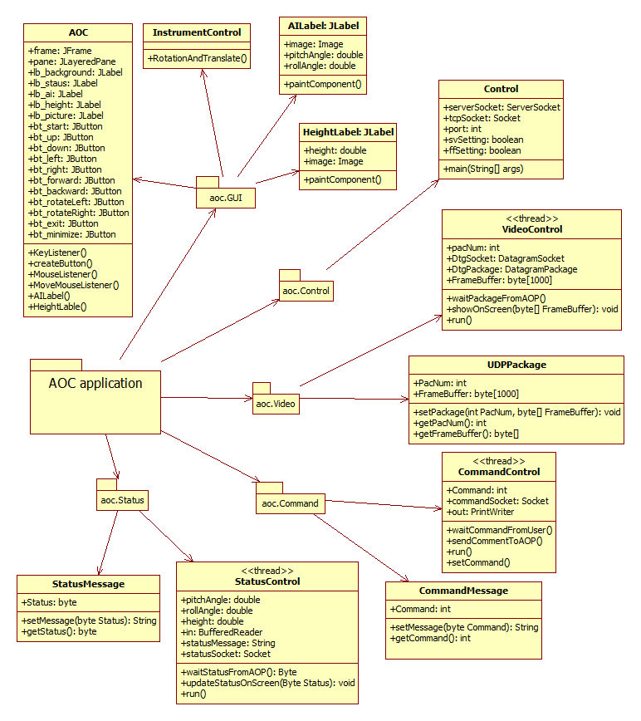
Figure 1: class diagram of AOC
No | Class Name | Description
01 | CommandControl | This class uses to receive pressing keyboard from users and send it to Android phone via TCP.
02 | CommandMessage | This class includes “set” and “get” method to establish command message structure.
03 | Control | This class is main class uses to control all of threads and GUI in application on computer.
04 | AOC | This class uses to create new Graphic User Interface for Application On Computer. It also Key Listener and Mouse Listener to monitor behavior of user
05 | AILabel | Uses to draw attitude indicator
06 | HeightLabel | Uses to draw height indicator
07 | InstrumentControl | This class includes method to draw height indicator, attitude indicator on Graphic User Interface.
08 | StatusControl | This class uses to receive status from AOP and update it to screen.
09 | StatusMessage | This class includes “set” and “get” method to establish status message structure.
10 | VideoControl | This class uses to receive video frame from AOP and update it to screen.
12 | UDPPackage | This class includes “set” and “get” method to establish UDP package structure.

CommandControl class
This class extends Thread uses to receive command when user press keyboard and send it to Android phone via TCP.

Attributes
No | Attribute | Type | Default | Note | Description
01 | commandSocket | Socket | Null |  | TCP socket uses to send command to AOP
02 | out | PrintWriter | Null |  | Uses OutputStream to send command to AOP
03 | command | Int | 0 |  | Uses to send to AOP
04 | county | Int | 0 |  | Uses to check time to send ‘y’ signal to AOP

Methods
No | Method | Description
01 | CommandControl | Default constructor
02 | CommandControl | Constructor uses to input TCP Socket
03 | setCommand | Set command for CommandControl class
04 | setCommandSocket | Set commandSocket for CommandControl class
05 | run | This method will run when thread starts.
06 | waitCommandFromUser | Uses to wait command from user ‘s input
07 | sendCommandToAOP | Uses to send command to AOP
      - CommandControl Method
This method is the constructor uses to input the command socket

Parameters & return
No | Parameter | Type | In/out | Default | Description
01 | commandSocket | Socket | In |  | This is TCP Socket
      - setCommand Method
This method is the constructor uses to input the command socket

Parameters & return
No | Parameter | Type | In/out | Default | Description
01 | command | int | In |  | This is command to control FUFO

      - setCommandSocket Method
This method is the constructor uses to input the command socket

Parameters & return
No | Parameter | Type | In/out | Default | Description
01 | commandSocket | Socket | In |  | This is TCP Socket
      - run Method
This method is the default method on the thread. Codes will be executed when thread is started.

Parameters & return
No | Parameter | Type | In/out | Default | Description
01 | command | int | In |  | This is command to control FUFO

Implementation
Initiate PrintWriter to send command to Android phone by input two parameters: OutputStream of commandsocket and Boolean variable “true”.
Create a while loop repeat forever.
In while loop: if command differs with zero, send command to AOP, else send “y” signal to AOP for AOP know that connection is good. Time between two transmittals is 500 milliseconds.

Control class
This class is main class uses to control all of threads and GUI in application on computer.

Attributes
No | Attribute | Type | Default | Note | Description
01 | serverSocket | ServerSocket | Null | private/static | This is Server Socket on AOC
02 | tcpSocket | Socket | Null | private/static | This is Socket to connect with AOP
03 | PORT | int | 8888 | final/static | Port of server
04 | stct | StatusControl | Null | public/static | Thread status control
05 | cmct | CommandControl | Null | public/static | Thread command control
06 | vdct | VideoControl | Null | public/static | Thread video control
07 | svSetting | boolean | false | public/static | Flag to check socket between AOP and AOC
08 | ffSetting | boolean | false | public/static | Flag to check socket between AOP and FUFO
09 | start | int | 0 | public/static | Flag to check socket whether start button pressed

Methods
No | Method | Description
01 | main | main method of the system
      - main Method
This method is main method of the system

Parameters & return
No | Parameter | Type | In/out | Default | Description
01 | args | String Array | In |  | Arguments input

Implementation
Initiate GUI AOC.
Start server
Wait for client connecting
Initiate and start three threads

AOC class
This is GUI class.

Attributes
No | Attribute | Type | Default | Note | Description
01 | frame | JFrame | null |  | Main Frame of application
02 | pane | JLayeredPane | null |  | Pane contains all component of GUI
03 | lb_background | JLabel | null |  | Set image background by this label
04 | lb_circle | JLabel | null |  | Circle of attitude indicator
05 | lb_status | JLabel | null |  | This label checks connection status of system
06 | lb_picture | JLabel | null |  | Video frame streamed from AOP
07 | lb_setPoint | JLabel | null |  | Height that user wants
08 | lb_text | JLabel | null |  | Text in label status
09 | lb_ai | AILabel | null |  | Attitude indicator
10 | lb_height | HeightLabel | null |  | Height indicator
12 | bt_start | JButton | null |  | Button start
13 | bt_right | JButton | null |  | Button right
14 | bt_left | JButton | null |  | Button left
15 | bt_forward | JButton | null |  | Button forward
16 | bt_backward | JButton | null |  | Button backward
17 | bt_up | JButton | null |  | Button up
18 | bt_down | JButton | null |  | Button down
19 | bt_rotateLeft | JButton | null |  | Button rotate left
20 | bt_rotateRight | JButton | null |  | Button rotate right
21 | bt_exit | JButton | null |  | Button exit
22 | bt_minimize | JButton | null |  | Button minimize

Methods
No | Method | Description
01 | AOC | constructor
02 | createButton | create a button in frame base on position, path of icon button
03 | mouseListener | Mouse listener
04 | keyListener | Key listener
05 | moveMouseListener | Mouse move listener
06 | AILabel | Label for attitude indicator
07 | HeightLabel | Lable for height indicator
      - AOC Constructor
This method is the AOC constructor.

Implementation
Initiate new JFrame for system. Set size map with size in screen design.
Set hide title bar, transparent, not resize.
Add components to frame base on position in screen design.
Add moveMouseListener, mouseListener, keyListener for this frame.
      - createButton Method
This method is used to create a button in frame base on position, path of icon button

Parameters & return
No | Parameter | Type | In/out | Default | Description
01 | text | String | In |  | Name of button
02 | path | String | In |  | Path of icon button
03 | x | int | In |  | the x-coordinate of button
04 | y | int | In |  | the y-coordinate of button
05 | width | int | In |  | Width of button
06 | height | int | In |  | Height of button

Implementation
SetContentAreaFilled for button is false
Set empty border.
Add button to pane with layer parameter is zero
Add mouse listener and key listener of this class
Return a button with upper parameter.
      - KeyListener
This object uses to listen the key input from user.

Implementation
Set correlative command and icon on GUI when user presses keyboard.
      - mouseListener
This object uses to listen the mouse input from user.

Implementation
Set correlative command and icon on GUI when user presses mouse.
      - moveMouseListener
This object uses to listen the move mouse from user.

Implementation
This objects uses for user to click and move frame to anywhere they want on desktop screen.

AILabel class
This class is extended JLabel uses to override method paintComponent to draw attitude indicator.

Parameters & return
No | Parameter | Type | In/out | Default | Description
01 | image | Image | In | null | Image for attitude indicator
02 | pitchAngle | Double | In | 0 | Pitch angle of FUFO
03 | rollAngle | Double | In | 0 | Roll angle of FUFO

Implementation
In paintComponent medthod, use RotateAndTranslate method of InstrumentControl to draw attitude indicator base on pitch angle and roll angle.

HeightLabel class
This class is extended JLabel uses to override method paintComponent to draw height indicator.

Parameters & return
No | Parameter | Type | In/out | Default | Description
01 | image | Image | In | null | Image for height indicator
02 | pitchAngle | Double | In | 0 | Pitch angle of FUFO
03 | rollAngle | Double | In | 0 | Roll angle of FUFO

Implementation
In paintComponent medthod, use RotateAndTranslate method of InstrumentControl to draw attitude indicator base on height.

InstrumentControl class
This class shows methods to draw attitude indicator and height indicator on screen

Methods
No | Method | Description
01 | RotateAndTranslate | Method to rotate and translate image base on pitch angle and roll angle
      - RotateAndTranslate Method
This Method to rorate and translate image base on pitch angle and roll angle.

Parameters & return
No | Parameter | Type | In/out | Default | Description
10 | Pe | Graphics | In |  | The paint area event where the image will be displayed
02 | Img | Image | In |  | The image to display
03 | alphaRot | Double | In |  | The angle of rotation in radian
04 | alphaTrs | Double | In |  | The angle of translation direction in radian, expressed in the rotated image coordinate system
05 | ptImg | Point | In |  | The location of the left upper corner of the image to display in the paint area in nominal situation
06 | deltaPx | int | In |  | The translation distance in pixel
07 | ptRot | Point | In |  | The location of the rotation point in the paint area
08 | scaleFactor | float | In |  | Multiplication factor on the display image

Implementation
Apply algorithm rotate and translate image to implement this method base on pitch and roll angle.

StatusControl class
This class extends Thread uses to receive status from Android phone via TCP.

Attributes
No | Attribute | Type | Default | Note | Description
01 | aoc | AOC | Null |  | GUI AOC
02 | statusSocket | Socket | Null |  | Uses to receive status from AOP
03 | in | BufferedReader | Null |  | Uses to read buffer
04 | sm | StatusMessage | Null |  | Uses to analyze message
05 | pitchAngle | Double | 0 |  | Pitch angle update to attitude indicator
06 | rollAngle | Double | 0 |  | Roll angle update to attitude indicator
07 | height | Double | 0 |  | Height update to height indicator
08 | statusMessage | String | Null |  | Status message

Methods
No | Method | Description
01 | StatusControl | Default constructor
02 | StatusControl | Constructor uses to input TCP Socket and AOC
03 | waitStatusFromeAOP | Uses to wait status from AOP via TCP
04 | updateStatusOnScreen | Uses to update pitch, roll angle, height to screen.
05 | run | This method will run when thread start.
      - StatusControl Method
This method is the constructor uses to input the status socket and AOC

Parameters & return
No | Parameter | Type | In/out | Default | Description
01 | statusSocket | Socket | In |  | This is TCP Socket
02 | aoc | AOC | In |  | GUI
      - waitStatusFromeAOP Method
This method uses to receive status from AOP

Implementation
Read line from bufferedReader to statusMessage.
Use StatusMessage class to analyze pitch angle, roll angle and height and set to variables pitchAngle, rollAngle, and height.
      - updateStatusOnScreen Method
This method uses to update roll angle, pitch angle, height to screen.

Parameters & return
No | Parameter | Type | In/out | Default | Description
01 | pitchAngle | Double | In |  | Pitch angle
02 | rollAngle | Double | In |  | Roll angle
03 | height | Double | In |  | heigh

Implementation
Set pitchAngle and rollAngle of lb_ai of aoc is pitchAngle and rollAngle.
Set pitchAngle of lb_height of aoc is height.
Repaint the frame.
      - run Method
This method is the default method on the thread. Codes will be executed when thread is started.

Implementation
Create a while loop repeat forever.
In while loop: include two methods: updateStatusOnScreen and waitStatusFromeAOP.

StatusMessage class
This class uses to analyze statusMessage received from AOP

Attributes
No | Attribute | Type | Default | Note | Description
01 | pitchAngle | Double | 0 |  | Pitch angle update to attitude indicator
02 | rollAngle | Double | 0 |  | Roll angle update to attitude indicator
03 | height | Double | 0 |  | Height update to height indicator
04 | statusMessage | String | Null |  | Status message

Methods
No | Method | Description
01 | setStatusMessge | Uses to create message from pitch angle, roll angle and height.
02 | getStatus | Uses to get pitch angle, roll angle and height from message.
      - setStatusMessge Method
This method uses to create message from pitch angle, roll angle and height

Parameters & return
No | Parameter | Type | In/out | Default | Description
01 | pitchAngle | Double | In |  | Pitch angle update to attitude indicator
02 | rollAngle | Double | In |  | Roll angle update to attitude indicator
03 | height | Double | In |  | Height update to height indicator
04 | statusMessage | String | Out |  | statusmessage

Implementation
Parse to string and combine three upper parameters to a string, between two parameters is a comma.
      - getStatus Method
This method uses to receive status from AOP

Parameters & return
No | Parameter | Type | In/out | Default | Description
01 | statusMessage | String | Out |  | statusmessage

Implementation
Split string by comma, convert to double and set it to three variable pitch angle, roll angle and height.

VideoControl class
This class extends Thread uses to receive video from Android phone via UDP.

Attributes
No | Attribute | Type | Default | Note | Description
01 | aoc | AOC | Null |  | GUI AOC
02 | udpSocket | DatagramSocket | Null |  | Uses to receive video from AOP
03 | udpPackage | DatagramPackage | Null |  | Datagram package
04 | pk | UDPpackage | Null |  | Package to receive video from AOP
05 | pacBuffer | Byte[] | Null |  | Buffer uses to save package

Methods
No | Method | Description
01 | VideoControl | Default constructor
02 | VideoControl | Constructor uses to input AOC
03 | waitPackageFromeAOP | Uses to wait package from AOP via UDP
04 | showOnScreen | Update image to screen.
05 | run | This method will run when thread start.
      - StatusControl Method
This method is the constructor uses to input AOC

Parameters & return
No | Parameter | Type | In/out | Default | Description
01 | aoc | AOC | In |  | GUI
      - waitPackageFromeAOP Method
This method uses to receive package from AOP

Implementation
Initiate new DatagramSocket with port 4444.
Initiate new DatagramPackage with two parameters: pacBuffer and length of this buffer
Receive udpPackage by udpsocket
      - showStatusOnScreen Method
This method uses to update roll angle, pitch angle, height to screen.

Parameters & return
No | Parameter | Type | In/out | Default | Description
01 | udpPackage | DatagramPackage | In |  | Udp package receive from aop

Implementation
Rescale picture with size 800,600
Show on screen.
      - run Method
This method is the default method on the thread. Codes will be executed when thread is started.

Implementation
Create a while loop repeat forever.
In while loop: include two methods: showOnScreen and waitPackageFromeAOP

Application on Phone

Class diagram
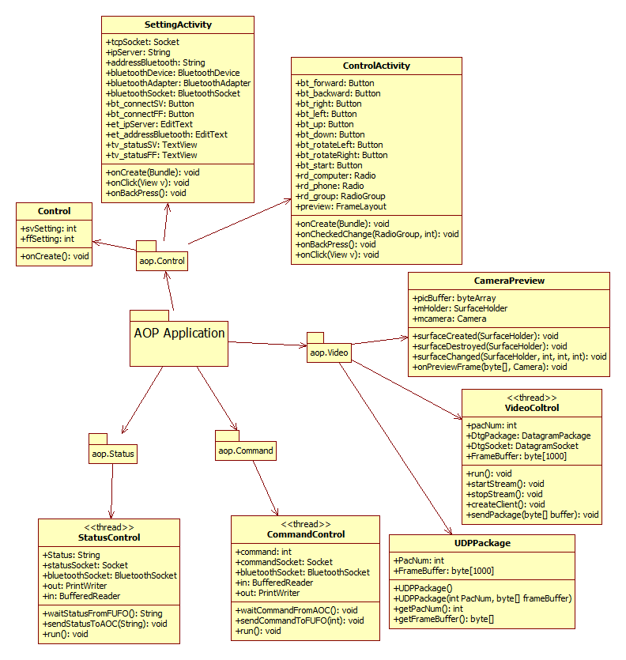
Figure 2: Class diagram of AOP

No | Class Name | Description
01 | Control | This class is the activity executes when application starts.
02 | SettingActivity | This class uses to controls operation on Setting tab
03 | ControlActivity | This class uses to controls operation on Control tab
04 | CameraPreview | This class uses to get video frame
05 | VideoControl | This class includes methods to control video
06 | StatusControl | This class includes methods to control status
07 | CommandControl | This class includes methods to control command
08 | UDPPackage | This class includes “set” and “get” method to establish UDP package structure.

Control class
This class is the activity executes when application starts.

Attributes
No | Attribute | Type | Default | Note | Description
01 | svSetting | Int | 0 | static | Flag to check connection between AOC and AOP
02 | ffSetting | Int | 0 | static | Flag to check connection between Firmware and AOP

Methods
No | Method | Description
01 | onCreate | Default method of this Activity
      - onCreate Method
This method is default method of this Activity

Implementation
Initiate two tabs “Setting” and “Control” and add to tabHost
Set currentTab is “Setting” Tab

SettingActivity class
This class extends Activity uses to display “Setting” tab.

Attributes
No | Attribute | Type | Default | Note | Description
01 | tcpSocket | Socket | Null |  | TCP socket for system
02 | ipServer | String | Null |  | IP address of AOC
03 | addressBluetooth | String | Null |  | Address of Bluetooth device
04 | bluetoothDevice | BluetoothDevice | Null |  | Uses to connect firmware
05 | bluetoothAdapter | BluetoothAdapter | null |  | Uses to connect firmware via Bluetooth
06 | bluetoothSocket | BluetoothSocket | Null |  | Uses to send and receive data with firmware
07 | bt_connectSV | Button | Null |  | Button connect to server
08 | bt_connectFF | Button | Null |  | Uses to connect to firmware
09 | et_ipServer | EditText | Null |  | Uses to input IP server
10 | et_addressBluetooth | EditText | Null |  | Uses to input Bluetooth device address
11 | tv_statusSV | TextView | Null |  | Uses to show connection status with AOC
12 | tv_statusFF | TextView | Null |  | Uses to show connection status with Firmware

Methods
No | Method | Description
01 | onCreate | Default method of this activity
02 | onBackPress | Method when users press “Back” button
03 | onClick | Method when users click button
      - onCreate Method
This method is default method of this activity

Implementation:
Initiate button, text view and edit text with method findViewById base on screen design in xml file.
Set on click listener for buttons.
Show dialog “Turn on Bluetooth” when Bluetooth of device turned off.
      - onBackPress Method
This method is the override method of system.

Implementation
Close Bluetooth Socket and TCP socket.
Exit the system
      - onClick method
This method is uses to implement method when pressing button

Implementation
When clicking button connect to server,
If not connect to Server, connect to server by TCP socket with port 8888
Set button text, status and svSetting when connecting ok.
Set command socket and status socket be TCP socket.
Send signal to AOC if connected to firmware.
If connected to server, close the connect

When clicking button connect to Firmware,
If not connect to firmware, connect to firmware by Bluetooth socket
Set button text, status and ffSetting when connect ok.
Set Bluetooth for command control and status control be Bluetooth socket.
Send signal to AOC if connected to AOC.
If connected to server, close the connect

ControlActivity class
This class extends Activity is uses to display “Control” tab.

Attributes
No | Attribute | Type | Default | Note | Description
01 | bt_forward | Button | Null |  | Button forward
02 | bt_backward | Button | Null |  | Button backward
03 | bt_right | Button | Null |  | Button right
04 | bt_left | Button | Null |  | Button left
05 | bt_up | Button | null |  | Button up
06 | bt_down | Button | Null |  | Button down
07 | bt_rotateLeft | Button | Null |  | Button rotate left
08 | bt_rotateRight | Button | Null |  | Button rotate right
09 | bt_start | Button | Null |  | Button start
10 | rd_computer | Radio | Null |  | Radio button computer
11 | rd_phone | Radio | Null |  | Radio button phone
12 | rd_group | RadioGroup | Null |  | Radio group
13 | preview | FrameLayout | Null |  | Frame layout uses for camera preview

Methods
No | Method | Description
01 | onCreate | Default method of this activity
02 | onBackPress | Method when users press “Back” button
03 | onClick | Method when users click button
04 | onCheckChange | Method when users change radio button
      - onCreate Method
This method is default method of this activity

Implementation:
Initiate button, text view and edit text with method findViewById base on screen design in xml file.
Set on click listener for buttons.
      - onBackPress Method
This method is the override method of system.

Implementation
Close Bluetooth Socket and TCP socket.
Exit the system
      - onClick method
This method is uses to implement method when pressing button

Implementation
Set command base on the button.
Left: a
Forward: w
Right: d
Backward: s
Up: o
Down: p
Start: f
Rotate left: l
Rotate right: r
      - onCheckChange method
This method is uses to implement method when change radio button

Implementation
The default is not check anyone
If users check control via computer, send signal ‘c’ to firmware. Set Control.controlMode is one.
If users check control via Phone, send signal ‘n’ to firmware. Show the control buttons.

CameraPreview class
This class extends SurfaceView uses to get video frame from camera in phone

Attributes
No | Attribute | Type | Default | Note | Description
01 | picBuffer | Byte[] | Null |  | Buffer of picture
02 | mHolder | SurfaceHolder | Null |  | Surface holder
03 | mCamera | Camera | Null |  | Camera of phone

Methods
No | Method | Description
01 | CameraPreview | Constructor uses to input Context and Camera
02 | surfaceCreate | Uses to create the surface
03 | surfaceDestroyed | Uses to when surface destroy
04 | surfaceChanged | Uses to when surface change
05 | onPreviewFrame | Uses to get frame buffer
      - CameraPreview Method
This method is the constructor uses to input Context and Camera

Parameters & return
No | Parameter | Type | In/out | Default | Description
01 | Context | Context | In |  | Context for camera preview
02 | Camera | Camera | In |  | Camera to record video

Implementation
Set mCamera equal this camera
Install a SurfaceHolder.Callback. We will get notified when the underlying surface is created and destroyed.
      - surfaceCreated Method
When the Surface is created, tell the camera where to draw the preview

Parameters & return
No | Parameter | Type | In/out | Default | Description
01 | Holder | SurfaceHolder | In |  | Surface Holder to draw the preview

Implementation
Set the camera callback to be the one defined in this class.
      - surFaceDestroyed method
Because the CameraDevice object is not a shared resource, it’s very important to release it when the activity is paused.

      - surfaceChanged method
If your preview can change or rotate, take care of those events here. Stop the preview before resizing or reformatting it.

Implementation
Stop Preview before making changes
      - onPreviewFrame Method
This method uses to get video frame when it is showing

Parameters & return
No | Parameter | Type | In/out | Default | Description
01 | data | byte[] | In |  | Frame data
02 | camera | Camera | In |  | Camera to record video

Implementation
Compress image into JPEG
Send to AOC.

StatusControl class
This class extends Thread uses to receive status from FUFO and send it to AOC.

Attributes
No | Attribute | Type | Default | Note | Description
01 | statusSocket | Socket | Null |  | TCP socket user to send status to AOC
02 | bluetoothSocket | BluetoothSocket | Null |  | Uses to receive status to Firmware
03 | out | PrintWriter | Null |  | Uses OutputStream to send status to AOC
04 | Status | String | Null |  | Status include pitch angle, roll angle and height
05 | in | BufferedReader | null |  | Uses to read buffer from Firmware

Methods
No | Method | Description
01 | StatusControl | Default constructor
02 | StatusControl | Constructor uses to input TCP Socket and Bluetooth Socket
03 | Run | This method will run when thread start.
04 | waitStatusFromFF | Uses to wait status from firmware
05 | sendStatusToAOC | Uses to send status to AOC
      - CommandControl Method
This method is the constructor uses to input the status socket and Bluetooth socket

Parameters & return
No | Parameter | Type | In/out | Default | Description
01 | statusSocket | Socket | In |  | This is TCP Socket
02 | bluetoothSocket | BluetoothSocket | In |  | This is Bluetooth socket uses to receive status from firmware

      - run Method
This method is the default method on the thread. Codes will be executed when thread is started.

Parameters & return
No | Parameter | Type | In/out | Default | Description
01 | Status | String | In |  | This is status to send to AOC

Implementation
Initiate PrintWriter to send status to AOC by input two parameters: OutputStream of statusSocket and Boolean variable “true”.
Create a while loop repeat forever.
In while loop: execute two methods: waitStatusFromFUFO and sendStatusToAOC
      - waitStausFromFUFO
This method is uses to receive status from FUFO

Implementation
Create a while loop repeat forever.
Use BufferedReader to read buffer sent from FUFO.

      - sendStatusToAOC
This method is uses to send status to AOC.

Implementation
Create a while loop repeat forever.
Use PrintWriter to send to AOC.

CommandControl class
This class extends Thread uses to receive command from AOC and send it to FUFO.

Attributes
No | Attribute | Type | Default | Note | Description
01 | commandSocket | Socket | Null |  | TCP socket user to receive command from AOC
02 | bluetoothSocket | BluetoothSocket | Null |  | Bluetooth Socket uses to send command to Firmware
03 | out | PrintWriter | Null |  | Uses OutputStream to send command to firmware
04 | command | Int | 0 |  | Command
05 | in | BufferedReader | null |  | Uses to read buffer from AOC

Methods
No | Method | Description
01 | CommandControl | Default constructor
02 | CommandControl | Constructor uses to input TCP Socket and Bluetooth Socket
03 | run | This method will run when thread starts.
04 | waitCommandFromAOC | Uses to wait command from AOC
05 | sendCommandToFUFO | Uses to send command to Firmware
      - CommandControl Method
This method is the constructor uses to input the command socket

Parameters & return
No | Parameter | Type | In/out | Default | Description
01 | commandSocket | Socket | In |  | This is TCP Socket
02 | bluetoothSocket | BluetoothSocket | In |  | This is Bluetooth socket uses to send command to firmware

      - run Method
This method is the default method on the thread. Codes will be executed when thread is started.

Parameters & return
No | Parameter | Type | In/out | Default | Description
01 | command | int | In |  | This is command to control FUFO

Implementation
Initiate PrintWriter to send command to FUFO by input two parameters: OutputStream of commandsocket and Boolean variable “true”.
Create a while loop repeat forever.
In while loop: if command differs with zero, sending command to FUFO, else sending “y” signal to FUFO for it to know that connections is good. Time between two transmittals is 500 milliseconds.
      - waitCommandFromAOC
This method is uses to receive command from AOC

Implementation
Create a while loop repeat forever.
Use BufferedReader to read buffer sent from AOC.

      - sendCommandToFUFO
This method is uses to send command to firmware.

Implementation
Create a while loop repeat forever.
Use PrintWriter to send to Firmware.

Error, exception handling
AOP will send ‘y’ signal to Firmware when not have command to notify that connection is good. If Firmware doesn’t receive ‘y’ signal or command in two seconds, it will turn off Firmware.
Status sent from Firmware to AOP will be checked to discovery error.
All exceptions will be handle to avoid system be attached.

Log, trace and debug
We will use Log4J to log all operation and exception of system for maintain.

Diagrams
This diagram describes the relation between components of the system, data transfer between AOP, AOC and Firmware.
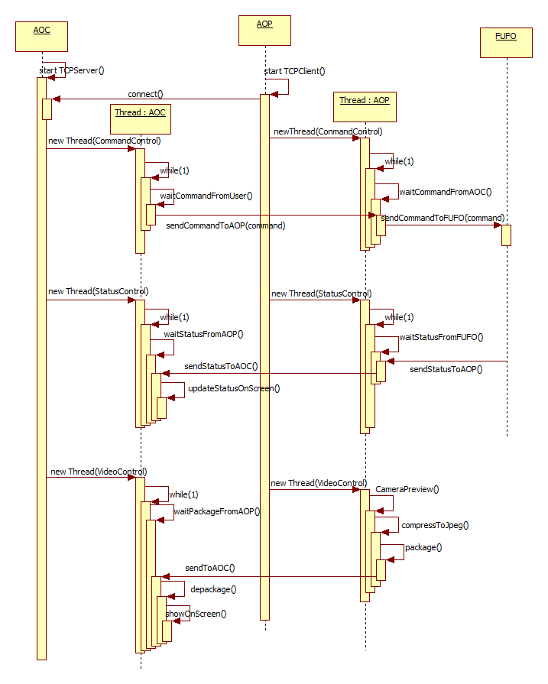
Figure 3: Sequence diagram of System

