Feasibility Report:
Microprocessor DSPIC30F4012
Author: Vũ Minh Phong

Overall of microprocessor DSPIC30F4012:
DSPIC30F4012 is a 28-pin micro processor published by MICROCHIP Technology Inc.
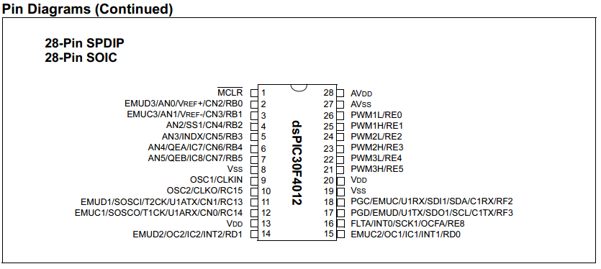
Features of DSPIC30F4012:
- 84 base instruction
- 24-bit wise instruction, 16-bit wise data path.
- 48kbytes on-chip Flash program space (16k instruction words)
- 2 Kbytes on-chip data RAM
- DC upto 40MHz external clock input
- 16x16 bit working register array.
- 16-bit compare /PWM output function.
- Five 16-bit timers.
- 6 PWM output channels.
- 3 duty cycle generators.
- 10-bit A/D with 6 input channels
- About half a size of PIC16f887.
- 1 UART channel
- 1 SPI channel + 1 I2C channel
- Operation voltage: 5V or 3.3V

Why it is suitable for FUFO project:

Fufo project need a controller circuit which is capacible of the followings:
- Have 1 SPI or 1 I2C connection for 1 Gyroscope.
- Have 3 A/D pins connection for 1 Accelerometer.
- Have 1 UART connection for Bluetooth module at 9600 baud rate
- Have 4 PWM outputs for 4 ESC.
- As small, light and cheap as possible.
What DSPIC30F4012 provides:
- 1 SPI/I2C connection
- 6 A/D input pins
- 1 UART connection
- 6 PWM output pin (can work independently)
- Can either work at 3.3V or 5V
- Clock upto 40Mhz (4Mhz is good enough for 9600 baud rate)
- 16 bits register for PWM is precise enough.
- The size is about a half of PIC16f887 (small and light)
- Do not have to care about price since we have a sponsor (Mr. HungPD)
- Similar to other Microchip product in development. We donot have to learn too many new things.
- Can use MpLab IDE or CCS C IDE for development.

