
MINISTRY OF EDUCATION AND TRAINING

FPT UNIVERSITY
Quadrocopter Hovering Capability Study
FPT UNIVERSITY FLYING OBJECT
Project code: FUFO

Hanoi, August 9th,2012
Authors:
Vu Minh Phong - 00885
Hoang Duc Hung - 60115
Vu Duc Thang - 60124
Ly Khoi Nguyen - 60206
Tran Thi Yen - 01269
Supervisor:
Phan Duy Hung - Instructor

Abstract
Unmanned Aerial Vehicle, also referred as UAV, are providing an increasing importance role in many aspect of human life today. As in the past few decades, UAV would be classified as an military area only due to the extremely high cost in both development and operation. However, due to the evolution of technology which lead to the reduction in price of technology equipments and parts, small UAVs are being researched and developed among the technology Universities and companies.
A simple low cost UAV solution will provide an attractive alternative to many civilian and even military applications where human, plane or helicopter would traditionally be used. These application could include: traffic/urban surveillance, aiding search and rescue operations, forest fire detection, national border protection, cross-border smuggling control, etc.
The objective of this project is to build and experiment with a low cost prototype UAV. This involves constructing a vehicle control system, as well as evaluating various design features and building materials.
The UAV is a Quadrocopter model, which is propelled using four motors and propellers in opposite directions. The detail of this model will be discussed more intensively later in this report.
The basic theory will mainly consist of modeling and control theory. However, there is some extend in filtering and controller constants finding technique which is crucial and valuable for every Quadrocopter related project. These extend will be discussed both theoretically and practically.
It is important to emphasize that existing solution on the market today are result of projects with far greater budgets than the one available here. Hence the goal is to experiment with a low-cost UAV and to determine what is possible to archive with small resource.

Table of Contents

1 Introduction 4
1.1 Purpose 4
1.2 Record of changes 4
1.3 Definitions and Acronyms 4
2 Abstract 5
3 The origin of idea 5
3.1 The fact of today security systems 5
3.2 Idea on FUFO Quadrocopter 7
3.3 FUFO big project 8
4 Overview of the Capstone project 9
5 Critical Assumption and Constraints 9
6 Potential Risks 9
7 General view 10
8 Scope 11
8.1 Project Overview 11
8.1.1 Core Business Cases and Approach 11
8.1.2 Project Milestones and Deliverables 12
8.2 Boundaries of the System 12
8.3 Development Environment 12
8.3.1 Hardware requirements 12
8.3.2 Software requirements 13
9 Hardware study 13
9.1 Hardware Overview 13
9.2 Microcontroller: dsPIC30f4012 13
9.2.1 Overview of dsPIC30f4012 13
9.2.2 Feasibility of dsPIC30f4012 in FUFO 14
9.3 Bluetooth module HC-06 15
9.3.1 Overview of HC-06 15
9.3.2 Feasibility of HC-06 in FUFO 16
9.4 9DOF: BMP085 + L3G4200D + ADXL345 + HMC5883L 17
9.4.1 L3G4200 17
9.4.2 ADXL345 19
9.5 Mystery FireDragon ESC 30A 20
9.6 Motor Himodel A2212-10T 1400kv 20
9.6.1 Brushless VS Brushed 20
9.6.2 Motor Himodel A2212-10T 1400kv 22
10 Software Study 23
10.1 Embedded Software 23
10.2 Real-time video transmission 25
10.3 Communication between the devices in FUFO system 26
10.3.1 Angular statuses communication 27
10.3.2 Control command communication 27
11 Project Organization 27
11.1 Software Process Model 27
11.2 Roles and Responsibilities 28
12 Project Management Plan 29
13 Risk Management 30
14 Coding Conventions 31
14.1 Naming Conventions 31
14.2 Comments 31
15 List of References 32

Introduction

Study objective
This study involves in making a low cost Quadrocopter with a restricted resource and evaluate the capability of its in hovering and observation. To some extent, this study will also include some aspect of Filtering technique and vehicle control method to determine what is the best achievable solution for this type of UAV without increasing the budget for development.

Definitions and Acronyms
Acronym | Definition | Note
FUFO | FPT University Flying Object
UAV | Unmanned Aerial Vehicle
PC | Personal Computer
PM | Project Manager
PTL | Project Technical Leader
TL | Team Leader
QA | Quality Assurance Officer
DS | Designer
DV | Developer
ESC | Electronic Speed Controller
SDK | Software Development Kit
BLDC | Brushless DC
UART | Universal Asynchronous Receiver/Transmitter
SPI | Serial Peripheral Interface
PWM | Pulse Width Modulation
SRS | Software Requirement Specification
FPS | Frame Per Second
RC | Remote Control
Dps | Degree Per Second
PID | Proportional-Integral-Derivative
INS | Inertial Frame

History
Research into the initial development of quad rotors began in the early twentieth century. One of the first engineers to attempt to design a quad rotor was Etienne Oemichen. Oemichen began his research in 1920 with the completion of the Oemichen No.1. This design consisted of four rotors and a 25 Horsepower motor; however, during tests flights the Oemichen No.1 was unable to obtain flight. Two years later Oemichen completed his second design; the Oemichen No.2. His second design consisted of four rotors and eight propellers along with a 125 Horsepower motor. Five of the propellers were used to achieve stable flight while two were used for propulsion and the final propeller being used to steer the aircraft. In April of 1914, the Oemichen No.2 achieved an FAI distance record for helicopters of 360m, which the Oemichen No.2 broke with a distance of 525m.
While Oemichen had begun working on his early designs in France, Dr. George de Bothezat and Ivan Jerome began their own research in January 1921 for the United States Army Air Corps. They completed their design in mid 1922, and the first test flight took place in October of 1922 in Dayton, Ohio. Bohezat‟s and Jerome‟s design weighed around 1700 kg at the time of take off and consisted of four six-bladed rotors along with a 220-HP motor. After many tests, the quad rotor was only able to achieve a maximum flight time of 1 minute 42 seconds and maximum height of 1.8 meters.
Following the research of Oemichen, Bothezat and Jerome, other researchers have attempted to create their own successful vertical flying machines. One such was being the Convertawings Model “A” quad rotor. The Convertawings Model “A” quad rotor was designed and built in the mid 1950‟s with civil and military purposes in mind. This particular quad rotor consisted of four rotors, two motors as well as wings. Due to lack of interest, however, the Convertawings Model “A” quad rotor was never mass produced.
Currently Bell Helicopter Textron and Boeing Integrated Defense Systems are doing joint researched on the development of the Bell Boeing Quad Tilt Rotor. The initial design consists of four 50-foot rotors powered by V-22 engines. The main role of the Bell Boeing Quad Tilt Rotor will be that of a cargo helicopter with the ability to deliver pallets of supplies or also deploy paratroopers. The first wind tunnel tests were completed in 2006 and the first prototype is expected to be built in 2012.

Quadrocopter Dynamic
In order to understand how to control the Quadrocopter, it is important to understand how it behaves first. This report assumes that the readers do not have many knowledge in aero space area, therefore, explanation on some aspect of this area is provided as clear as possible with as less math as possible.

Inertial frame and Body frame
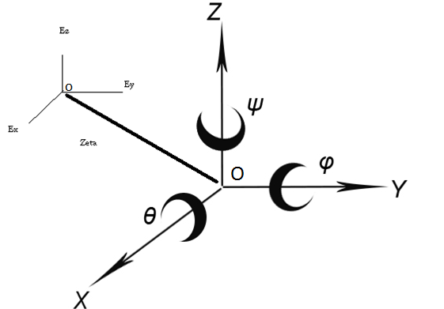
Figure 1: Inertial frame OExEyEz and Body frame OXYZ
Inertial Frame, some time called Reference Frame or Navigation Frame, denoted as INS, is a 3-axis frame for referencing purpose of a spectacular object in space.
Body Frame is a 3-axis frame that represents the object in space. It is always located with regard to an Inertial Frame.
The body of a Quadrocopter is assumed as a rigid body, the Origin of its Body Frame is located at the mass center.
The inertial frame of a Quadrocopter is earth. How is this possible? The answer is simple: Because the earth is giant compares to the size of a Quadrocopter, therefore it can be assumed as flat. Oz vector of Inertial frame points toward the center of gravity.
In a complex Quadrocopter navigation system, there must be at least two INSs. The first one has the same Origin with the Body frame and the second one has an Origin located on earth surface. This separation is necessary because a Quadrocopter has two general behaviors:
- Maintains its Euler angular positions.
- Maintains its position in space.
To maintain its Euler angular positions, a Body frame need an INS that has the very same Origin with it, that is how Euler Angles are measured. This INS is denoted as INS1. However, the body frame will eventually need to know its position in a space, or to be more detailed, its Origin position in space. In order to archive this, a INS with a fixed Origin on the earth surface is defined. This INS is denoted as INS2.
As the two INS are existed together, a body frame now will have to vectors of position in space:
𝜂₁ = [x,y,z]; (1)
𝜂₂ = [𝜃,𝜑,𝜓]; (2)
(1) is the position of Body Frame's Origin with regard to INS2. x, y ,z are also called the translational unit vectors.
(2) is the Euler Angular position of Body Frame with regard to INS1. 𝜃,𝜑,𝜓 is also called the rotational unit vectors.
NOTE: all the Euler Angles must follow a general direction rule which could be either Right-Hand rule or Left-Hand rule.

Quadrocopter assumptions
The following assumptions have to be made before further discussing on Quadrocopter dynamic:
- The Earth is flat, stationary and therefore an approximate Inertial Frame.
- The atmosphere is at rest relative to the ground (zero wind).
- The motors respond rate is fast enough to neglect.
- The flapping angles of the rotors is negligible.
- Force are symmetric in flight and act at center of mass.
- Change in relative air velocity is negligible.

Quadrocopter dynamic
With regard to (1) and (2), the followings state vectors of the Quadrocopter can be defined:
𝜂 = [𝜂₁, 𝜂₂]; (3)
v = [v₁,v₂]; (4)
v₁ ₌ [v_{x},v_{y,}v_{z}]; (5)
v₁ ₌ [ω_{x},ω_{y,}ω_{z}]; (6)
where (3) are described relative to the Inertial Reference Frames while (5) and (6) represent the velocity vector of linear translational movement and rotational movement of Quadrocopter Body Frame , respectively.
The inertial and body-fixed velocity relation can be represent with a QRT UAV Jacobian matrix[......]:

Figure 2 below shows the motor alignment scheme of a quadrocopter and its motion which is induced by the combination of 4 motors.
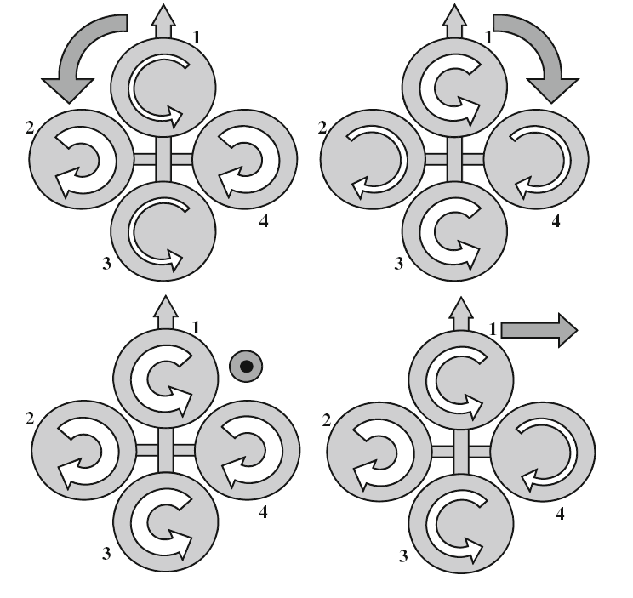
Figure 2: Motors alignment scheme.

Critical Assumption and Constraints
The project is focus on evaluating the Quadrocopter system. Many commercial aspect of the system such as economically effective, mass production of product, etc will not be implemented. Some technical aspects which are too complicated will not be implement as well due to the short duration of this project.
The system will be tested mostly in well-equipped laboratory environment, which may be far different to the real environment.

Potential Risks
- Domain
- Lack of knowledge in Aerodynamic area.
- Lack of knowledge in Robotic and control area.
- Need some time for studying and training as well as support from supervisor and from acquainted experts.

- Technology
- Lack of experience on Android programming environment.
- Lack of experience on Hardware circuit design.
- Lack of experience on mechanical design.
- Need some time for studying and training as well as support from supervisors.

- Hardware
- The circuit is designed by un-experienced student may contain time-consuming potential bugs.
- The cost for equipment and electrical component is always high for student.
- The chosen electrical components may not compatible with each other.
- Need review and support from supervisors.

General view
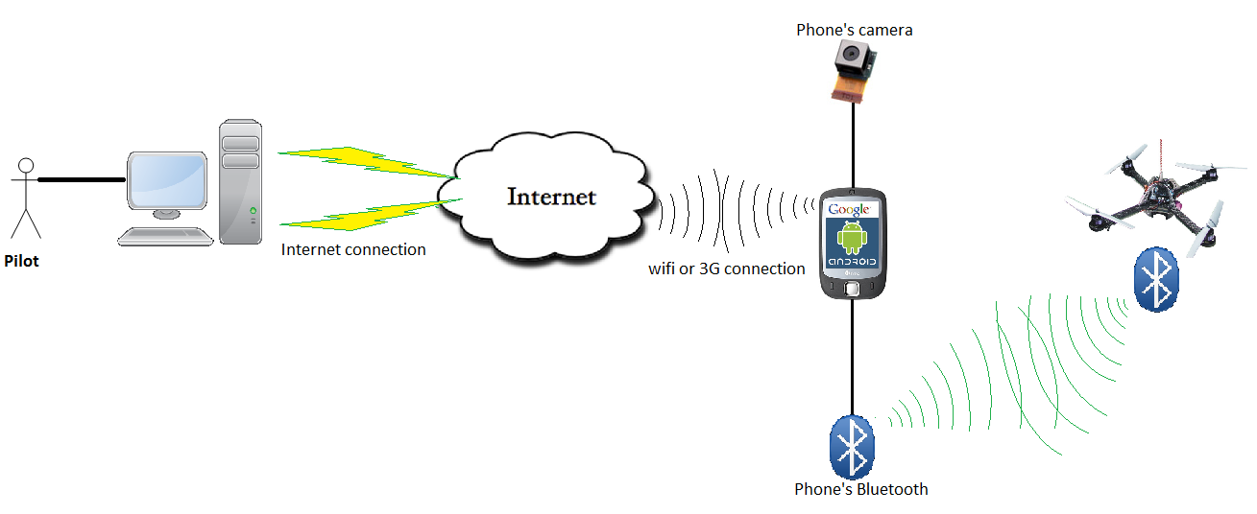
Figure 7.1: General view of the system
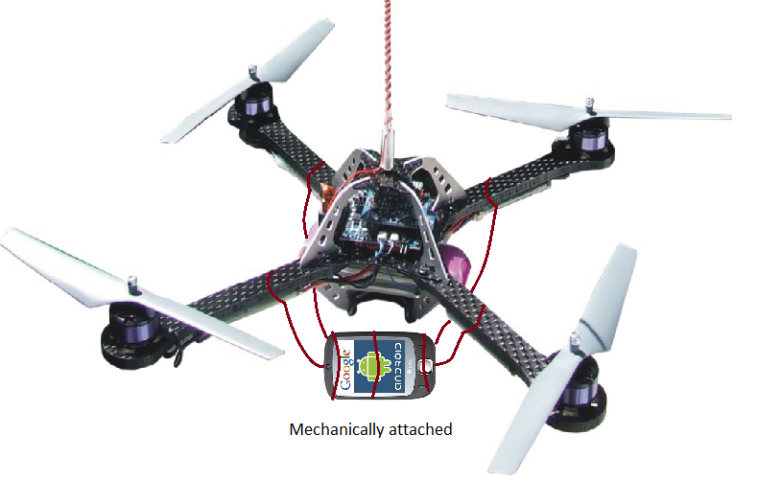
Table 7.2: Android phone is attached to the Quadrocopter mechanically.

Scope

Project Overview

Core Business Cases and Approach
The main system will be an embedded system with PC and Android phone interface. The system is focusing on testing the functions for study and research purpose.
The system will provide the following main features:
  - Un-experienced pilot will pilot the Quadrocopter from his/her PC via Internet.
  - Pilot can also pilot the Quadrocopter from the Android phone in a short distant (at least 10 meters^{[2]}).
  - Pilot can see real-time updating angular statuses in a standard way which is the same as an Attitude Indicator^{[3]}.
  - Pilot can see real-time video stream in Android Phone's Camera on his/her PC via Internet, this video stream is just a sequence of JPEG pictures, which FPS equals to at most 10 FPS.^{[8]}

Project Milestones and Deliverables

No | Stage | Committed | Actual | Deviation | Note
1 | Project Management Plan | 15-May-12
2 | SRS V1.0 | 25-May-12
3 | Detailed design | 28-May-12
4 | Final package + User Manual + Test report | 25-July-12
5 | 2 Study reports | 01-August-12
Table 8.1.2.1: Android phone is attached to the Quadrocopter mechanically.

Boundaries of the System
The system under development of this Capstone Project will include:
  - The software installer on PC
  - The software installer on Android 2.2
  - A Quadrocopter
  - A study report on Hovering capability of Quadrocopter
  - A study report on Real-time transmission
  - User manual
  - SRS
  - Design documents
  - Test documents
  - Source code

Development Environment
Below is the list of hardware and software requirements needed for development environment:

Hardware requirements
  - An Oscilloscope.
  - Pickit2 or ICD2 programmer.
  - Bread boards.
  - Multi-meter.
  - Soldering iron.
  - Mechanical tool: pliers, screwdriver, screw.
  - Carbon material for making RC plane frame.
  - A PC with the minimum configuration: 4 Gb of RAM, Core 2 Duo 2.0 Ghz.
  - A phone runs on Android 2.2 or above.

Software requirements
  - Operating system: Windows 7, Android 2.2
  - Framework: JAVA 1.6 or above.
  - IDE: Eclipse 3.7.1, Android SDK 2.2, MpLab 8.76 C30, Matlab 7.7
  - Programmer: ICD2 or Pickit2
  - Design software: Proteus 7.7, Altium Designer 10, Photoshop CS3.

Hardware study

Hardware Overview
After several months of studying the possibilities of hardware components for this Capstone project, the team has decided to use the below components to make the Quadrocopter:
- 1 Microcontroller: dsPIC30f4012.
- 1 Bluetooth module: HC-06
- 1 Sensor module: 9DOF: BMP085 + L3G4200D + ADXL345 + HMC5883L
- 4 ESCs: Mystery FireDragon ESC 30A
- 4 Motors: Himodel A2212-10T 1400kv
Each of these components will be clearly discussed in the next parts.

Microcontroller: dsPIC30f4012

Overview of dsPIC30f4012
DSPIC30F4012 is a 28-pin micro processor published by MICROCHIP Technology Inc.
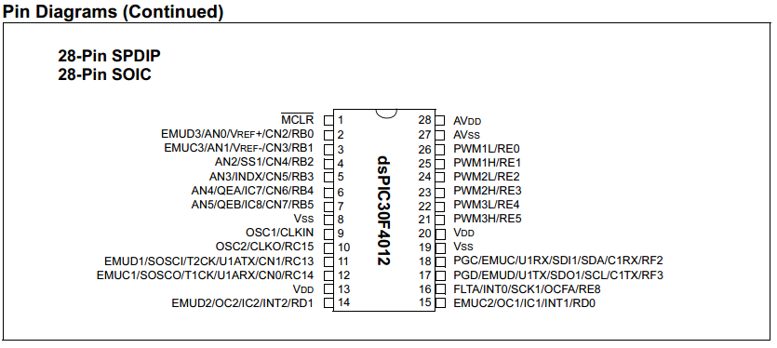
Figure 9.2.1.1: dsPIC30F4012 pin diagram
Features of DSPIC30F4012:
- 84 base instruction
- 24-bit wise instruction, 16-bit wise data path.
- 48kbytes on-chip Flash program space (16k instruction words)
- 2 Kbytes on-chip data RAM
- DC upto 40MHz external clock input
- 16x16 bit working register array.
- 16-bit compare /PWM output function.
- Five 16-bit timers.
- 6 PWM output channels.
- 3 duty cycle generators.
- 10-bit A/D with 6 input channels
- About half a size of PIC16f887.
- 1 UART channel
- 1 SPI channel + 1 I2C channel
Operation voltage: 5V or 3.3V

Feasibility of dsPIC30f4012 in FUFO
FUFO's circuit needs | dsPIC30d4012 provide | Status
Have 1 I2C connection for 1 module 9DOF sensor | x1 SPI/I2C connection | OK
Have 1 UART connection for Bluetooth module at 9600 baud rate. | - Clock upto 40Mhz (4Mhz is good enough for 9600 baud rate)  - x1 UART connection | OK
Have 4 PWM outputs for 4 ESC | - x6 PWM output pin (can work independently)  - x5 16 bits timers  - 3 duty cycle generators | OK
Work at 3.3V | Can either work at 3.3V or 5V | OK
As small, light and cheap as possible | - Mr. Phan Duy Hung is going to sponsor the needed Microprocessors for the project. However, the price of the Microcontroller is 120,000VND on average, which is acceptable.  - The size is about a half of PIC16f887 (small and light) | OK
Require as little effort to learn as possible | - Similar to other Microchip product in development. We donot have to learn too many new things.  - Can use MpLab IDE and for development. | OK
Table 9.2.2.1: Feasibility of dsPIC30F4012

Bluetooth module HC-06

Overview of HC-06
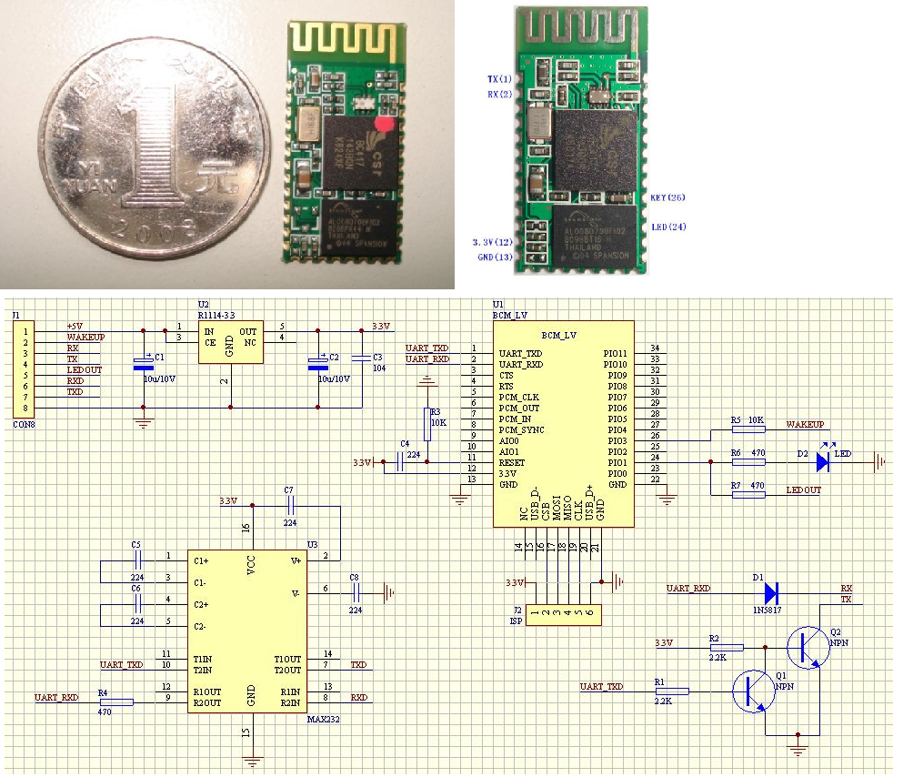
Figure 9.3.1.1: HC-06
Features:
- Use the CSR Bluetooth chip, compatible with the Bluetooth V2.0 protocol
- Slave
- Operating Voltage 3.3V
- Adjustable baud rate : 1200，2400，4800，9600,19200，38400，57600，115200
- Size: 28mm x 15 mm x 2.35mm
- Operating Current 40 mA
- Sleep Current < 1mA
- Program with AT command language
- UART interface
- Range 30ft ~ 9,1m
- Made in China
Price: 350,000 VND

Feasibility of HC-06 in FUFO
FUFO's circuit needs | dsPIC30d4012 provide | Status
Use a Bluetooth module to establish UART connection between Android phone and Microprocessor | Use the CSR Bluetooth chip, compatible with the Bluetooth V2.0 protocol | OK
10m range is enough | Range ~9.1m (30 feet) | OK
Baud rate = 9600 | Adjustable baud rate : 1200，2400，4800，9600,19200，38400，57600，115200 | OK
Small size | Size: 28mm x 15 mm x 2.35mm | OK
UART interface | - Program with AT command language  - UART interface | OK
Buyable | The only Bluetooth module can be found in Vietnam market at this time | OK
Table 9.3.2.1: Feasibility of HC-06

9DOF: BMP085 + L3G4200D + ADXL345 + HMC5883L
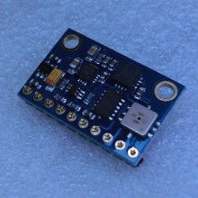
Figure 9.3.1.1: 9DOF: BMP085 + L3G4200D + ADXL345 + HMC5883L
9DOF: BMP085 + L3G4200D + ADXL345 + HMC5883L is a Chinese-made sensor module that consists the following sensors:
  - L3G4200: gyroscope
  - ADXL345: accelerometer
  - BMP085: pressure sensor
  - HMC5883L: digital compass
Price of this module is 1,100,000VND
This is the only sensor module our team can find in Vietnam. FUFO project only need Accelerometer and Gyroscope sensors.
Each of these sensors will be discussed in the following part.

L3G4200

Features
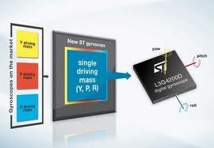
Figure 9.4.1.1.1: L3G4200D Gyroscope
- Three selectable full scales (250/500/2000 dps)
- I2C/SPI digital output interface
- 16 bit-rate value data output
- 8-bit temperature data output
- Two digital output lines (interrupt and data ready)
- Integrated low- and high-pass filters with user-selectable bandwidth
- Ultra-stable over temperature and time
- Wide supply voltage: 2.4 V to 3.6 V
- Low voltage-compatible IOs (1.8 V)
- Embedded power-down and sleep mode
- Embedded temperature sensor
- Embedded FIFO
- High shock survivability
- Extended operating temperature range (-40 °C to +85 °C)
- ECOPACK® RoHS and “Green” compliant

Feasibility
Why it is suitable for FUFO project?
  - ultra-stable three-axis digital output gyroscope
  - I2C/SPI digital output interface
  - 16 bit-rate value data output
  - 8-bit temperature data output
  - Wide supply voltage: 2.4 V to 3.6 V
  - Three selectable full scales (250/500/2000 dps) is capable of measuring rates with a user-selectable bandwidth.
  - The only Accelerometer that we can find in Vietnam.

ADXL345

Features
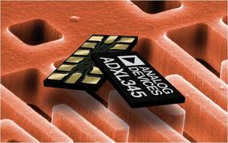
Figure 9.4.2.1.1: ADXL345 accelerometer sensor

- Ultralow power: as low as 23 μA in measurement mode and 0.1 μA in standby mode at VS = 2.5 V (typical)
- Power consumption scales automatically with bandwidth
- User-selectable resolution:
- Fixed 10-bit resolution
- Full resolution, where resolution increases with g range, up to 13-bit resolution at ±16g (maintaining 4 mg/LSB scale factor in all g ranges)
- Patent pending, embedded memory management system with FIFO technology minimizes host processor load
- Single tap/double tap detection
- Activity/inactivity monitoring
- Free-fall detection
- Supply voltage range: 2.0 V to 3.6 V
- I/O voltage range: 1.7 V to VS
- SPI (3- and 4-wire) and I2C digital interfaces
- Flexible interrupt modes map to either interrupt pin
- Measurement ranges selectable via serial command
- Bandwidth selectable via serial command
- Wide temperature range (−40°C to +85°C)
- 10,000 g shock survival
- Pb free/RoHS compliant
- Small and thin: 3 mm × 5 mm × 1 mm LGA package
- 3-Axis, selectable sensitivity: ±2 g/±4 g/±8 g/±16 g Digital Accelerometer

Feasibility
Why it is suitable for FUFO project?
- 3-Axis Digital Accelerometer
- Flexibly selectable sensitivity: ±2 g/±4 g/±8 g/±16g
- High shock survival: 10000g
- Supply voltage range: 2.0 V to 3.6 V
- I/O voltage range: 1.7 V to 2.5 V
- SPI (3- and 4-wire) and I2C digital interfaces
- The only Gyroscope sensor that we can find in Vietnam.

Mystery FireDragon ESC 30A
ESC is Electronic Speed Controller, a simple circuit board that handles the work of controlling speed of Brushless DC motor. After connect all the wire to correct position, the motor's speed can be controlled by the corresponding PWM signal input into ESC.
Here are some features of Mystery FireDragon ESC 30A, which is available on the market:
- Weight: 22g (including wire)
- Max Current: 35A (for ten seconds)
- BEC: 2A at 5V
- Input: 2 - 3 Lithium-ion Polymer.
- Price: 220,000VND

Motor Himodel A2212-10T 1400kv

Brushless VS Brushed
Motor is the device that generate power to rotate the propeller. There are two type of motor: brushed motor and brushless motor. The two figures below will show some concepts
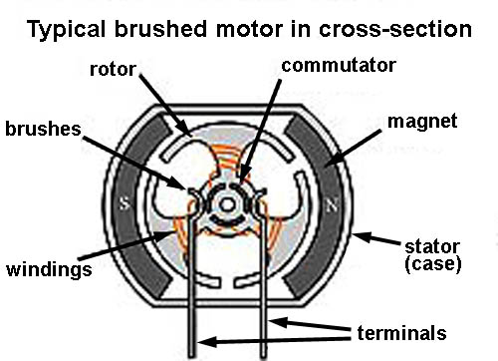
Figure 9.6.1.1: Brushed Motor
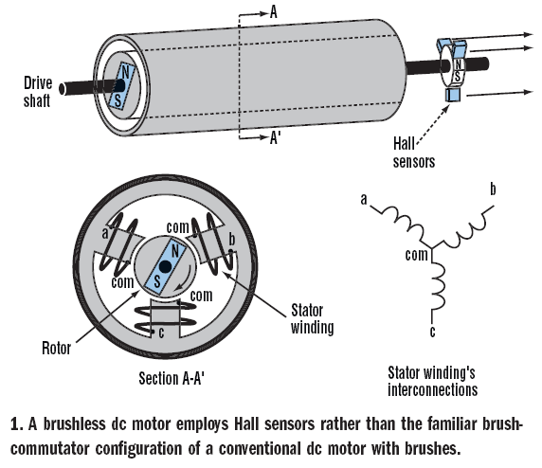
Figure 9.6.1.2: Brushless Motor

Brush VS Brushless:
- BLDC motors are often more efficient at converting electricity into mechanical power than brushed motors.
- The maximum power that can be applied to a BLDC motor is exceptionally high, limited almost exclusively by heat, which can weaken the magnets.
- BLDC motor has more torque per watt (increased efficiency), increased reliability, reduced noise, longer lifetime (no brush and commutation erosion).

Motor Himodel A2212-10T 1400kv
Features:
- No. Of cells:2-3 Li-Poly
- Brushless motor.
- Max. efficiency current:6-18A (>75%)
- No load current / 10 V:0,7 A
- Dimensions:27.5x30 mm
- Shaft diameter: 3.17 mm
- Weight:47 g
- Recommend prop : 8x4,9x5
- Thrust : 800g +
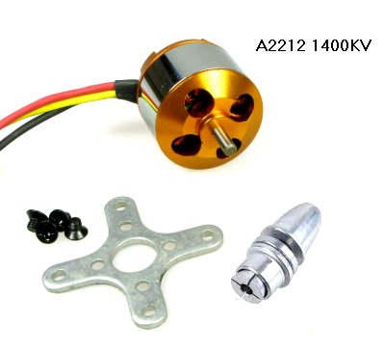
Figure 9.6.2.1: Motor Himodel A2212-10T 1400kv
Explanation:
- 1400kv or 1400RPM/V (RPM is revolutions per minute). Example:
  - Use power 1V for this: 1400 x 1 = 1400 revolutions/minute.
  - Use power 10V : 1400 x 10 = 14.000 revolutions/minute.
- Max. efficiency current: As the motor performance, the higher efficiency of energy is, the lower of energy loss.
- No load current / 10 V:0,7 A mean: if motor doesn’t work, power loss is 10V : 0,7A.
- Recommends Propeller : 8x4, 9x5:
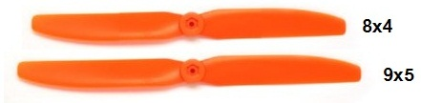
Figure 9.6.2.2: Propeller 8x4 and 9x5

Software Study
There are many aspect of software which may be involved in FUFO project. In this document, only the most concerned software aspect will be mentioned.

Embedded Software
Quadrocopter is an unique aerial model that can fly base on the adjustment of each of its four motors speed.^{[9]} The Figure 10.1.1 below will show an example of how the Quadrocopter work:
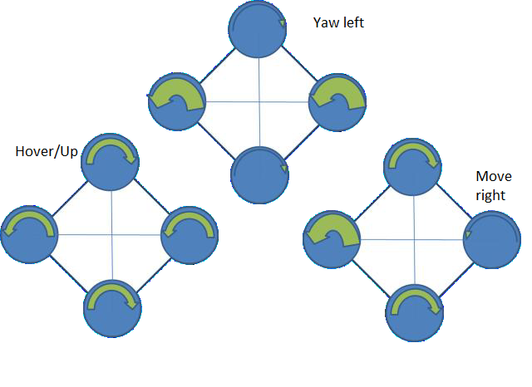
Figure 10.1.1: Quadrocopter torque patterns and related motions
The general Coordinate for Quadrocopter are:

q=(x,y,z,θ,φ,ψ) | [1]
Where (x, y, z) denote the position of the center of mass of the rotorcraft relative to the frame, and (θ, φ, ψ) are the three Euler angles which represent the orientation of the craft.
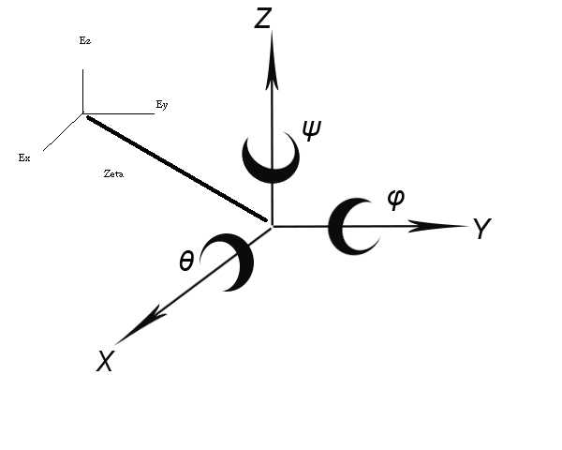
Figure 10.1.2: Body and inertial frame coordinate Axis used in this paper
The aim of the embedded software in the Microcontroller is to generate a PWM signal to every ESCs to control the speed of the motors bases on the control input from user in manual mode and angular input from Gyroscope and Accelerometer in Autonomous - Dynamic Balancing mode.
In manual mode, user will just send hover UP/DOWN/LEFT/RIGHT/BACK/FRONT commands, and the embedded software will control the PWM duty cycle base on them.
However, in Autonomous - Dynamic Balancing mode, the Quadrocopter will have to automatically maintain a parallel plain with the plain that perpendicular to the earth gravitational force vector. This can only be archived using the Accelerometer and Gyroscope's angular inputs with Proportional-Integral-Derivative (PID) control theory in the software which is full of control algorithm. Since every team member of FUFO is Software Engineering student, this control theory can be a serious challenge. However, this is what makes the project interesting.
A more clearly reference and application of PID to Quadrocopter system has been mentioned in "Modeling and Control of Mini-Flying Machines"^{[10]} and " Design Optimization of a Quadrotor Capable of Autonomous Flight". The project team members will base on those papers and books to design and program the PID system in FUFO embedded software.

Real-time video transmission
In this project, a real-time video transmission from Quadrocopter to pilot computer is vital for pilot to control the craft in a long distance. At first, FUFO team intended to integrate a Wifi module and a CMOS Camera module to the Quadrocopter to send picture. However, that may lead to many risks upon the complexity of the main circuit and the short time period system development of this Capstone project. Finally, FUFO team decided to use an Android 2.3 Phone instead to solve that issue because an Android 2.3 phone is cheap, and already have integrated camera module and Wifi and 3G module. The Android phone can also communicate with the Quadrocopter via its Bluetooth module. This should not be a problem since the Android SDK has already supported it. That is how the FUFO system looked like the figure 7.1.
The real challenge in this section of FUFO system is the real-time video transmission. That challenge's cause is the limited bandwidth characteristic of Vietnam Internet infrastructure. It is quite impossible to send a 30 FPS high definition video from the Android Phone to the pilot's PC under the Internet Bandwidth. Fortunately, after study the " UAV Imagery Frame Rate and Resolution Requirements Study "^{[8]} created by Advance Technology department of Vitro Corporation, the team has figured out that the FPS of an UAV's camera video that is being streamed to pilot can be at 4 FPS in minimum, and JPEG compression of the pictures is not a problem because the pilot can still complete his/her tasks.
With those information, FUFO team has made a prototype of sending picture sequence from an Android phone's 320x240 camera to the PC at approximately 10FPS under JPEG compression. The result is quite positive:
Picture resolution | 320x240
Compression method | JPEG - 50% quality
Mean time of taking a picture and compressing it | 124 ms (+5 ms or -5ms)
File size before compression | 112.5 KB
Mean of file size after compression | 8KB (+2KB or -2KB)
Mean of delay time when send a picture with Viettel 3G | 1s
Mean of delay time when send a picture with 10/100mbs Wifi | 40ms
UDP Packet size | 10KB
Loss rate of packet transmitted by UDP via 10/100mbs Wifi | 0/1000 packet = 0%
Loss rate of packet transmitted by UDP via Viettel 3G | 12/1071 packets ~ 1%
Mean of time needed to draw a picture to screen by JAVA SWING | 5ms
Total delay time using Viettel 3G | ~ 1s
Total time for a picture to go from phone's camera to PC's application screen using 10/100mbs Wifi | 169ms
Possible FPS | 8 FPS
Bandwidth needed | ~78KB/second
Table 9.2.1: Prototype result of real-time video transmission
The results shown by the prototype have clearly proven that this is a good solution for the real-time video transmission section of FUFO project. Further design based on this study will be made as soon as possible.

Communication between the devices in FUFO system
As discussed in the above parts, the phone application will connect to the Quadrocopter via Bluetooth, and will connect to PC via Internet Protocol. However, the requirements for each connection are not cleared. The following parts will discuss further about these requirement.

Angular statuses communication
With regards to the requirement about sending angular statuses from Quadrocopter to PC, FUFO team has found out that the Android phone should be the intermediary between Quadrocopter and PC. The system can archive this purpose by sending angular statuses from Quadrocopter to Android Phone via Bluetooth protocol 2.0 with RS232 interface and then the Android phone will send them to PC using TCP/IP.

Control command communication
The same as angular statuses communication, but in a reserved order of communicating, PC will send user control command to Android Phone via TCP/IP and then that command will be sent to the Quadrocopter via Bluetooth protocol 2.0 with RS232 interface.
The point of using TCP/IP in this application is very important. The reason behinds this decision is the system must ensure that every command from pilot will be sent to the Quadrocopter or it will be uncontrollable and may crash during its hovering time, any loss in the communication line will not be tolerated. TCP/IP has a method to solve this problem in losing data during transmission, therefore it is chosen among other protocols of Internet.

Project Organization

Software Process Model
This project is a big project which involved development in three platforms (PC, Android, Embedded system), but FUFO team only have 4 months to complete it. Therefore, every step of the project must be as accurate as possible. To archive this, the process model of the project should be iterative and incremental development model^{[4]}(figure 9.1.1).
The Embedded Software design and development model^{[5]} (figure 9.1.2) will also be applied in the Embedded platform because it will gain a lot of benefits from the Iterative model. If every part of the Embedded Software design and development model is done in an iterative way, the risk of redesigning hardware will be decreased.
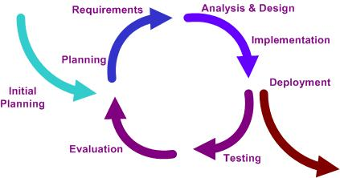
Figure 9.1.1: An iterative development model.
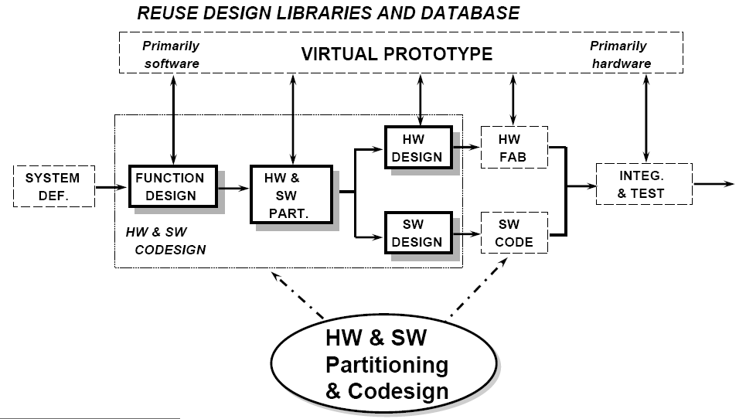
Figure 9.1.2: An Embedded software design and Development.

Roles and Responsibilities
Project Instructor
  - Mr. Phan Duy Hung
Project team member
- Due to the multiplatform characteristic of FUFO project, the team had to split in two main teams, each has its own mission that contributes to the project:
- FUFO - Hardware team: includes HungHD, ThangVD - Working on the Quadrocopter hardware and embedded software design and development.
- VP - Software team: includes NguyenLK, YenTT - Working on developing the Software in PC and Android platform.
- Project manager: PhongVM
- Project Quality Control: YenTT
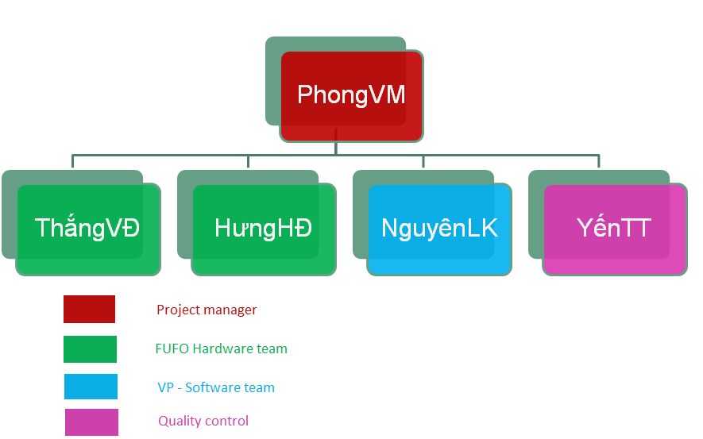
Figure 9.1.2: FUFO's team members.
The figure 9.2.1 below will describe the role of each team member in the whole project and in each team.
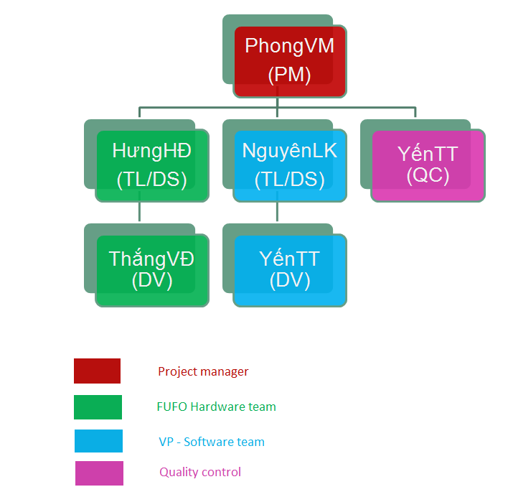
Figure 9.1.2: Team members and roles in FUFO project.

Project Management Plan
The full plan of FUFO project is attached in the same folder with this document.

Risk Management
ID | Risk Description | Probability | Effect | Status | Action | Contingency
1 | Quadrocopter Frame Design:  Lack of aerodynamic knowledge may lead to permanent issues with the frame design | Very high | Tolerable | Occurred | Reuse the designed frame design of other projects which involving design a quadrocopter | Get from internet
2 | Testing damage:  The first version of Quadrocopter may lack of stability, which may result in damage while testing. | Very high | Serious | Potential | Tie the Quadrocopter into ground.
3 | Human injuries:  People may get injuries from the test activities of FUFO because of electricity or sharp propellers. | Very high | Serious | Potential | Always double check the testing and working environment safety before testing.
4 | PID knowledge:  Team member lack of robotic and control knowledge, especially PID. | Very high | Serious | Occurred | Prepare knowledge for robotic and control by materials and internet. | Request support from friends or someone that is expert of PID and robotic and control.
5 | Hardware failure:  Lack of experience in hardware design may lead to unexpected failure. | Very High | Serious | Occurred | Ask for review and support from supervisors and experienced acquaintances.
6 | Project Management skill:  Project Manager lacks of project management skill | Moderate | Serious | Occurred | Project Manager prepares knowledge from text book in library | Ask many experienced Project Manager as possible when getting trouble
7 | Human resource:  Some time team member will have to off several day due to personal reasons. | Moderate | Tolerable | Potential | Estimate buffer time in project plan and require all team member to inform team 1 week before off.
8 | Hardware complexity:  It would be too hard to make every single circuit module in 4 months. | Very High | Serious | Potential | Buy any circuit modules that available on market, only design the main board. | Search on internet.
Table 11.1: Android phone is attached to the Quadrocopter mechanically.

Coding Conventions
The following rules follow the standard rules for developing applications using JAVA and C++.

Naming Conventions
Java: Refer to FPT Software guideline on Standard JAVA coding convention.^{[6]}
C30: Refer to Google coding convention.^{[7]}

Comments
- Comments should be written in order to make code understandable and maintainable.
- In Java and Android application, only write comments when necessary.
- In Embedded software, write comment on every configuration bit or register to describe the effect of it.
- Use // for comments on code lines, use /** **/ for comment on functions.
- Do not write comments if the code is easily understandable without comment.
- Perform spelling check on comments and also make sure proper grammar and punctuation is used.

List of References
[1] | - "Enhanced reversible lithium storage in a nano-sized silicon/grapheme composite" <http://www.sciencedirect.com/science/article/pii/S1388248109006225>  - Ieee Spectrum. “Silicon-Grapheme Sandwich Creates Li-ion Batteries with Ten Times Longer Charge Life”. <http://spectrum.ieee.org/nanoclast/semiconductors/materials/silicongraphene-sandwich-creates-liion-batteries-with-ten-times-longer-charge-life>  - Ieee Spectrum. “Grapheme-Silicon Anodes for Li-ion Batteries Go Commercial”. <http://spectrum.ieee.org/nanoclast/semiconductors/nanotechnology/graphenesilicon-anodes-for-liion-batteries-go-commercial>
[2] | "Bluetooth Basic "http://www.bluetooth.com <http://www.bluetooth.com/Pages/Basics.aspx>
[3] | Wikipedia. "Attitude Indicator". Wikipedia.org. <http://en.wikipedia.org/wiki/Attitude_indicator>
[4] | Wikipedia. (Jan 28, 2012). “Iterative and incremental development”. Wikipedia.org. Feb 3, 2012 <http://en.wikipedia.org/wiki/Iterative_and_incremental_development>
[5] | Phan Duy Hung. "Embedded System Development Overview". FPT University
[6] | FPT Software. August, 15th 2003 "Standard Java Coding convention".
[7] | Benjy Weinberger. "Google C++ Style Guide". Google Inc.  < http://google-styleguide.googlecode.com/svn/trunk/cppguide.xml>
[8] | Merryanna L. Swartz, Daniel F. Wallace, John M. Libert, Sharon Tkacz, Daniel Soloman, "UAV Imagery Frame Rate and Resolution Requirements Study", Advance technology department, Vitro Corporation. Feb 28,1992
[9] | Antonio DiCesare, Kyle Gustafson, Paul Lindenfelzer. "Design Optimization of a Quadrotor Capable of Autonomous Flight", Worcester Polytechnic Institute.
[10] | P. Castillo, R. Lozano, and A.E. Dzul, "Modeling and Control of Mini-Flying Machines",. Springer-Verlag, New York, 2005

