Report on Control system of Quadrocopter

I-FUFO's Quadrocopter requirement
To be sure about the control method we will use in this project, we have to classify the requirements of this Quadrocopter:
- The Quadrocopter must:
+ Keep balance in the middle of the air.
- The Quadrocopter should:
+ Maintain a reasonable specified altitude.
- The Quadrocopter do not need to:
+ Hover from point A to point B in space automatically.
+ Adjust its position in the space (Similar to hover from point A to point B).
Those requirement is for simplifying the Control system of Quadrocopter, which gives advantages to the development time and hardware design since we only use Accelerometer and Gyroscope in this project.

II-Analysis the requirement

a. The "must" requirement:
According to my previous report, to keep the Quadrocopter balance in the middle of the air, only three variables of the Quadrocopter dynamic need to be considered: 𝜓 (yaw), 𝜃 (roll), 𝜑(pitch). Each of these variables is an Euler angle which represent the difference between the Body frame and the Inertial Frame, given that the considered Inertial Frame has its Origin (O) at the same place as the Body frame's Origin, at the Mass Center of the Quadrocopter. This Inertial Frame has the same Oz's direction as the Ground Frame. (Figure 1)
That is the theory, in fact, we have the Origin of the Inertial Frame and Body Frame according to the Accelerometer sensor's Origin because it is the only measurable Origin in the system. The Measured variables in Accelerometer can be converted to 𝜓, 𝜃, 𝜑 via some equations which will be discussed in the next parts of this report.
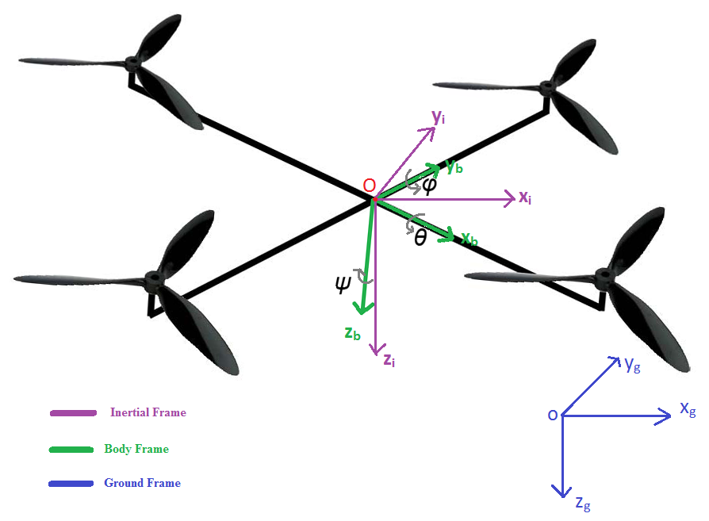Figure 1
After measuring all the needed angle, the control system will automatically calculate the needed PWM for each motor to rotate the Body Frame into the Inertial Frame. We will use PID control system to archive this. Figure 2 shows the Euler Angles according to Right Hand Rule.
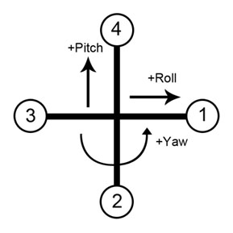
Figure 2
Each yaw, pitch, roll angle will need a PID equation to calculate the needed PWM value. We can simply understand this by assume the Inertial Frame's angles are the "desired angles" and the Body Frame's angles are the "actual angles". Each yaw, pitch, roll angle will have the following equation in embedded environment^{[1]}:
e = desired angle - actual angle
total_e = total_e + e
P = K_{p}e
I = K_{i}*total_e*∆t
D = K_{d}(current_e - last_e)/ ∆t = Kd*gyro_output
angle_sum = P + I + D
where "dt" is the time period between each read from sensors.
According to firgure 2 and the PID control system, PWM of each motor can be calculate as:
PWM_motor1 = roll_sum + yaw_sum
PWM_motor2 = – pitch_sum – yaw_sum
PWM_motor3 = – roll_sum + yaw_sum
PWM_motor4 = pitch_sum – yaw_sum

b. The "should" requirement:
To maintain a specified altitude, the Quadrocopter must have a sensor which measure the distant between the ground and the vehicle. That sensor can be either an Infrared RangeFinder sensor or a Pressure Sensor. However, including another sensor may increase the development time, and lead to many risk.
After review many solution on this problem, we decided that the Quadrocopter will maintain a blinded-altitude. A blinded-altitude is an altitude measured by the forces of motor, not by the metric system.
We are assumed that there is a constant k, that:
Motor's force = k*PWM value.
What we input into the motor controller is a PWM value, and then the motor will produce a corresponding force. That force will lift the Quadrocopter to an expected altitude which depends mostly on the characteristic of that environment (Temperature, air density, position on the earth, etc). To get to this expected altitude, the pilot need to observe the current altitude of the Quadrocopter and adjust the PWM value. The expected PWM value is called the "Thrust Floor". This Thrust Floor is only related to the altitude measurement of the Quadrocopter, therefore, we have to combine it with the PWM values of pitch, roll, yaw angles to make the Quadrocopter balance in a expected altitude. The PWM value of each motor is now calculated as^{[1]}:
PWM_motor1 = Thrust_Floor + roll_sum + yaw_sum
PWM_motor2 = Thrust_Floor – pitch_sum – yaw_sum
PWM_motor3 = Thrust_Floor – roll_sum + yaw_sum
PWM_motor4 = Thrust_Floor + pitch_sum – yaw_sum

III-Gyroscope and Accelerometer:

a. Gyroscope:
Gyroscope is a sensor that measures the angular velocity of its own frames. It is like comparing the current angular position of its frame and the last angular position of its frame over an amount of time, then calculate the angular velocity of this angular movement.
The angular velocity of gyroscope is based on the movement of its Euler angle. Therefore, its output should be: 𝜓', 𝜃', 𝜑'.
In this project, the needed variable is 𝜓, 𝜃, 𝜑. Therefore a small conversion should be applied:
𝜓 = 𝜓'∆t
𝜃 = 𝜃'∆t
𝜑 = 𝜑'∆t
Where ∆t is the time between two sample.
But these values are just instant value of angle changed during ∆t. To get the angler changed compare with the set-point value, we must integrate the instant angular values over time:
𝜓_{a} = 𝜓_{a} + 𝜓'∆t
𝜃_{a} = 𝜃_{a} + 𝜃'∆t
𝜑_{a} = 𝜑_{a} + 𝜑'∆t
However, due to the extremely sensitive characteristic of the gyroscope sensor we are using (L3G4200D), the noise in angular velocity data are generally unavoidable and when the gyro data is integrated, the noise will also be integrated together. Furthermore, the gyroscope has its limitation where the output is not a constant offset when it is in static condition. In fact, this value will keep changing especially when there is temperature change. This condition is called drift. Although the drifting is very small, when we are dealing with integration, even the smallest offset will cause the integrated data to grow to infinity.
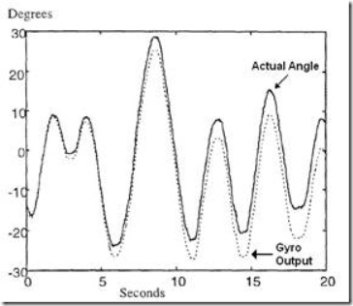
Figure 3
Therefore we have to filter the data and get the most correct values of 𝜓, 𝜃, 𝜑. The filtering method can be either applied before calculating 𝜓, 𝜃, 𝜑 or right after it or both. There is some methods shown in the Application note of L3G4200D sensor for filtering the noise of angular velocity data, I will not mention it in this report, but maybe it will be mentioned in the next report if we find it is necessary. In this project, we surely use an filtering method after the calculation of 𝜓, 𝜃, 𝜑, which might be Kalman Filter or Complementary Filter. These filters is data fusion filters that need another sensor to calculate 𝜓, 𝜃, 𝜑. Apparently, that other sensor will be an Accelerometer, which will be discussed in the next part of this report.

b. Accelerator
This report is based on the Application Note for FreeScale Accelerometer product, and I will assume that their document is right. Any equation given in this report will be assumed as right and do not need to be proven again. If you want the proven part, please find in the reference list at the end of this report.
Accelerator is a sensor that measures the acceleration of the force as projections in its body frame. One of the most common force that can be measured by an accelerator is the Gravity force of the Earth.
The data that an accelerator output is the projection of the acceleration in Ox, Oy, Oz of its body frame. If we know the direction of the force, we can eventually calculate the Euler angle of Accelerometer's body frame with respects to the Inertial frame of that force by multiplying with a direction cosine transformation matrix. However, it is proven that we can only calculate the 𝜃, 𝜑 angles with a given Gravity vector, and the rotation about that vector, or in other word, the 𝜓 angle is yet to be known. This lead to the fact that in the filter methods, we will not use 𝜓 angle from Accelerometer.
Given a perfect environment, in which the only force that affect the accelerometer is the Gravity force as Figure 4:
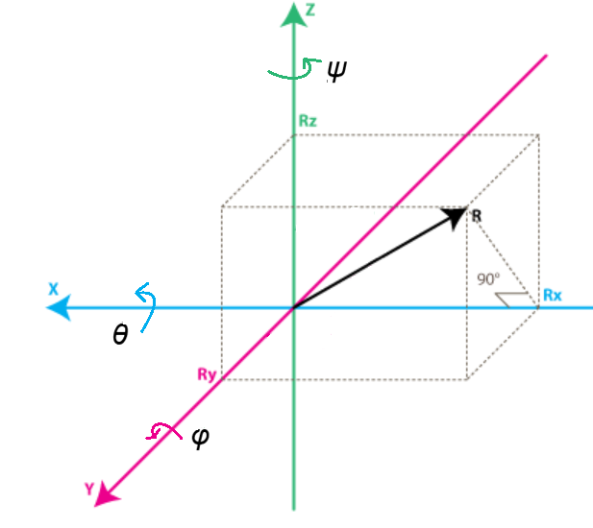
Figure 4
Rx, Ry, Rz is the projection of vector R on the corresponding Ox, Oy, Oz of the body frame, and vector R is the Gravitational Force's Acceleration Vector.
For this environment, the equation below can be used to find the 𝜃, 𝜑 angle:
Tan(𝜃) = Ry/Rz
Tan(𝜑) = -Rx / SQRT(Ry² + Rz²)
Now we have Tan(𝜑) and tan(𝜃), but this lead to an infinite number of solutions at multiples of 360º. Restricting the range of 𝜑 and 𝜃 angles to lie in the range -180º and 180º will help. But this eventually this solution leads to two unique conventions as shown in the Application Note. In this project, we will use the conventions used in the Aero space industry which is that the 𝜃 angle can range between -180º and 180º, but the 𝜑 is restricted to -90º to 90º.
However, the inverse tangent function of Tan(𝜃) is mathematically defined for all value of Rz and Ry with one exception where both Ry and Rz is equal to Zero. This condition occurs when the Accelerometer is aligned with its x-axis pointing vertically upward or down ward. Even if the Accelerometer is not exactly vertical, the inverse tangent can still be dominated by the noise in Rx or Ry and produce an unstable and essentially random estimate of the 𝜃 angle. This issue will not happen to Tan(𝜑) because when we apply the constraint that Rx²+Ry²+Rz² = 1g (the length of vector R), it clearly shown that it is impossible for denominator and numerator to be simultaneously equal to Zero and give an unstable angle estimate. However this constraint will eventually fail if there is any handshake, linear acceleration, sensor noise, etc.
There is no perfect solution to the problem of 𝜑 and 𝜃 angles singularities in its Tangent equations. One workaround, which is commonly used in the aerospace industry, is to still use the Tan(𝜑) function but to modify Tan(𝜃) function as below:
Tan(𝜑) = -Rx / SQRT(Ry² + Rz²)
Tan(𝜃) = Ry/SQRT(Rz² + µRx²)
Where µ is a fraction of Rx². We can determine which value of µ is suitable for the project based on actual measurement of Accelerometer. I suggest that the project should use µ = 0.01 as shown in the Application Note. The smaller µ is, the lesser the errors are, but the more µC resource will be used in processing the number.
As we can see, the Tan(𝜃) function is an approximation and its errors can be calculated and have been shown in the Application Note, page 14 and 15.
The inverse tangent function now can be used to calculate the angles, but please keep in mind that these angle are in Radians, to convert them to Degree, simply multiply them by 180/π.
𝜑 =(180/π) * Arctan[ -Rx / SQRT(Ry² + Rz²) ]
𝜃 =(180/π) * Arctan[ Ry/SQRT(Rz² + µRx²) ]
Unfortunately, all of the above equation based on the assumption that only Gravity force affect the Accelerometer. In this project, any movement of the Quadrocopter could result in a linear force that change the result of the Accelerometer, thus make the calculated angle become inaccurate. Typically, the acceleration components causing by the dynamic movement of the Quadrocopter only happens in a short period of time, while the gravity acceleration is acting on the robot permanently. By low-pass filtering the data from the accelerometer, we can filter out the unwanted high frequency acceleration components and we are left with only the gravity acceleration which can be used to calculate the Euler angle of the Quadrocopter.
𝜑_{lp} = k.𝜑_{lp} + (1-k) 𝜑
𝜃_{lp} = k. 𝜃_{lp} + (1-k) 𝜃
Where k is the coefficient of a Time-Constant. Time-Constant is the relative duration of signal it will act on. For the Low-pass filter, signals is much longer than the time constant pass through unaltered while signals shorter than the time constant a filtered out. An analysis on the Accelerometer signals will help find this constant. Time-constant τ and its coefficient can be found like this (http://en.wikipedia.org/wiki/Low-pass_filter#Passive_digital_realization):
τ = k. ∆t/(1-k)
k = τ/( τ+∆t)
Where ∆t is the time between two samples.
However, the low-pass filter will increase the latency and slow down the response time of the measurement as shown in the figure 5 below. That’s where the gyroscope comes in with the Complementary Filter.
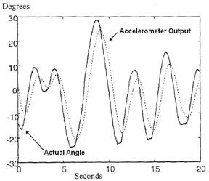
Figure 5

c. Magnetometer
The Magnetometer is a sensor that used to find the North direction of the Earth. Its behavior is similar to Accelerometer, but the inertial vector that is used to navigate is headed North instead of the center of the Earth. Therefore, it is possible to use this sensor to find the Yaw angle of the Quadrocopter. With the assumption that the Ox vector of the Inertial Frame has the same direction with the North inertial vector of the Magnetometer, we can use the following equation (which is converted directly from the equation of Accelerometer) to find Yaw Angle:
𝜃 = (180/π) * Arctan[ Ry/SQRT(Rz² + µRx²) ]
𝜓 = (180/π) * Arctan[ Ry/SQRT(Rx² + µRz²) ]
Where Ry, Rx, Rz is the measured value from the Magnetometer.

IV-Filter

a. Kalman Filter vs Complementary Filter
In this project, we use two sensors ( MEMS accelerometer and MEMS gyroscope) to calculate the same Euler Angles. This lead to the work of merging signals from Gyroscope and Accelerometer by a math filter.
The gyroscope has a drift and in a few time the values returned are completely wrong. The accelerometer, from the other side, while returns a true value when the acceleration is progressive, it suffers much the vibrations, returning values ​​of the angle wrong.
To filter the signals, it is usually used the Kalman Filter, very complex from the math point of view. There is also a simple filter, called the Complementary Filter that could be used.
From theoretical point of view, Kalman Filter is the best filter, but because of the complexion of its algorithm, it may need to much resource of the Microcontroller to work. Complementary is a more easy, faster Filter for the Microcontroller. In practice, its results is not too different from the results of the Kalman Filter, as shown in an example in Figure 6.
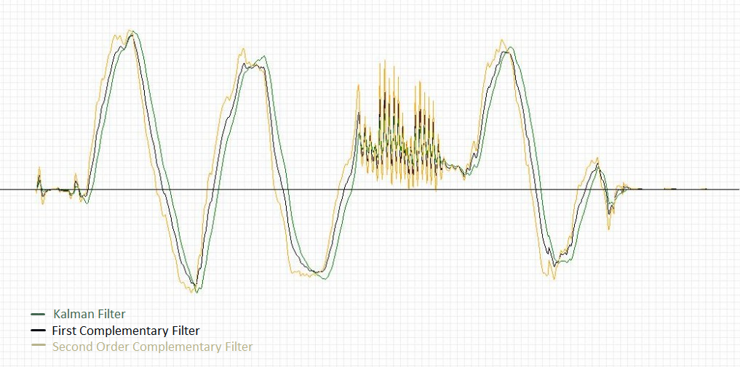
Figure 6
In this report, I will focus on the explanation of Complementary Filter. Kalman Filter will be updated to this report if it is crucial to the success of the project.

b. Complementary Filter
After studying the characteristics of both gyros and accelerometer, we know that they have their own strengths and weakness. The calculated Euler angle from the accelerometer data has slow response time, while the integrated Euler angle from the gyro data is subjected to drift over a period of time. In other words, we can say that the accelerometer data is useful for long term while the gyro data is useful for short term.
One of the simplest ways to combine the data from the gyro and the accelerometer is by using the complementary filter. Complementary filter is designed in such a way that the strength of one sensor will be used to overcome the weaknesses of the other sensor which is complementary to each other.
In this application, the task of the complementary filter is to make use of the integrated angle from the gyro in short period, and then the low pass filtered data from the accelerometer is used to correct the drift of the angle over long period of time. The offset of the gyro sensor will also be continuously updated and corrected. This will result in a drift free and fast responding estimated Euler angle.
The equations for Angle Complementary Filter are:
𝜑_{comp} = k(𝜑_{comp} + 𝜑'_{gyro}*∆t) + (1-k) 𝜑_{Acc}
𝜃_{comp} = k(𝜃_{comp} + 𝜃'_{gyro}*∆t) + (1-k) 𝜃_{Acc}
𝜓 _{comp} = k(𝜓 _{comp} + 𝜓 '_{gyro}*∆t) + (1-k) 𝜓 _{mag}
Where k is the coefficient of a Time-Constant. (𝜑_{comp} + 𝜑'_{gyro}*∆t) is the Integrated angle 𝜑 calculation for Gyroscope output. 𝜑_{Acc} is the calculated angle 𝜑 from Accelerometer (without a Low-pass filter). The same for angle 𝜃. 𝜓 _{mag} is the calculated angle from Magnetometer.
Time-Constant is the relative duration of signal it will act on. For the Low-pass filter, signals is much longer than the time constant pass through unaltered while signals shorter than the time constant a filtered out. An analysis on the Accelerometer signals will help find this constant. Time-constant τ and its coefficient can be found like this:
τ = k. ∆t/(1-k)
k = τ/( τ+∆t)
Where ∆t is the time between two samples.

V-Reference
1. Wyvern Quadrocopter, Pennsylvania University, <http://airhacks.org/?page_id=5>
2. Kalman Filter Vs Complementary Filter, Robottini, <http://robottini.altervista.org/kalman-filter-vs-complementary-filter>
3. Direction Cosine, Wikipedia <http://en.wikipedia.org/wiki/Direction_cosine>
4. Accelerometer & Gyro tutorial, www.Instructables.com <http://www.instructables.com/id/Accelerometer-Gyro-Tutorial/>
5. Euler Angle, Wikipedia <http://en.wikipedia.org/wiki/Euler_angles>
6. The Balance Filter, Shane Colton, June-25th-2007,MIT
7. Building and controlling the Quadrocopter, Pavel Chmelar, December 2011, University of Pardubice.
8. Quadrotor Dynamics and Control, Randal W.Beard, Feb-19th - 2008, Brigham Young University.
9. Measuring Tilt Angle with Gyro and Accelerometer, Kong Wai Weng, May 2009, RH2T Magazine Vol.1, <http://tutorial.cytron.com.my/2012/01/10/measuring-tilt-angle-with-gyro-and-accelerometer/>

