- Definitions, Acronyms and Abbreviations
Abbreviations | Description | Comment
FUFO | FPT University Flying Object
PWM | Pulse-width modulation
I2C | Inter-integrated circuit
UART | Universal asynchronous receiver/transmitter
TMR | Timer
Accel | Accelerometer
Gyros | Gyroscope
Baro | Barometer

- FUFO State diagram

FUFO system will base on this following State Diagram:
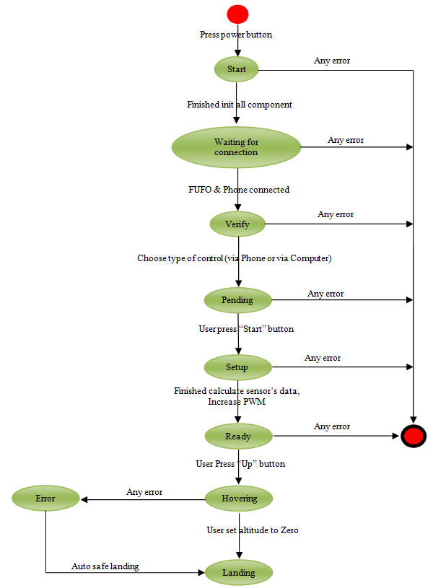

Figure 1 - FUFO State Diagram

- Start State
- When power turn on, first state of FUFO is “Start”, in this state, FUFO will init communication method as I2C, UART, and modules as PWM, Accel, Gyros, Baro, TMR2.
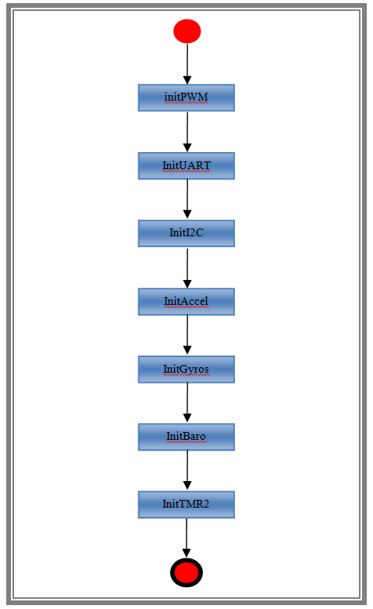
Figure 2 – Start State Diagram

- WaitingForConnection
- FUFO check Bluetooth connection between FUFO and Phone.
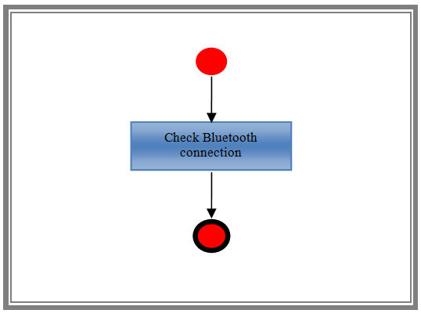
Figure 3 - Waiting for connection

- Verify
- We can control FUFO via Phone or via Computer. In this state, FUFO will check type of control.
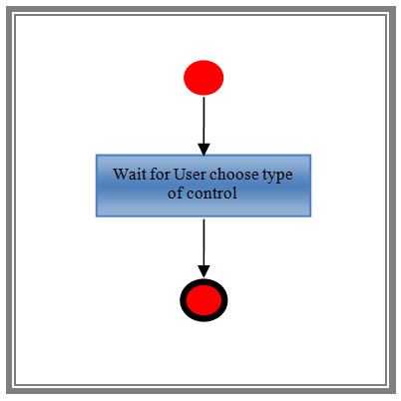
Figure 4 - Verify State Diagram

- Pending
- In state Pending, FUFO wait in while loop util user press Start button to start FUFO.
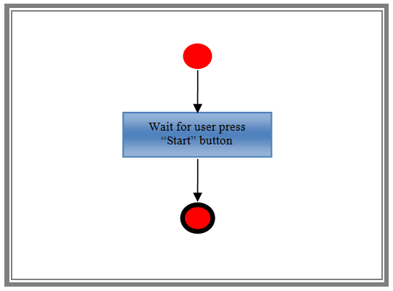
Figure 5 - Pending State Diagram

- Setup
- FUFO will increase PWM to the set level (40% of thrust rate), and also calculate data get from sensor to reduce noise in gyros.
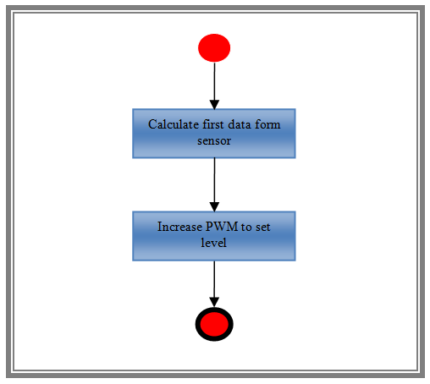
Figure 6 - Setup State Diagram

- Ready
- When finish increase PWM and calculate sensor’s data, FUFO run in Ready State. This state will wait for user press “Up” button to increase altitude of FUFO, turn TMR2 On, and turn PID on for FUFO archive to set altitude(0.5 m).
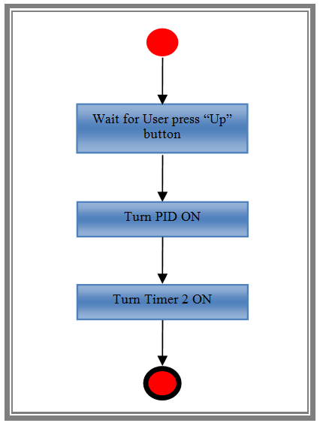
Figure 7 - Ready State Diagram

- Hovering
- In state Hovering, FUFO get instruction of user (Up, Down, Left, Right, Backward, Forward), when interrupt Timer 2 10ms occur, FUFO calculate data get from sensor to control FUFO base on instruction of User.
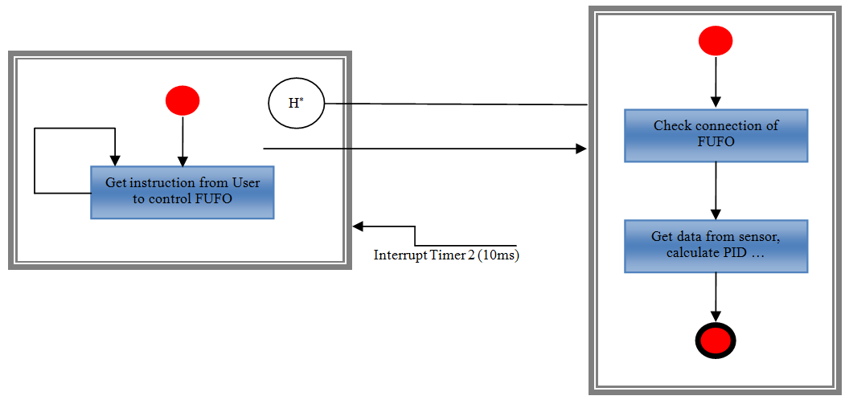
Figure 8 - Hovering State Diagram

- Landing
- When user set altitude to 0m, FUFO run in Landing state, it will decrease PWM to set level, and move to Pending state to setup for next fly.
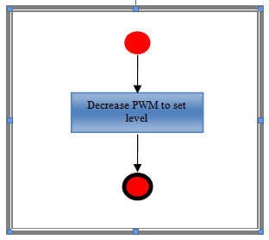
Figure 9 - Landing State Diagram

