Feasibility report:
Module Bluetooth HC-06
Author: Vũ Minh Phong

Overall module Bluetooth HC-06:
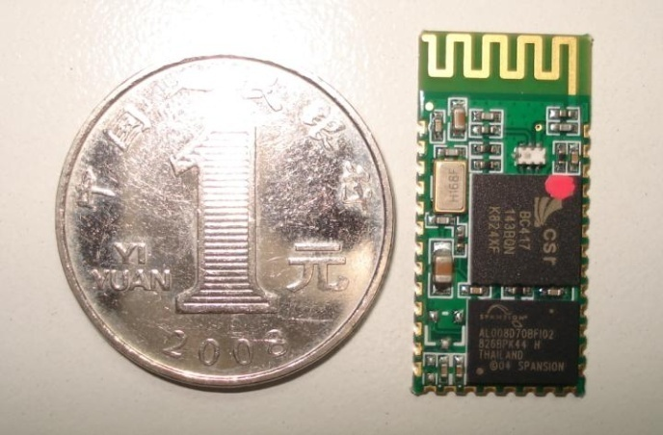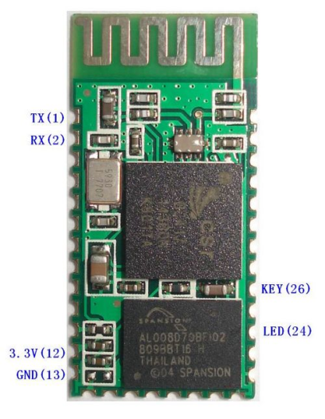
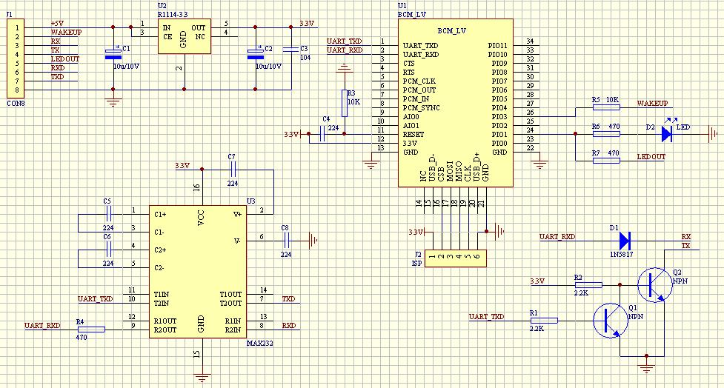
Feature:
- Use the CSR Bluetooth chip, compatible with the Bluetooth V2.0 protocol
- Slave
- Operating Voltage 3.3V
- Adjustable baud rate : 1200，2400，4800，9600,19200，38400，57600，115200
- Size: 28mm x 15 mm x 2.35mm
- Operating Current 40 mA
- Sleep Current < 1mA
- Program with AT command language
- UART interface
- Range 30ft ~ 9,1m
- Made in China
Price: 280.000 VND

Why it is suitable for FUFO project:

What is expected in FUFO project:
- Use a Bluetooth module to establish UART connection between Android phone and MicroProccessor.
- 10m range is enough.
- Baud rate = 9600
- Small size.
- UART interface
What module HC-06 provide:
- Use the CSR Bluetooth chip, compatible with the Bluetooth V2.0 protocol
- Adjustable baud rate : 1200，2400，4800，9600,19200，38400，57600，115200
- Range ~9.1m
- Size: 28mm x 15 mm x 2.35mm
- Program with AT command language
- UART interface
- The only Bluetooth module can be found in Vietnam market at this time.

How to use:

1. Default setting of HC-06:
Slave, 9600 baud rate, N, 8, 1. Pincode 1234

2. AT Command:
After connect HC-06 module with the MicroProcessor, we can send the AT Commands to HC-06 module through UART interface to control it. These are the basic commands:
- Communications Test :
Sent : AT
receive : OK

- Change baud rate :
Sent : AT+BAUD1
receive : OK1200

Sent : AT+BAUD2
receive : OK2400

1---------1200
2---------2400
3---------4800
4---------9600
5---------19200
6---------38400
7---------57600
8---------115200
Baud rate setting can be save even power down.

- Change Bluetooth device name:
Sent : AT+NAMEdevicename
receive : OKname
(devicename is the name you want the device to be , and it will be searched with this name)
Name setting can be save even power down.

- Change Pincode:
Sent : AT+PINxxxx
receive : OKsetpin
(xxxx is the pin code you set)
Pin code can be save even power down.

