

FUFO-VP
Software Requirement Specification

Project Code: FUFO_VP
Document Code: FUFO_VP_SRS – v1.0.1

Ha Noi, February 28th, 2012

Record of change

*A - Added M - Modified D - Deleted
Effective Date | Changed Items | A*  M, D | Change Description | New Version
2012.02.28 | Introduction | A | Add new introduction | 1.0.1
2012.02.28 | Overall | A | Add new overall | 1.0.1
2012.03.01 | Function Specific | A | Add 2 new use-case | 1.0.1
2012.03.01 | User Interface | A | Add new User Interface | 1.0.1
2012.03.02 | Non-function | A | Add non-function specific | 1.0.1
2012.03.05 | Non-function | M | Edit to meet Pong’s feedback | 1.0.1

SIGNATURE PAGE

ORIGINATOR: NguyenLK February 28th, 2012
Team Leader

REVIEWERS: <Name> <Date>
<Position>

<Name, if it’s needed> <Date>
<Position>

APPROVAL: <Name> <Date>
<Position>
TABLE OF CONTENTS
1 Introduction 5
1.1 Purpose 5
1.2 Scope 5
1.3 Definitions, Acronyms, and Abbreviations 5
1.4 References 5
1.5 Overview 5
2 Overall Description 6
3 Specific Requirements 7
3.1 Functionality 7
3.2 Usability 8
3.3 Reliability 9
3.4 Performance 9
3.5 Purchased Components 9
3.6 Interfaces 10

Introduction

Purpose
Specify the purpose of this SRS. The SRS fully describes the external behavior of the application or subsystem identified. It also describes nonfunctional requirements, design constraints, and other factors necessary to provide a complete and comprehensive description of the requirements for the software.

Scope
The VP Project is a subsystem of FUFO project. It is designed for controlling FUFO through internet with 3G or Wi-Fi connection. It allows users to see what is recorded from phone’s camera on FUFO and control it.

Definitions, Acronyms, and Abbreviations
Acronym | Definition | Note
SRS | Software Requirement Specification
AOP | Application on phone
AOC | Application on computer
FUFO | FPT University Flying Object | Controlled by AOC through AOP

References
N/A

Overview
The content of this SRS is organized as follow:
- Section 1 is a general introduction to this document.
- Section 2 is an overall description to describe the general factors that affect the products and its requirements.
- Section 3 is a specific requirement of product.
- Section 4 is supporting information that makes the SRS easier to use.

Overall Description

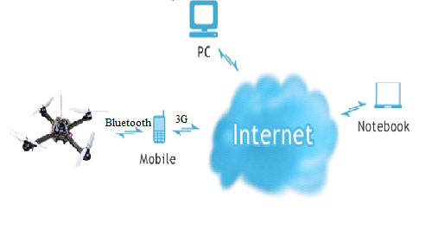
Figure 1 : Overall Description

The VP project includes an application on Android phone (AOP) and an application on computer (AOC).

AOC is a socket server, used to receive video from the Android phone and control the FUFO by sending command to AOP when receive status from FUFO’s sensor.

AOP is a socket client. It sends video to AOC in real-time. It also receives command from AOC and controls FUFO by sending AOC’s commands via Bluetooth.

Specific Requirements

Functionality
- Control the FUFO

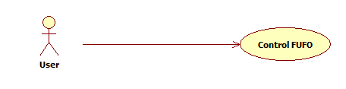

User Case ID | UC_1
Name | Control FUFO
Goal | User can control the FUFO, help it turn left, turn right, go straight or turn back, go up or go down.
Actors | User
Pre-conditions | User sets up the connection with FUFO via AOC and AOP.
Post-conditions | User stops the connection with FUFO via AOC and AOP.
Main Flow | - User sets up the connection with FUFO via AOC and AOP.  - User can see received status from FUFO’s sensor on screen of AOC.  - User could control the FUFO by using keyboard on computer and based on FUFO’s status and streamed video.  - User stops the connection with FUFO via AOC.
Exception | If connection between computer and FUFO fail, show error message.
Open Issues | N/A

- See live video from FUFO on computer

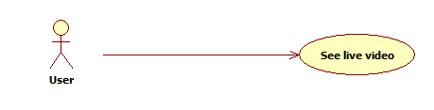

User Case ID | UC_2
Name | See live video
Goal | User can see live video that is recorded on camera on FUFO to control the FUFO.
Actors | User
Pre-conditions | User sets up the connection with FUFO via AOC.
Post-conditions | User stops the connection with FUFO via AOC.
Main Flow | - User sets up the connection with FUFO via AOC and AOP.  - User can see live video which FUFO is streaming to AOC.  - User stops the connection with FUFO via AOC.
Exception | If connection between computer and FUFO fail, show error message.
Open Issues | N/A

Usability
Application is easy to use and understand.
GUI is simple and easy to understand.
User can configure the application by themselves after 1 guide time.
User can use this application without knowledge about network or IT.
User can use Hotkey to control the AOC.

Reliability
The application will operate accurately.
There are many solutions to control FUFO by itself while the connection is not available.
Video stream should work as stable as possible for controlling FUFO.
Interface has to display status received from FUFO's sensors.

Performance
The maximum delay time when sending command from computer to FUFO is 0.5s, average is 0.2 seconds.
The maximum delay time when streaming video from FUFO to computer is 1s, average is 0.5 seconds.
The application can be used in the weak and old system with Pentium 3 CPU and 256 Mb RAM.

Purchased Components
This application uses an Android phone placed on FUFO to control and stream video to computer. The required version of Android phone OS is 2.2 (Froyo).

Interfaces

User Interfaces
- Interface of AOC

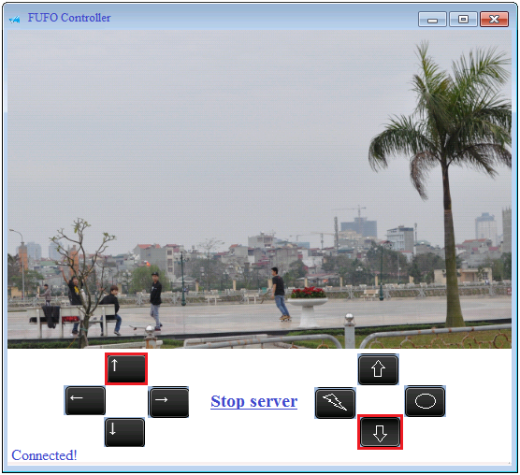

- User Interface of AOP

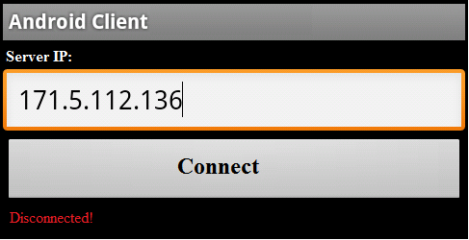

Hardware Interfaces
The Android Phone can also connect to 3G and Wi-Fi.

Software Interfaces
The Android Phone must support developing API for Bluetooth, record camera and support RTSP (real time stream protocol).

