- Definitions, Acronyms and Abbreviations
Abbreviations | Description | Comment
FUFO | FPT University Flying Object
PWM | Pulse-width modulation
I2C | Inter-integrated circuit
UART | Universal asynchronous receiver/transmitter
TMR | Timer
Accel | Accelerometer
Gyros | Gyroscope
Baro | Barometer

- FUFO State diagram

FUFO system will base on this following State Diagram:
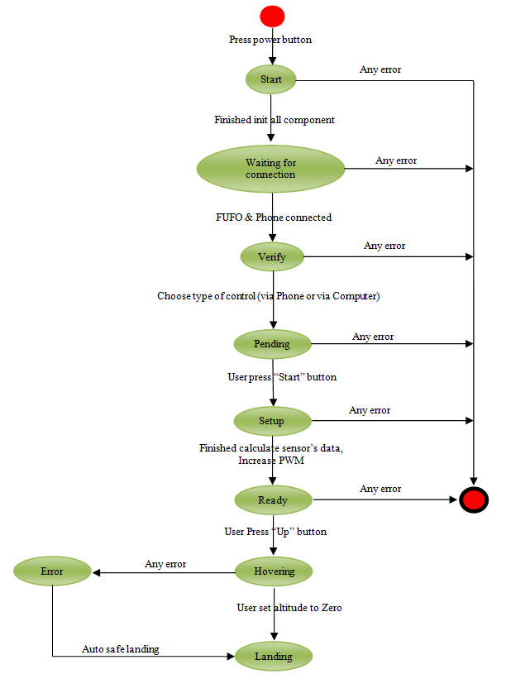

Figure 1 - FUFO State Diagram

- Start State
- When power turn on, first state of FUFO is “Start”, in this state, FUFO will init communication method as I2C, UART, and modules as PWM, Accel, Gyros, Baro, TMR2,
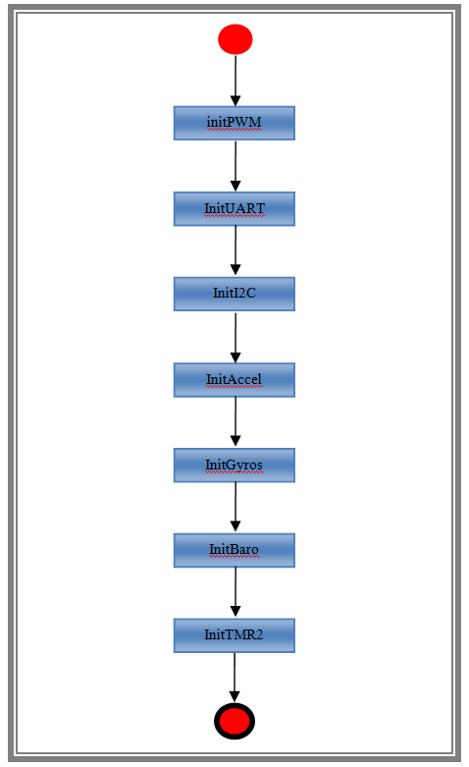
Figure 2 – Start State Diagram

- WaitingForConnection
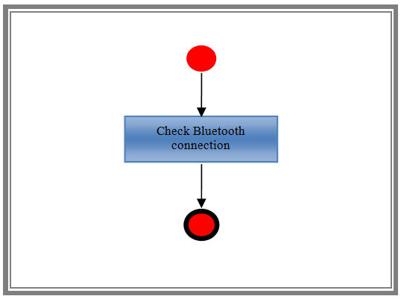
Figure 3 - Waiting for connection

- Verify
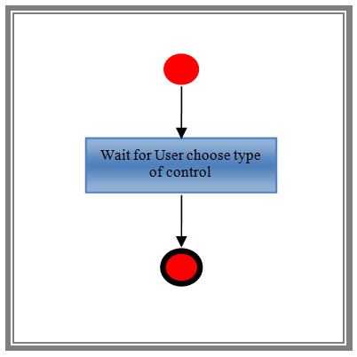
Figure 4 - Verify State Diagram

- Pending
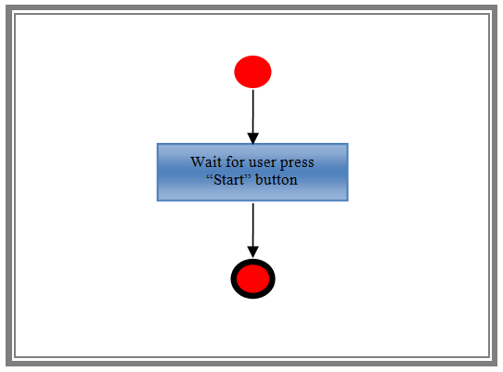
Figure 5 - Pending State Diagram

- Setup
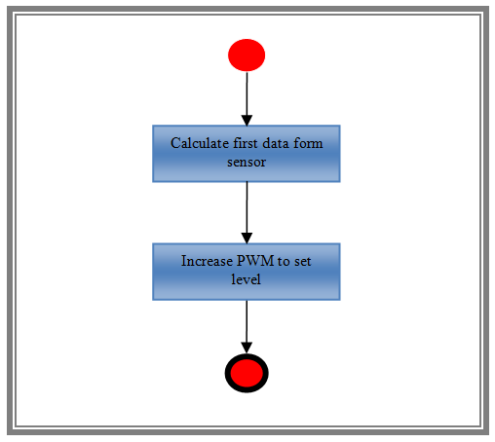
Figure 6 - Setup State Diagram

- Ready
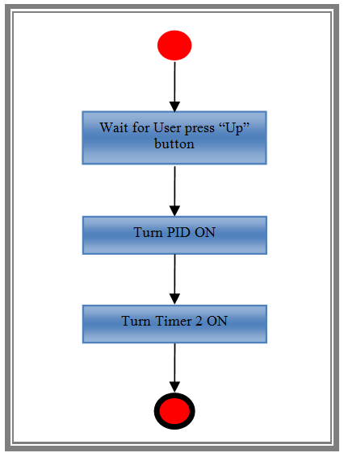
Figure 7 - Ready State Diagram

- Hovering
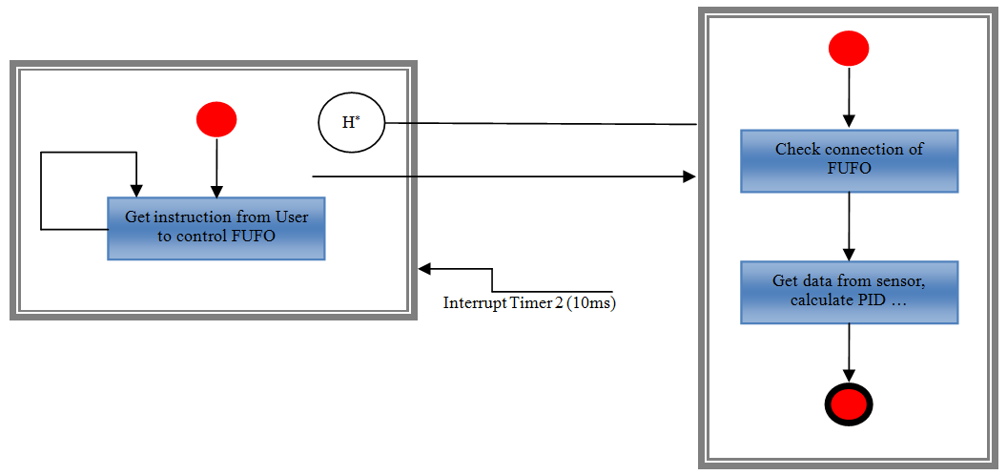
Figure 8 - Hovering State Diagram

- Landing
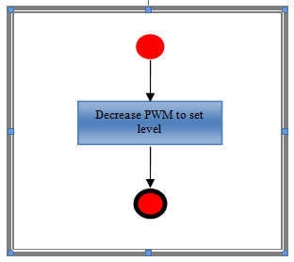
Figure 9 - Landing State Diagram

